Create EC2 and login into it using SSH
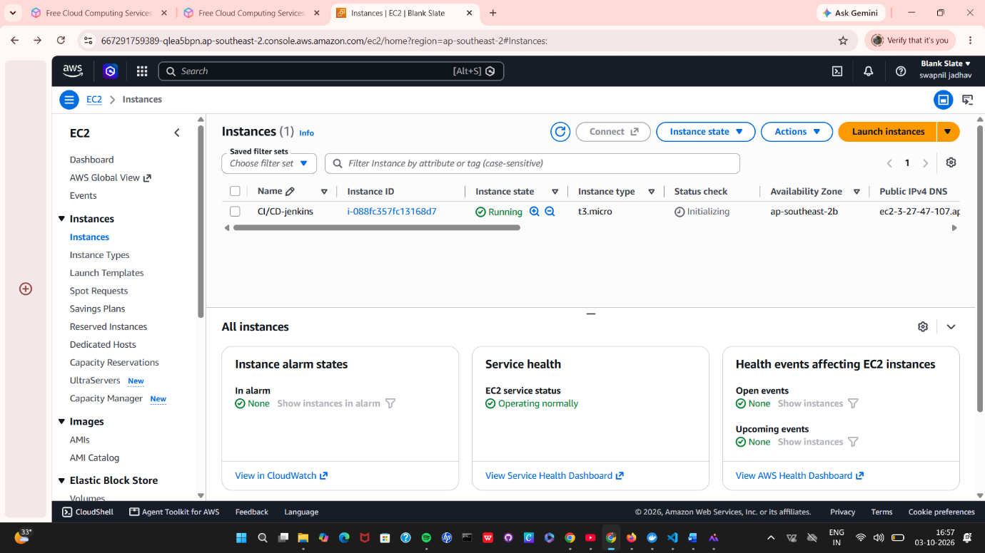

Install Jenkins in EC2
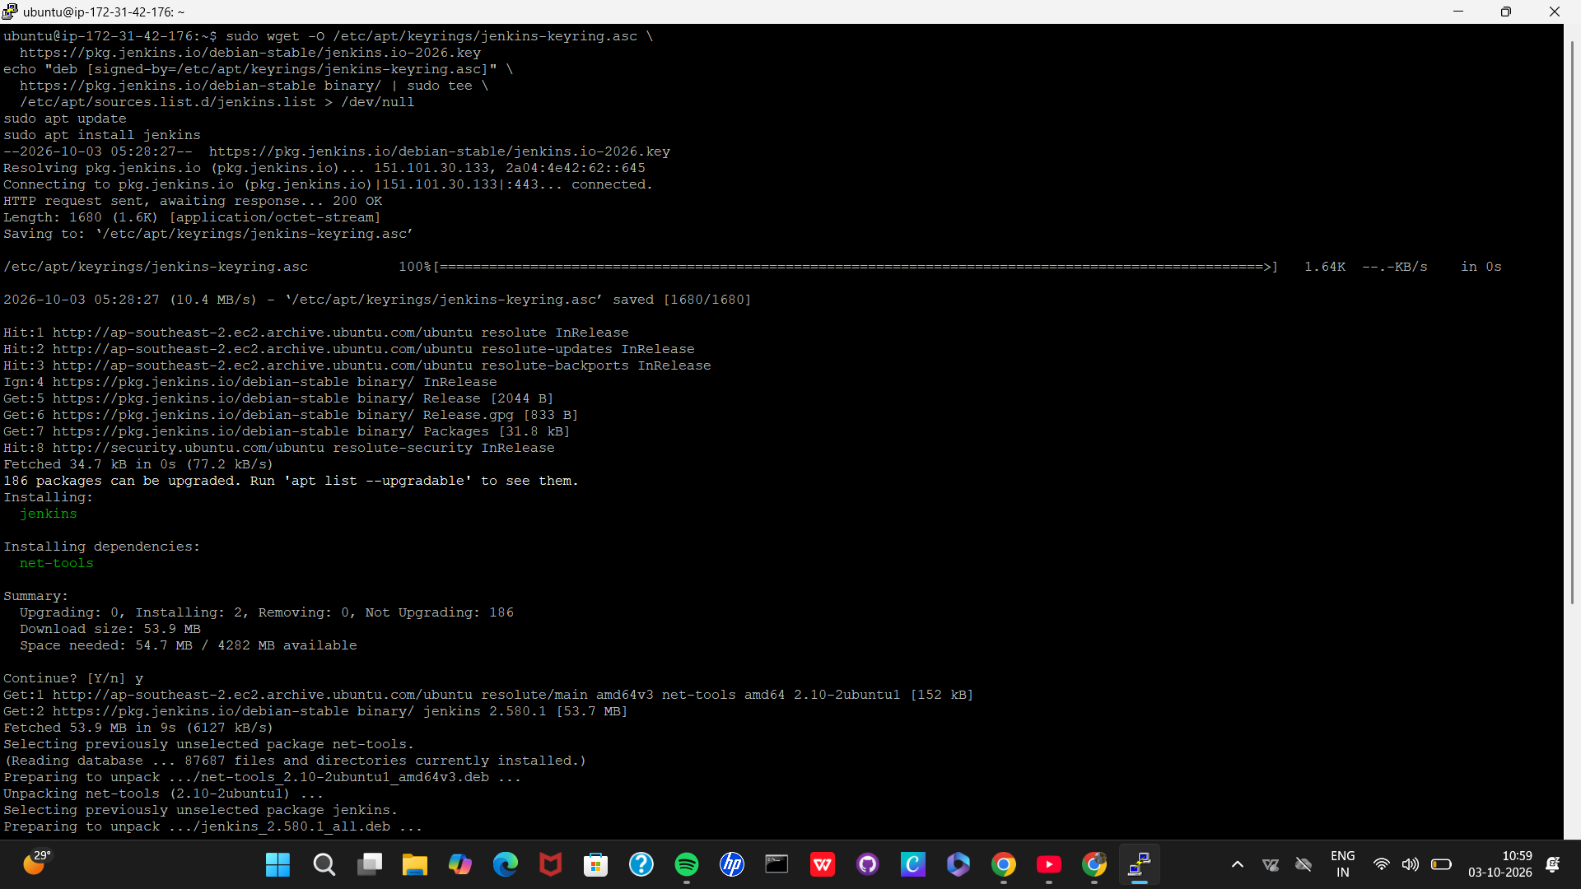

Login into Jenkins using Ec2 public IP and port number
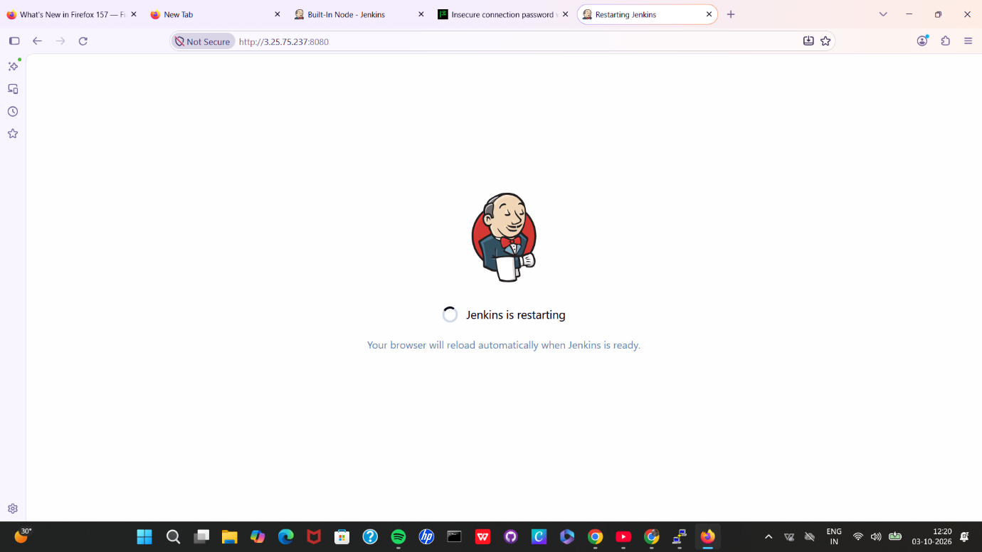

Add plugins (Docker)
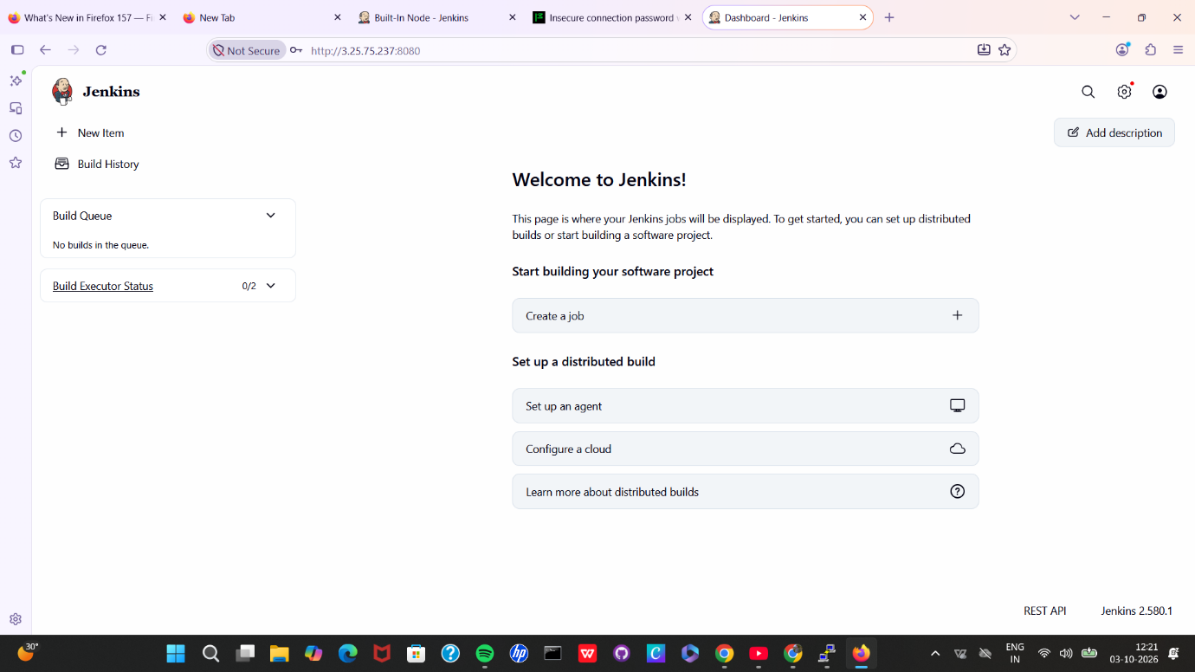

Successfully created the pipeline
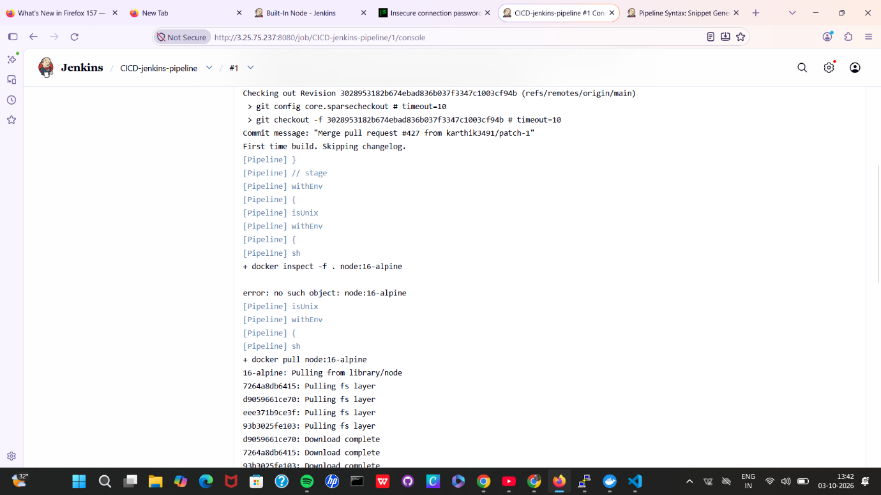

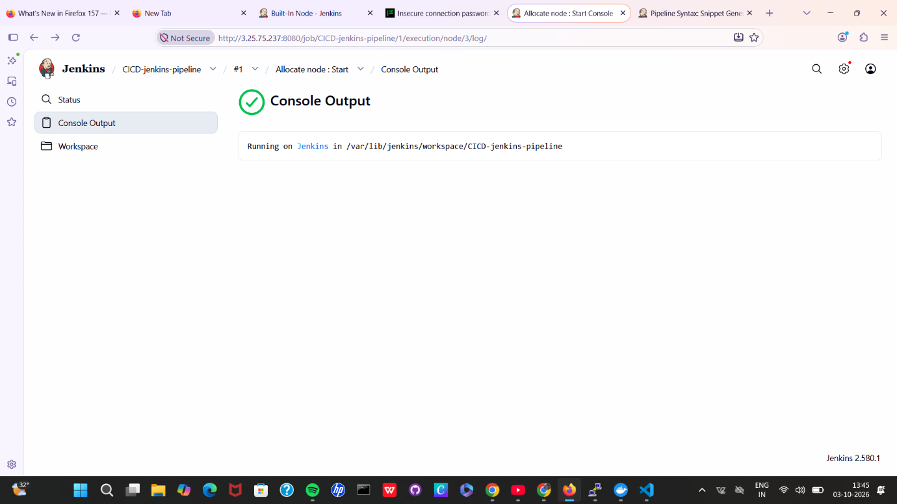

Used docker as agent in Jenkins project setup and I found tis as very useful in terms of cost and also in terms of efficiency.
