Jessica Nguyen

CSS430, Project 1J

Shell.java

1. **DESIGN**
2. Flowchart: (clearer image in gg drive link)

<https://drive.google.com/file/d/1e2RtNTyVvnOA7aPzb43PGWzb5owkETkt/view?usp=sharing>

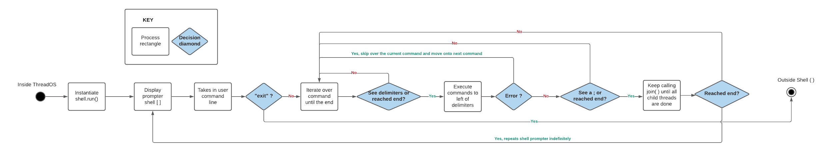

1. Components: 3 methods

* Public Shell( ) -- constructor

/* Shell() -- constructor

Postconditions: a Shell( ) object has been instantiated;

listOfChildThreads is initiated to empty HashSet

*/

* Public void run ( ) -- execution method

/* run() -- execution method

Preconditions: listOfChildThreads is initiated as HashSet

Postconditions: interprets user input commands and executes them as independent processes; The behavior of the shell simply repeats until the user enters “exit”

*/

* Private String [ ] generate -- helper method

/* generate() -- private helper method

Parameters: String [ ] args that stores the user input command

int start represents the starting index of the current child process

int end represents the ending index of the current child process

Preconditions: String[ ] args is not null

int start >= 0 and < args.length

int end >= 0 and < args.length

Postconditions: returns null if start < end

returns a String[ ] that contains command for the subprocess in args starting at index start, ending at index enD

*/

1. **HOW TO TEST SHELL.JAVA.**

* When debugging the code, I printed out System.out.println() after every line just to see what the current array looks like when iterating through the user input command
* Test cases:
  + Normal: A series of sequential and concurrent programs
* Abnormal: I chose a mix of valid + invalid statements; placing random letters after the number; putting an invalid command in between 2 or more valid commands; inputting only delimiters; not putting a space before the delimiter was one mistake I first made when testing the program

1. **OUTPUT**

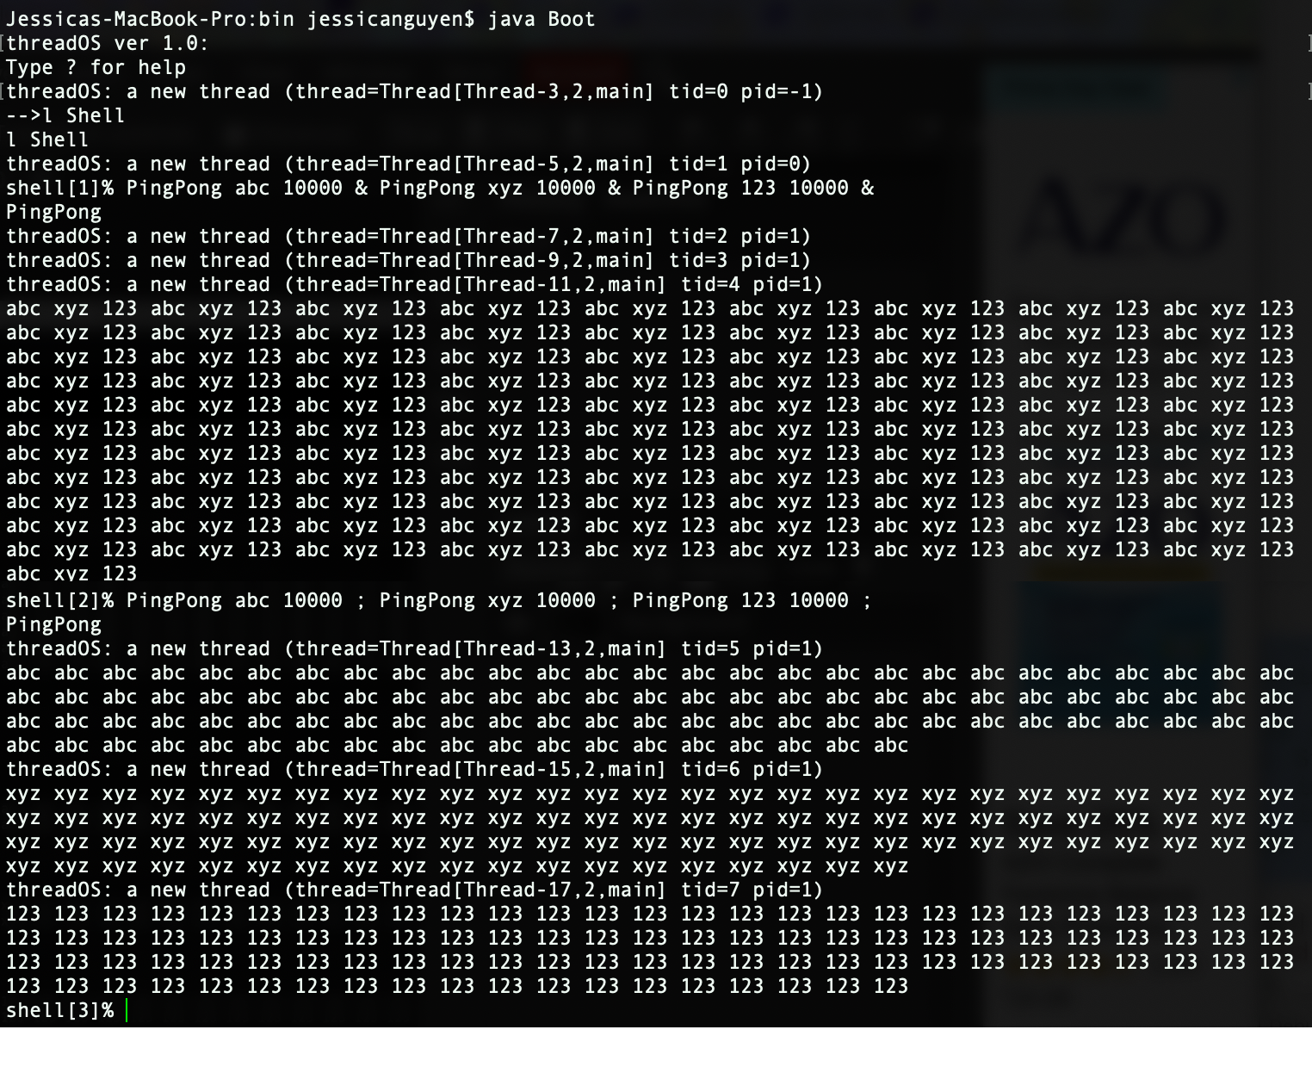

Some other edge cases:

Shell[1] : extra parameters

Shell[2] : a delimiter right after the number

Shell[3] : an empty command between 2 delimiters

Shell[4] : no commands, just delimiters

Shell[5] : random delimiters next to each other

Shell[6] : no space between number and delimiter

