Hello World!

Welcome To Baeldung!

***Green Welcome To Baeldung***

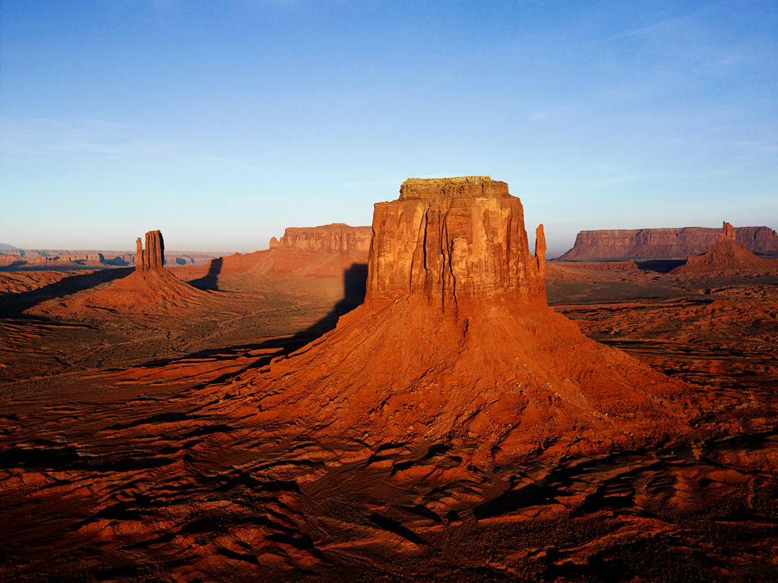

|  |  |  |
| --- | --- | --- |
| ***Green Welcome To Baeldung*** | ***Green Welcome To Baeldung*** | ***Green Welcome To Baeldung*** |
| ***Green Welcome To Baeldung*** | ***Green Welcome To Baeldung*** | ***Green Welcome To Baeldung*** |
| ***Green Welcome To Baeldung*** | ***Green Welcome To Baeldung*** | ***Green Welcome To Baeldung*** |