PRDA–03 HR ANALYTICS
KPI Values & Dashboard Analysis Report
1. Executive KPI Summary
22,214  TOTAL EMPLOYEES | 24.75%  REMOTE WORKERS | 75.25%  HQ WORKERS | 38.43  AVERAGE AGE
2. KPI Interpretation
• Total workforce: 22,214 employees.
• Remote workforce: 24.75%; Headquarters workforce: 75.25%.
• Average employee age: 38.43 years.
3. Dashboard Visualizations
The following charts are the screenshots supplied for the project. They are included without modification.
Hiring Rate by Year
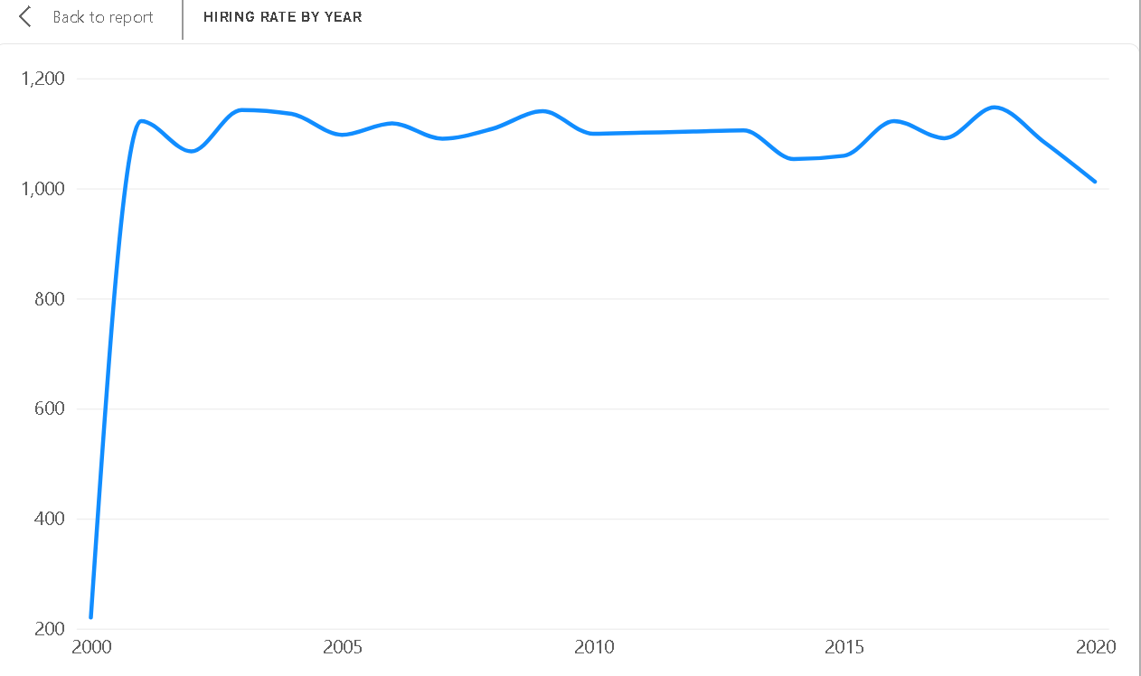
Gender of Employees
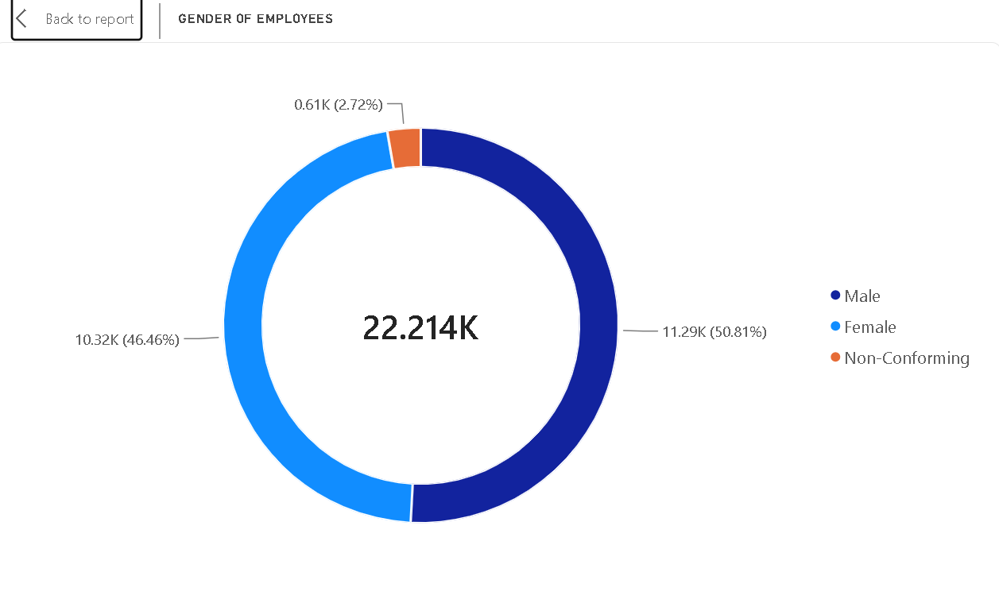

Employees by State
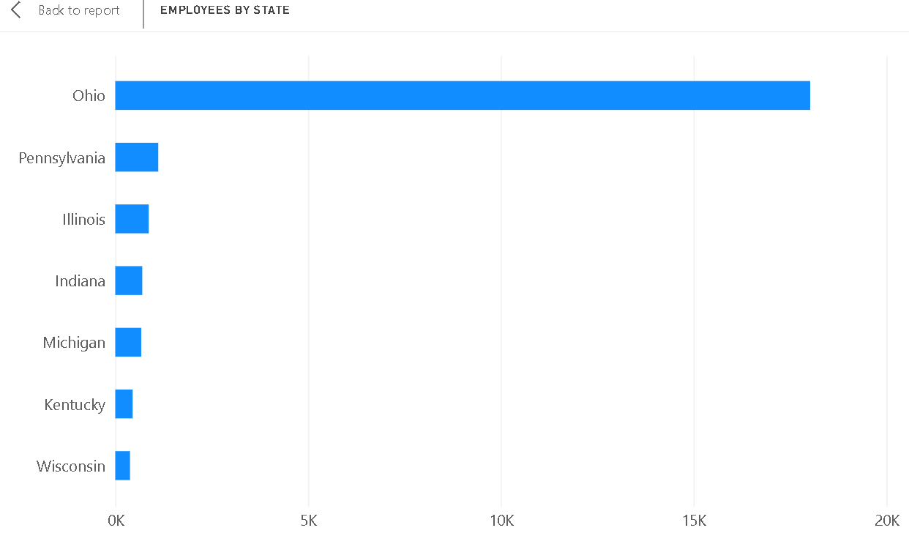
Employees by Department
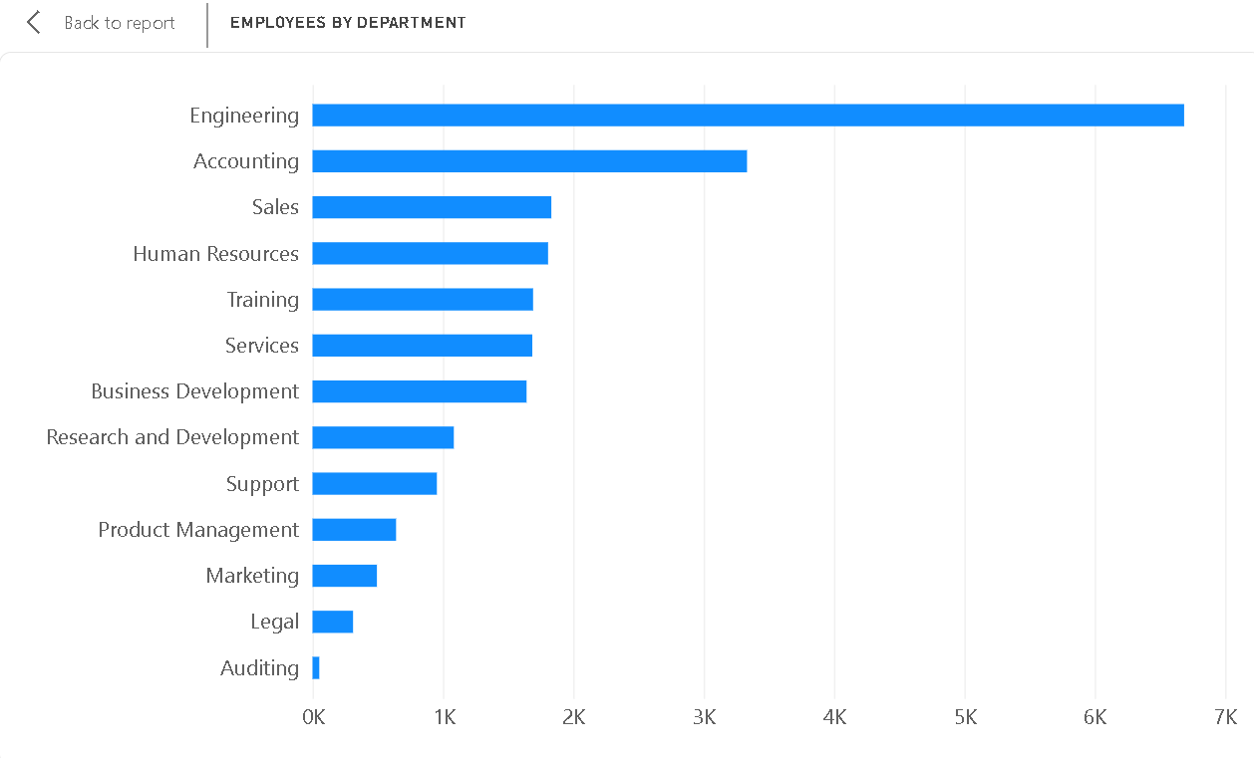

Employees by Race
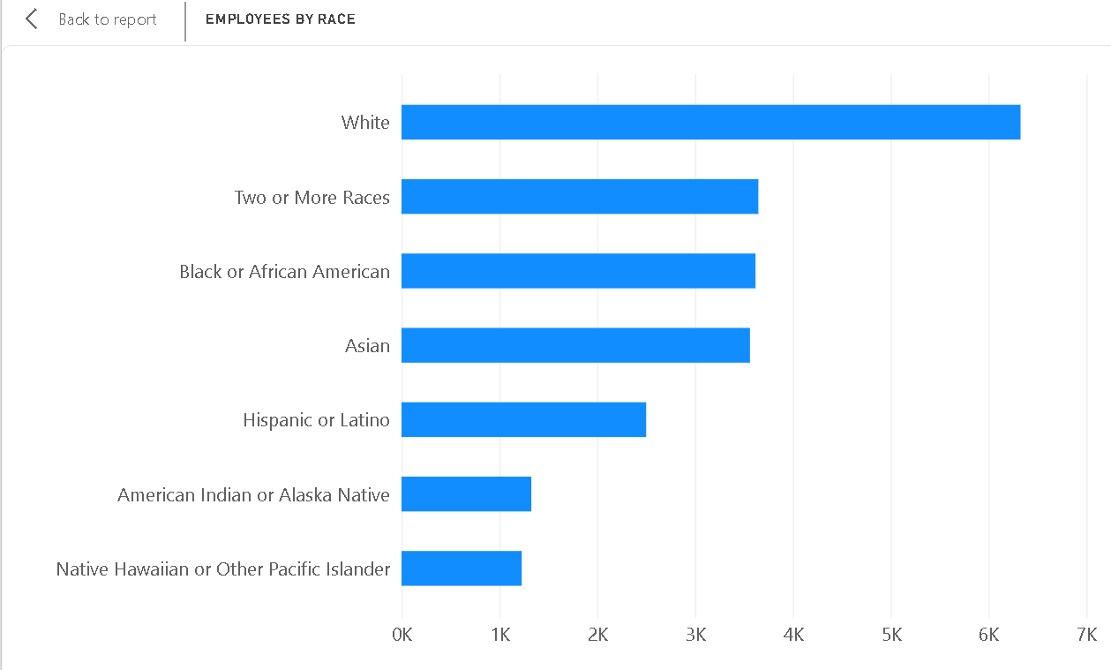
4. Key Insights
• Engineering is the largest department with 6,686 employees.
• Ohio is the dominant workforce location with 18,025 employees.
• The workforce is predominantly Headquarters-based (75.25%), with 24.75% working remotely.
• Gender representation is relatively balanced: Male 50.81%, Female 46.46%, and Non-Conforming 2.72%.
• White is the largest race category with 6,328 employees.
• Annual hiring is broadly stable around 1,000–1,150 employees in most years; 2018 has the highest count at 1,147.
5. Business Recommendations
• Review engineering workforce capacity regularly because it is the largest department.
• Evaluate Ohio's high geographic concentration and consider broader talent distribution where appropriate.
• Use role-level productivity and retention measures when evaluating future remote-work expansion.
• Monitor diversity by department and job level in addition to overall workforce representation.
• Use historical hiring patterns as a baseline for workforce and recruitment planning.
6. Conclusion
The dashboard provides a concise view of workforce size, work location, age profile, hiring trends, gender distribution, geographic concentration, departmental structure, and workforce diversity.

