CDACL-002 — Customer Segmentation
Analysis Report — U.S. Shopping Trends Dataset (3,900 customers)

1. Executive Summary
This report analyzes the U.S. shopping trends dataset (3,900 customer records, 19 attributes) to (1) recommend which products should carry discounts, (2) examine card spending patterns by age, season and location, and (3) segment customers into actionable groups using K-Means clustering.
- Discounts are best targeted at specific low-rated, high-volume items (e.g. Shirt, Jeans, Blouse, Scarf, Shorts, Pants) rather than at whole categories, which are largely uniform in this dataset.
- Credit Card users consistently out-spend Debit Card users across every age band; Fall and Winter show the highest average spend and card usage; spend varies by up to ~25% between the highest- and lowest-spending states.
- Four customer segments emerge from Age, Purchase Amount, Review Rating and Previous Purchases — a VIP high-spending segment, a happy young value segment, an at-risk young segment, and a price-sensitive older segment — each mapped to a distinct marketing campaign in Section 4.

2. Task 1 — Which Product Categories Should Get Discounts?
Approach: discounts are most justified where demand signals are weaker — i.e., lower review ratings, which suggest softer customer satisfaction or product-market fit. We examined this at both the Category level and the more granular Item level.

2.1 Category-level view
The four broad categories — Clothing, Accessories, Footwear, Outerwear — are nearly identical on average rating (3.72–3.79), average spend ($57–60), and current discount rate (42–44%). Category alone is not a useful lens for discount targeting in this dataset.

2.2 Item-level view
At the item level there is real spread in review ratings. The chart below ranks all 25 items by average rating.
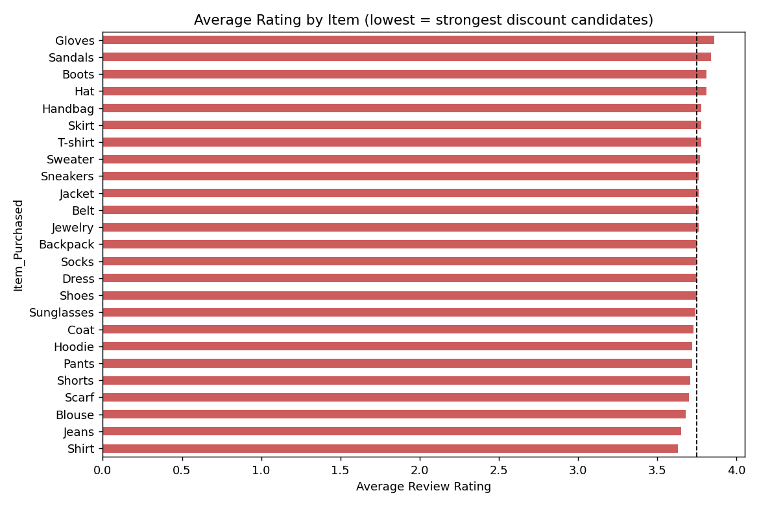
Figure 1: Average review rating by item, lowest to highest.
The lowest-rated items — Shirt, Jeans, Blouse, Scarf, Shorts and Pants (average ratings ~3.63–3.72, below the dataset average of ~3.75) — are the strongest discount candidates: a modest discount can offset weaker perceived value, encourage hesitant buyers, and move inventory that isn't earning organic repeat interest. Conversely, top-rated items such as Gloves, Sandals, Boots and Hat are already performing well and should retain full margin rather than being discounted.

3. Task 2 — Card Spending by Age, Season and Location

3.1 Age
Average spend is fairly flat across age groups (roughly $59–61 for every band from 18–25 through 66–70) — age alone is a weak predictor of order size. However, within every age band, Credit Card shoppers consistently out-spend Debit Card shoppers, with the gap widest among 26–35 year-olds (~$61 vs ~$55).
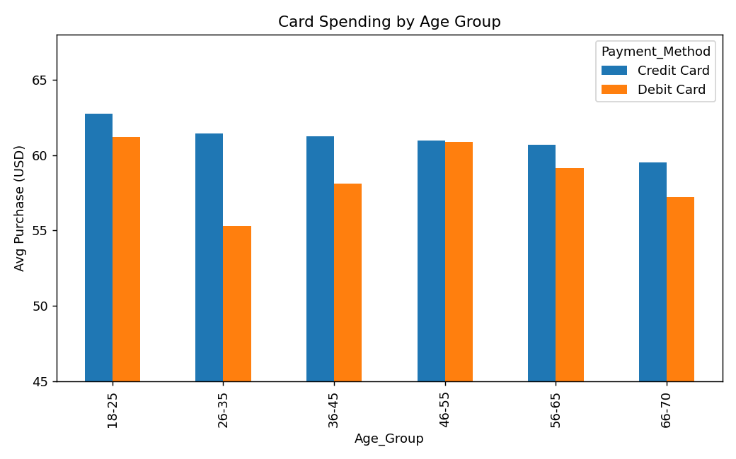
Figure 2: Average card spend by age group and card type.

3.2 Season
Fall ($61.56) and Winter ($60.36) show the highest average spend and the highest card-usage rates (36.4% and 34.7% respectively), while Spring and Summer are lower on both measures — consistent with cold-weather and holiday-season purchases skewing toward higher-ticket, card-paid items.
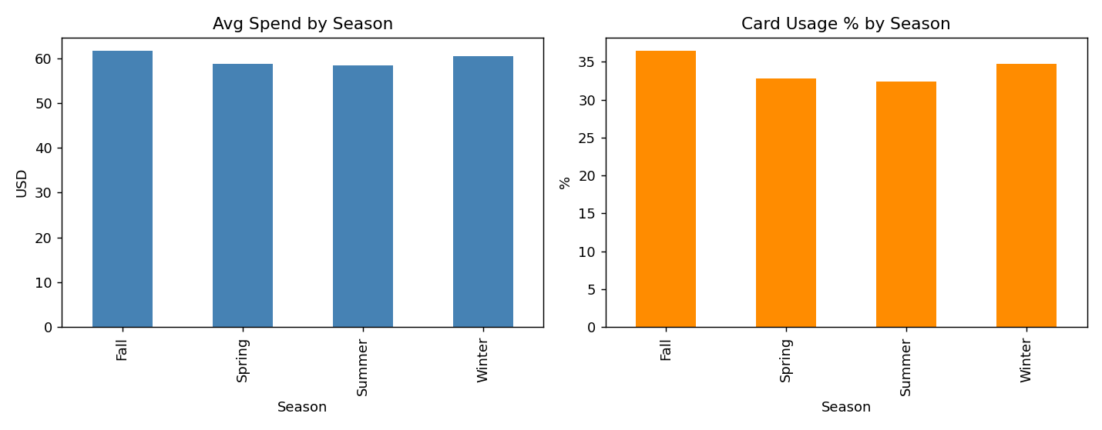
Figure 3: Average spend and card-usage rate by season.

3.3 Location
Spend varies meaningfully by state. Alaska, Pennsylvania and Arizona average $66–68 per order, while Connecticut, Kansas and Delaware average only $54–56 — roughly a 25% gap between the highest- and lowest-spending states, useful for regional pricing and marketing decisions.
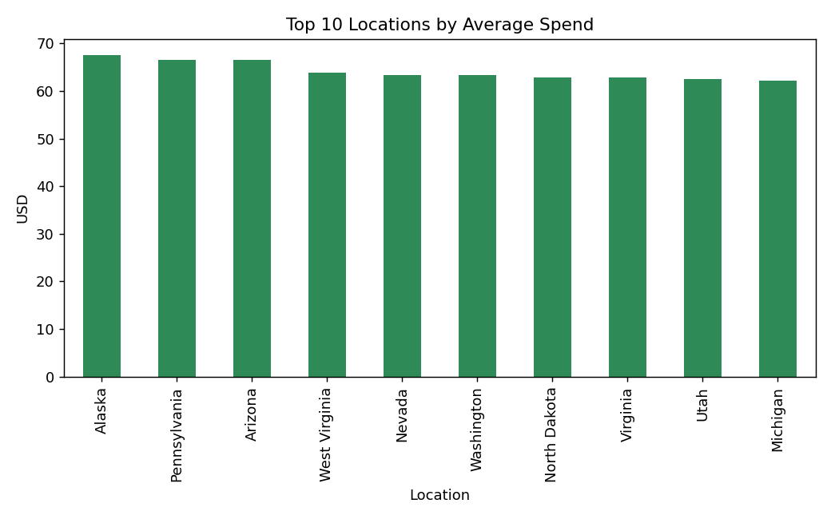
Figure 4: Top 10 U.S. states by average spend.

4. Customer Segmentation

4.1 Method
Customers were clustered on four standardized numeric features — Age, Purchase Amount, Review Rating and Previous Purchases — using K-Means. K was selected by evaluating the Elbow method (inertia) and Silhouette score across K = 2 to 8.
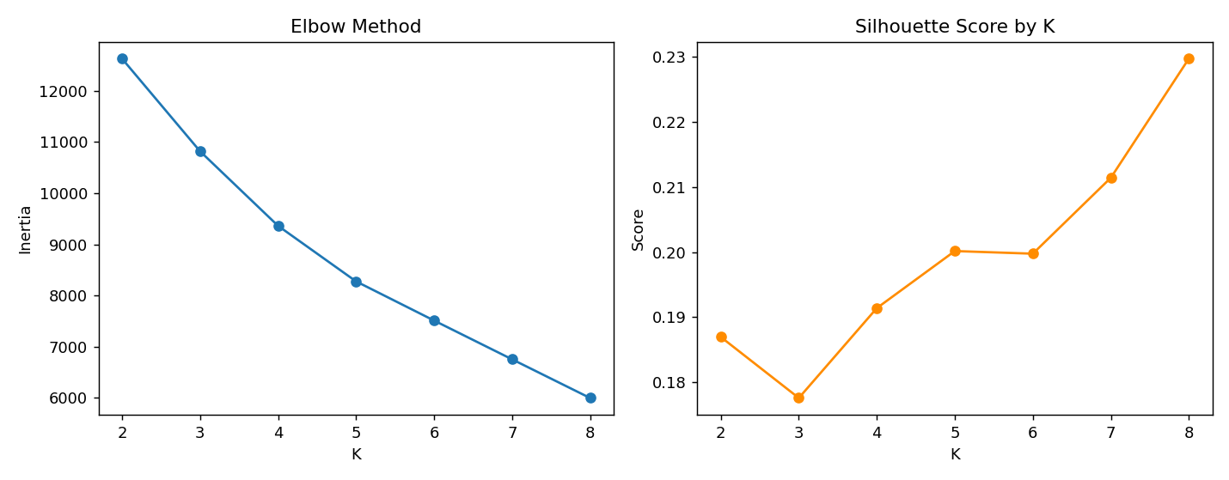
Figure 5: Elbow (inertia) and Silhouette score across candidate values of K.
Silhouette scores are modest throughout (0.18–0.23) — this dataset does not contain strongly separated natural clusters, so we prioritized a K that is both a local peak in silhouette and practical to act on. K=4 gives a local silhouette peak (0.191, up from 0.178 at K=3) and produces four large, stable clusters that map cleanly to distinct campaigns. Higher K values (7–8) only marginally improve silhouette while fragmenting the base into segments too small to target separately, so K=4 was selected as the final model.
4.1.1 Preprocessing & Standardization Evidence
Data-quality checks found 0 missing values, 0 duplicate rows and 0 duplicate Customer IDs. The four clustering variables were standardized with StandardScaler so that each variable has approximately mean 0 and standard deviation 1 before K-Means.
Feature | Original Mean | Original Std | Standardized Mean | Standardized Std
Age | 44.068 | 15.206 | 0.000 | 1.000
Purchase Amount (USD) | 59.764 | 23.682 | 0.000 | 1.000
Review Rating | 3.750 | 0.716 | 0.000 | 1.000
Previous Purchases | 25.352 | 14.445 | 0.000 | 1.000

4.2 Cluster Profiles
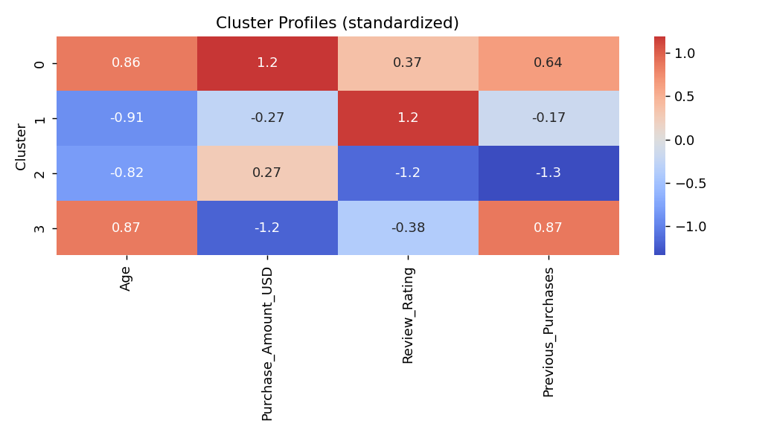
Figure 6: Standardized cluster profiles across the four clustering features.
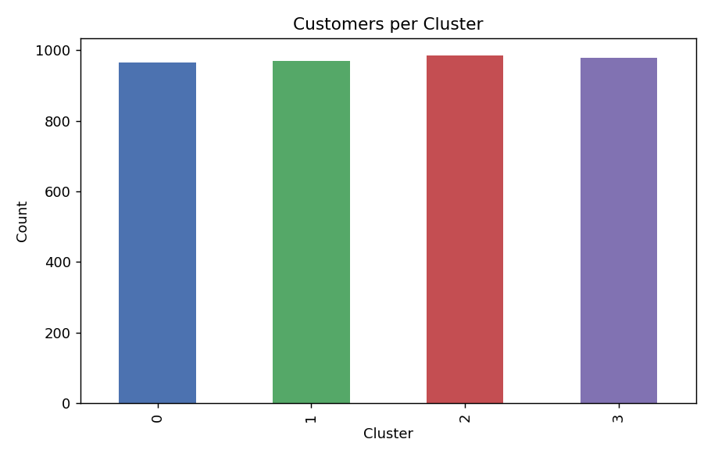
Figure 7: Number of customers per cluster (well balanced, ~966–986 each).

4.3 Segment Descriptions & Targeted Campaigns
Cluster | Profile | Dominant Factors | Recommended Campaign
0 | Older (~56 yrs), high spend ($82), high rating (3.96) | Age ↑, Spend ↑, Rating ↑ | VIP / loyalty programme: early access to premium Clothing & Accessories, exclusive bundles. No heavy discounting needed — satisfaction is already high.
1 | Younger (~31 yrs), moderate spend ($55), highest rating (4.43) | Age ↓, Rating ↑↑ | Referral & advocacy campaign: these are the happiest customers — incentivize referrals/reviews, upsell subscription.
2 | Younger (~33 yrs), decent spend ($65), lowest rating (3.09) | Age ↓, Rating ↓↓ | Retention / win-back campaign: churn-risk segment — service-recovery outreach, satisfaction surveys, targeted discounts.
3 | Older (~56 yrs), lowest spend ($38), moderate rating (3.54) | Age ↑, Spend ↓ | Value / discount-led campaign: price-sensitive segment — free-shipping thresholds, bundle deals to grow basket size.
Overall, Age and Purchase Amount are the two features that separate clusters most clearly, with Review Rating providing the key secondary split among younger customers (Cluster 1 vs. Cluster 2) — distinguishing genuinely happy repeat buyers from an at-risk group that spends but rates poorly.

5. Conclusion
- Apply discounts at the item level — not category level — focusing on Shirt, Jeans, Blouse, Scarf, Shorts and Pants.
- Use card type (Credit vs. Debit), season and location as inputs to regional and seasonal promotional timing — prioritize Fall/Winter and high-spend states for premium offers.
- Run four segment-specific campaigns: VIP loyalty (Cluster 0), referral/advocacy (Cluster 1), retention/win-back (Cluster 2), and value/discount-led (Cluster 3).
Full code, computations and all charts are available in the companion Jupyter notebook (CDACL-002_Customer_Segmentation.ipynb).

