

Princess Sumaya University for Technology
Department of Data Science Semester 2025/2026

Plant Disease Detection from Leaf Images Using Deep Learning

Prepared By:
Faisal Quntar
Jad Kandah
Sanad Al-Madani

Supervised By:
Samer El-Kababji

Project Submitted in partial fulfillment for the degree of Bachelor of Science in
Data Science

2025

Declaration of Originality

This document has been written entirely by the undersigned team members of the project. The source of every quoted text is clearly cited and there is no ambiguity in where the quoted text begins and ends. The source of any illustration, image or table that is not the work of the team members is also clearly cited. We are aware that using non-original text or material or paraphrasing or modifying it without proper citation is a violation of the university’s regulations and is subject to legal actions.

Names and Signatures of team members:

Jad Kandah
Faisal Quntar
Sanad Al-Madani

Acknowledgments

We would like to express our sincere gratitude to our supervisor, Dr. Samer El-Kababji, for his continuous guidance, valuable feedback, and support throughout the development of this project. His expertise and constructive suggestions played a major role in shaping the direction and quality of our work. We would also like to thank the Data Science and AI Department for providing the academic support and resources needed to conduct this project. Finally, we extend our appreciation to our colleagues, friends, and family for their encouragement and support during this journey.

Summary

Plant diseases present a challenge to the agricultural output, especially in rural areas where farmers struggle with limited access to agricultural experts and internet. Identifying the disease early is an important role to minimize the crop loss, making the informed treatment choices. The project addresses these issues by introducing an offline first plant disease detection system that utilizes deep learning and leaf image classification.
The system is built around a deep learning model that learns from a data of leaf images. The data was gathered from various public agricultural datasets, we specifically choose crops that are essential to the Jordanian agriculture, like olive, wheat, tomato, and potato. We will create a comprehensive data preprocessing pipeline that include cleaning the dataset, standardizing labels, normalizing images, augmenting data, and splitting the dataset in a stratified manner.
From a system design perspective, the solution is a mobile first architecture built specifically for an on-device inference. This way the farmer can take or upload pictures of leaves and get a prediction without the need of an internet connection. Also, there will be online features for user authentication, syncing history, and future scalability. To make sure it works well offline, disease names and explanations are stored locally using a predefined translation dictionary, so there will be no need for any external translation services.
Additionally, the project includes a clear architecture and logical system design, complete with UML diagrams that illustrate the training pipeline, deployment architecture, system behavior, and user interaction flows. The end result will be a trained deep learning model ready for mobile deployment, a working mobile application prototype, and thorough technical documentation.
In summary, the project shows how the deep learning can be practically applied in agriculture by providing a deployable, offline capable plant disease detection system that meets the real-world challenges faced by farmers.

List of Abbreviations

List the abbreviations you have used in your project if there are any and what they stand for.
CNN: Convolutional Neural Network
UML: Unified Modeling Language
CSV: Comma-Separated Values
GPU: Graphics Processing Unit
OS: Operating System
API: Application Programming Interface
SQL: Structured Query Language
RGB: Red, Green, Blue
JPEG: Joint Photographic Experts Group
UI: User Interface
ERD: Entity Relationship Diagram
AI: Artificial Intelligence
ML: Machine Learning

Table of Contents

Declaration of Originality 2
Summary 4
List of Abbreviations 5
Table of Figures 9
Table of Tables 10
Introduction 11
1.1 Overview 11
1.2 Problem Statement 11
1.3 Related Work 12
1.4 Contribution 12
Project Plan 13
2.1 Project Deliverables 13
2.2 Project Tasks 13
2.3 Roles and Responsibilities 15
Requirements Specification 17
3.1 Stakeholders 17
3.2 Platform Requirements 18
3.2.1 Training Environment Requirements 18
3.2.2 Mobile Application Requirements 18
3.2.3 Backend Server Requirements 19
3.3 Functional Requirements 19
3.4 Non-Functional Requirements 22
3.5 Other Requirements 24
System Design 25
4.1 Architectural Design 25
4.2 Logical Model Design 27
4.3 Physical Model Design 32
Data Preprocessing 34
5.1 Data Collection and Description 34
5.1.1 Data Sources 34
5.1.2 Data Collection Process 34
5.1.3 Data Metadata 35
5.2 Data Profiling and Engineering 35
5.2.1 Data Quality Assessment 35
5.2.2 Data Cleaning Techniques 35
5.3 Feature Engineering 36
5.3.1 Feature Extraction 36
5.3.2 Image Normalization 36
5.3.3 Feature Selection and Dimensionality Reduction 36
5.3.4 Data Augmentation 36
5.4 Data Loading 37
5.4.1 Dataset Splitting 37
5.4.2 Data Storage Format 37
5.4.3 Justification for Classification Approach 37
Implementation 38
6.1 General Implementation Description 38
6.2 Pipeline Implementation Description 39
6.3 Model Implementation 40
6.4 Additional Implementation Details 41
6.4.1 Appendix Code References 41
6.4.2 System Architecture 42
6.4.3 Critical Algorithms and Techniques 42
6.4.4 Implemented vs Deferred Features 43
6.4.5 Additional Notes 44
Testing 44
7.1 Testing Approach 44
7.2 Testing Results 44
7.3 Discussion (optional) 44
Conclusions and Future Work 45
Users’ Manual 46
Document Changes 47
Code Documentation 48
References 49

Table of Figures
Figure 1: Gantt Chart Showing the Work Flow 15
Figure 2: Context Diagram 24
Figure 3: Container Diagram (Deployment) 25
Figure 4: Activity Diagram (Deployment) 26
Figure 5: Use Case Diagram 27
Figure 6: Sequence Diagram (Registration) 28
Figure 7: Sequence Diagram (login + Request Diagnosis) 29
Figure 8: Sequence Diagram (login + view History) 30
Figure 9: Three Images Showing Sign in, Home and Profile Screens 31
Figure 10: Three Images Showing the Settings, Camera, and Gallery Screens 31
Figure 11: Three Images Showing Two Different Parts of the Result Screen, and the History Screen 32
Figure 12: Entity Relationship Diagram 32

Table of Tables
Table 1: High-Level Project Tasks and Dependencies 12
Table 2: Task Split Among Team Members 14
Table 3: System Stakeholders 16
Table 4: Platform Requirements by Sub-System 18

Chapter 1

Introduction

1.1 Overview
Agriculture sits at the heart of food security and economic stability, and healthy plants are the backbone of productive farming. But most farmers might run into trouble when it comes into spotting plant diseases early. Sometimes experts are not around when you need them. Different diseases can look almost the same, and infections tend to spread fast. These factors chip away at crop yields and production, eventually threatening the economic stability of the entire farming communities.
Deep learning changed everything here. Because computers can now analyze complex images accurately, farmers do not have to wait for a lab to tell them what is wrong with their plants. A quick photo on a smartphone is often all it takes to get a reliable answer.
Our work focuses on applying deep learning to detect diseases across eleven major crop types. We picked these datasets because they include maize, wheat, olives and peaches, specifically because of how important they are to Jordanian agriculture. It was important to us that the model reflects the actual mix of species found in our local fields.
Our main focus was making this work without a constant internet connection. By building the deep learning model to run locally on a mobile device, we are making sure it is actually useful for farmers in the real world, especially in areas where internet is not available.

1.2 Problem Statement
To know if a plant has a disease in an early stage is so hard even for an expert sometimes. Most of the farmers usually struggle with overlapping symptoms, and a single misdiagnosis that can lead to a high cost, and ineffective treatments that might threat an entire harvest. This problem happens a lot specially in the remote areas, where most farmers cannot get good advice from a professional agricultural engineer, this leaves the farming community vulnerable to preventable losses.
This project addresses the challenges that are mentioned before by developing a deep learning system that is designed for the real time plant disease classification. The research’s primary deliverables are:
- A high accuracy detection model specifically trained to identify the unique disease found in the crop.
- This model was built into a mobile ready version by optimizing the mobile deployment for the mobile hardware, so that it is possible to use the model in areas where the internet connection is not available.
This system is built primarily for the farmers especially the farmers who need a reliable answer right on that time to save their harvest. Beyond the farm gate, its utility extends to the agriculture firms looking to streamline their operations, same goes for the engineers and field inspectors tasked with monitoring crop health across a wide region. Even for students and researchers, the tool serves as a practical bridge between theoretical plant pathology and real-world application.
The most important part of this project is the offline model. We designed it with the reality of rural Jordan in mind, where a data connection is often a hard to get there. This happened by letting the model lives on the device itself.

1.3 Related Work
Researchers have jumped into using deep learning to spot plant diseases from images. Most of the projects train CNNs like AlexNet, VGGNet, ResNet, or MobileNet on big public datasets, PlantVillage is the most prominent. These models usually do a great job in detection when it comes to identifying diseases from clean, well-lit leaf images.
But there are problems, a lot of these systems struggle when the lighting is not perfect or the background looks different from what the models trained on. Most have not been deployed for real use. They focus on clean datasets, not messy field images. If you are a farmer without a stable internet connection, almost none of these tools work offline or on a phone.
Instead of just building another model that looks good on lab data, the goal here is to create something practical, something farmers can actually use on their phones, right there in the field, even without internet. The deep learning backbone is still there, but every decision is about making the system useful in real conditions, not just in theory.

1.4 Contribution
- Novelty in the idea: The project introduces a plant disease detection system, enabling diagnosis directly in the field.
- Audience it serves and how: The system primarily supports farmers by providing quick, accessible disease identification from leaf images, while also assisting agricultural engineers and researchers as a rapid diagnostic tool.
- A complete offline-first pipeline integrating dataset preparation, model training, and mobile-ready deployment, with backend synchronization for enhanced services.

Chapter 2

Project Plan

2.1 Project Deliverables
- A large trained deep learning model on a server that runs only when connected to the internet, that is able to classify images into their correct classes.
- A small trained deep learning model local on the user's phone that runs only when offline, that is able to classify images into their correct classes but in a weaker way.
- All code used in the project including preprocessing, training, evaluation, and model exports.
- Simple mobile app capable of running the model locally and performing on-device disease classification.
- Documentation for the entire project.
- Dataset metadata that will be in CSV form that describe the crops, diseases and train/validation/test splits.
- Dataset Storage that contains the complete image dataset that will most likely be places on a google drive.
- An evaluation of the outputs using the standard metrics, confusion matrix, and results that we get when we test the model.

2.2 Project Tasks
The tasks in this project are as follows:
Table 1: High-Level Project Tasks and Dependencies
Task No. | Task Name | Description | Duration | Dependencies
2.2.1 | Requirement Identification | Identify functional and non-functional requirements of the system. | 1 week | None
2.2.2 | Requirement Modeling | Organize and formalize the identified requirements into a structured model to guide system design and implementation. | 1 week | 2.2.1
2.2.3 | Dataset Analysis and Statistical Assessment | Analyze the plant leaf image dataset to assess dataset size, class distribution, crop coverage, and train/validation/test splits. | 1 week | 2.2.1
2.2.4 | Development Strategy Definition | Define the development strategy, including hardware environment, software tools, programming languages, and deployment approach for mobile and backend components. | 1 week | 2.2.2
2.2.5 | Market Need | Assess the market need for plant disease detection systems and compare existing solutions with the proposed project. | 1 week | 2.2.1
2.2.6 | Ethical Considerations Analysis | Analyze ethical aspects related to data usage, user privacy, and reliance on automated disease predictions. | 1 week | 2.2.1
2.2.7 | Architecture Design | Design the high-level system architecture defining the training pipeline, mobile application, on-device inference, and backend services. | 1 week | 2.2.2
2.2.8 | User and System Interface Design | Design the user interface of the mobile application and define system interactions between components. | 1 week | 2.2.7
2.2.9 | Backend and Data Storage Design | Design backend services for user management, authentication, and usage history storage. | 1 week | 2.2.7
2.2.10 | Data Pipeline Implementation | Implement data preprocessing, augmentation, and data loading pipelines for model training. | 2 weeks | 2.2.3
2.2.11 | Model Training and Evaluation | Train the CNN-based deep learning model and evaluate its performance using appropriate metrics. | 2 weeks | 2.2.10
2.2.12 | Model Export and Mobile Integration | Export the trained model to a mobile-ready format and integrate it into the mobile application. | 1 week | 2.2.11
2.2.13 | Mobile Application Implementation | Implement the mobile application for image capture, on-device inference, and result presentation. | 2 weeks | 2.2.12
2.2.14 | Backend Services Implementation | Implement backend services for authentication, history storage, translation, and optional online inference. | 2 weeks | 2.2.9
2.2.15 | Testing | Test the system components, including model performance, mobile application functionality, and backend integration. | 1 week | 2.2.13, 2.2.14
2.2.16 | Documentation | Prepare and finalize project documentation according to the graduation project template. | 1 week | All previous tasks

2.3 Roles and Responsibilities
The roles are split into the following:
Table 2: Task Split Among Team Members
Task | Owner | Supporting | Deliverables | Estimated Workload
Requirement Identification | Jad | Sanad | List of functional and non-functional requirements | Medium – Requires careful analysis and coordination, but limited technical implementation.
Requirement Modeling | Jad | Faisal | Structured requirements specification | Medium – Logical continuation of requirements with moderate documentation effort.
Dataset Analysis and Statistical Assessment | Sanad | Faisal | Dataset statistics, class distribution analysis | High – Involves data exploration, validation, and interpretation critical to model design.
Development Strategy Definition | Faisal | Jad | Development tools and deployment strategy document | Low – High-level decisions with limited technical depth at this stage.
Market Need and Competitor Assessment | Faisal | Jad | Market analysis summary | Low – Research-based task with minimal technical dependency.
Ethical Considerations Analysis | Jad | Faisal | Ethics discussion section | Low – Conceptual analysis with limited workload.
Architecture Design | Jad | Sanad | System architecture diagram and description | Medium – Requires system-level thinking and coordination across components.
User Interface and System Interface Design | Faisal | Jad | UI flow sketches and interface description | Medium – Design-focused task with moderate effort.
Backend and Data Storage Design | Sanad | Jad | Backend design description | Medium – Conceptual design without full implementation at this stage.
Data Pipeline Implementation | Sanad | Faisal | Data preprocessing and loading scripts | High – Core technical task involving experimentation and debugging.
Model Training and Evaluation | Sanad | Jad | Trained models, evaluation metrics | High – Computationally and conceptually intensive, central to project success.
Model Export and Mobile Integration | Jad | Sanad | Exported model and integration notes | Medium – Requires coordination between ML and mobile constraints.
Mobile Application Implementation | Faisal | Jad | Mobile application prototype | High – UI logic, image handling, and inference integration.
Backend Services Implementation | Sanad | Faisal | Backend APIs and database setup | Medium – Implementation-focused but limited in scope.
Testing | Jad | Sanad,  Faisal | Test cases and results | Medium – Distributed testing across components.
Documentation | Jad | Sanad,  Faisal | Final project report | High – Continuous effort requiring integration of all project parts.

Gantt Chart:
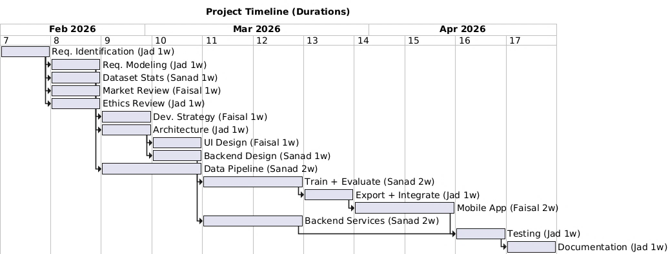
Figure 1: Gantt Chart Showing the Work Flow

Chapter 3

Requirements Specification

3.1 Stakeholders
Table 3: System Stakeholders
Stakeholder | Description | Interaction with the System | Importance of Role
Farmer (End User) | The primary user of the system who relies on the application to identify plant diseases. | Uses the mobile application to capture or upload leaf images and receive disease predictions with confidence values. | Core stakeholder; system usability, accuracy, and language support are driven by this role.
System Developer / Designer | The project team responsible for designing, implementing, and testing the system. | Designs the architecture, develops the deep learning model, mobile application, and backend services, and maintains the codebase. | Critical for system correctness, performance, maintainability, and successful delivery.
Agricultural Expert / Researcher | A domain expert who may validate results or use the system for analysis and research purposes. | Reviews disease classifications and may provide feedback on model accuracy and relevance. | Supports model validation and increases domain credibility of the system.
System Administrator | Responsible for managing backend services and system data. | Manages user accounts, authentication, system logs, and backend availability. | Ensures system reliability, data security, and proper operation of backend components.
Academic Supervisor | Oversees and evaluates the project as part of the graduation requirements. | Reviews system design, documentation, and final outcomes. | Defines academic constraints and evaluates the project’s quality and completeness.

3.2 Platform Requirements
The system consists of multiple parts a training environment, a mobile application, and backend services. Each sub system got a specific software and hardware requirement to work right. Some of the requirements are important the system work without them, others are recommended to improve performance, usability, or scalability.

3.2.1 Training Environment Requirements
The training environment is used for data preprocessing, model training, and evaluation. This environment is required only during development and experimentation.
- Mandatory requirements:
  - General-purpose operating system.
  - Python based development environment.
  - Deep learning framework capable of training CNNs.
- Recommended requirements:
  - GPU acceleration and sufficient memory to reduce training time and support larger batch sizes.

3.2.2 Mobile Application Requirements
The mobile application is how the users interact with the system. It runs the trained model on the device and connects to backend services when an internet connection is available.
- Mandatory requirements:
  - Modern smartphone with a camera, sufficient processing power to run the trained model locally, and local storage for the application and model files.
The mobile application must support full offline operation, all the way from image capture to the display of results.

3.2.3 Backend Server Requirements
The backend server supports user management, data storage, and online services. It is accessed only when the mobile application is connected to the internet.
- Mandatory requirements:
  - Server environment capable of handling authentication requests and storing user-related data.
- Recommended requirements:
  - Scalable infrastructure and secure storage mechanisms to support future expansion.
Table 4: Platform Requirements by Sub-System
Sub-System | Mandatory Requirements | Recommended Requirements
Training Environment | Python runtime, deep learning framework, standard operating system, CPU-based computation | GPU acceleration, increased RAM, faster storage
Mobile Application | Smartphone device, camera, local storage, support for on-device inference | Internet connectivity for backend features
Backend Server | Server OS, application runtime, user authentication support, data storage | Scalable hosting, enhanced security mechanisms

3.3 Functional Requirements
This section describes the functional requirements of the proposed plant disease detection system. Each requirement has an input, an output, processing steps, constraints, and its priority.
Functional Requirement 1: User Authentication
Input: User credentials (username & password).
Output: Authentication status.
Process: When connected to the internet user authentication is performed. Once authenticated, the system allows continued offline usage using a locally stored session.
Constraints: Internet Connectivity and handling data in a secure manner.
Priority: Essential.
Functional Requirement 2: Leaf Image Capture
Input: Camera input using mobile device.
Output: Captured leaf image.
Process:The user captures the image throught the mobile application using the phone camera.
Constraints: The phone must have a functional camera since poor image quality may affect the classification result.
Priority: Essential.
Functional Requirement 3: Leaf Image Upload
Input: Image uploaded from device local storage.
Output: The uploaded image.
Process: The system allows the user to upload an existing image of a plant leaf from local storage.
Constraints: Supported image formats and file size limitations apply.
Priority: Recommended.
Functional Requirement 4: Disease Classification
Input: Leaf image.
Output: Predicted disease class and confidence score.
Process: The system preprocesses the input image and applies the trained convolutional neural network to generate a prediction.
Constraints: Performance depends on available computing resources.
Priority: Essential.
Functional Requirement 5: Offline Inference Support
Input: Leaf image.
Output: Predicted disease class and confidence score.
Process: The system performs disease classification locally on the mobile device without requiring internet connectivity.
Constraints: Limited by device processing power and local storage capacity.
Priority: Essential.

Functional Requirement 6: Online Inference Support
Input: Leaf image.
Output: Predicted disease class and confidence score.
Process: When internet connectivity is available, the system supports remote inference for; however, this is not required for core functionality.
Constraints: Requires a stable network connection and may introduce latency.
Priority: Essential.
Functional Requirement 7: Result Presentation
Input: Predicted disease class and confidence score.
Output: Displayed result to the user.
Process: The system presents the classification result in a clear and understandable format within the mobile application.
Constraints: The interface must remain simple and suitable for non-technical users.
Priority: Essential.
Functional Requirement 8: Result Translation
Input: Predicted disease class and confidence score.
Output: Arabic textual explanation or translation.
Process: Disease names and explanations are provided using a locally stored translation dictionary to ensure offline availability.
Constraints: Since dictionary is hard-coded any change would need to be manually updated.
Priority: Recommended.
Functional Requirement 9: User History Storage
Input: Classification result.
Output: User history saved.
Process: Past diagnoses are stored in the system backend database, linked to the authenticated user account. When offline, history records are stored locally and then synced with the backend once connected to the internet.
Constraints: Internet connectivity.
Priority: Recommended.

Functional Requirement 10: Model Update Capability
Input: The updated model.
Output: An updated local model version.
Process: An updated model version replaces the old one on the mobile phone.
Constraints: Internet connectivity is needed and compatibility with the mobile device is also needed.
Priority: Recommended.

3.4 Non-Functional Requirements
Non-functional requirements define the quality attributes and constraints of the system rather than specific functionalities. These requirements describe how the system should perform, how secure and usable it should be, and the constraints under which it operates.
Non-Functional Requirement 1: Performance
The system should provide the results of classification in a reasonable amount of time after image submission.
- Constraint: Performance almost entirely depends on either network connectivity or device hardware.
- Priority: Essential.
Non-Functional Requirement 2: Usability
The mobile application needs to be easy to use by users, particularly farmers. The user interface should be very simple, intuitive, and it should require minimal interaction to obtain results.
- Constraint: The interface needs to support clear presentation of results, yet it should not overwhelm the user.
- Priority: Essential.
Non-Functional Requirement 3: Reliability
The system should be stable and should provide predictions under normal usage conditions. Offline-first operation improves reliability in rural environments.
- Constraint: Reliability depends on both the quality of images submitted and availability of backend services when required.
- Priority: Essential.

Non-Functional Requirement 4: Availability
The system should be available whenever the user launches the application. Also backend dependent features should function when an internet connection is available.
- Constraint: The online services are dependent on server availability and network connectivity.
- Priority: Essential.
Non-Functional Requirement 5: Security
The system should protect user data and ensure secure access to backend services. User authentication and stored information must be handled securely.
- Constraint: Requires secure communication channels and proper access control mechanisms.
- Priority: Essential.
Non-Functional Requirement 6: Scalability
The system should be allowed for future expansion in terms of supporting additional crops, diseases, or an increased number of users.
- Constraint: Scalability may depend on backend infrastructure and available resources.
- Priority: Recommended.
Non-Functional Requirement 7: Maintainability
The system should be modular to allow for updates, bug fixes, and model improvements with little impact on existing functionality.
- Constraint: Needs clear code organization and documentation.
- Priority: Recommended.
Non-Functional Requirement 8: Portability
The system should be compatible to different mobile OS and environments with minimal changes.
- Constraint: Depends on framework compatibility and platform support.
- Priority: Recommended.
Non-Functional Requirement 9: Accuracy
The disease classification results should have acceptable accuracy suitable for decision support.
- Constraint: Accuracy is influenced by a lot if factors like dataset quality, model limitations, and image conditions.
- Priority: Essential.

Non-Functional Requirement 10: Localization
The system should have Arabic language output to ensure accessibility for local farmers.
- Constraint: Dependent on availability of translation services when online.
- Priority: Recommended.

3.5 Other Requirements
Other Requirement 1: Data Transmission Protocols
All data communication between the application and backend should use secure data transmission protocols.
- Constraint: Communication must be encrypted so that user data and authentication information can be protected.
Other Requirement 2: Data Storage Format
User-related data, such as authentication information and prediction history, should be stored in structured and standard data formats.
- Constraint: Stored data must be organized to allow efficient retrieval and future expansion.
Other Requirement 3: Model File Management
The trained model should be stored and distributed in a format suitable for mobile deployment.
- Constraint: The model format must be compatible with the chosen mobile framework and support future updates without requiring changes to the application logic.

Other Requirement 4: External Service Dependency
Optional system features that depend on external services, such as result translation, should fail gracefully if the service is unavailable.
- Constraint: Core disease classification functionality must remain unaffected by the availability of external services.

Chapter 4

System Design
In this section, provide the appropriate diagrams with Propper’s justification. Also, it should include the physical model design of your system.

4.1 Architectural Design
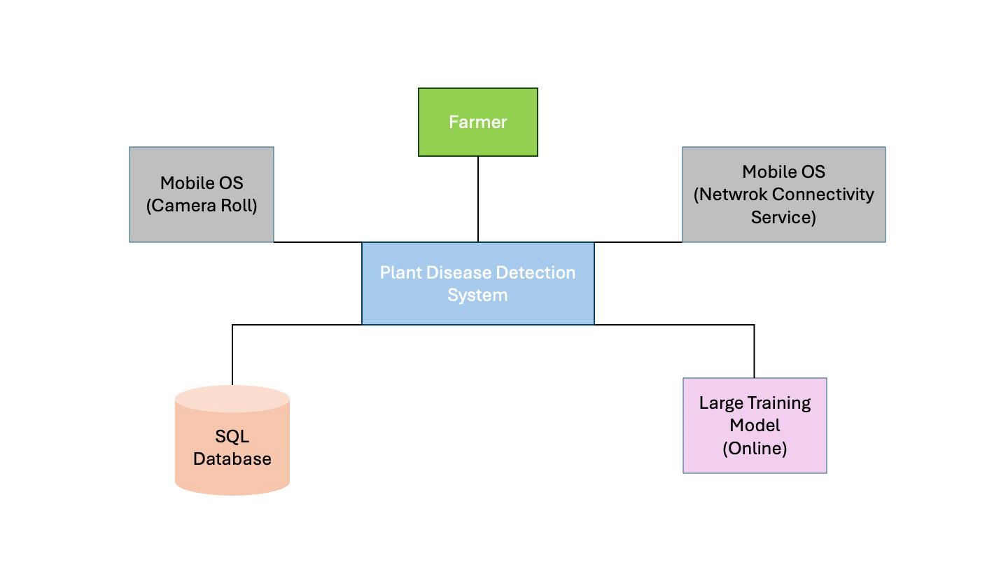
Large scale diagram that describes the different system components like interface, database, pipeline, model and the way they are connected.
Figure 2: Context Diagram
Description:
This context diagram shows how the Farmer interacts with the Plant Disease Detection System, which uses mobile device services (camera and network), a backend database, and an online model to diagnose plant diseases.
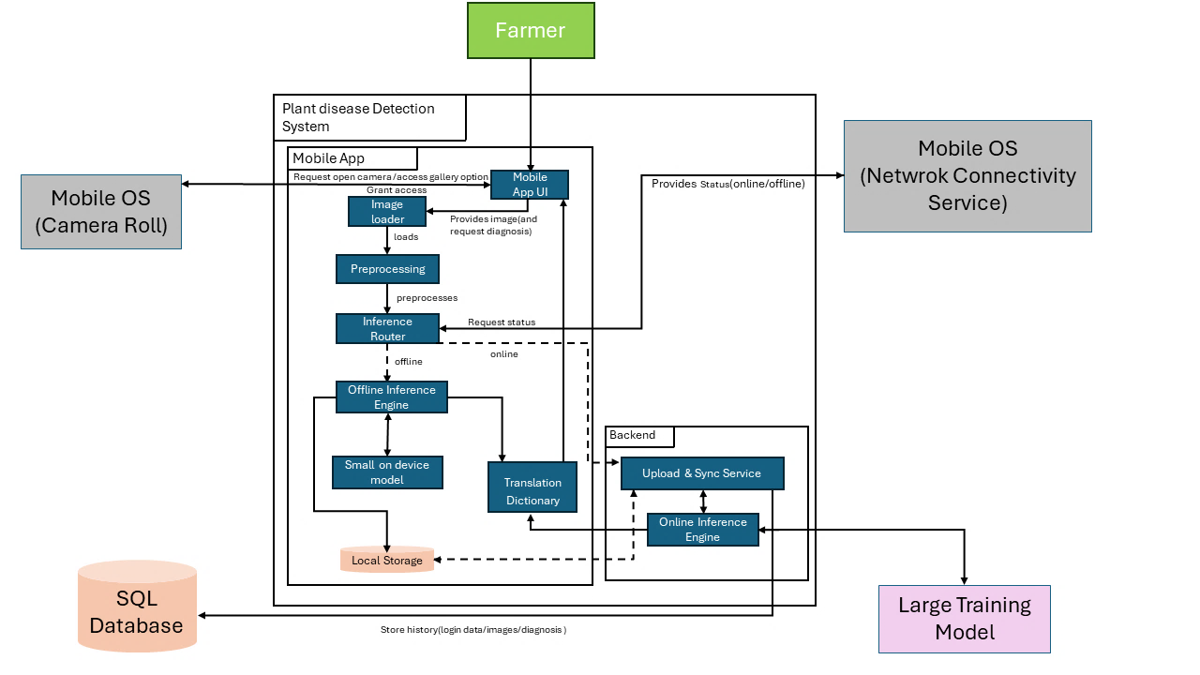
Figure 3: Container Diagram (Deployment)

Description:
This container diagram shows how the Plant Disease Detection System processes leaf images through a mobile app, routing inference either locally or online based on network availability, and returning translated diagnosis results to the farmer. It also illustrates how results and user data are stored and synchronized with the backend database.

4.2 Logical Model Design
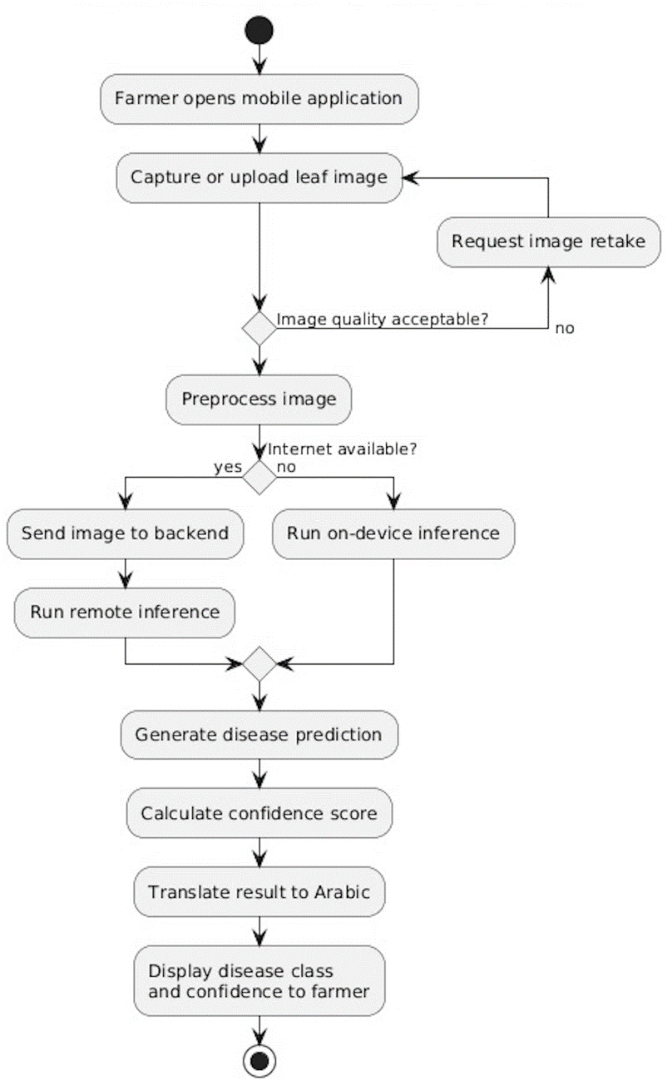
In this section, provide both a high level and low-level design of the system you will develop.
Figure 4: Activity Diagram (Deployment)

Description:
This activity diagram describes the workflow of the plant disease detection process from the farmer perspective. The farmer captures or uploads a leaf image, and the quality gets checked before processing. The system then preprocesses the image and determines whether an internet connection is available. If online, inference is performed remotely. Otherwise, the model runs locally on the device. At last, the system generates a disease prediction with a confidence score, translates the result into Arabic, and displays it to the user.
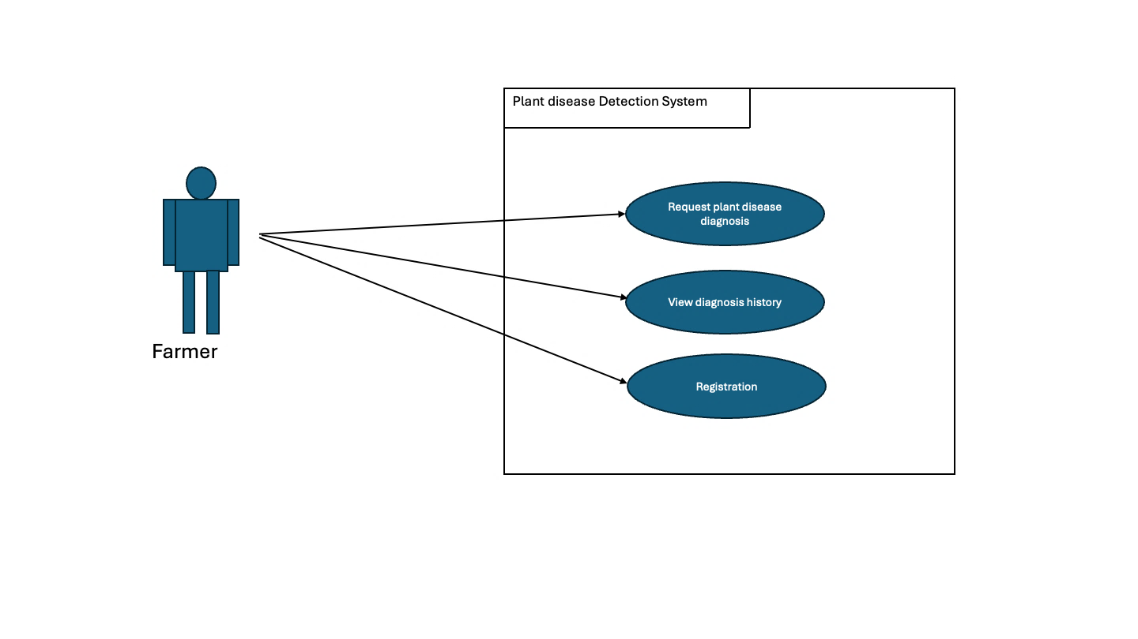
Figure 5: Use Case Diagram

Description:
This use case diagram shows the Farmer interacting with the Plant Disease Detection System to register, request a plant disease diagnosis, and view past diagnosis history. It highlights the main actions available to the farmer within the system.

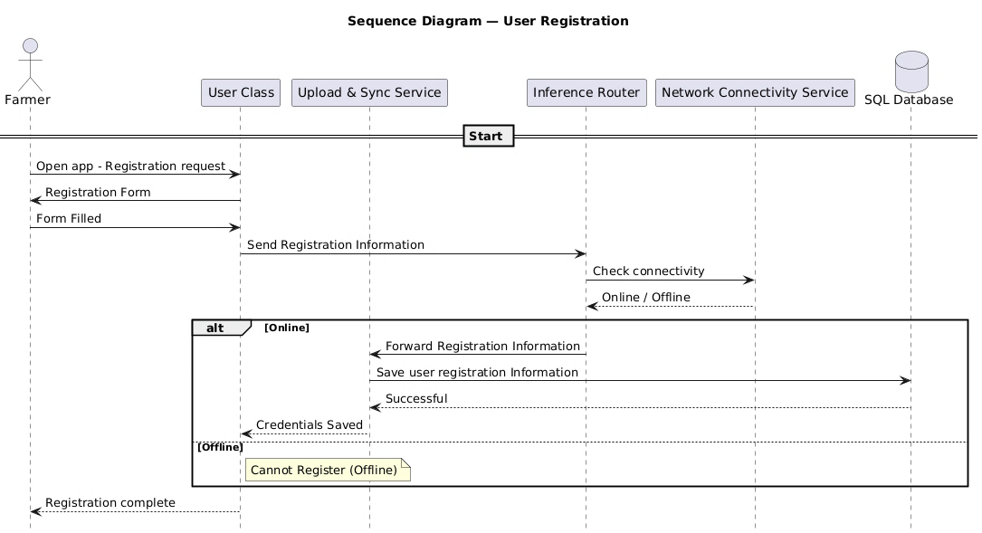
Figure 6: Sequence Diagram (Registration)

Description:
This sequence diagram shows how a farmer registers in the system by interacting with the User Class, which checks network connectivity and, if online, saves the registration data to the SQL database via the Upload & Sync Service. If the device is offline, registration is blocked and the user is notified.

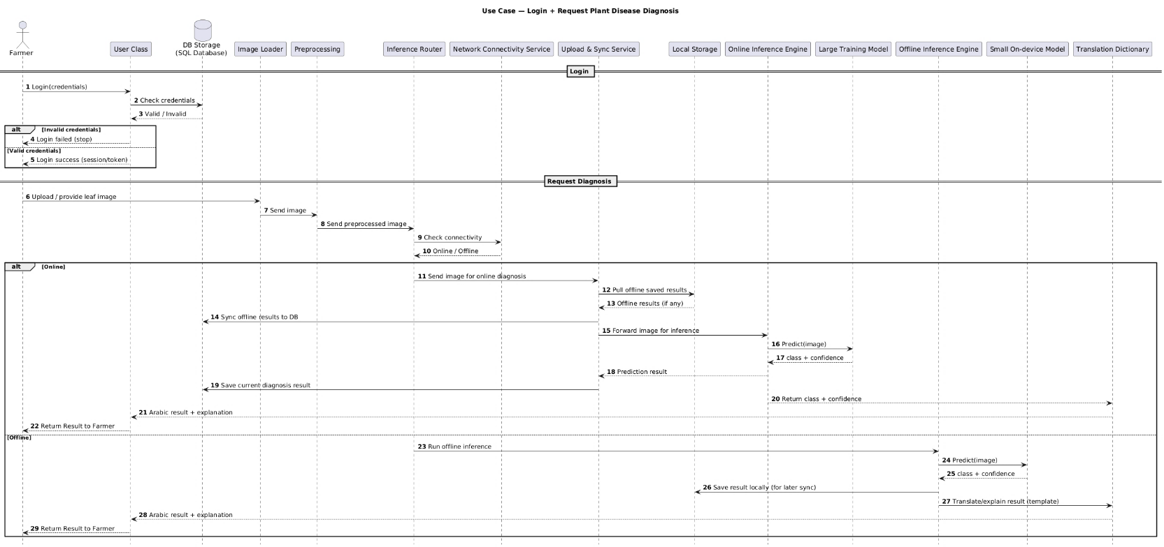
Figure 7: Sequence Diagram (login + Request Diagnosis)

Description:
This sequence diagram shows how a farmer logs into the system and then requests a plant disease diagnosis, where the image is processed and routed to either online or offline inference based on network availability. The system returns the predicted disease, confidence, and an Arabic explanation, while handling data storage and synchronization transparently.

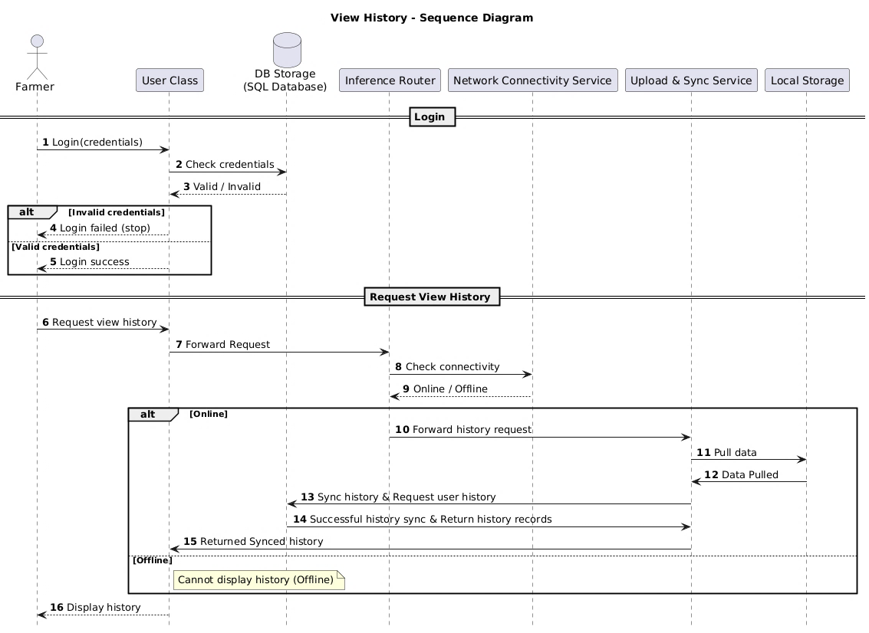
Figure 8: Sequence Diagram (login + view History)

Description:
This sequence diagram shows the farmer logging into the system, then requesting to view diagnosis history. If the device is online, the system syncs and retrieves history records from the database and displays them; if offline, the history cannot be displayed.

4.3 Physical Model Design
- User Interface/System interface Design :
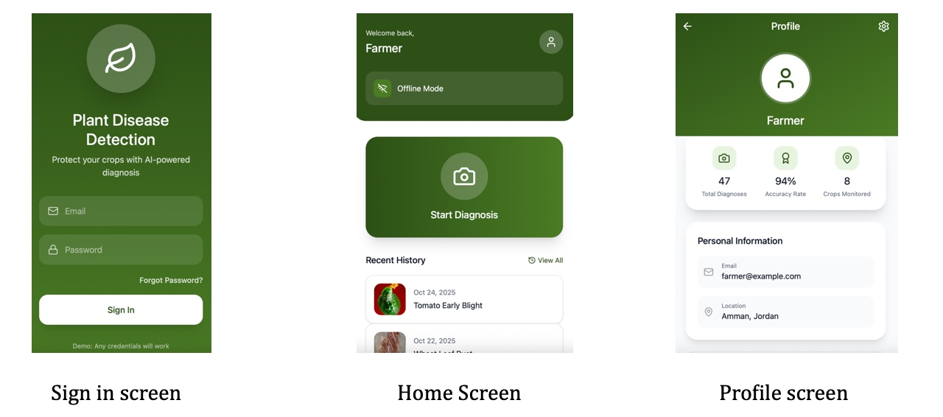
Figure 9: Three Images Showing Sign in, Home and Profile Screens

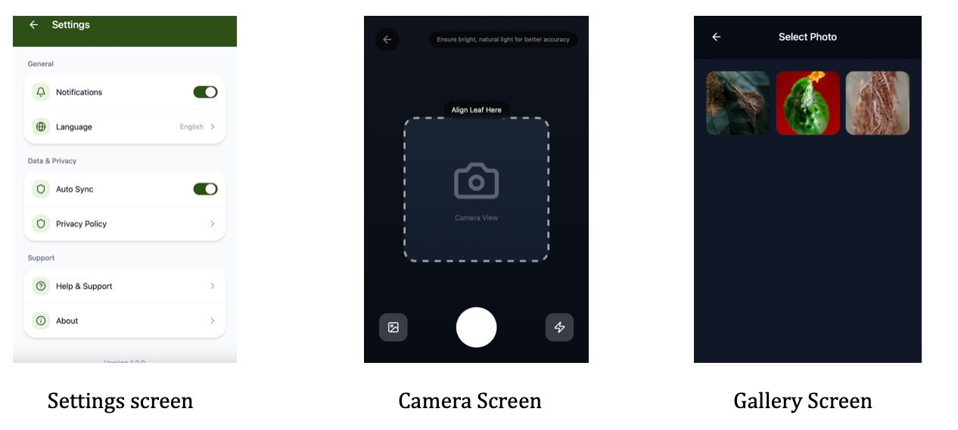
Figure 10: Three Images Showing the Settings, Camera, and Gallery Screens
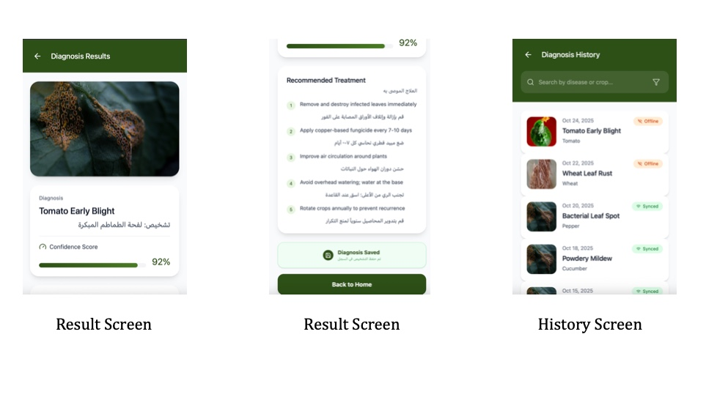
Figure 11: Three Images Showing Two Different Parts of the Result Screen, and the History Screen

Data Base Storage (Entity Relationship Diagram):
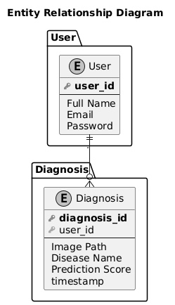
Figure 12: Entity Relationship Diagram

Chapter 5

Data Preprocessing

5.1 Data Collection and Description
This project follows a data driven approach, where everything depends on the quality and variety of the data we collected. The data used in this project was obtained from multiple publicly agricultural image datasets.
The datasets was selected to make sure that compatibility with crops and diseases commonly found in Jordan are particularly those that affects the vegetables, fruits, and olive trees.

5.1.1 Data Sources
- Olive Leaf Image Dataset [11]
- Olive Leaf Disease Dataset (Zeytin) [12]
- Wheat Plant Diseases [13]
- 20k+ Multi‑Class Crop Disease Images [14]
- New Plant Diseases Dataset [15]

5.1.2 Data Collection Process
The data collection process was automated with using a pipeline we implemented inside a Jupyter Notebook. We used the Kaggle API for authentication which allowed us to download and extract the image dataset. Each dataset will be downloaded, unzipped, and stored in a raw data directory (data_raw) before preprocessing.

5.1.3 Data Metadata
Each image in the final dataset will be associated with the following metadata fields:
- Image path
- Crop name
- Disease label
- Dataset source
- Dataset split (train, validation, test)
This metadata is stored in structured CSV files to facilitate training, evaluation.

5.2 Data Profiling and Engineering

5.2.1 Data Quality Assessment
After data extraction, we might face some challenges with the raw datasets which might be:
- Inconsistent folder structures across datasets
- Different naming conventions for crops and diseases
- Variable image resolutions and formats
- Presence of duplicate or near-duplicate images
- Class imbalance across diseases
A data profiling step would be performed by scanning directory structures and image distributions to identify missing classes, corrupted files, and inconsistent labels.

5.2.2 Data Cleaning Techniques
To address these issues, the following cleaning steps would be applied:
- Standardize the folder structure, all datasets will be mapped into a unified directory structure: jordan_dataset / images / crop_name / disease_name / image.jpg
- Only valid image formats (.jpg, .jpeg, .png) will be used, all other images would automatically be skipped.
- Synchronizing image labels, disease names from different datasets would be standardized (Tomato___Late_blight → Tomato / Late_blight) to maintain label consistency.

5.3 Feature Engineering

5.3.1 Feature Extraction
Since this project focuses on image classification, features are implicitly extracted by a deep learning model (CNN). Therefore, traditional manual feature extraction would not be required.
Instead, feature preparation would be focused on image normalization, which ensures that the neural network learns meaningful visual patterns rather than dataset artifacts.

5.3.2 Image Normalization
Each image would be processed as follows:
- Converted to RGB color space
- Resized to a fixed resolution of pixels
- Saved in JPEG format with consistent quality settings
This step ensures uniform input dimensions and stabilizes model training.

5.3.3 Feature Selection and Dimensionality Reduction
Both feature selection and dimensionality reduction can be handled by the convolutional layers, during the model training. This process is considered to be in best practices in the deep learning image classification.

5.3.4 Data Augmentation
To remove class imbalance, data augmentation would be applied to make classes that do not have enough data to have more data. Techniques included:
- Random rotations
- Horizontal and vertical flips
- Brightness and contrast adjustment
- Small geometric transformations
These techniques increase dataset diversity and improve the model’s ability to generalize, particularly for underrepresented disease classes.

5.4 Data Loading

5.4.1 Dataset Splitting
After preprocessing, the dataset would be split into:
- Training
- Validation
- Testing
The split would be performed using stratified sampling based on crop disease labels to ensure balanced class representation across all subsets.

5.4.2 Data Storage Format
The final dataset would consist of:
- A structured image directory (jordan_dataset/images)
- Metadata CSV files:
  - metadata_train.csv
  - metadata_val.csv
  - metadata_test.csv
These files would be directly compatible with PyTorch and TensorFlow data loaders.

5.4.3 Justification for Classification Approach
We picked image classification not object detection, because most plant disease spread across the whole leaf, drawing the boxes around the disease would not help. Classification saves time, it needs less computing power. That makes it good for mobile apps.

Chapter 6

Implementation

6.1 General Implementation Description
The system was implemented as a full-stack plant disease detection application consisting of a machine learning pipeline, a Django REST backend, and a React Native mobile application.
The main programming language used for the backend and machine learning components is Python. Python was selected because it provides strong support for artificial intelligence, image processing, and backend development.
The ML implementation uses PyTorch and Torchvision for training and loading deep learning models such as MobileNetV3 and ResNet50. OpenCV, Pillow, NumPy, and Albumentations are used for image preprocessing, resizing, normalization, quality checking, and background removal. MobileSAM is also used to support segmentation-based preprocessing.
The backend was developed using Django and Django REST Framework. Django was chosen because it provides a structured project architecture, built-in authentication support, database integration, and fast API development. Django REST Framework is used to expose REST APIs for authentication, prediction, disease information, prediction history, and admin dashboard features. SimpleJWT is used for token-based authentication, which is suitable for mobile applications.
The mobile application was implemented using TypeScript, React Native, and Expo. React Native was chosen because it allows the same codebase to run on mobile platforms and web during development. TypeScript was used to improve code reliability through static typing.
The app uses React Navigation for screen navigation, Axios for API communication, AsyncStorage for local storage, Expo Camera and Expo Image Picker for image input, and ONNX Runtime Web for local/offline inference support.
The database layer uses SQLite during development through Django’s ORM. No handwritten SQL queries are used in the implementation; database operations are handled through Django models, serializers, querysets, and migrations. This improves maintainability and reduces the risk of SQL errors.
The system also uses CSV, JSON, YAML, and PlantUML files. CSV files store dataset metadata, JSON files are used for app configuration, localization, and model manifests, YAML files store model/runtime configuration, and PlantUML files are used for architecture documentation.

Implementation Overview
The current implementation contains approximately 11,447 lines of source code across Python, TypeScript, TSX, and JavaScript files.
Table 5: Implementation Overview
Item | Count
Python files | 91
Python lines of code | 9,229
Backend Python files | 62
Backend lines of code | 2,204
ML/training/export Python files | 29
ML/training/export lines of code | 7,025
Mobile TypeScript/TSX/JS files | 24
Mobile app lines of code | 2,218
Django apps | 5
Django REST serializer classes | 8
Mobile screens/pages | 10
The backend is divided into five main Django apps: authentication, prediction, diseases, history, and adminpanel. The main database models implemented are the custom user model, disease information model, and prediction history model.
The mobile application includes ten main screens: Login, Sign Up, Home, Camera, Gallery, Result, History, Profile, Settings, and Admin Dashboard.

6.2 Pipeline Implementation Description
The pipeline is implemented as an end-to-end system covering data preparation, model training, backend inference, and mobile integration.
Data Pipeline: The dataset is organized into train, validation, and test folders using the format Crop___Disease, allowing automatic class mapping and labeling. Preprocessing uses Python, OpenCV, Pillow, NumPy, Pandas, and Albumentations for resizing, normalization, and augmentation. Training includes advanced augmentation, while validation and testing use minimal processing. Weather metadata was explored only as an experimental multimodal input using synthetic timestamps and Open-Meteo values; it was excluded from the final deployed system, which uses image-only prediction.
Model Training and Export: The pipeline is built using PyTorch and supports models such as MobileNetV3, ResNet50, and EfficientNet. The process includes loading data, applying transformations, training models, computing metrics (accuracy, F1-score, mIoU), and saving checkpoints with experiment tracking. Two modes are used: offline (MobileNetV3 for fast local inference) and online (ResNet50 for higher accuracy). Models are exported to ONNX format along with a JSON manifest for mobile deployment.
Backend Pipeline: The backend is implemented using Django REST Framework. The prediction flow includes receiving an image at the /api/predict/ endpoint, validating and preprocessing it using OpenCV, applying quality and leaf detection checks, optionally performing segmentation, running model inference, storing the result, and returning a JSON response. Invalid images such as blurry, dark, or non-leaf images are filtered before inference.
APIs: The system includes APIs for authentication (register, login, JWT), prediction, disease information, user history, offline synchronization, and admin management.
Mobile Integration: The mobile application is built using React Native (Expo and TypeScript). It allows users to capture or select images, run offline inference using ONNX models, or send images to the backend for online prediction. Offline results are stored locally and synchronized with the backend when connectivity is available.

6.3 Model Implementation
The system uses deep learning image classification models to detect plant diseases from leaf images, with two deployment modes: an offline lightweight model and an online higher-capacity backend model.

Model Choice and Rationale:
Multiple CNN architectures were evaluated, including MobileNetV3 (Small and Large), EfficientNet-B0, ResNet50, and multimodal ResNet variants. These models were selected due to their proven performance in transfer learning and image classification tasks.
The chosen offline model is MobileNetV3-Small, as it offers an optimal balance between accuracy, speed, and model size, making it suitable for mobile devices. It achieved approximately 94.7% test accuracy, 0.78 mIoU, and a compact size of about 6.14 MB.
The selected online model is an image-only ResNet50 trained on 512x512 background-removed images. Although the multimodal ResNet50 achieved the highest test accuracy, the image-only ResNet50 achieved a very close accuracy while producing a higher mIoU, much lower validation loss, and a much shorter training time. It achieved around 95.31% test accuracy and 0.8168 mIoU. For this reason, the final online system uses ResNet50 without weather data or multimodal inputs.
The final models classify images into 55 crop and disease classes, covering both healthy and diseased conditions across multiple crops.
Model Development:
The models were developed using transfer learning with pretrained architectures from Torchvision. Final classification layers were replaced to match the 55 output classes.
The dataset was split into training, validation, and testing sets. Images were resized to 512x512, normalized using ImageNet standards, and augmented during training using techniques such as cropping, flipping, affine transformations, color shifts, shadows, and blur.
Training configuration included a batch size of 4, learning rate of 0.001, CrossEntropyLoss, Adam optimizer, and StepLR scheduler. Early stopping was applied with patience of 5 epochs for offline models and 12 epochs for online models. Model selection was based on best validation accuracy.
Multimodal experiments combined image features with environmental metadata (e.g., temperature, humidity), using advanced techniques such as AdamW, label smoothing, and learning rate scheduling. These experiments were useful for comparison, but the final model selection favored image-only ResNet50 because it was simpler, faster to train, had lower validation loss, and did not require weather metadata.
All experiments were tracked using MLflow, recording metrics such as accuracy, mIoU, F1-score, model size, and training time. A ranking mechanism was used to compare models across performance and efficiency.
Model Serving:
The backend serves predictions via the POST /api/predict/ endpoint. Uploaded images are validated, preprocessed, optionally segmented, and passed to the model for inference. The model is loaded once and reused to ensure efficient response times.
For offline use, the MobileNetV3-Small model is exported to ONNX format. The mobile application loads the model using ONNX Runtime and applies preprocessing based on a JSON manifest, enabling local inference without backend dependency.

6.4 Additional Implementation Details

6.4.1 Appendix Code References
The main functions are provided in the appendix and referenced by file and line numbers. For example, preprocessing is implemented in pipeline.py (lines 18–64), quality checks in quality.py (11–63), leaf validation in leaf_check.py (5–62), prediction flow in views.py (18–93), inference in inference.py (22–226), training in train_core.py (119–480), model creation in model_factory.py (13–217), and ONNX export in export_mobile_model.py (296–370). Mobile-side inference and sync are handled in localInference.ts, offlineQueue.ts, and useAutoSync.ts.

6.4.2 System Architecture
The system follows a layered architecture:
mobile app → backend API → preprocessing → model inference → database → response.
Two modes exist:
- Online: image sent to backend, processed, and predicted using ResNet50
- Offline: image processed locally using ONNX model, stored, and later synchronized

6.4.3 Critical Algorithms and Techniques
Runtime Prediction Pipeline:
The core algorithm processes an input image through validation, preprocessing, inference, and storage.
Pseudo-code:
- Input: image, mode
- Validate request
- Decode image
- Run quality checks → reject if invalid
- Run leaf-color validation → reject if not leaf
- If online → apply segmentation
- Run model inference
- Retrieve disease info
- Save result
- Return prediction
This approach reduces invalid inputs and improves prediction reliability.

Transfer Learning:
Pretrained CNNs (MobileNetV3, ResNet50, EfficientNet) are fine-tuned for classification.
Steps:
- Load pretrained model
- Replace final layer
- Train on dataset
- Evaluate and save best model
This reduces training time and improves performance with limited data.
Offline Inference and Sync:
ONNX model runs locally on mobile, predictions stored, then synced later.
Pseudo-code:
- Load ONNX model
- Preprocess image
- Run inference
- Store result locally
- If online → sync with backend

6.4.4 Implemented vs Deferred Features
Implemented:
- User authentication (JWT)
- Image capture and upload
- Disease prediction (online and offline)
- Image quality and leaf validation
- Prediction history
- Admin dashboard
- Offline storage and sync
- Bilingual interface

Partially implemented:
- Push notifications (UI only)
- Treatment recommendations (basic data only)
- Weather and multimodal experiments (research only; not deployed)
Deferred:
- Real-time GPS/weather integration
- Full production deployment
- Automated model retraining

6.4.5 Additional Notes
The key design decision was separating online and offline modes. This ensures usability even without internet access while still allowing high-accuracy backend predictions.
The system is modular, separating training, inference, mobile logic, and synchronization, which improves maintainability and scalability.

Chapter 7

Testing

7.1 Testing Approach
The testing phase was designed to evaluate the machine learning models, preprocessing pipeline, backend services, mobile application, and complete system workflow. Since the project includes both an online backend model and an offline mobile model, testing was performed at several levels: model evaluation, pipeline validation, API testing, mobile app testing, and full end-to-end system testing.
Evaluation Measures
The main evaluation measures used for model testing were:
- Accuracy: measures the percentage of correctly classified images.
- Mean Intersection over Union (mIoU): used to evaluate class-level prediction quality and give better insight into performance across imbalanced classes.
- Macro-F1 score: used in multimodal experiments to measure balanced performance across all classes.
- Validation loss: used to monitor overfitting and support early stopping.
- Model size: important for selecting the offline model, since it must run on mobile devices.
- Number of parameters: used to compare model complexity and efficiency.
- Training time: used to compare practical feasibility between models.
Accuracy alone was not considered sufficient because some classes had more images than others. Therefore, mIoU, Macro-F1, model size, and training time were also considered when selecting the final models.
Model Testing Approach
Several deep learning models were trained and compared. The offline candidates included:
- MobileNetV3 Small
- MobileNetV3 Large
- EfficientNet-B0

The online candidates included:
- ResNet50
- EfficientNet-B0
- Multimodal ResNet50
- Image-only ResNet50
- Metadata-only MLP
- Late-fusion multimodal ResNet50
The offline model was selected based on a balance between accuracy, model size, and suitability for mobile deployment. The online model was allowed to be larger because it runs on the backend server, but it was still selected based on overall reliability rather than accuracy alone. Although the multimodal ResNet50 had the highest accuracy, the image-only ResNet50 was chosen because its accuracy was very close, its mIoU was higher, its validation loss was much lower, and it trained much faster without requiring weather data.
Each model was trained using the training split, validated using the validation split, and finally evaluated using the unseen test split. MLflow was used to record experiment parameters, metrics, model size, number of parameters, and training time.
Data Splitting Technique
The dataset was divided into three splits:
- Training set: used to train the model.
- Validation set: used during training to tune the model and apply early stopping.
- Test set: used only after training to evaluate final performance.
A stratified splitting strategy was used where possible so that each disease class was represented in the train, validation, and test sets. The dataset contained 55 final model classes, including crops such as apple, tomato, wheat, olive, grape, maize, potato, orange, peach, cauliflower, and eggplant.
The available metadata files show approximately:
Table 6: Dataset Split Summary
Split | Number of Images
Training | 40,292
Validation | 8,634
Test | 8,634
Total | 57,560

Data augmentation was applied to underrepresented classes to reduce class imbalance. Augmentation techniques included flipping, rotation, brightness/contrast adjustment, shifting, scaling, and rotation.
Pipeline Testing Approach
The preprocessing and inference pipeline was tested separately from the models. The pipeline includes:
- Image upload or capture from the mobile app.
- Image quality checking.
- Optional background removal using SAM.
- Image resizing and normalization.
- Model inference.
- Disease metadata lookup.
- Saving prediction history.
Initial tests showed that very high accuracy was suspicious, so additional tests were performed to check whether models were learning actual leaf features or relying on background patterns. Two important checks were used:
- Blur test: the center/leaf area of images was blurred and the model was tested again.
- Grad-CAM visualization: used to inspect which parts of the image influenced model predictions.
These tests showed that the model sometimes relied on background regions. As a result, SAM-based background removal was introduced and the models were retrained using background-removed images.
Complete System Testing Approach
The complete system was tested using end-to-end workflows:
- User registers or logs in through the mobile app.
- User captures or uploads a plant leaf image.
- The app chooses online or offline mode.
- In online mode, the image is sent to the Django backend.
- The backend preprocesses the image, runs inference, returns the prediction, and stores the result.
- In offline mode, the mobile app runs the ONNX model locally and saves the result in an offline queue.
- When internet connection returns, queued offline predictions are synced to the backend.
- The user can view prediction history.
- Admin users can view dashboard statistics.
Backend API tests were also written for authentication, prediction history, disease metadata, offline sync, and admin endpoints.

7.2 Testing Results
The experiments were carried out in multiple stages. Early experiments compared lightweight and larger models using fewer epochs and smaller image sizes. Later experiments used the full dataset, higher image resolution, background removal, and longer training.
Table 7: Model Testing Results
Experiment Stage | Model | Image Size | Test Accuracy | Test mIoU | Notes
Initial online | EfficientNet-B0 | 224 | 0.7401 | 0.3367 | Best early online model
Initial offline | MobileNetV3 Small | 224 | 0.7287 | 0.2896 | Best early offline model
Longer training online | EfficientNet-B0 | 224 | 0.7666 | 0.3442 | Improved after more epochs
Longer training offline | MobileNetV3 Small | 224 | 0.7638 | 0.3384 | Smallest and efficient
Full dataset offline | MobileNetV3 Small | 512 | 0.9875 | 0.9052 | Very high result, later investigated
Full dataset offline | EfficientNet-B0 | 512 | 0.9881 | 0.9039 | Highest accuracy but larger
Background-removed offline | MobileNetV3 Small | 512 | 0.9480 | 0.7826 | Final practical offline candidate
Background-removed online | Multimodal ResNet50 | 256 | 0.8940 | 0.6869 | First background-removed online result
Background-removed online | Multimodal ResNet50 | 512 | 0.9544 | 0.8024 | Highest accuracy; not selected
Background-removed online | Image-only ResNet50 | 512 | 0.9531 | 0.8168 | Selected online model

The best offline model after considering size, accuracy, and mobile suitability was MobileNetV3 Small. Although EfficientNet-B0 achieved slightly higher accuracy in some experiments, MobileNetV3 Small was much smaller and more suitable for offline mobile inference.
The highest-accuracy online experiment was the Multimodal ResNet50 trained on background-removed 512x512 images, but it was not selected for deployment. The selected online model was the image-only ResNet50 because it achieved nearly the same accuracy, a higher mIoU, much lower validation loss, faster training, and did not require weather data. The selected image-only ResNet50 achieved:
- Test Accuracy: 95.31%
- Test mIoU: 81.68%
- Model Type: image-only ResNet50, no weather metadata required
The selected image-only ResNet50 achieved close accuracy to the multimodal model while improving mIoU and reducing validation loss and training time. This made it more practical for the final backend because it removed the need for runtime weather data and multimodal input handling.
The offline MobileNetV3 Small background-removed model achieved:
- Test Accuracy: 94.80%
- Test mIoU: 78.26%
- Model Size: approximately 6 MB
This made it appropriate for local mobile inference.
A background-cheating test was also performed because the original full-dataset models produced extremely high accuracy. The model achieved:
- Normal image accuracy: 98.75%
- Blurred image accuracy: 20.84%
Grad-CAM visualizations showed that some predictions were influenced by image background areas rather than only the leaf region. This result affected the system design and led to the use of SAM background removal.

7.3 Discussion
The testing phase had a direct impact on the final design of the system. At first, the high accuracy of the full-dataset models appeared successful, but further testing showed that the models may have been learning background patterns. This was an important finding because a model that depends on background information may perform poorly in real-world farm conditions.
As a result, background removal was added to the pipeline. Although the accuracy decreased after removing the background, the results became more reliable because the model was forced to focus more on the leaf itself.
Another important decision was the separation between online and offline models. The online model can be larger and more accurate because it runs on the backend, while the offline model must be lightweight enough to run on a mobile device. Therefore, MobileNetV3 Small was chosen for offline use, while the image-only ResNet50 was used for online prediction. The multimodal ResNet50 was not selected despite its slightly higher accuracy because the image-only ResNet50 gave a better mIoU, lower validation loss, faster training, and a simpler deployment without weather data.
Testing also confirmed the importance of offline functionality. The mobile app can still provide predictions without internet access and sync results later when the connection returns. This improves usability for farmers in areas with unstable internet connectivity.

Chapter 8

Conclusions and Future Work

The proposed plant disease detection system has shown promising results, however, there are several areas that can be improved and extended in future work to improve the system’s accuracy, usability and scalability.
- ⁠One major improvement is the development of a particular model that checks the presence of a plant leaf in the captured image before disease classification. A dedicated model for leaf detection and validation will make the prediction process more reliable and reduce false inputs.
- Another future improvement is to expand the dataset to support crops from different regions and international markets, rather than focusing mainly on the Jordanian crops we should increase the variety of plant species, diseases, environmental conditions, and image sources will increase the model's generalization and applicability in global agriculture.
- In future iterations of the system, farmers will be prompted to provide additional contextual information when uploading images, such as weather conditions, temperature, humidity, soil conditions, irrigation status and geographic location. This data can be entered manually by the farmers, or pulled automatically via real time weather APIs and environmental data services. Such information collection would not only help improve the accuracy of current disease prediction, but also help build a richer dataset for future multimodal training models that combine image analysis with environmental and agricultural factors.
- Another potential improvement is the integration of a treatment recommendation system that provides farmers with suitable agricultural solutions based on the diagnosed disease. The system could also suggest suitable fertilizers, pesticides, irrigation modifications or preventive measures to help in minimizing crop damage and improve productivity. Such recommendations could be derived from the knowledge of agricultural experts and constantly updated with real feedback from farmers and historical data on treatments.

These improvements can significantly improve the practicality, intelligence and scalability of the proposed system and promote the future development of smart agriculture solutions.
Appendix A

Users’ Manual

Provide a description (textual and pictorial) of how the system can be installed and used and how the errors messages should be interpreted.

Appendix B

Document Changes

Discuss here any changes you have made to the document you have submitted in Project 1 and the reasons behind the changes.

Appendix C

Code Documentation

C.1 Project Overview
The Plant Disease Detection System is a machine learning, backend, and mobile application project for classifying plant leaf diseases from images.
The system includes:
• A machine learning pipeline for training plant disease classification models.
• A Django REST backend for authentication, prediction, disease metadata, history, and admin access.
• A React Native / Expo mobile application for image capture, gallery upload, result display, offline queueing, and synchronization.
• MkDocs documentation that explains the system structure, source code modules, and implementation workflow.
The current implementation supports 11 crop groups and 55 disease or healthy classes. The model class labels follow this format:
- Crop___Disease
Examples:
- Tomato___Early_blight
- Olive___Peacock_spot
- Wheat___Yellow_Rust
- Apple___healthy

C.2 System Architecture
The system is divided into three main layers:
1. Machine Learning Layer
This layer handles dataset preparation, preprocessing, training, evaluation, experiment tracking, and model export.

2. Backend Layer
This layer is implemented with Django REST Framework. It provides authentication, prediction APIs, disease metadata, prediction history, offline sync, and admin APIs.
3. Mobile Application Layer
This layer is implemented with React Native and Expo. It allows users to log in, capture or upload leaf images, view predictions, change settings, and sync offline results.
Main online prediction flow:
Mobile App -> Frontend Common Preprocessing -> Django API -> Backend Preprocessing -> Model Inference -> Disease Lookup -> Prediction Response
Offline-oriented prediction flow:
Mobile App -> Frontend Preprocessing -> Local ONNX Model -> Local Disease Metadata -> Offline Queue -> Sync When Online

C.3 Dataset and Data Pipeline
The active dataset is stored in:
- jordan_dataset/
The dataset is organized into train, validation, and test splits:
jordan_dataset/
train/
Crop/
Disease/
image.png
val/
Crop/
Disease/
image.png
test/
Crop/
Disease/
image.png

The current dataset contains:
• 11 crop groups.
• 55 total classes.
• 48,213 training images.
• 8,536 validation images.
• 8,532 test images.
• 65,281 total images.
The dataset was built by combining public plant disease datasets, including datasets for general plant diseases, olive leaves, wheat diseases, and multi-class crop disease images.
Preprocessing includes:
• Loading RGB images.
• Resizing and cropping images to the configured image size.
• Normalizing images using ImageNet mean and standard deviation.
• Applying Albumentations augmentation during training.
• Skipping corrupted or unreadable images.
• Using MobileSAM-based background removal for selected dataset variants.

Runtime preprocessing is now split between the frontend and backend. The common preprocessing step is called from the mobile camera and gallery screens before either online upload or offline inference. Online inference then performs any extra backend-only preprocessing, such as MobileSAM background removal, before the backend model runs.
The basic image pipeline is:
image -> frontend preprocessing -> backend preprocessing -> model -> prediction

C.4 Background Removal and Metadata
The project includes MobileSAM-based background removal.
Important files:
- src/dissdetector/preprocessing/remove_background_sam.py
- src/dissdetector/preprocessing/sam_background.py
- backend/prediction/preprocessing/sam_utils.py
The background removal process:
• Loads the MobileSAM checkpoint.
• Generates a leaf mask.
• Cleans the mask using OpenCV morphology.
• Places the leaf on a white background.
• Crops around the detected leaf region.
• Saves the processed image.
During experimentation, the project generated weather metadata for multimodal model comparison:
- jordan_dataset/metadata_weather.csv
Metadata fields include:
• temperature
• humidity
• wind speed
• precipitation
• soil moisture
• generated timestamp
• crop name
• disease name
This metadata is synthetic because the original image datasets do not contain real capture timestamps. It was used only for experimental comparison and is not used by the final online or offline prediction system.

C.5 Models
The project supports image-only models for deployment and includes metadata-aware models for experimental comparison.
Image-only models include:
• ResNet50
• Image-only ResNet50
• MobileNetV3 Small
• MobileNetV3 Large
• EfficientNet-B0
Experimental metadata-aware models include:
• Multimodal ResNet50
• Metadata-only MLP
• Late-fusion multimodal ResNet50

The model factory is implemented in:
- src/dissdetector/models/model_factory.py
This file creates the correct PyTorch model based on the configured model name. It also defines multimodal model classes for experimentation, while the deployed online model remains image-only ResNet50.

The online backend currently uses an image-only ResNet50:
- saved_models/image_only_resnet50_background_removed_512_epochs40.pth

The backend offline mode uses a lightweight MobileNetV3 Small:
- saved_models/mobilenet_v3_small_512_background_removed_epochs25.pth

The mobile/web offline asset uses an exported ONNX model:
- mobile-app/assets/mobile_models/offline_model.onnx

C.6 Training Pipeline
The image-only training pipeline is implemented in:
- src/dissdetector/training/train_core.py
This module handles:
• Building training and validation transforms.
• Loading train, validation, and test datasets.
• Building a shared class mapping.
• Creating PyTorch dataloaders.
• Training image-only models.
• Applying early stopping.
• Saving and loading checkpoints.
• Evaluating test accuracy and mIoU.

The experimental multimodal training pipeline is implemented in:
- src/dissdetector/training/multimodal_core.py
This module handles:
• Loading weather metadata.
• Normalizing metadata features.
• Creating multimodal datasets.
• Training models that use both image and metadata inputs.
• Supporting metadata-only experiments.
• Computing accuracy, mIoU, macro-F1, and loss.
• Applying early stopping and checkpointing.

The training code uses:

• PyTorch
• Torchvision
• Albumentations
• OpenCV
• MLflow
• Pandas
• NumPy

C.7 Experiment Tracking

MLflow is used to track training experiments.

The tracking database is:

mlflow.db

Experiment runs are stored in:

mlruns/

Experiment configuration files are:

- src/dissdetector/config/online_models.yaml
- src/dissdetector/config/offline_models.yaml

The experiment runner is:

- src/dissdetector/experiments/run_mlflow_experiment.py

It logs:

• model name
• batch size
• learning rate
• number of epochs
• image size
• dataset variant
• validation accuracy
• validation loss
• test accuracy
• test mIoU
• model size
• parameter count
• training time

Model ranking is handled by:

- src/dissdetector/experiments/rank_models.py

C.8 Inference Pipeline

Backend inference is implemented in:

- backend/prediction/inference.py

The backend loads models as reusable singletons so that they are not reloaded for every request.

The inference process:
• The mobile app runs the common frontend preprocessing step.
• If online mode is used, the processed image is uploaded to the backend.
• The backend decodes the uploaded image.
• In online mode, the backend applies extra preprocessing such as MobileSAM leaf extraction.
• In offline backend mode, the backend skips SAM preprocessing.
• The selected model runs inference.
• The predicted index is converted to a class key.
• The class key is mapped to disease information.
• The prediction result is returned to the mobile app.
Backend preprocessing is implemented in:
- backend/prediction/preprocessing/pipeline.py
- backend/prediction/preprocessing/quality.py
- backend/prediction/preprocessing/sam_utils.py

Common quality checks are handled by the frontend preprocessing module. The backend quality-check code remains available as a fallback, but the active backend preprocessing path focuses on decoding and online-only extra preprocessing.

In online mode, the backend applies MobileSAM leaf extraction before inference.
C.9 Backend Code Structure

The backend is located in:

backend/

Main backend apps:

backend/authentication/
backend/prediction/
backend/diseases/
backend/history/
backend/adminpanel/
backend/config/

The authentication app provides:

• custom email-based user model
• registration
• login
• JWT token refresh
• profile endpoint
• password change endpoint

The prediction app provides:

• image upload validation
• image preprocessing
• model inference
• disease lookup
• prediction history creation

The diseases app provides:

• disease metadata storage
• English and Arabic crop names
• English and Arabic disease names
• health status
• read-only disease metadata API

The history app provides:

• user prediction history
• filtering by crop or date
• offline prediction sync endpoint

The admin panel app provides:

• admin user list
• admin prediction list
• admin disease metadata management
• admin dashboard statistics

C.10 Backend API Endpoints

Important backend endpoints include:

GET /api/health/
POST /api/auth/register/
POST /api/auth/login/
POST /api/auth/refresh/
GET /api/auth/profile/
PUT /api/auth/change-password/
GET /api/diseases/
GET /api/diseases/{id}/
POST /api/predict/
GET /api/history/
POST /api/history/sync/
GET /api/admin/users/
GET /api/admin/predictions/
GET /api/admin/predictions/stats/
GET /api/admin/diseases/
POST /api/admin/diseases/
PUT /api/admin/diseases/{id}/
DELETE /api/admin/diseases/{id}/

The prediction endpoint accepts multipart form data:

image required
source_type camera or gallery
mode online or offline

The response includes:

• success
• mode
• prediction_key
• confidence
• is_healthy
• disease_info

C.11 Mobile Application

The mobile application is located in:

mobile-app/

Main mobile folders:

mobile-app/src/screens/
mobile-app/src/services/
mobile-app/src/store/
mobile-app/src/types/
mobile-app/src/i18n/

Important screens:

LoginScreen.tsx
SignUpScreen.tsx
HomeScreen.tsx
CameraScreen.tsx
GalleryScreen.tsx
ResultScreen.tsx
HistoryScreen.tsx
ProfileScreen.tsx
SettingsScreen.tsx
AdminDashboardScreen.tsx

Important services:

src/services/auth/apiClient.ts
src/services/offline/localInference.ts
src/services/offline/offlineQueue.ts
src/services/offline/diseaseMetadata.ts
src/services/sync/useAutoSync.ts
src/services/preprocessing/imagePreprocessing.ts

The mobile app supports:

• user login and registration
• camera image capture
• gallery image selection
• common frontend preprocessing before upload or local inference
• online backend prediction
• local offline-oriented prediction
• result display
• English and Arabic labels
• history display
• offline queueing
• automatic sync when connectivity returns

C.12 Offline Queue and Sync

Offline prediction records are stored using AsyncStorage.

The queue is implemented in:

mobile-app/src/services/offline/offlineQueue.ts

When the app is offline or offline mode is selected:

1. The app runs local inference where available.
2. The prediction result is saved to the offline queue.
3. The result is shown to the user.
4. When connectivity returns, queued records are sent to the backend.

Automatic synchronization is implemented in:

mobile-app/src/services/sync/useAutoSync.ts

Sync can be triggered when:

• the app reconnects to the backend
• the app returns to the foreground
• the queue changes
• periodic polling detects pending records

C.13 Model Export

The model export utility is implemented in:

src/dissdetector/export/export_mobile_model.py

It exports image-only PyTorch checkpoints to ONNX.

The export utility:

• loads a PyTorch checkpoint
• resolves the model name
• resolves the image size
• resolves the class mapping
• exports the model to ONNX
• writes an offline model manifest
• validates ONNX output against PyTorch output when possible
• blocks multimodal model export for offline mobile use

Multimodal models are not exported or deployed because they require metadata features and add complexity, while the selected image-only ResNet50 provides the better overall balance for the final online system.

Exported mobile files:

mobile-app/assets/mobile_models/offline_model.onnx
mobile-app/assets/mobile_models/offline_model_manifest.json

C.14 Code Module Summary

Important ML modules:

model_factory.py
Creates image-only model architectures and experimental multimodal architectures.

train_core.py
Handles image-only training, dataloading, augmentation, loss computation, validation, checkpoints, and evaluation.

multimodal_core.py
Handles experimental metadata-aware training using image tensors plus weather metadata features.

export_mobile_model.py
Exports image-only PyTorch checkpoints to ONNX and writes the mobile model manifest.

Important backend modules:

prediction/views.py
Receives prediction requests and returns prediction responses.

prediction/inference.py
Loads backend models and runs inference.

prediction/preprocessing/pipeline.py
Decodes uploaded images and applies backend-only preprocessing. In online mode it applies SAM background removal; in offline backend mode it skips SAM.

diseases/models.py
Stores disease metadata linked to model class keys.

history/models.py
Stores prediction history records.

authentication/models.py
Defines the custom email-based user model.

Important mobile modules:

apiClient.ts
Handles API communication and JWT token refresh.

ModelModeContext.tsx
Tracks online/offline prediction mode and network availability.

imagePreprocessing.ts
Runs the shared frontend preprocessing step before online upload or offline inference. It checks image quality in the web implementation, prepares a processed image URI, and is used by both camera and gallery workflows.

localInference.ts
Runs ONNX Runtime Web inference for the offline-oriented app path.

offlineQueue.ts
Stores and syncs offline prediction records.

useAutoSync.ts
Automatically syncs queued records when connectivity returns.

C.15 Generating the Documentation

The project documentation is written with MkDocs.

The documentation source files are stored in:

docs/

The MkDocs navigation and configuration are stored in:

mkdocs.yml

To preview the documentation locally:

cd /home/ * /plant-disease-detection
python3 -m pip install -r requirements-dev.txt
python3 -m mkdocs serve

Then open:

http://127.0.0.1:8000

To generate the final static documentation site:

python3 -m mkdocs build

The generated HTML files are placed in:

site/

The Word appendix uses the written documentation content, while the generated MkDocs site is used for browsing and verification.

References

[1] Mohanty, S. P., Hughes, D. P., & Salathé, M. (2016). Using deep learning for image-based plant disease detection. Frontiers in plant science, 7, 215232.
https://doi.org/10.3389/fpls.2016.01419
[2] Ferentinos, K. P. (2018). Deep learning models for plant disease detection and diagnosis. Computers and electronics in agriculture, 145, 311-318.
https://doi.org/10.1016/j.compag.2018.01.009
[3] Hughes, D., & Salathé, M. (2015). An open access repository of images on plant health to enable the development of mobile disease diagnostics. arXiv preprint arXiv:1511.08060.
https://arxiv.org/abs/1511.08060
[4] Too, E. C., Yujian, L., Njuki, S., & Yingchun, L. (2019). A comparative study of fine-tuning deep learning models for plant disease identification. Computers and Electronics in Agriculture, 161, 272-279.
https://doi.org/10.1016/j.compag.2018.03.032
[5] Kamilaris, A., & Prenafeta-Boldú, F. X. (2018). Deep learning in agriculture: A survey. Computers and Electronics in Agriculture, 147, 70–90. https://doi.org/10.1016/j.compag.2018.02.016
[6] Dial “A” for agriculture: A review of information and communication technologies for agricultural extension in developing countries by J. C. Aker (2011), published in Agricultural Economics. https://doi.org/10.1111/j.1574-0862.2011.00545.x
[7] C4 Model. Visualising software architecture.
https://c4model.com
[8] ICARDA (International Center for Agricultural Research in the Dry Areas). (n.d.). Plant disease management in dryland farming systems.
https://www.icarda.org
[9] University of Jordan, Faculty of Agriculture. (n.d.). Research studies on plant diseases and agricultural practices in Jordan.
https://agriculture.ju.edu.jo
[10] National Center for Agricultural Research (NARC), Jordan. (n.d.). Plant disease incidence reports and agricultural extension bulletins.
https://narc.gov.jo

Data Sets:
[11] Kaggle, “New Plant Diseases Dataset (Augmented),” 2018.
Available: https://www.kaggle.com/datasets/vipoooool/new-plant-diseases-dataset
[12] Kaggle, “Olive Leaf Image Dataset,” 2020.
Available: https://www.kaggle.com/datasets/habibulbasher01644/olive-leaf-image-dataset
[13] Kaggle, “Zeytin – Olive Leaf Disease Dataset,” 2020.
Available: https://www.kaggle.com/datasets/serhathoca/zeytin
[14] Kaggle, “Wheat Plant Diseases Dataset,” 2021.
Available: https://www.kaggle.com/datasets/kushagra3204/wheat-plant-diseases
[15] Kaggle, “20k+ Multi-Class Crop Disease Images,” 2022.
Available: https://www.kaggle.com/datasets/jawadali1045/20k-multi-class-crop-disease-images
[16] Citrus Leaf Disease Image
Available: https://www.kaggle.com/datasets/myprojectdictionary/citrus-leaf-disease-image
[17] Dataset for Detecting Diseases in Sweet Orange Leaves
Available: https://data.mendeley.com/datasets/p4sd47b6rz/1

