

Princess Sumaya University for Technology
Department of Data Science Semester 2025/2026

Plant Disease Detection Using Deep Learning from Leaf Images

Prepared By:
Faisal Quntar
Jad Kandah
Sanad Al-Madani

Supervised By:
Samer El-Kababji

Project Submitted in partial fulfillment for the degree of Bachelor of Science in
Data Science

2025

Declaration of Originality

This document has been written entirely by the undersigned team members of the project. The source of everyquoted text is clearly cited and there is no ambiguity in where the quoted text begins and ends. The source of any illustration, image or table that is not the work of the team members is also clearly cited. We are aware that using non-original text or material or paraphrasing or modifying it without proper citation is a violation of the university’s regulations and is subject to legal actions.

Names and Signatures of team members:

Acknowledgments

Express your appreciation to whoever helped you during your work or even before!

Summary

Give a complete but concise description of your work. The summary is a brief overview of your motivation, statement of purpose, general methodological approach, major results, discussion and conclusion. The abstract should not exceed one page.

List of Abbreviations

List the abbreviations you have used in your project if there are any and what they stand for.
CNN: Convolutional Neural Network.
UML: Unified Modeling Language.
Table of Contents

Declaration of Originality 2
Summary 4
List of Abbreviations 5
Table of Figures 8
Table of Tables 9
Introduction 10
1.1 Overview 10
1.2 Problem Statement 10
1.3 Related Work 11
Project Plan 12
2.1 Project Deliverables 12
13
2.2 Project Tasks 14
2.3 Roles and Responsibilities 15
2.4 Risk Assessment 15
2.5 Project Management Tools 15
Requirements Specification 16
3.1 Stakeholders 16
3.2 Platform Requirements 16
3.3 Functional Requirements 18
3.4 Non-Functional Requirements 20
3.5 Other Requirements 20
System Design 21
4.1 Architectural Design: 21
4.2 Logical Model Design 21
4.3 Physical Model Design 21
Data Preprocessing 22
5.1 Data Collection and Description 22
5.2 Data Profiling and Engineering 22
5.3 Feature Engineering 22
5.4 Data Loading 22
Users’ Manual 23
Document Changes 24
Code Documentation 25
References 26

Table of Figures

Figure 1: High-Level System Architecture for the Plant Disease Detection Model 12

Table of Tables
Table 1: High-Level Project Tasks and Dependencies: 14
Table 2: System Stakeholders 16
Table 3: Platform Requirements by Sub-System 17

Chapter 1

Introduction

1.1 Overview
Agriculture plays a central role in food security and economic stability, and plant health is a critical factor in the productivity of agricultural systems. Farmers often struggle to diagnose plant diseases early due to limited access to experts, visual similarity between diseases, and the rapid spread of infections in crops. These challenges directly affect yield quality, production volume, and the economic sustainability of agricultural communities.
At the same time, advances in deep learning, particularly CNNs, have demonstrated a strong ability to learn complex visual patterns and perform image-based classification tasks with high accuracy. These methods offer an opportunity to support farmers by providing accessible, fast, and reliable disease diagnosis through simple leaf images captured using mobile devices.
This project leverages deep learning, specifically CNN-based image classification, to identify plant diseases from leaf photographs. The dataset used in this work includes eleven agriculturally significant crops: Apple, Cauliflower, Eggplant, Grape, Maize, Olive, Orange, Peach, Potato, Tomato, and Wheat. These crops reflect a wide range of plant species and include many that are relevant to agricultural practices in Jordan.
The long-term goal of this work is to develop a trained deep learning model that can be integrated into a mobile application, allowing users, primarily farmers, to perform disease diagnosis locally on their devices without requiring internet connectivity.

1.2 Problem Statement
Farmers commonly face difficulty in accurately identifying plant diseases during early stages of infection. Misdiagnosis or delayed diagnosis can lead to inappropriate treatment, increased crop loss, and reduced agricultural productivity. Limited access to agricultural experts in rural areas further intensifies this problem.
This project addresses these issues by developing a deep learning–based plant disease classification system using leaf images. The outcome of the project is:
- A trained convolutional neural network model capable of classifying diseases in leaf images across the eleven target crops.
- A mobile-application-ready model optimized for on-device inference, enabling users to diagnose plant diseases without requiring network access.

Target Audience and Impact
- Primary users: Farmers seeking quick, accessible, and accurate plant disease diagnosis.
- Secondary users: Agricultural engineers, researchers, field inspectors, and students interested in plant pathology or precision agriculture.
The expected impact includes reducing crop losses through timely disease identification, improving decision-making for treatment, and increasing overall agricultural efficiency.

1.3 Related Work
Plant disease classification using image-based deep learning has been widely studied in recent years. Several research efforts have utilized large public datasets, such as PlantVillage, to train CNN for leaf-based disease identification. Models such as AlexNet, VGGNet, ResNet, and MobileNet have achieved strong performance in these studies, demonstrating the suitability of CNN architectures for this task.
However, many existing systems face limitations including:
- Limited generalization across diverse lighting conditions and backgrounds.
- Lack of deployment in real-world environments such as farms.
- Focus on laboratory-quality datasets rather than practical field images.
- Absence of mobile or offline inference capabilities, restricting accessibility for farmers.
Compared to existing work, this project focuses on building a practical, deployable model that operates locally on mobile devices, addressing accessibility and real-world usability challenges. While drawing on deep learning methods established in prior research, the system developed here is designed specifically to serve agricultural users in field conditions.
1.4 Contribution:
- Novelty in the idea: The project introduces a plant disease detection system, enabling diagnosis directly in the field.
- Audience it serves and how: The system primarily supports farmers by providing quick, accessible disease identification from leaf images, while also assisting agricultural engineers and researchers as a rapid diagnostic tool.
- Novelty in the structure of the pipeline: The pipeline integrates multiple data sources, organizes them into a unified multi-crop dataset, and prepares the trained model for mobile-ready export, forming a complete end-to-end workflow.
Chapter 2

Project Plan

2.1 Project Deliverables
- Trained Deep Learning Model: A CNN-based plant disease classification model prepared for mobile deployment.
- Source Code: All project code for preprocessing, training, evaluation, and model export.
- Mobile Application Prototype: A simple mobile app capable of running the model locally and performing on-device disease classification.
- Documentation: Full project documentation following the PSUT graduation project template.
- Dataset Metadata: Structured CSV files describing crops, diseases, and train/validation/test splits.
- External Dataset Storage: The complete image dataset stored on Google Drive and used for model training.
- Evaluation Outputs: Metrics, confusion matrices, and results collected during model testing.
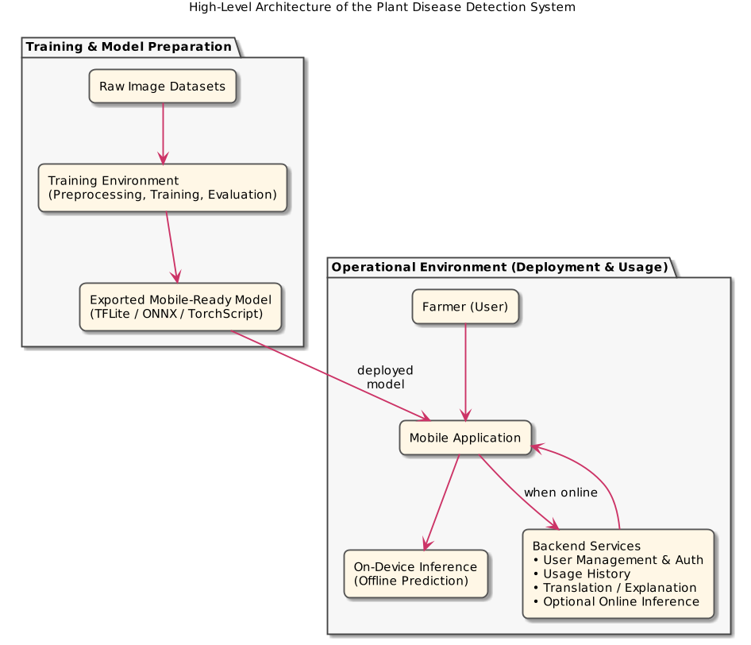
Figure 1: High-Level System Architecture for the Plant Disease Detection Model

2.2 Project Tasks
The project is subdivided into high-level tasks covering the analysis, design, and implementation phases. Each task is defined with an estimated duration and its dependencies to support structured planning and scheduling.
Table 1: High-Level Project Tasks and Dependencies:
Task No. | Task Name | Description | Duration | Dependencies
2.2.1 | Requirement Identification | Identify functional and non-functional requirements of the system. | 1 week | None
2.2.2 | Requirement Modeling | Organize and formalize the identified requirements into a structured model to guide system design and implementation. | 1 week | 2.2.1
2.2.3 | Dataset Analysis and Statistical Assessment | Analyze the plant leaf image dataset to assess dataset size, class distribution, crop coverage, and train/validation/test splits. | 1 week | 2.2.1
2.2.4 | Development Strategy Definition | Define the development strategy, including hardware environment, software tools, programming languages, and deployment approach for mobile and backend components. | 1 week | 2.2.2
2.2.5 | Market Need | Assess the market need for plant disease detection systems and compare existing solutions with the proposed project. | 1 week | 2.2.1
2.2.6 | Ethical Considerations Analysis | Analyze ethical aspects related to data usage, user privacy, and reliance on automated disease predictions. | 1 week | 2.2.1
2.2.7 | Architecture Design | Design the high-level system architecture defining the training pipeline, mobile application, on-device inference, and backend services. | 1 week | 2.2.2
2.2.8 | User and System Interface Design | Design the user interface of the mobile application and define system interactions between components. | 1 week | 2.2.7
2.2.9 | Backend and Data Storage Design | Design backend services for user management, authentication, and usage history storage. | 1 week | 2.2.7
2.2.10 | Data Pipeline Implementation | Implement data preprocessing, augmentation, and data loading pipelines for model training. | 2 weeks | 2.2.3
2.2.11 | Model Training and Evaluation | Train the CNN-based deep learning model and evaluate its performance using appropriate metrics. | 2 weeks | 2.2.10
2.2.12 | Model Export and Mobile Integration | Export the trained model to a mobile-ready format and integrate it into the mobile application. | 1 week | 2.2.11
2.2.13 | Mobile Application Implementation | Implement the mobile application for image capture, on-device inference, and result presentation. | 2 weeks | 2.2.12
2.2.14 | Backend Services Implementation | Implement backend services for authentication, history storage, translation, and optional online inference. | 2 weeks | 2.2.9
2.2.15 | Testing | Test the system components, including model performance, mobile application functionality, and backend integration. | 1 week | 2.2.13, 2.2.14
2.2.16 | Documentation | Prepare and finalize project documentation according to the graduation project template. | 1 week | All previous tasks

2.3 Roles and Responsibilities
Discuss the roles and responsibilities of each team-member in relation to each of the tasks. Be specific and provide enough details to allow an outsider to judge the workload for each team-member.

2.4 Risk Assessment
For each task, describe any associated risks that may prevent completing them. Indicate how probable the risk is, its impact on the system and how you plan to cope with it if it appears.

2.5 Project Management Tools
Describe here any tools you intend to use to manage the development of the system, such as version control software and project management software.

Chapter 3

Requirements Specification

3.1 Stakeholders
Table 2: System Stakeholders
Stakeholder | Description | Interaction with the System | Importance of Role
Farmer (End User) | The primary user of the system who relies on the application to identify plant diseases. | Uses the mobile application to capture or upload leaf images and receive disease predictions with confidence values. | Core stakeholder; system usability, accuracy, and language support are driven by this role.
System Developer / Designer | The project team responsible for designing, implementing, and testing the system. | Designs the architecture, develops the deep learning model, mobile application, and backend services, and maintains the codebase. | Critical for system correctness, performance, maintainability, and successful delivery.
Agricultural Expert / Researcher | A domain expert who may validate results or use the system for analysis and research purposes. | Reviews disease classifications and may provide feedback on model accuracy and relevance. | Supports model validation and increases domain credibility of the system.
System Administrator | Responsible for managing backend services and system data. | Manages user accounts, authentication, system logs, and backend availability. | Ensures system reliability, data security, and proper operation of backend components.
Academic Supervisor | Oversees and evaluates the project as part of the graduation requirements. | Reviews system design, documentation, and final outcomes. | Defines academic constraints and evaluates the project’s quality and completeness.

3.2 Platform Requirements
The proposed system consists of multiple sub-systems, including a training environment, a mobile application, and backend services. Each sub-system has specific software and hardware requirements to ensure correct operation. Some requirements are mandatory for the system to function, while others are recommended to improve performance, usability, or scalability.

3.2.1 Training Environment Requirements
The training environment is used for data preprocessing, model training, and evaluation. This environment is required only during development and experimentation.
- Mandatory requirements include a general-purpose operating system, a Python-based development environment, and a deep learning framework capable of training convolutional neural networks.
- Recommended requirements include access to GPU acceleration and sufficient memory to reduce training time and support larger batch sizes.

3.2.2 Mobile Application Requirements
The mobile application is the primary interface for end users. It supports on-device inference and can optionally connect to backend services when an internet connection is available.
- Mandatory requirements include a modern smartphone with a camera, sufficient processing power to run the trained model locally, and local storage for the application and model files.
- Recommended requirements include an internet connection for optional features such as user authentication, history synchronization, and result translation services.

3.2.3 Backend Server Requirements
The backend server supports user management, data storage, and optional online services. It is accessed only when the mobile application is connected to the internet.
- Mandatory requirements include a server environment capable of handling authentication requests and storing user-related data.
- Recommended requirements include scalable infrastructure and secure storage mechanisms to support future expansion.
Table 3: Platform Requirements by Sub-System
Sub-System | Mandatory Requirements | Recommended Requirements
Training Environment | Python runtime, deep learning framework, standard operating system, CPU-based computation | GPU acceleration, increased RAM, faster storage
Mobile Application | Smartphone device, camera, local storage, support for on-device inference | Internet connectivity for backend features
Backend Server | Server OS, application runtime, user authentication support, data storage | Scalable hosting, enhanced security mechanisms

3.3 Functional Requirements
This section describes the functional requirements of the proposed plant disease detection system. Each requirement specifies the expected system behavior, including inputs, outputs, processing steps, constraints, and priority.

Functional Requirement 1: User Authentication
Input: User credentials (e.g., username and password).
Output: Authentication status (successful or failed login).
Process: The system verifies user credentials through the backend server to grant secure access to the mobile application.
Constraints: Requires internet connectivity and secure handling of user data.
Priority: Essential.

Functional Requirement 2: Leaf Image Capture
Input: Live camera input from the mobile device.
Output: Captured leaf image.
Process: The mobile application allows the user to capture an image of a plant leaf using the device camera.
Constraints: The device must have a functional camera; poor image quality may affect classification accuracy.
Priority: Essential.

Functional Requirement 3: Leaf Image Upload
Input: Image file selected from device storage.
Output: Uploaded leaf image.
Process: The system allows the user to upload an existing image of a plant leaf from local storage.
Constraints: Supported image formats and file size limitations apply.
Priority: Recommended.

Functional Requirement 4: Disease Classification
Input: Leaf image.
Output: Predicted disease class and confidence score.
Process: The system preprocesses the input image and applies the trained convolutional neural network to generate a prediction.
Constraints: Performance depends on available computing resources.
Priority: Essential.

Functional Requirement 5: Offline Inference Support
Input: Leaf image.
Output: Predicted disease class and confidence score.
Process: The system performs disease classification locally on the mobile device without requiring internet connectivity.
Constraints: Limited by device processing power and local storage capacity.
Priority: Recommended.

Functional Requirement 6: Online Inference Support
Input: Leaf image.
Output: Predicted disease class and confidence score.
Process: When internet connectivity is available, the system may send the image to backend services for remote inference.
Constraints: Requires a stable network connection and may introduce latency.
Priority: Recommended.

Functional Requirement 7: Result Presentation
Input: Predicted disease class and confidence score.
Output: Displayed result to the user.
Process: The system presents the classification result in a clear and understandable format within the mobile application.
Constraints: The interface must remain simple and suitable for non-technical users.
Priority: Essential.

Functional Requirement 8: Result Translation
Input: Predicted disease class and confidence score.
Output: Arabic textual explanation or translation.
Process: The system translates or explains the classification result in Arabic using an external language service when internet access is available.
Constraints: Dependent on third-party API availability and internet connectivity.
Priority: Recommended.

Functional Requirement 9: User History Storage
Input: Prediction results and timestamps.
Output: Stored user history records.
Process: The system stores past diagnosis results in the backend database, linked to the authenticated user account.
Constraints: Requires backend availability and authenticated access.
Priority: Recommended.

Functional Requirement 10: Model Update Capability
Input: Updated model file.
Output: Updated local model version.
Process: The system allows the deployed model to be updated when a newer version becomes available.
Constraints: Requires internet connectivity and compatibility with the mobile application.
Priority: Recommended.

3.4 Non-Functional Requirements
Examples of non-functional requirements include: requirements related to performance, storage limits, code quality, documentation, accessibility, security, reliability, scalability, portability, user interface ease-of-use, etc.
Provide an example for each non-functional requirement in your system

3.5 Other Requirements
Include here any requirements that may not directly fall under any of the sections before. Examples include restrictions on which APIs can be used, data transmission protocols, data storage formats, etc.
Chapter 4

System Design
In this section, provide the appropriate diagrams with Propper’s justification. Also, it should include the physical model design of your system.

4.1 Architectural Design:
Large scale diagram that describes the different system components like interface, database, pipeline, model and the way they are connected.

4.2 Logical Model Design
In this section, provide both a high level and low level design of the system you will develop. Here is a list of the diagrams that you may need to provide:
Object Oriented Approach:
- Use Case Diagrams.
- Object Diagrams.
- Package and Class Diagrams.
- Component Diagram.
- Deployment Diagram.
- Activity Diagram.
- Sequence Diagram.
- State Transition Diagram.
Make sure to organize this chapter into sections and subsections in a manner that is appropriate to the provided information. Make sure also to stick the formatting used in the other chapters.

4.3 Physical Model Design
System physical design may include the following as needed:
- User Interface/System interface Design
- Database design
- Pipeline design
- Initial model design
Chapter 5

Data Preprocessing
This chapter is needed for data driven projects.
This chapter should describe issues related to the data ETL pipeline, including data extraction, data engineering, feature engineering, and the loading processes. The code functions related to this chapter should be provided in the Appendix. You need to refer to the line of codes while you describe your data pipeline in the following sections.

5.1 Data Collection and Description
In this section, you need to provide a detailed description of the data source and data collection process. You need to provide the metadata of your data and show a sample of the data.

5.2 Data Profiling and Engineering
This section should show a summary of the data quality issues and data cleaning. You should provide a clear justification of the techniques used. You need to provide examples of sample data before and after the data-cleaning process.

5.3 Feature Engineering
This section should show the feature preparation process, including feature extraction, feature rescaling, feature selection, and dimensionality reduction. You should provide a clear justification of the techniques used. You need to summarize the extracted features and provide examples of the prepared features.

5.4 Data Loading
This section should summarize the loading process of the prepared data in the data storage.
Appendix A

Users’ Manual

Provide a description (textual and pictorial) of how the system can be installed and used and how the errors messages should be interpreted.

Appendix B

Document Changes

Discuss here any changes you have made to the document you have submitted in Project 1 and the reasons behind the changes.

Appendix C

Code Documentation

List the code documentation. Such a documentation can usually be automatically generated using tools like JavaDoc and Doxygen.

References
Use any referencing style/standard and be consistent. Consider the IEEE citation style. IEEE citation style includes in-text citations, numbered in square brackets, which refer to the full citation listed in the reference list at the end of the paper. The reference list is organized numerically, not alphabetically.

