

Princess Sumaya University for Technology
Department of Data Science Semester 2025/2026

Plant Disease Detection from Leaf Images Using Deep Learning

Prepared By:
Faisal Quntar
Jad Kandah
Sanad Al-Madani

Supervised By:
Samer El-Kababji

Project Submitted in partial fulfillment for the degree of Bachelor of Science in
Data Science

2025

Declaration of Originality

This document has been written entirely by the undersigned team members of the project. The source of every quoted text is clearly cited and there is no ambiguity in where the quoted text begins and ends. The source of any illustration, image or table that is not the work of the team members is also clearly cited. We are aware that using non-original text or material or paraphrasing or modifying it without proper citation is a violation of the university’s regulations and is subject to legal actions.

Names and Signatures of team members:

Acknowledgments

Express your appreciation to whoever helped you during your work or even before!

Summary

Plant diseases present a challenge to the agricultural output, especially in rural areas where farmers struggle with limited access to agricultural experts and internet. Identifying the disease early is an important role to minimize the crop loss, making the informed treatment choices. The project addresses these issues by introducing an offline first plant disease detection system that utilizes deep learning and leaf image classification.
The system is built on a deep learning model that is trained with the leaf images gathered from various public agricultural datasets, covering key crops like olive, wheat, tomato, potato, and maize. We will create a comprehensive data preprocessing pipeline that includes cleaning the dataset, standardizing labels, normalizing images, augmenting data, and splitting the dataset in a stratified manner.
From a system design perspective, the solution is around the mobile architecture that emphasizes on device inference. This means that the farmer can take or upload pictures of leaves and get disease predictions without needing an internet connection. There are online features for user authentication, syncing history, and future scalability. To make sure it works well offline, disease names and explanations are stored locally using a predefined translation dictionary, so there is no need for an external translation services.
Additionally, the project includes a clear architecture and logical system design, complete with UML diagrams that illustrate the training pipeline, deployment architecture, system behavior, and user interaction flows. The end result will be a trained deep learning model ready for mobile deployment, a working mobile application prototype, and thorough technical documentation.
In summary, the project shows how the deep learning can be practically applied in agriculture by providing a deployable, offline capable plant disease detection system that meets the real world challenges faced by farmers.

List of Abbreviations

List the abbreviations you have used in your project if there are any and what they stand for.
CNN: Convolutional Neural Network.

Table of Contents

Declaration of Originality 2
Summary 4
List of Abbreviations 5
Table of Figures 8
Table of Tables 9
Introduction 10
1.1 Overview 10
1.2 Problem Statement 10
1.3 Related Work 11
1.4 Contribution 11
Project Plan 12
2.1 Project Deliverables 12
2.2 Project Tasks 13
2.3 Roles and Responsibilities 14
Requirements Specification 16
3.1 Stakeholders 16
3.2 Platform Requirements 16
3.2.1 Training Environment Requirements 17
3.2.2 Mobile Application Requirements 17
3.2.3 Backend Server Requirements 17
3.3 Functional Requirements 18
3.4 Non-Functional Requirements 20
3.5 Other Requirements 22
System Design 24
4.1 Architectural Design 24
4.2 Logical Model Design 27
28
4.3 Physical Model Design 31
Data Preprocessing 33
5.1 Data Collection and Description 33
5.1.1 Data Sources 33
5.1.2 Data Collection Process 33
5.1.3 Data Metadata 34
5.2 Data Profiling and Engineering 34
5.2.1 Data Quality Assessment 34
5.2.2 Data Cleaning Techniques 34
5.3 Feature Engineering 35
5.3.1 Feature Extraction 35
5.3.2 Image Normalization 35
5.3.3 Feature Selection and Dimensionality Reduction 35
5.3.4 Data Augmentation 35
5.4 Data Loading 36
5.4.1 Dataset Splitting 36
5.4.2 Data Storage Format 36
5.4.3 Justification for Classification Approach 36
Users’ Manual 37
Document Changes 38
Code Documentation 39
References 40

Table of Figures
Figure 1: Gantt Chart Showing the Work Flow 15
Figure 2: Context Diagram 26
Figure 3: Container Diagram (Deployment) 27
Figure 4: Container Diagram (Training) 28
Figure 5: Activity Diagram (Training) 29
Figure 6: Activity Diagram (Training) 30
Figure 7: Sequence Diagram 31
Figure 8: Use Case Diagram 32
Figure 9: Three Images Showing Sign in, Home and Profile Screens 33
Figure 10: Three Images Showing the Settings, Camera, and Gallery Screens 33
Figure 11: Three Images Showing two Result Screens, and the History Screen 34

Table of Tables
Table 1: High-Level Project Tasks and Dependencies 13
Table 2: Task Split Among Team Members 14
Table 3: System Stakeholders 17
Table 4: Platform Requirements by Sub-System 19

Chapter 1

Introduction

1.1 Overview
Agriculture sits at the heart of food security and economic stability, and healthy plants are the backbone of productive farming. But most farmers might run into trouble when it comes into spotting plant diseases early. Sometimes experts are not around when you need them. Different diseases can look almost the same, and infections tend to spread fast. These factors chip away at crop yields and production, eventually threatening the economic stability of the entire farming communities.
Deep learning changed everything here. Because computers can now analyze complex images accurately, farmers do not have to wait for a lab to tell them what is wrong with their plants. A quick photo on a smartphone is often all it takes to get a reliable answer.
Our work focuses on applying deep learning to detect diseases across eleven major crop types. We picked this list which includes maize and wheat alongside regional essentials like olives and peaches, specifically because of their importance to Jordanian agriculture. It was important to us that the model reflects the actual mix of species found in our local fields.
We focused on making this work without a constant internet connection. By building the deep learning model to run locally on a mobile device, we are making sure it is actually useful for farmers in the real world, especially in areas where signal is weak or non-existent.

1.2 Problem Statement
Identifying the plant diseases in their earliest stages is often harder than it looks like. Most farmers usually struggle with overlapping symptoms, and a single misdiagnosis can lead to costly, ineffective treatments that might threat an entire harvest. This struggle is particularly severe in remote areas, where professional agricultural advice most farmers cannot get, leaving farming communities vulnerable to preventable losses.
This project addresses these challenges by developing a deep learning system that is designed for the real time plant disease classification. The primary deliverables of this research are:
High Accuracy Detection Model: A deep learning architecture trained to identify the specific pathologies that are across the project target crops.
Optimized Mobile Deployment: A small version of the model designed for edge computing, enabling the offline model in agricultural environments where areas that the internet connectivity is unavailable.
This system is built for the farmers, especially the farmers who need an answer right now to save a harvest. Beyond the farm gate, its utility extends to agricultural firms looking to streamline their operations, as well as the engineers and field inspectors tasked with monitoring crop health across the region. Even for students and researchers, the tool serves as a practical bridge between theoretical plant pathology and real world application.
The most important element of this project is the offline capability. We designed it with the reality of rural Jordan in mind, where a data connection is often a luxury, not a guarantee. By ensuring the model lives on the device itself.

1.3 Related Work
In the last few years, researchers have jumped into using deep learning to spot plant diseases from images. Most of them train convolutional neural networks (CNNs) like AlexNet, VGGNet, ResNet, or MobileNet on big public datasets, PlantVillage is a popular choice. These models usually do a great job when it comes to identifying diseases from clean, well-lit leaf photos.
But there are problems. A lot of these systems struggle when the lighting isn’t perfect or the background looks different from what the models saw during training. Most haven’t really made it out of the lab, either. They tend to focus on polished datasets, not messy field images. And if you’re a farmer out in the field without a stable internet connection, almost none of these tools work offline or on a phone.
This project takes a different approach. Instead of just building another model that looks good on lab data, the goal here is to create something practical, something farmers can actually use on their phones, right there in the field, even without internet. The deep learning backbone is still there, but every decision is about making the system useful in real conditions, not just in theory.

1.4 Contribution
- Novelty in the idea: The project introduces a plant disease detection system, enabling diagnosis directly in the field.
- Audience it serves and how: The system primarily supports farmers by providing quick, accessible disease identification from leaf images, while also assisting agricultural engineers and researchers as a rapid diagnostic tool.
- A complete offline-first pipeline integrating dataset preparation, model training, and mobile-ready deployment, with backend synchronization for enhanced services.

Chapter 2

Project Plan

2.1 Project Deliverables
- A large trained deep learning model on a server that runs only when connected to the internet, that is able to classify images into their correct classes.
- A small trained deep learning model local on the user's phone that runs only when offline, that is able to classify images into their correct classes but in a weaker way.
- All code used in the project including preprocessing, training, evaluation, and model exports.
- Simple mobile app capable of running the model locally and performing on-device disease classification.
- Documentation for the entire project.
- Dataset metadata that will be in CSV form that describe the crops, diseases and train/validation/test splits.
- Dataset Storage that contains the complete image dataset that will most likely be places on a google drive.
- An evaluation of the outputs using the standard metrics, confusion matrix, and results that we get when we test the model.

2.2 Project Tasks
The tasks in this project are as follows:
Table 1: High-Level Project Tasks and Dependencies
Task No. | Task Name | Description | Duration | Dependencies
2.2.1 | Requirement Identification | Identify functional and non-functional requirements of the system. | 1 week | None
2.2.2 | Requirement Modeling | Organize and formalize the identified requirements into a structured model to guide system design and implementation. | 1 week | 2.2.1
2.2.3 | Dataset Analysis and Statistical Assessment | Analyze the plant leaf image dataset to assess dataset size, class distribution, crop coverage, and train/validation/test splits. | 1 week | 2.2.1
2.2.4 | Development Strategy Definition | Define the development strategy, including hardware environment, software tools, programming languages, and deployment approach for mobile and backend components. | 1 week | 2.2.2
2.2.5 | Market Need | Assess the market need for plant disease detection systems and compare existing solutions with the proposed project. | 1 week | 2.2.1
2.2.6 | Ethical Considerations Analysis | Analyze ethical aspects related to data usage, user privacy, and reliance on automated disease predictions. | 1 week | 2.2.1
2.2.7 | Architecture Design | Design the high-level system architecture defining the training pipeline, mobile application, on-device inference, and backend services. | 1 week | 2.2.2
2.2.8 | User and System Interface Design | Design the user interface of the mobile application and define system interactions between components. | 1 week | 2.2.7
2.2.9 | Backend and Data Storage Design | Design backend services for user management, authentication, and usage history storage. | 1 week | 2.2.7
2.2.10 | Data Pipeline Implementation | Implement data preprocessing, augmentation, and data loading pipelines for model training. | 2 weeks | 2.2.3
2.2.11 | Model Training and Evaluation | Train the CNN-based deep learning model and evaluate its performance using appropriate metrics. | 2 weeks | 2.2.10
2.2.12 | Model Export and Mobile Integration | Export the trained model to a mobile-ready format and integrate it into the mobile application. | 1 week | 2.2.11
2.2.13 | Mobile Application Implementation | Implement the mobile application for image capture, on-device inference, and result presentation. | 2 weeks | 2.2.12
2.2.14 | Backend Services Implementation | Implement backend services for authentication, history storage, translation, and optional online inference. | 2 weeks | 2.2.9
2.2.15 | Testing | Test the system components, including model performance, mobile application functionality, and backend integration. | 1 week | 2.2.13, 2.2.14
2.2.16 | Documentation | Prepare and finalize project documentation according to the graduation project template. | 1 week | All previous tasks

2.3 Roles and Responsibilities
The roles are split into the following:
Table 2: Task Split Among Team Members
Task | Owner | Supporting | Deliverables | Estimated Workload
Requirement Identification | Jad | Sanad | List of functional and non-functional requirements | Medium – Requires careful analysis and coordination, but limited technical implementation.
Requirement Modeling | Jad | Faisal | Structured requirements specification | Medium – Logical continuation of requirements with moderate documentation effort.
Dataset Analysis and Statistical Assessment | Sanad | Faisal | Dataset statistics, class distribution analysis | High – Involves data exploration, validation, and interpretation critical to model design.
Development Strategy Definition | Faisal | Jad | Development tools and deployment strategy document | Low – High-level decisions with limited technical depth at this stage.
Market Need and Competitor Assessment | Faisal | Jad | Market analysis summary | Low – Research-based task with minimal technical dependency.
Ethical Considerations Analysis | Jad | Faisal | Ethics discussion section | Low – Conceptual analysis with limited workload.
Architecture Design | Jad | Sanad | System architecture diagram and description | Medium – Requires system-level thinking and coordination across components.
User Interface and System Interface Design | Faisal | Jad | UI flow sketches and interface description | Medium – Design-focused task with moderate effort.
Backend and Data Storage Design | Sanad | Jad | Backend design description | Medium – Conceptual design without full implementation at this stage.
Data Pipeline Implementation | Sanad | Faisal | Data preprocessing and loading scripts | High – Core technical task involving experimentation and debugging.
Model Training and Evaluation | Sanad | Jad | Trained models, evaluation metrics | High – Computationally and conceptually intensive, central to project success.
Model Export and Mobile Integration | Jad | Sanad | Exported model and integration notes | Medium – Requires coordination between ML and mobile constraints.
Mobile Application Implementation | Faisal | Jad | Mobile application prototype | High – UI logic, image handling, and inference integration.
Backend Services Implementation | Sanad | Faisal | Backend APIs and database setup | Medium – Implementation-focused but limited in scope.
Testing | Jad | Sanad,  Faisal | Test cases and results | Medium – Distributed testing across components.
Documentation | Jad | Sanad,  Faisal | Final project report | High – Continuous effort requiring integration of all project parts.

Gantt Chart:
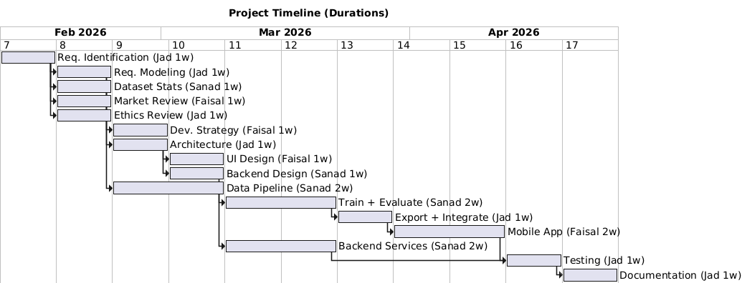
Figure 1: Gantt Chart Showing the Work Flow

Chapter 3

Requirements Specification

3.1 Stakeholders
Table 3: System Stakeholders
Stakeholder | Description | Interaction with the System | Importance of Role
Farmer (End User) | The primary user of the system who relies on the application to identify plant diseases. | Uses the mobile application to capture or upload leaf images and receive disease predictions with confidence values. | Core stakeholder; system usability, accuracy, and language support are driven by this role.
System Developer / Designer | The project team responsible for designing, implementing, and testing the system. | Designs the architecture, develops the deep learning model, mobile application, and backend services, and maintains the codebase. | Critical for system correctness, performance, maintainability, and successful delivery.
Agricultural Expert / Researcher | A domain expert who may validate results or use the system for analysis and research purposes. | Reviews disease classifications and may provide feedback on model accuracy and relevance. | Supports model validation and increases domain credibility of the system.
System Administrator | Responsible for managing backend services and system data. | Manages user accounts, authentication, system logs, and backend availability. | Ensures system reliability, data security, and proper operation of backend components.
Academic Supervisor | Oversees and evaluates the project as part of the graduation requirements. | Reviews system design, documentation, and final outcomes. | Defines academic constraints and evaluates the project’s quality and completeness.

3.2 Platform Requirements
The system consists of multiple parts a training environment, a mobile application, and backend services. Each sub system got a specific software and hardware requirement to work right. Some of the requirements are important the system work without them, others are recommended to improve performance, usability, or scalability.

3.2.1 Training Environment Requirements
The training environment is used for data preprocessing, model training, and evaluation. This environment is required only during development and experimentation.
- Mandatory requirements:
  - General-purpose operating system.
  - Python based development environment.
  - Deep learning framework capable of training CNNs.
- Recommended requirements:
  - GPU acceleration and sufficient memory to reduce training time and support larger batch sizes.

3.2.2 Mobile Application Requirements
The mobile application is how the users interacts with the system. It runs the trained model on the device and connects to backend services when an internet connection is available.
- Mandatory requirements:
  - Modern smartphone with a camera, sufficient processing power to run the trained model locally, and local storage for the application and model files.
The mobile application must support full offline operation, all the way from image capture to the display of results.

3.2.3 Backend Server Requirements
The backend server supports user management, data storage, and online services. It is accessed only when the mobile application is connected to the internet.
- Mandatory requirements:
  - Server environment capable of handling authentication requests and storing user-related data.
- Recommended requirements:
  - Scalable infrastructure and secure storage mechanisms to support future expansion.
Table 4: Platform Requirements by Sub-System
Sub-System | Mandatory Requirements | Recommended Requirements
Training Environment | Python runtime, deep learning framework, standard operating system, CPU-based computation | GPU acceleration, increased RAM, faster storage
Mobile Application | Smartphone device, camera, local storage, support for on-device inference | Internet connectivity for backend features
Backend Server | Server OS, application runtime, user authentication support, data storage | Scalable hosting, enhanced security mechanisms

3.3 Functional Requirements
This section describes the functional requirements of the proposed plant disease detection system. Each requirement shows the expected system behavior, including inputs, outputs, processing steps, constraints, and priority.

Functional Requirement 1: User Authentication
Input: User credentials (e.g., username and password).
Output: Authentication status (successful or failed login).
Process: User authentication is performed when internet connectivity is available. Once authenticated, the system allows continued offline usage using a locally stored session.
Constraints: Requires internet connectivity and secure handling of user data.
Priority: Essential.
Functional Requirement 2: Leaf Image Capture
Input: Live camera input from the mobile device.
Output: Captured leaf image.
Process: The mobile application allows the user to capture an image of a plant leaf using the device camera.
Constraints: The device must have a functional camera; poor image quality may affect classification accuracy.
Priority: Essential.

Functional Requirement 3: Leaf Image Upload
Input: Image file selected from device storage.
Output: Uploaded leaf image.
Process: The system allows the user to upload an existing image of a plant leaf from local storage.
Constraints: Supported image formats and file size limitations apply.
Priority: Recommended.
Functional Requirement 4: Disease Classification
Input: Leaf image.
Output: Predicted disease class and confidence score.
Process: The system preprocesses the input image and applies the trained convolutional neural network to generate a prediction.
Constraints: Performance depends on available computing resources.
Priority: Essential.
Functional Requirement 5: Offline Inference Support
Input: Leaf image.
Output: Predicted disease class and confidence score.
Process: The system performs disease classification locally on the mobile device without requiring internet connectivity.
Constraints: Limited by device processing power and local storage capacity.
Priority: Essential.
Functional Requirement 6: Online Inference Support
Input: Leaf image.
Output: Predicted disease class and confidence score.
Process: When internet connectivity is available, the system supports remote inference for; however, this is not required for core functionality.
Constraints: Requires a stable network connection and may introduce latency.
Priority: Essential.
Functional Requirement 7: Result Presentation
Input: Predicted disease class and confidence score.
Output: Displayed result to the user.
Process: The system presents the classification result in a clear and understandable format within the mobile application.
Constraints: The interface must remain simple and suitable for non-technical users.
Priority: Essential.
Functional Requirement 8: Result Translation
Input: Predicted disease class and confidence score.
Output: Arabic textual explanation or translation.
Process: Disease names and explanations are provided using a locally stored translation dictionary to ensure offline availability.
Constraints: Dependent on third-party API availability and internet connectivity.
Priority: Recommended.
Functional Requirement 9: User History Storage
Input: Prediction results and timestamps.
Output: Stored user history records.
Process: The system stores past diagnosis results in the backend database, linked to the authenticated user account. When offline, history records are stored locally and synchronized with the backend once connectivity is restored.
Constraints: Requires backend availability and authenticated access.
Priority: Recommended.
Functional Requirement 10: Model Update Capability
Input: Updated model file.
Output: Updated local model version.
Process: The system allows the deployed model to be updated when a newer version becomes available.
Constraints: Requires internet connectivity and compatibility with the mobile application.
Priority: Recommended.

3.4 Non-Functional Requirements
Non-functional requirements define the quality attributes and constraints of the system rather than specific functionalities. These requirements describe how the system should perform, how secure and usable it should be, and the constraints under which it operates.
Non-Functional Requirement 1: Performance
The system should provide disease classification results within an acceptable response time after image submission.
- Constraint: Performance may vary depending on device hardware and network conditions.
- Priority: Essential.

Non-Functional Requirement 2: Usability
The mobile application should be easy to use by non-technical users, particularly farmers. The user interface should be simple, intuitive, and require minimal interaction to obtain results.
- Constraint: The interface must support clear presentation of results without overwhelming the user.
- Priority: Essential.
Non-Functional Requirement 3: Reliability
The system should operate consistently and provide stable predictions under normal usage conditions. Offline-first operation improves reliability in rural agricultural environments.
- Constraint: Reliability depends on the quality of input images and availability of backend services when required.
- Priority: Essential.
Non-Functional Requirement 4: Availability
The system should be available for use whenever the user launches the mobile application. Backend-dependent features should function when an internet connection is available.
- Constraint: Online services are subject to server availability and network connectivity.
- Priority: Essential.
Non-Functional Requirement 5: Security
The system should protect user data and ensure secure access to backend services. User authentication and stored information must be handled securely.
- Constraint: Requires secure communication channels and proper access control mechanisms.
- Priority: Essential.
Non-Functional Requirement 6: Scalability
The system should be designed to allow future expansion, such as supporting additional crops, diseases, or increased numbers of users.
- Constraint: Scalability may depend on backend infrastructure and available resources.
- Priority: Recommended.
Non-Functional Requirement 7: Maintainability
The system should be modular and well-structured to allow updates, bug fixes, and model improvements with minimal impact on existing functionality.
- Constraint: Requires clear code organization and documentation.
- Priority: Recommended.

Non-Functional Requirement 8: Portability
The system should be adaptable to different mobile platforms and environments with minimal changes.
- Constraint: Portability depends on framework compatibility and platform support.
- Priority: Recommended.

Non-Functional Requirement 9: Accuracy
The disease classification results should achieve acceptable accuracy levels suitable for decision support.
- Constraint: Accuracy is influenced by dataset quality, model limitations, and image conditions.
- Priority: Essential.
Non-Functional Requirement 10: Localization
The system should support Arabic language output to ensure accessibility for local users.
- Constraint: Dependent on availability of translation services when online.
- Priority: Recommended.

3.5 Other Requirements
Other Requirement 1: API Usage Restrictions
The system should rely only on publicly available and well-documented APIs for external services such as language translation or explanation generation.
- Constraint: Proprietary or undocumented APIs should be avoided to ensure system reliability and maintainability.
Other Requirement 2: Data Transmission Protocols
All communication between the mobile application and backend services should use secure data transmission protocols.
- Constraint: Network communication must be encrypted to protect user data and authentication information.

Other Requirement 3: Data Storage Format
User-related data, such as authentication information and prediction history, should be stored in structured and standard data formats.
- Constraint: Stored data must be organized to allow efficient retrieval and future expansion.
Other Requirement 4: Model File Management
The trained model should be stored and distributed in a format suitable for mobile deployment.
- Constraint: The model format must be compatible with the chosen mobile framework and support future updates without requiring changes to the application logic.
Other Requirement 5: External Service Dependency
Optional system features that depend on external services, such as result translation, should fail gracefully if the service is unavailable.
- Constraint: Core disease classification functionality must remain unaffected by the availability of external services.

Chapter 4

System Design
In this section, provide the appropriate diagrams with Propper’s justification. Also, it should include the physical model design of your system.

4.1 Architectural Design
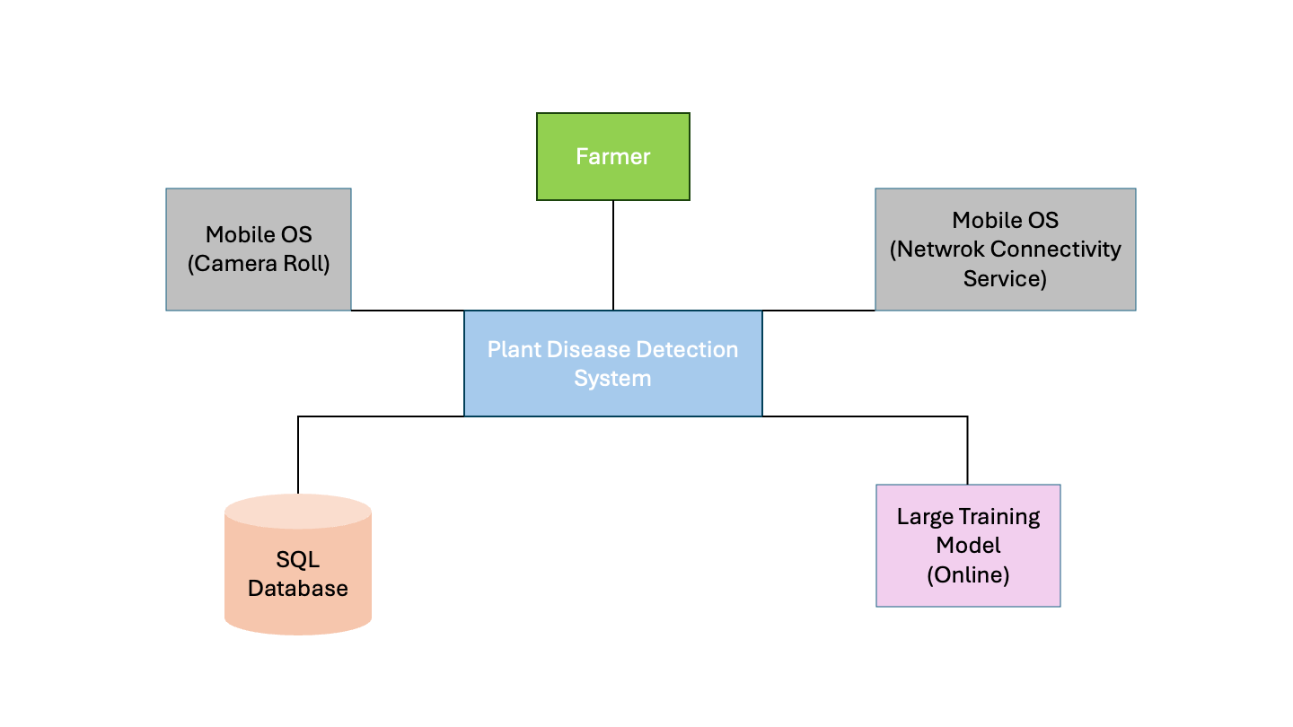
Large scale diagram that describes the different system components like interface, database, pipeline, model and the way they are connected.
Figure 2: Context Diagram
Description:
This context diagram shows how the Farmer interacts with the Plant Disease Detection System, which uses mobile device services (camera and network), a backend database, and an online model to diagnose plant diseases.
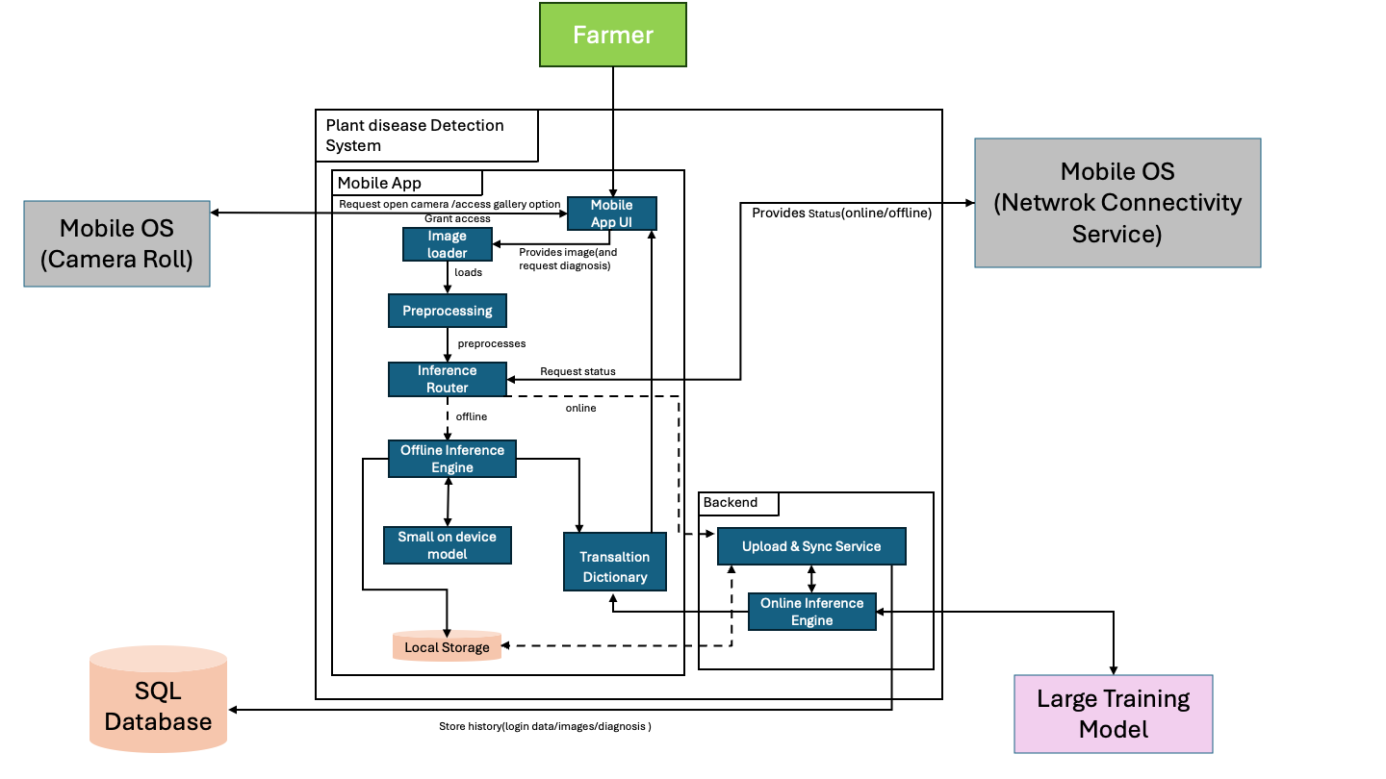
Figure 3: Container Diagram (Deployment)

Description:
This container diagram shows how the Plant Disease Detection System processes leaf images through a mobile app, routing inference either locally or online based on network availability, and returning translated diagnosis results to the farmer. It also illustrates how results and user data are stored and synchronized with the backend database.

4.2 Logical Model Design
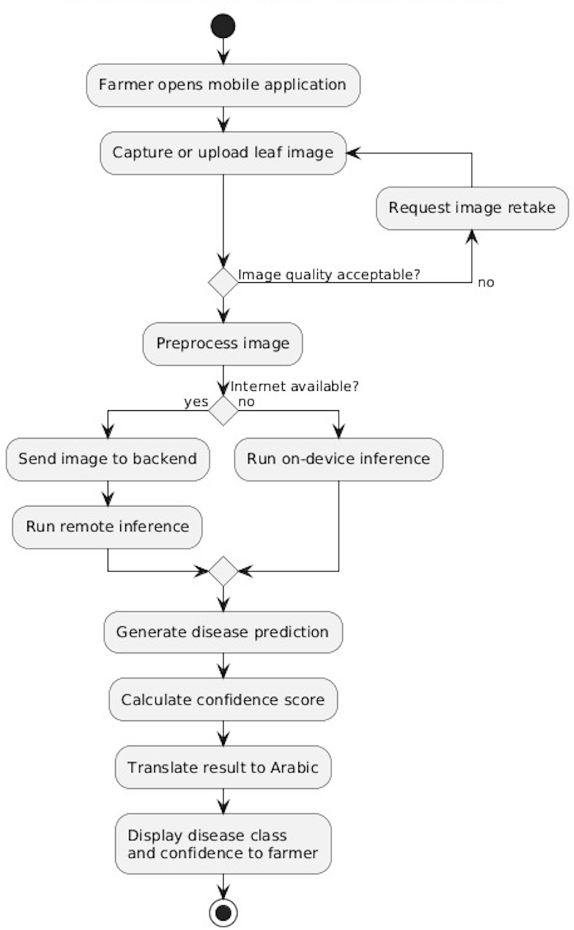
In this section, provide both a high level and low-level design of the system you will develop.

Figure 4: Activity Diagram (Deployment)

Description:
This activity diagram describes the workflow of the plant disease detection process from the farmer perspective. The farmer captures or uploads a leaf image, and the quality gets checked before processing. The system then preprocesses the image and determines whether an internet connection is available. If online, inference is performed remotely. Otherwise, the model runs locally on the device. At last, the system generates a disease prediction with a confidence score, translates the result into Arabic, and displays it to the user.
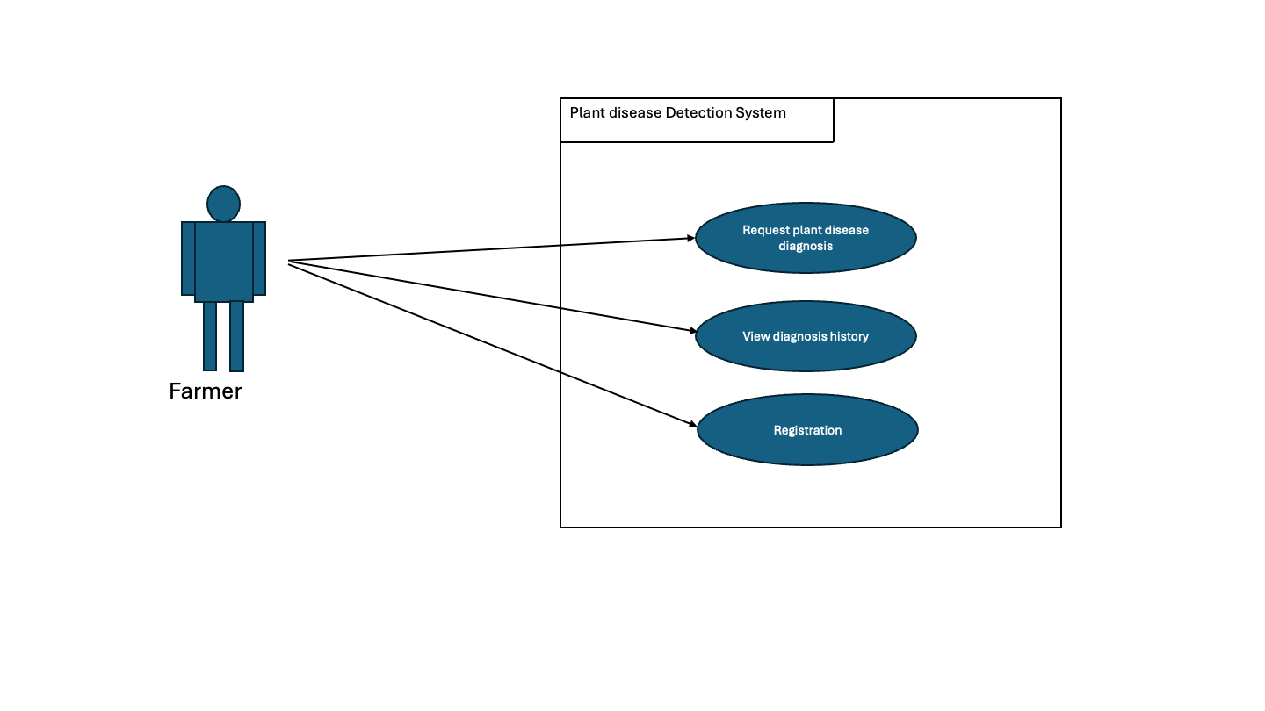
Figure 5: Use Case Diagram

Description:
This use case diagram shows the Farmer interacting with the Plant Disease Detection System to register, request a plant disease diagnosis, and view past diagnosis history. It highlights the main actions available to the farmer within the system.

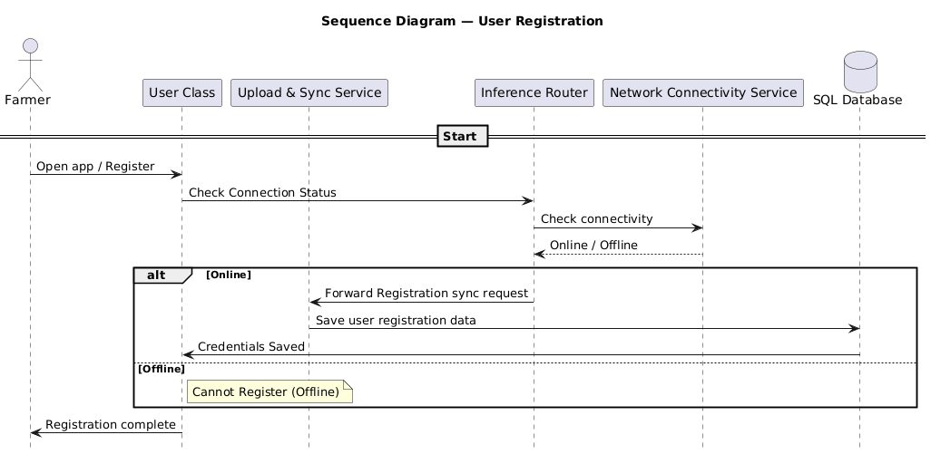
Figure 6: Sequence Diagram (Registration)

Description:
This sequence diagram shows how a farmer registers in the system by interacting with the User Class, which checks network connectivity and, if online, saves the registration data to the SQL database via the Upload & Sync Service. If the device is offline, registration is blocked and the user is notified.

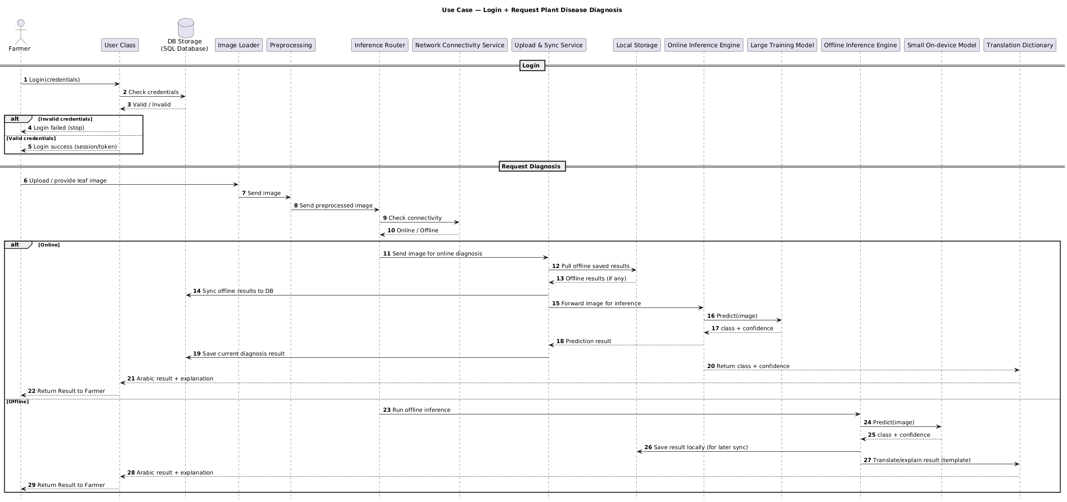
Figure 7: Sequence Diagram (login + Request Diagnosis)

Description:
This sequence diagram shows how a farmer logs into the system and then requests a plant disease diagnosis, where the image is processed and routed to either online or offline inference based on network availability. The system returns the predicted disease, confidence, and an Arabic explanation, while handling data storage and synchronization transparently.

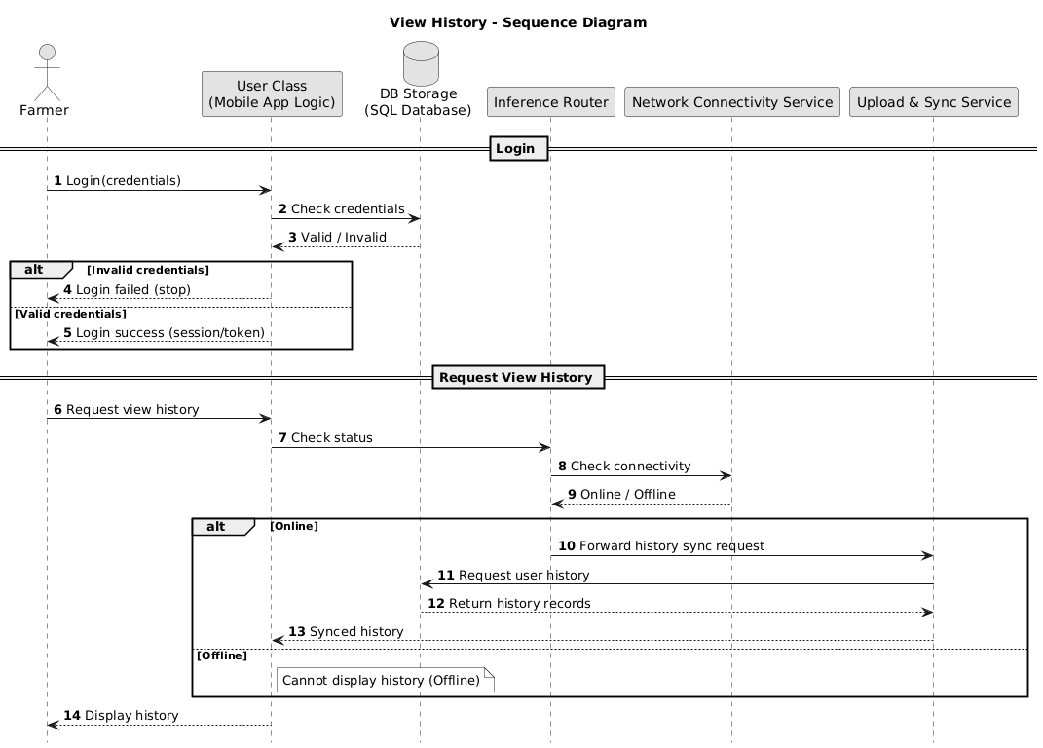
Figure 8: Sequence Diagram (login + view History)

Description:

This sequence diagram shows the farmer logging into the system, then requesting to view diagnosis history. If the device is online, the system syncs and retrieves history records from the database and displays them; if offline, the history cannot be displayed.

4.3 Physical Model Design
- User Interface/System interface Design :
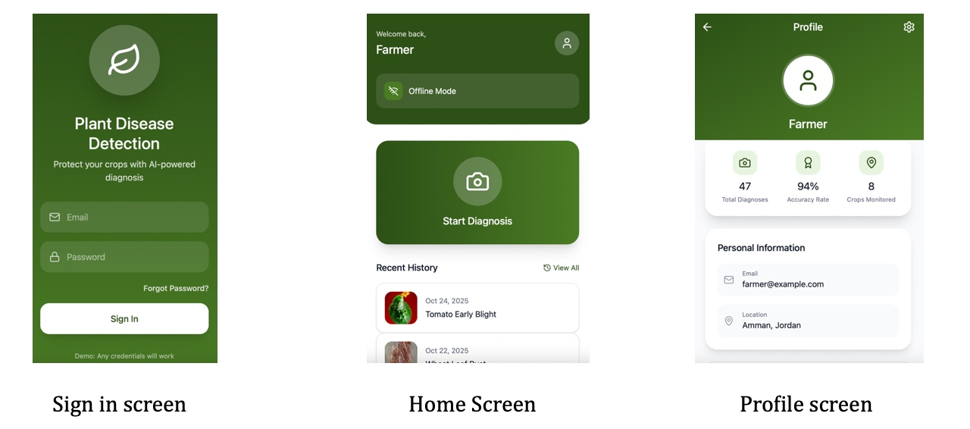
Figure 9: Three Images Showing Sign in, Home and Profile Screens

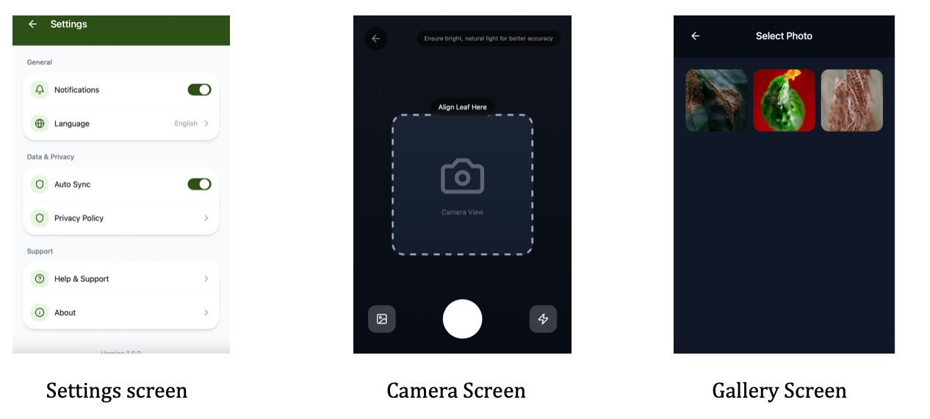
Figure 10: Three Images Showing the Settings, Camera, and Gallery Screens
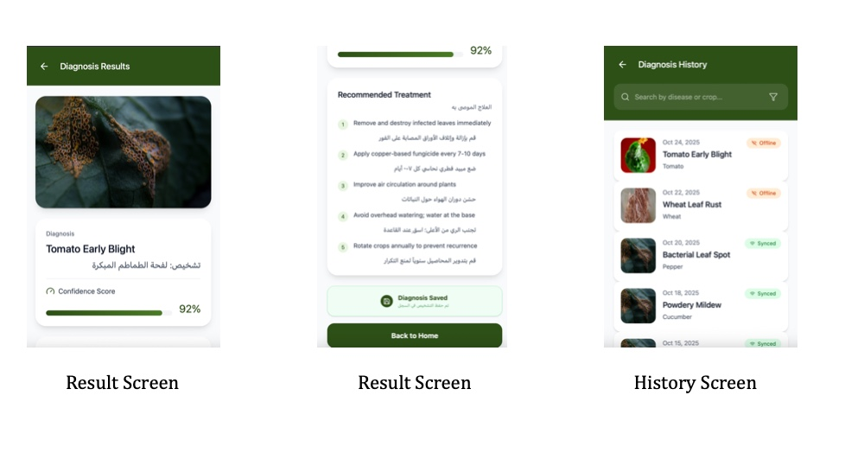
Figure 11: Three Images Showing Two Different Parts of the Result Screen, and the History Screen
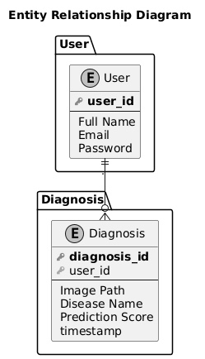

Figure 12: Entity Relationship Diagram

Chapter 5

Data Preprocessing

5.1 Data Collection and Description
This project follows a data driven approach, where everything depends on the quality and variety of the data we collected. The data used in this project was obtained from multiple publicly agricultural image datasets.
The datasets was selected to make sure that compatibility with crops and diseases commonly found in Jordan are particularly those that affects the vegetables, fruits, and olive trees.

5.1.1 Data Sources
Olive Leaf Image Dataset: https://www.kaggle.com/datasets/habibulbasher01644/olive-leaf-image-dataset kaggle.com
Olive Leaf Disease Dataset (Zeytin): https://www.kaggle.com/datasets/serhathoca/zeytin kaggle.com
Wheat Plant Diseases: https://www.kaggle.com/datasets/kushagra3204/wheat-plant-diseases kaggle.com
20k+ Multi‑Class Crop Disease Images : https://www.kaggle.com/datasets/jawadali1045/20k-multi-class-crop-disease-images
New Plant Diseases Dataset: https://www.kaggle.com/datasets/vipoooool/new-plant-diseases-dataset?utm_source=chatgpt.com

5.1.2 Data Collection Process
The data collection process was automated with using a pipeline we implemented inside a Jupyter Notebook. We used the Kaggle API for authentication which allowed us to download and extract the image dataset. Each dataset will be downloaded, unzipped, and stored in a raw data directory (data_raw) before preprocessing.

5.1.3 Data Metadata
Each image in the final dataset will be associated with the following metadata fields:
- Image path
- Crop name
- Disease label
- Dataset source
- Dataset split (train, validation, test)
This metadata is stored in structured CSV files to facilitate training, evaluation.

5.2 Data Profiling and Engineering

5.2.1 Data Quality Assessment
After data extraction, we might face some challenges with the raw datasets which might be:
- Inconsistent folder structures across datasets
- Different naming conventions for crops and diseases
- Variable image resolutions and formats
- Presence of duplicate or near-duplicate images
- Class imbalance across diseases
A data profiling step would be performed by scanning directory structures and image distributions to identify missing classes, corrupted files, and inconsistent labels.

5.2.2 Data Cleaning Techniques
To address these issues, the following cleaning steps would be applied:
- Standardize the folder structure, all datasets will be mapped into a unified directory structure: jordan_dataset / images / crop_name / disease_name / image.jpg
- Only valid image formats (.jpg, .jpeg, .png) will be used, all other images would automatically be skipped.
- Synchronizing image labels, disease names from different datasets would be standardized (Tomato___Late_blight → Tomato / Late_blight) to maintain label consistency.

5.3 Feature Engineering

5.3.1 Feature Extraction
Since this project focuses on image classification, features are implicitly extracted by a deep learning model (CNN). Therefore, traditional manual feature extraction would not be required.
Instead, feature preparation would be focused on image normalization, which ensures that the neural network learns meaningful visual patterns rather than dataset artifacts.

5.3.2 Image Normalization
Each image would be processed as follows:
- Converted to RGB color space
- Resized to a fixed resolution of pixels
- Saved in JPEG format with consistent quality settings
This step ensures uniform input dimensions and stabilizes model training.

5.3.3 Feature Selection and Dimensionality Reduction
Both feature selection and dimensionality reduction can be handled by the convolutional layers, during the model training. This process is considered to be in best practices in the deep learning image classification.

5.3.4 Data Augmentation
To remove class imbalance, data augmentation would be applied to make classes that do not have enough data to have more data. Techniques included:
- Random rotations
- Horizontal and vertical flips
- Brightness and contrast adjustment
- Small geometric transformations
These techniques increase dataset diversity and improve the model’s ability to generalize, particularly for underrepresented disease classes.

5.4 Data Loading

5.4.1 Dataset Splitting
After preprocessing, the dataset would be split into:
- Training
- Validation
- Testing
The split would be performed using stratified sampling based on crop disease labels to ensure balanced class representation across all subsets.

5.4.2 Data Storage Format
The final dataset would consist of:
- A structured image directory (jordan_dataset/images)
- Metadata CSV files:
  - metadata_train.csv
  - metadata_val.csv
  - metadata_test.csv
These files would be directly compatible with PyTorch and TensorFlow data loaders.

5.4.3 Justification for Classification Approach
We picked image classification not object detection, because most plant disease spread across the whole leaf, drawing the boxes around the disease would not help. Classification saves time, it needs less computing power. That makes it good for mobile apps.

Appendix A

Users’ Manual

Provide a description (textual and pictorial) of how the system can be installed and used and how the errors messages should be interpreted.

Appendix B

Document Changes

Discuss here any changes you have made to the document you have submitted in Project 1 and the reasons behind the changes.

Appendix C

Code Documentation

List the code documentation. Such a documentation can usually be automatically generated using tools like JavaDoc and Doxygen.

References

[1] Mohanty, S. P., Hughes, D. P., & Salathé, M. (2016). Using deep learning for image-based plant disease detection. Frontiers in plant science, 7, 215232.
https://doi.org/10.3389/fpls.2016.01419
[2] Ferentinos, K. P. (2018). Deep learning models for plant disease detection and diagnosis. Computers and electronics in agriculture, 145, 311-318.
https://doi.org/10.1016/j.compag.2018.01.009
[3] Hughes, D., & Salathé, M. (2015). An open access repository of images on plant health to enable the development of mobile disease diagnostics. arXiv preprint arXiv:1511.08060.
https://arxiv.org/abs/1511.08060
[4] Too, E. C., Yujian, L., Njuki, S., & Yingchun, L. (2019). A comparative study of fine-tuning deep learning models for plant disease identification. Computers and Electronics in Agriculture, 161, 272-279.
https://doi.org/10.1016/j.compag.2018.03.032
[5] Kamilaris, A., & Prenafeta-Boldú, F. X. (2018). Deep learning in agriculture: A survey. Computers and Electronics in Agriculture, 147, 70–90. https://doi.org/10.1016/j.compag.2018.02.016
[6] Dial “A” for agriculture: A review of information and communication technologies for agricultural extension in developing countries by J. C. Aker (2011), published in Agricultural Economics. https://doi.org/10.1111/j.1574-0862.2011.00545.x
[7] C4 Model. Visualising software architecture.
https://c4model.com
[8] ICARDA (International Center for Agricultural Research in the Dry Areas). (n.d.). Plant disease management in dryland farming systems.
https://www.icarda.org
[9] University of Jordan, Faculty of Agriculture. (n.d.). Research studies on plant diseases and agricultural practices in Jordan.
https://agriculture.ju.edu.jo
[10] National Center for Agricultural Research (NARC), Jordan. (n.d.). Plant disease incidence reports and agricultural extension bulletins.
https://narc.gov.jo

Data Sets:
[11] Kaggle, “New Plant Diseases Dataset (Augmented),” 2018.
Available: https://www.kaggle.com/datasets/vipoooool/new-plant-diseases-dataset
[12] Kaggle, “Olive Leaf Image Dataset,” 2020.
Available: https://www.kaggle.com/datasets/habibulbasher01644/olive-leaf-image-dataset
[13] Kaggle, “Zeytin – Olive Leaf Disease Dataset,” 2020.
Available: https://www.kaggle.com/datasets/serhathoca/zeytin
[14] Kaggle, “Wheat Plant Diseases Dataset,” 2021.
Available: https://www.kaggle.com/datasets/kushagra3204/wheat-plant-diseases
[15] Kaggle, “20k+ Multi-Class Crop Disease Images,” 2022.
Available: https://www.kaggle.com/datasets/jawadali1045/20k-multi-class-crop-disease-images

