

Princess Sumaya University for Technology
Department of Data Science Semester 2025/2026

Plant Disease Detection Using Deep Learning from Leaf Images

Prepared By:
Faisal Quntar
Jad Kandah
Sanad Al-Madani

Supervised By:
Samer El-Kababji

Project Submitted in partial fulfillment for the degree of Bachelor of Science in
Data Science

2025

Declaration of Originality

This document has been written entirely by the undersigned team members of the project. The source of everyquoted text is clearly cited and there is no ambiguity in where the quoted text begins and ends. The source of any illustration, image or table that is not the work of the team members is also clearly cited. We are aware that using non-original text or material or paraphrasing or modifying it without proper citation is a violation of the university’s regulations and is subject to legal actions.

Names and Signatures of team members:

Acknowledgments

Express your appreciation to whoever helped you during your work or even before!

Summary

Give a complete but concise description of your work. The summary is a brief overview of your motivation, statement of purpose, general methodological approach, major results, discussion and conclusion. The abstract should not exceed one page.

List of Abbreviations

List the abbreviations you have used in your project if there are any and what they stand for.
CNN: Convolutional Neural Network.
UML: Unified Modeling Language.
Table of Contents

Declaration of Originality 2
Summary 4
List of Abbreviations 5
Table of Figures 8
Table of Tables 9
Introduction 10
1.1 Overview 10
1.2 Problem Statement 10
1.3 Related Work 11
1.4 Contribution 11
Project Plan 12
2.1 Project Deliverables 12
2.2 Project Tasks 13
2.3 Roles and Responsibilities 14
2.4 Risk Assessment 14
2.5 Project Management Tools 14
Requirements Specification 15
3.1 Stakeholders 15
3.2 Platform Requirements 15
3.2.1 Training Environment Requirements 16
3.2.2 Mobile Application Requirements 16
3.2.3 Backend Server Requirements 16
3.3 Functional Requirements 17
3.4 Non-Functional Requirements 19
3.5 Other Requirements 21
System Design 23
4.1 Architectural Design: 23
4.2 Logical Model Design 24
4.3 Physical Model Design 24
Data Preprocessing 26
5.1 Data Collection and Description 26
5.1.1 Data Sources 26
5.1.2 Data Collection Process 27
5.1.3 Data Metadata 27
5.2 Data Profiling and Engineering 27
5.2.1 Data Quality Assessment 27
5.2.2 Data Cleaning Techniques 28
5.3 Feature Engineering 28
5.3.1 Feature Extraction 28
5.3.2 Image Normalization 28
5.3.3 Feature Selection and Dimensionality Reduction 29
5.3.4 Data Augmentation 29
5.4 Data Loading 29
5.4.1 Dataset Splitting 29
5.4.2 Data Storage Format 29
5.4.3 Justification for Classification Approach 30
Users’ Manual 30
Document Changes 31
Code Documentation 32
References 33

Table of Figures

Figure 1: Three Images Showing Sign in, Home and Profile Screens 24
Figure 2: Three Images Showing the Settings, Camera, and Gallery Screens 24
Figure 3: Three Images Showing two Result Screens, and the History Screen 25

Table of Tables
Table 1: High-Level Project Tasks and Dependencies: 14
Table 2: System Stakeholders 16
Table 3: Platform Requirements by Sub-System 17

Chapter 1

Introduction

1.1 Overview
Agriculture plays a central role in food security and economic stability, and plant health is a critical factor in the productivity of agricultural systems. Farmers often struggle to diagnose plant diseases early due to limited access to experts, visual similarity between diseases, and the rapid spread of infections in crops. These challenges directly affect yield quality, production volume, and the economic sustainability of agricultural communities.
At the same time, advances in deep learning, particularly CNNs, have demonstrated a strong ability to learn complex visual patterns and perform image-based classification tasks with high accuracy. These methods offer an opportunity to support farmers by providing accessible, fast, and reliable disease diagnosis through simple leaf images captured using mobile devices.
This project leverages deep learning, specifically CNN-based image classification, to identify plant diseases from leaf photographs. The dataset used in this work includes eleven agriculturally significant crops: Apple, Cauliflower, Eggplant, Grape, Maize, Olive, Orange, Peach, Potato, Tomato, and Wheat. These crops reflect a wide range of plant species and include many that are relevant to agricultural practices in Jordan.
The long-term goal of this work is to develop a trained deep learning model that is designed as an offline-first mobile system, where disease diagnosis is performed locally on the device without requiring internet connectivity, allowing users, primarily farmers, to perform disease diagnosis locally on their devices without requiring internet connectivity.

1.2 Problem Statement
Farmers commonly face difficulty in accurately identifying plant diseases during early stages of infection. Misdiagnosis or delayed diagnosis can lead to inappropriate treatment, increased crop loss, and reduced agricultural productivity. Limited access to agricultural experts in rural areas further intensifies this problem.
This project addresses these issues by developing a deep learning–based plant disease classification system using leaf images. The outcome of the project is:
- A trained convolutional neural network model capable of classifying diseases in leaf images across the target crops.
- A mobile-application-ready model optimized for on-device inference, enabling users to diagnose plant diseases without requiring network access.

Target Audience and Impact
- Primary users: Farmers seeking quick, accessible, and accurate plant disease diagnosis. Agricultural Companies seeking to better their efficiency.
- Secondary users: Agricultural engineers, researchers, field inspectors, and students interested in plant pathology or precision agriculture.
The expected impact includes reducing crop losses through timely disease identification, improving decision-making for treatment, and increasing overall agricultural efficiency.
To ensure usability in rural and low-connectivity environments, the proposed solution prioritizes offline operation while supporting optional online inference.

1.3 Related Work
Plant disease classification using image-based deep learning has been widely studied in recent years. Several research efforts have utilized large public datasets, such as PlantVillage, to train CNN for leaf-based disease identification. Models such as AlexNet, VGGNet, ResNet, and MobileNet have achieved strong performance in these studies, demonstrating the suitability of CNN architectures for this task.
However, many existing systems face limitations including:
- Limited generalization across diverse lighting conditions and backgrounds.
- Lack of deployment in real-world environments such as farms.
- Focus on laboratory-quality datasets rather than practical field images.
- Absence of mobile or offline inference capabilities, restricting accessibility for farmers.
Compared to existing work, this project focuses on building a practical, deployable model that operates locally on mobile devices, addressing accessibility and real-world usability challenges. While drawing on deep learning methods established in prior research, the system developed here is designed specifically to serve agricultural users in field conditions.

1.4 Contribution
- Novelty in the idea: The project introduces a plant disease detection system, enabling diagnosis directly in the field.
- Audience it serves and how: The system primarily supports farmers by providing quick, accessible disease identification from leaf images, while also assisting agricultural engineers and researchers as a rapid diagnostic tool.
- A complete offline-first pipeline integrating dataset preparation, model training, and mobile-ready deployment, with optional backend synchronization for enhanced services.
Chapter 2

Project Plan

2.1 Project Deliverables
- Trained Deep Learning Model: A CNN-based plant disease classification model prepared for mobile deployment.
- Source Code: All project code for preprocessing, training, evaluation, and model export.
- Mobile Application Prototype: A simple mobile app capable of running the model locally and performing on-device disease classification.
- Documentation: Full project documentation following the PSUT graduation project template.
- Dataset Metadata: Structured CSV files describing crops, diseases, and train/validation/test splits.
- External Dataset Storage: The complete image dataset stored on Google Drive and used for model training.
- Evaluation Outputs: Metrics, confusion matrices, and results collected during model testing.

Split them into two diagrams, the model is also a separate entity the input and output are form the farmer in the model
what is the best architectural pattern for my project (layer architecture) for the right side , training side pattern pipe and filter
Almost the same with activity diagrams in the behavioural

2.2 Project Tasks
The project is subdivided into high-level tasks covering the analysis, design, and implementation phases. Each task is defined with an estimated duration and its dependencies to support structured planning and scheduling.
Table 1: High-Level Project Tasks and Dependencies:
Task No. | Task Name | Description | Duration | Dependencies
2.2.1 | Requirement Identification | Identify functional and non-functional requirements of the system. | 1 week | None
2.2.2 | Requirement Modeling | Organize and formalize the identified requirements into a structured model to guide system design and implementation. | 1 week | 2.2.1
2.2.3 | Dataset Analysis and Statistical Assessment | Analyze the plant leaf image dataset to assess dataset size, class distribution, crop coverage, and train/validation/test splits. | 1 week | 2.2.1
2.2.4 | Development Strategy Definition | Define the development strategy, including hardware environment, software tools, programming languages, and deployment approach for mobile and backend components. | 1 week | 2.2.2
2.2.5 | Market Need | Assess the market need for plant disease detection systems and compare existing solutions with the proposed project. | 1 week | 2.2.1
2.2.6 | Ethical Considerations Analysis | Analyze ethical aspects related to data usage, user privacy, and reliance on automated disease predictions. | 1 week | 2.2.1
2.2.7 | Architecture Design | Design the high-level system architecture defining the training pipeline, mobile application, on-device inference, and backend services. | 1 week | 2.2.2
2.2.8 | User and System Interface Design | Design the user interface of the mobile application and define system interactions between components. | 1 week | 2.2.7
2.2.9 | Backend and Data Storage Design | Design backend services for user management, authentication, and usage history storage. | 1 week | 2.2.7
2.2.10 | Data Pipeline Implementation | Implement data preprocessing, augmentation, and data loading pipelines for model training. | 2 weeks | 2.2.3
2.2.11 | Model Training and Evaluation | Train the CNN-based deep learning model and evaluate its performance using appropriate metrics. | 2 weeks | 2.2.10
2.2.12 | Model Export and Mobile Integration | Export the trained model to a mobile-ready format and integrate it into the mobile application. | 1 week | 2.2.11
2.2.13 | Mobile Application Implementation | Implement the mobile application for image capture, on-device inference, and result presentation. | 2 weeks | 2.2.12
2.2.14 | Backend Services Implementation | Implement backend services for authentication, history storage, translation, and optional online inference. | 2 weeks | 2.2.9
2.2.15 | Testing | Test the system components, including model performance, mobile application functionality, and backend integration. | 1 week | 2.2.13, 2.2.14
2.2.16 | Documentation | Prepare and finalize project documentation according to the graduation project template. | 1 week | All previous tasks

2.3 Roles and Responsibilities
Discuss the roles and responsibilities of each team-member in relation to each of the tasks. Be specific and provide enough details to allow an outsider to judge the workload for each team-member. Could generate a gantt chart

2.4 Risk Assessment
For each task, describe any associated risks that may prevent completing them. Indicate how probable the risk is, its impact on the system and how you plan to cope with it if it appears.

2.5 Project Management Tools
Describe here any tools you intend to use to manage the development of the system, such as version control software and project management software.

Chapter 3

Requirements Specification

3.1 Stakeholders
Table 2: System Stakeholders
Stakeholder | Description | Interaction with the System | Importance of Role
Farmer (End User) | The primary user of the system who relies on the application to identify plant diseases. | Uses the mobile application to capture or upload leaf images and receive disease predictions with confidence values. | Core stakeholder; system usability, accuracy, and language support are driven by this role.
System Developer / Designer | The project team responsible for designing, implementing, and testing the system. | Designs the architecture, develops the deep learning model, mobile application, and backend services, and maintains the codebase. | Critical for system correctness, performance, maintainability, and successful delivery.
Agricultural Expert / Researcher | A domain expert who may validate results or use the system for analysis and research purposes. | Reviews disease classifications and may provide feedback on model accuracy and relevance. | Supports model validation and increases domain credibility of the system.
System Administrator | Responsible for managing backend services and system data. | Manages user accounts, authentication, system logs, and backend availability. | Ensures system reliability, data security, and proper operation of backend components.
Academic Supervisor | Oversees and evaluates the project as part of the graduation requirements. | Reviews system design, documentation, and final outcomes. | Defines academic constraints and evaluates the project’s quality and completeness.

3.2 Platform Requirements
The proposed system consists of multiple sub-systems, including a training environment, a mobile application, and backend services. Each sub-system has specific software and hardware requirements to ensure correct operation. Some requirements are mandatory for the system to function, while others are recommended to improve performance, usability, or scalability.

3.2.1 Training Environment Requirements
The training environment is used for data preprocessing, model training, and evaluation. This environment is required only during development and experimentation.
- Mandatory requirements include a general-purpose operating system, a Python-based development environment, and a deep learning framework capable of training convolutional neural networks.
- Recommended requirements include access to GPU acceleration and sufficient memory to reduce training time and support larger batch sizes.

3.2.2 Mobile Application Requirements
The mobile application is the primary interface for end users. It supports on-device inference and can optionally connect to backend services when an internet connection is available.
- Mandatory requirements include a modern smartphone with a camera, sufficient processing power to run the trained model locally, and local storage for the application and model files.
- Recommended requirements include an internet connection for optional features such as user authentication, history synchronization, and result translation services.
The mobile application must support full offline operation, including image capture, preprocessing, inference, and result presentation.

3.2.3 Backend Server Requirements
The backend server supports user management, data storage, and online services. It is accessed only when the mobile application is connected to the internet.
- Mandatory requirements include a server environment capable of handling authentication requests and storing user-related data.
- Recommended requirements include scalable infrastructure and secure storage mechanisms to support future expansion.
Table 3: Platform Requirements by Sub-System
Sub-System | Mandatory Requirements | Recommended Requirements
Training Environment | Python runtime, deep learning framework, standard operating system, CPU-based computation | GPU acceleration, increased RAM, faster storage
Mobile Application | Smartphone device, camera, local storage, support for on-device inference | Internet connectivity for backend features
Backend Server | Server OS, application runtime, user authentication support, data storage | Scalable hosting, enhanced security mechanisms

3.3 Functional Requirements
This section describes the functional requirements of the proposed plant disease detection system. Each requirement specifies the expected system behavior, including inputs, outputs, processing steps, constraints, and priority.

Functional Requirement 1: User Authentication
Input: User credentials (e.g., username and password).
Output: Authentication status (successful or failed login).
Process: User authentication is performed when internet connectivity is available. Once authenticated, the system allows continued offline usage using a locally stored session.
Constraints: Requires internet connectivity and secure handling of user data.
Priority: Essential.
Functional Requirement 2: Leaf Image Capture
Input: Live camera input from the mobile device.
Output: Captured leaf image.
Process: The mobile application allows the user to capture an image of a plant leaf using the device camera.
Constraints: The device must have a functional camera; poor image quality may affect classification accuracy.
Priority: Essential.

Functional Requirement 3: Leaf Image Upload
Input: Image file selected from device storage.
Output: Uploaded leaf image.
Process: The system allows the user to upload an existing image of a plant leaf from local storage.
Constraints: Supported image formats and file size limitations apply.
Priority: Recommended.
Functional Requirement 4: Disease Classification
Input: Leaf image.
Output: Predicted disease class and confidence score.
Process: The system preprocesses the input image and applies the trained convolutional neural network to generate a prediction.
Constraints: Performance depends on available computing resources.
Priority: Essential.
Functional Requirement 5: Offline Inference Support
Input: Leaf image.
Output: Predicted disease class and confidence score.
Process: The system performs disease classification locally on the mobile device without requiring internet connectivity.
Constraints: Limited by device processing power and local storage capacity.
Priority: Essential.
Functional Requirement 6: Online Inference Support
Input: Leaf image.
Output: Predicted disease class and confidence score.
Process: When internet connectivity is available, the system supports remote inference for; however, this is not required for core functionality.
Constraints: Requires a stable network connection and may introduce latency.
Priority: Essential.
Functional Requirement 7: Result Presentation
Input: Predicted disease class and confidence score.
Output: Displayed result to the user.
Process: The system presents the classification result in a clear and understandable format within the mobile application.
Constraints: The interface must remain simple and suitable for non-technical users.
Priority: Essential.
Functional Requirement 8: Result Translation
Input: Predicted disease class and confidence score.
Output: Arabic textual explanation or translation.
Process: Disease names and explanations are provided using a locally stored translation dictionary to ensure offline availability.
Constraints: Dependent on third-party API availability and internet connectivity.
Priority: Recommended.
Functional Requirement 9: User History Storage
Input: Prediction results and timestamps.
Output: Stored user history records.
Process: The system stores past diagnosis results in the backend database, linked to the authenticated user account. When offline, history records are stored locally and synchronized with the backend once connectivity is restored.
Constraints: Requires backend availability and authenticated access.
Priority: Recommended.
Functional Requirement 10: Model Update Capability
Input: Updated model file.
Output: Updated local model version.
Process: The system allows the deployed model to be updated when a newer version becomes available.
Constraints: Requires internet connectivity and compatibility with the mobile application.
Priority: Recommended.

3.4 Non-Functional Requirements
Non-functional requirements define the quality attributes and constraints of the system rather than specific functionalities. These requirements describe how the system should perform, how secure and usable it should be, and the constraints under which it operates.
Non-Functional Requirement 1: Performance
The system should provide disease classification results within an acceptable response time after image submission.
- Constraint: Performance may vary depending on device hardware and network conditions.
- Priority: Essential.

Non-Functional Requirement 2: Usability
The mobile application should be easy to use by non-technical users, particularly farmers. The user interface should be simple, intuitive, and require minimal interaction to obtain results.
- Constraint: The interface must support clear presentation of results without overwhelming the user.
- Priority: Essential.
Non-Functional Requirement 3: Reliability
The system should operate consistently and provide stable predictions under normal usage conditions. Offline-first operation improves reliability in rural agricultural environments.
- Constraint: Reliability depends on the quality of input images and availability of backend services when required.
- Priority: Essential.
Non-Functional Requirement 4: Availability
The system should be available for use whenever the user launches the mobile application. Backend-dependent features should function when an internet connection is available.
- Constraint: Online services are subject to server availability and network connectivity.
- Priority: Essential.
Non-Functional Requirement 5: Security
The system should protect user data and ensure secure access to backend services. User authentication and stored information must be handled securely.
- Constraint: Requires secure communication channels and proper access control mechanisms.
- Priority: Essential.
Non-Functional Requirement 6: Scalability
The system should be designed to allow future expansion, such as supporting additional crops, diseases, or increased numbers of users.
- Constraint: Scalability may depend on backend infrastructure and available resources.
- Priority: Recommended.
Non-Functional Requirement 7: Maintainability
The system should be modular and well-structured to allow updates, bug fixes, and model improvements with minimal impact on existing functionality.
- Constraint: Requires clear code organization and documentation.
- Priority: Recommended.
Non-Functional Requirement 8: Portability
The system should be adaptable to different mobile platforms and environments with minimal changes.
- Constraint: Portability depends on framework compatibility and platform support.
- Priority: Recommended.

Non-Functional Requirement 9: Accuracy
The disease classification results should achieve acceptable accuracy levels suitable for decision support.
- Constraint: Accuracy is influenced by dataset quality, model limitations, and image conditions.
- Priority: Essential.
Non-Functional Requirement 10: Localization
The system should support Arabic language output to ensure accessibility for local users.
- Constraint: Dependent on availability of translation services when online.
- Priority: Recommended.

3.5 Other Requirements
Other Requirement 1: API Usage Restrictions
The system should rely only on publicly available and well-documented APIs for external services such as language translation or explanation generation.
- Constraint: Proprietary or undocumented APIs should be avoided to ensure system reliability and maintainability.
Other Requirement 2: Data Transmission Protocols
All communication between the mobile application and backend services should use secure data transmission protocols.
- Constraint: Network communication must be encrypted to protect user data and authentication information.

Other Requirement 3: Data Storage Format
User-related data, such as authentication information and prediction history, should be stored in structured and standard data formats.
- Constraint: Stored data must be organized to allow efficient retrieval and future expansion.
Other Requirement 4: Model File Management
The trained model should be stored and distributed in a format suitable for mobile deployment.
- Constraint: The model format must be compatible with the chosen mobile framework and support future updates without requiring changes to the application logic.
Other Requirement 5: External Service Dependency
Optional system features that depend on external services, such as result translation, should fail gracefully if the service is unavailable.
- Constraint: Core disease classification functionality must remain unaffected by the availability of external services.

Chapter 4

System Design
In this section, provide the appropriate diagrams with Propper’s justification. Also, it should include the physical model design of your system.

4.1 Architectural Design:
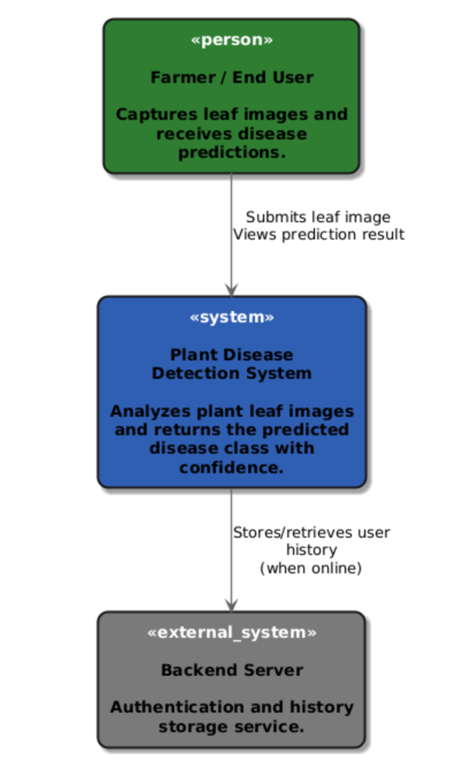
Large scale diagram that describes the different system components like interface, database, pipeline, model and the way they are connected.

Figure 1: Context Diagram

Description:
The Farmer submits a leaf image to the Plant Disease Detection System, which analyzes the image locally or remotely and returns the predicted disease with confidence. When online, the system synchronizes user history with the backend server for authentication and storage.
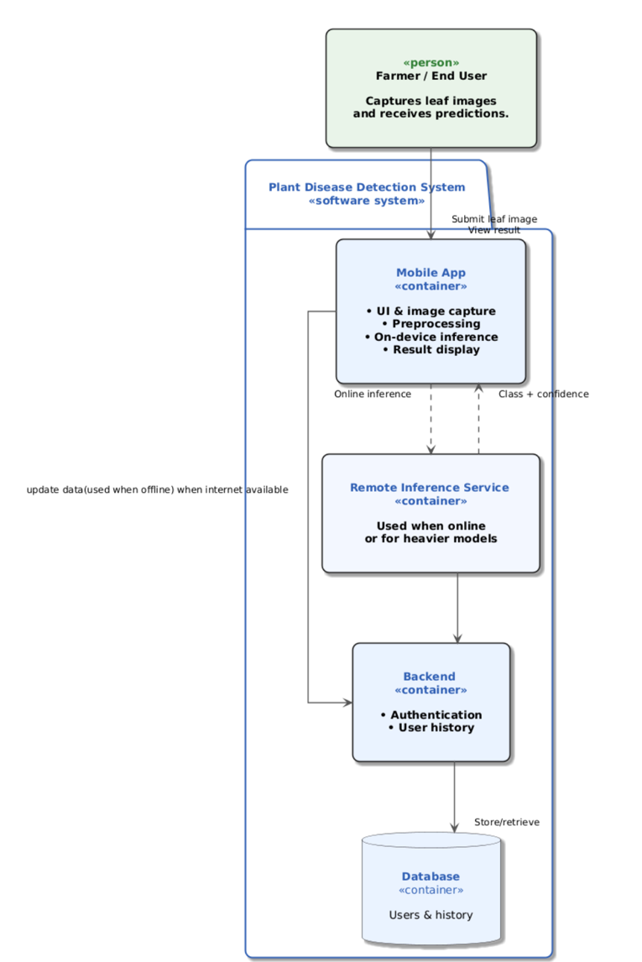

Figure 2: Container Diagram (Deployment)

Description:
This container diagram illustrates the interaction between its main components of the Plant Disease Detection System. The farmer interacts with the system through a mobile application, which handles image capture, preprocessing, and on-device disease classification. When an internet connection is available, the mobile application can communicate with a remote inference service for online prediction or heavier models. A backend server manages user authentication and synchronizes user history with a central database, particularly when the application reconnects after offline usage. This design supports an offline-first workflow while enabling online while connected to internet services for better functionality and data persistence.

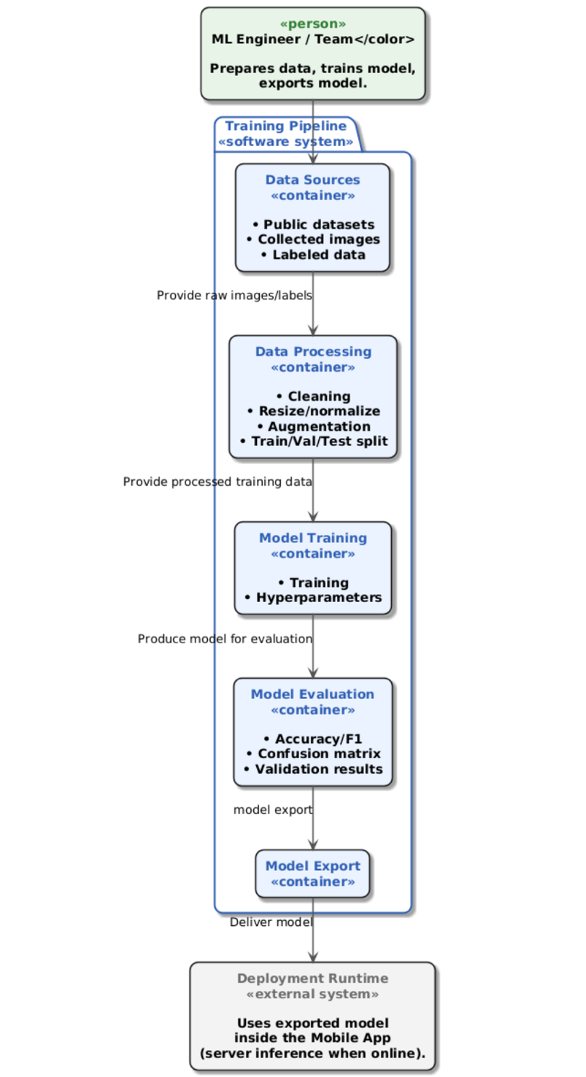

Figure 3: Container Diagram (Training)

Description:
This diagram explains the training pipeline used to develop the plant disease detection model. Raw labeled images from multiple data sources are first preprocessed through cleaning, normalization, augmentation, and dataset splitting. The processed data is then used to train and evaluate a deep learning model. After validation, the trained model is exported. The exported model is finally delivered to the deployment runtime for use in mobile or server based inference when online.
4.2 Logical Model Design
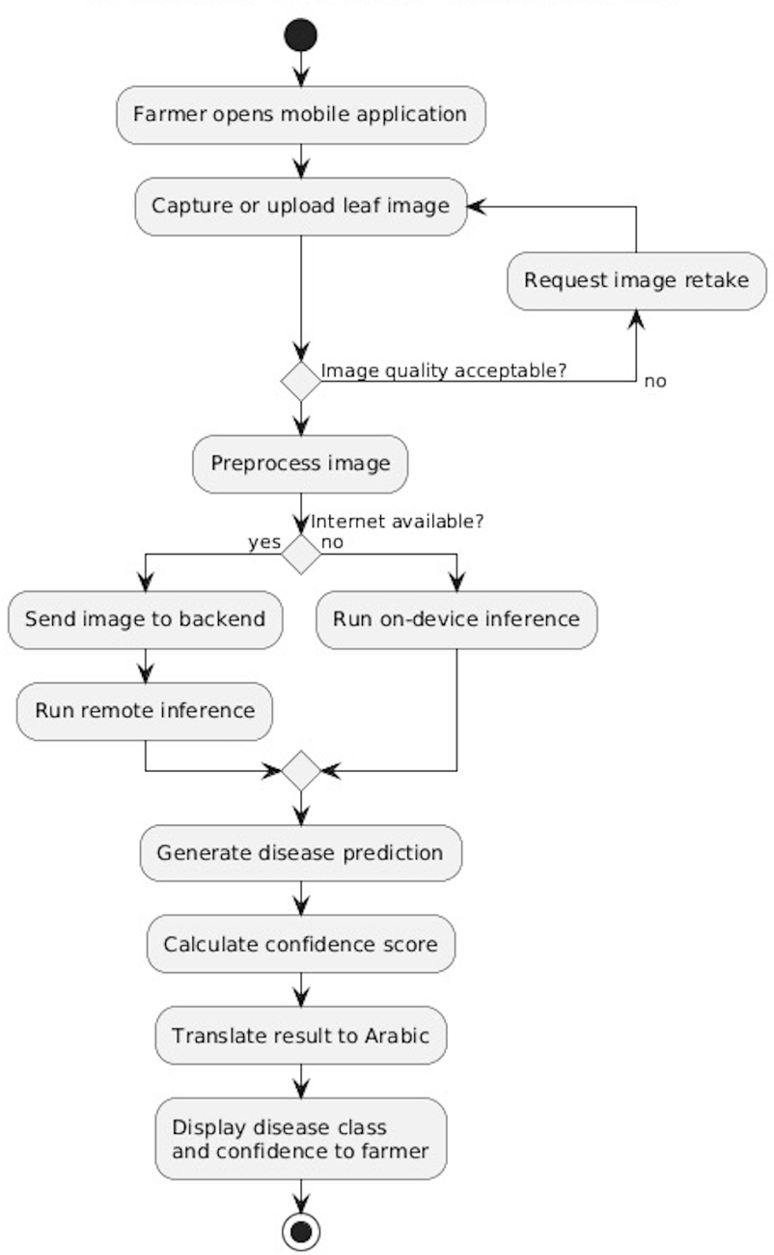
In this section, provide both a high level and low level design of the system you will develop.

Figure 4: Activity Diagram (Training)

Description:
This activity diagram describes the workflow of the plant disease detection process from the farmer perspective. The farmer captures or uploads a leaf image, and the quality gets checked before processing. The system then preprocesses the image and determines whether an internet connection is available. If online, inference is performed remotely. Otherwise, the model runs locally on the device. At last, the system generates a disease prediction with a confidence score, translates the result into Arabic, and displays it to the user.
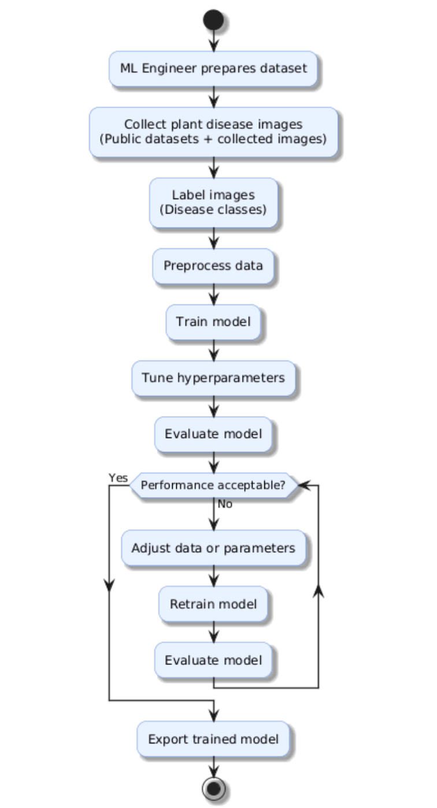
Figure 5: Activity Diagram (Training)

Description:
This activity diagram shows the end-to-end training workflow of the plant disease classification model. The process begins with the machine learning engineer preparing and collecting plant disease images from public datasets and additional sources, followed by labeling images according to disease classes. The data is then preprocessed to ensure consistency and quality before model training begins. After training, the model’s performance is evaluated, and if the results are under a certain threshold, a loop is triggered to adjust the data preprocessing steps or hyperparameters and retrain the model. This cycle continues until acceptable performance is achieved, after which the final trained model is exported for deployment in the mobile application.
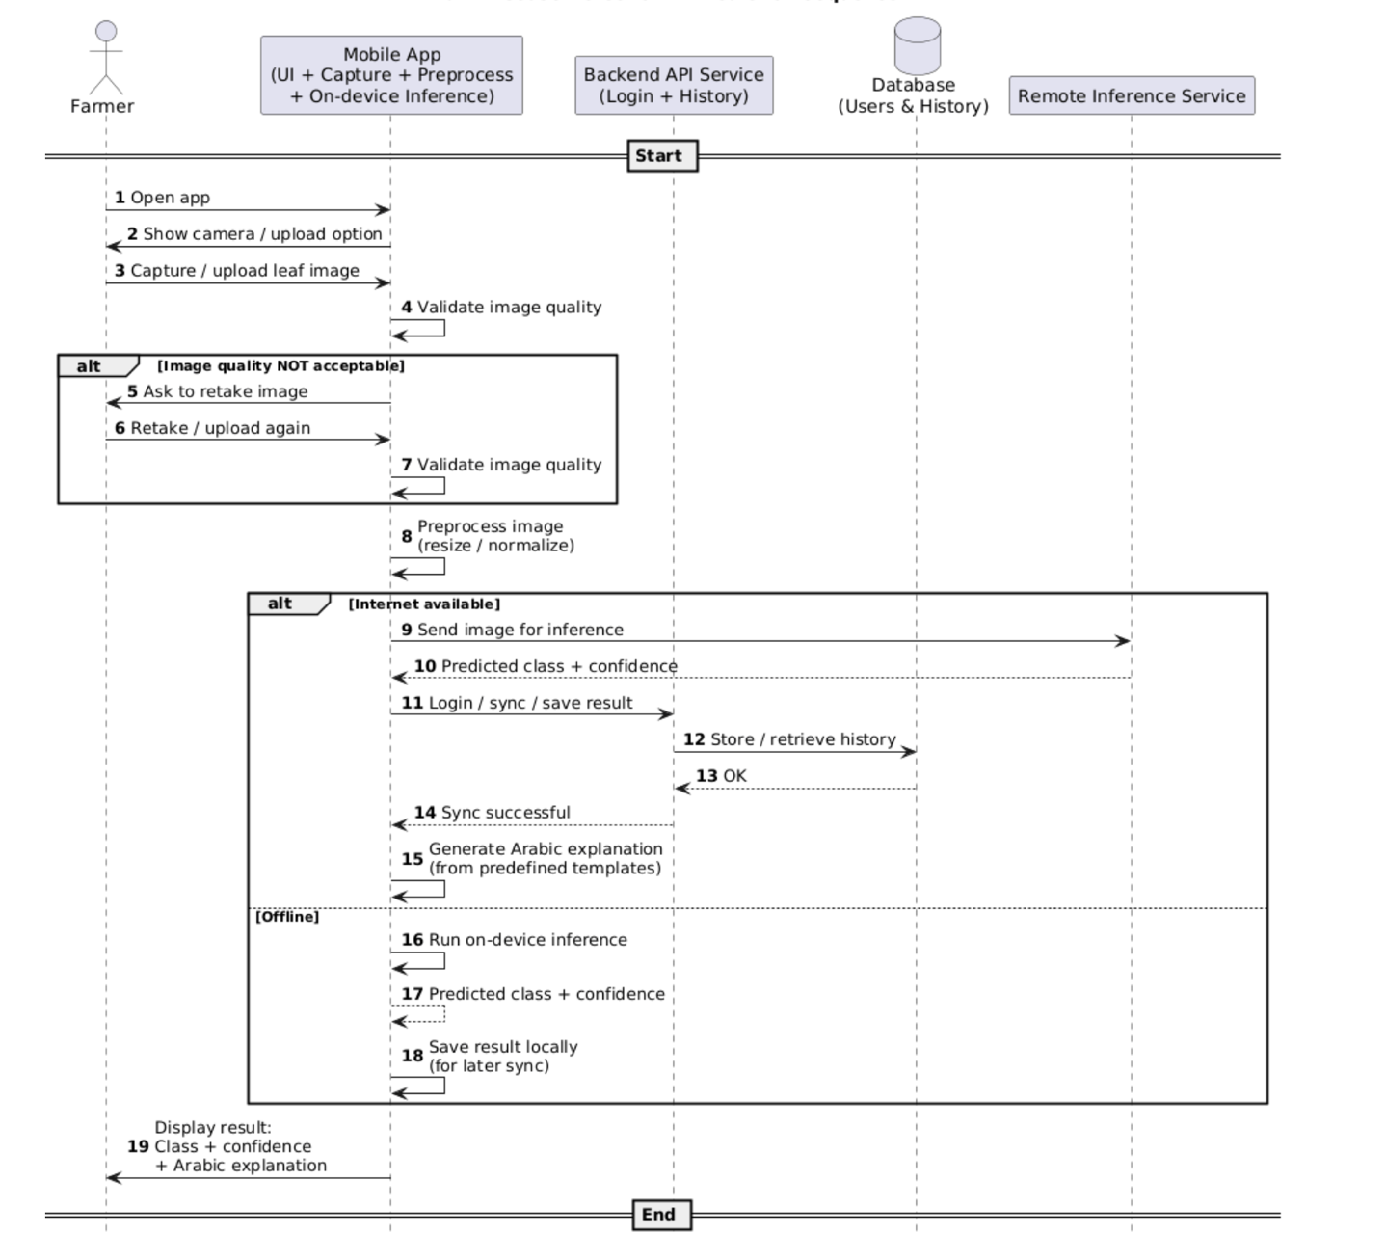
Figure 6: Sequence Diagram

Description:
This sequence diagram shows how a plant disease prediction is performed from start to finish. The farmer opens the mobile app, captures or uploads a leaf image, and the app first validates image quality, asking for a retake if needed. The image is then preprocessed. If the device is online, the image is sent to a remote inference service to generate the disease class and confidence, after which the app logs in to the backend API to store and sync the result in the database and generates an Arabic explanation using predefined templates. If the device is offline, the app performs on-device inference and saves the result locally for later synchronization. In both cases, the final output—disease class, confidence score, and Arabic explanation —is displayed to the farmer.

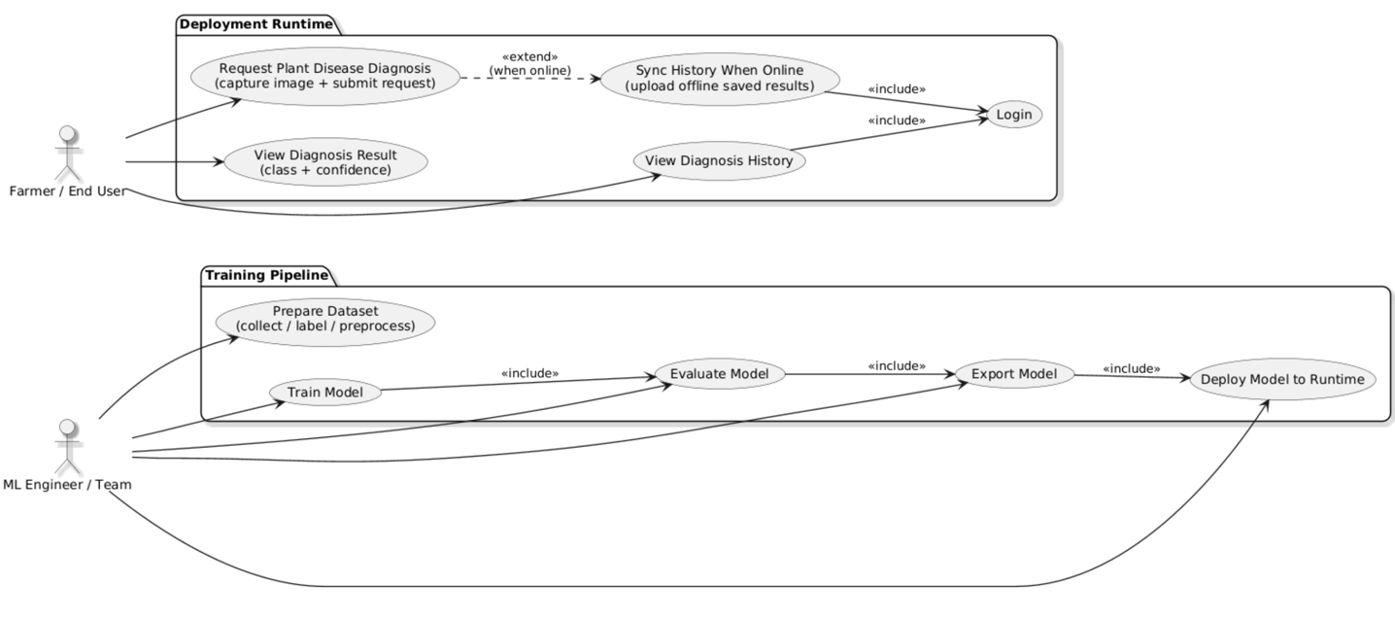
Description:
Figure 7: Use Case Diagram
This use case diagram shows how the ML Engineer prepares, trains, evaluates, and deploys the plant disease detection model, while the Farmer/End User interacts with the deployed system to request plant disease diagnoses, view results, and manage diagnosis history with optional online synchronization.

4.3 Physical Model Design
- User Interface/System interface Design :
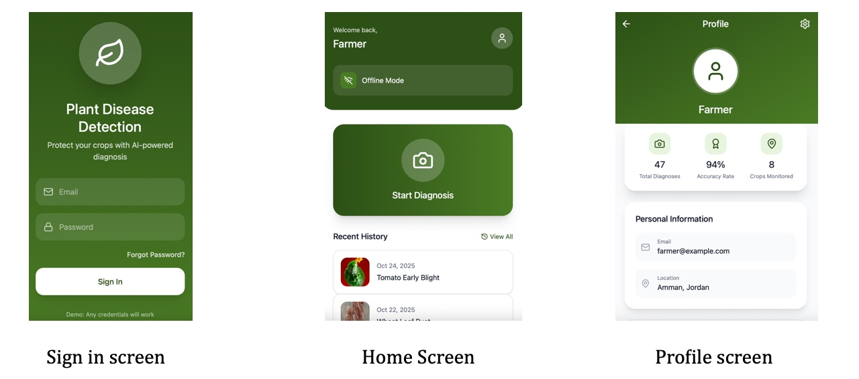
Figure 8: Three Images Showing Sign in, Home and Profile Screens
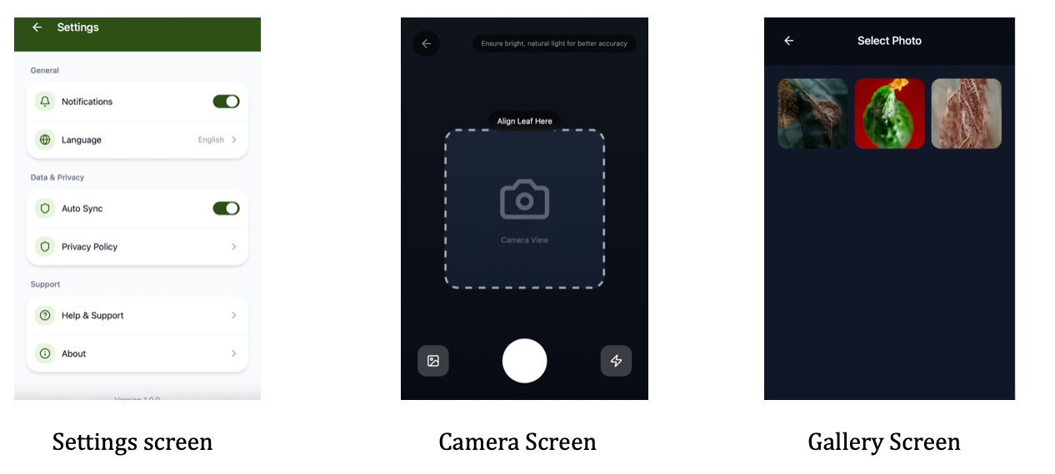
Figure 9: Three Images Showing the Settings, Camera, and Gallery Screens
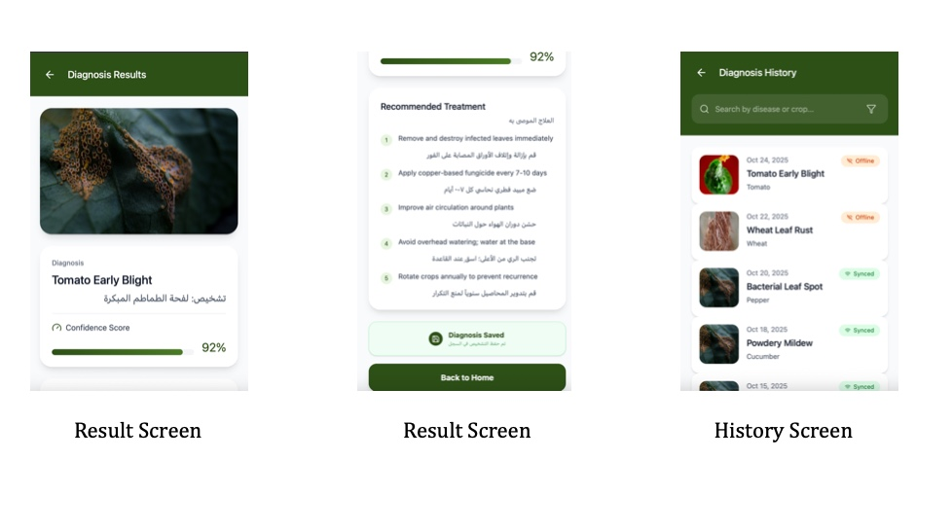
Figure 10: Three Images Showing two Result Screens, and the History Screen

Chapter 5

Data Preprocessing

5.1 Data Collection and Description
This project follows a data-driven approach, where the performance of the plant disease classification model depends heavily on the quality, diversity, and relevance of the collected data. The data used in this project was obtained from multiple publicly available agricultural image datasets, primarily hosted on Kaggle.
The datasets were selected to ensure compatibility with crops and diseases commonly found in Jordan, particularly those affecting vegetables, fruits, and olive trees.

5.1.1 Data Sources
Olive Leaf Image Dataset — https://www.kaggle.com/datasets/habibulbasher01644/olive-leaf-image-dataset kaggle.com
Olive Leaf Disease Dataset (Zeytin) — https://www.kaggle.com/datasets/serhathoca/zeytin kaggle.com
Wheat Plant Diseases — https://www.kaggle.com/datasets/kushagra3204/wheat-plant-diseases kaggle.com
20k+ Multi‑Class Crop Disease Images — https://www.kaggle.com/datasets/jawadali1045/20k-multi-class-crop-disease-images
New Plant Diseases Dataset — https://www.kaggle.com/datasets/vipoooool/new-plant-diseases-dataset?utm_source=chatgpt.com

5.1.2 Data Collection Process
The data collection process was fully automated using a pipeline we implemented inside a Jupyter Notebook. The Kaggle API was used to authenticate, download, and extract datasets. Each dataset was downloaded, unzipped, and stored in a raw data directory (data_raw) before preprocessing.
All images were collected in their original labeled form, preserving the dataset authors annotations to ensure correctness.

5.1.3 Data Metadata
Each image in the final dataset is associated with the following metadata fields:
- Image path
- Crop name
- Disease label
- Dataset source
- Dataset split (train, validation, test)
This metadata is stored in structured CSV files to facilitate training, evaluation.

5.2 Data Profiling and Engineering

5.2.1 Data Quality Assessment
After data extraction, the raw datasets exhibited several quality challenges:
- Inconsistent folder structures across datasets
- Different naming conventions for crops and diseases
- Variable image resolutions and formats
- Presence of duplicate or near-duplicate images
- Class imbalance across diseases
A data profiling step was performed by scanning directory structures and image distributions to identify missing classes, corrupted files, and inconsistent labels.

5.2.2 Data Cleaning Techniques
To address these issues, the following cleaning steps were applied:
- Folder Standardization: All datasets were mapped into a unified directory structure: jordan_dataset / images / crop_name / disease_name / image.jpg
- Image Validation: Only valid image formats (.jpg, .jpeg, .png) were retained, other images were automatically skipped.
- Label Harmonization: Disease names from different datasets were standardized (Tomato___Late_blight → Tomato / Late_blight) to maintain label consistency.

5.3 Feature Engineering

5.3.1 Feature Extraction
Since this project focuses on image classification, features are implicitly extracted by a deep learning model (CNN). Therefore, traditional manual feature extraction was not required.
Instead, feature preparation focused on image normalization, which ensures that the neural network learns meaningful visual patterns rather than dataset artifacts.

5.3.2 Image Normalization
Each image was processed as follows:
- Converted to RGB color space
- Resized to a fixed resolution of pixels
- Saved in JPEG format with consistent quality settings
This step ensures uniform input dimensions and stabilizes model training.

5.3.3 Feature Selection and Dimensionality Reduction
Feature selection and dimensionality reduction are handled by convolutional layers during model training. This aligns with best practices in deep learning image classification.

5.3.4 Data Augmentation
To remove class imbalance, data augmentation was applied to make classes that dont have enough data to have more data. Techniques included:
- Random rotations
- Horizontal and vertical flips
- Brightness and contrast adjustment
- Small geometric transformations
These techniques increase dataset diversity and improve the model’s ability to generalize, particularly for underrepresented disease classes.

5.4 Data Loading

5.4.1 Dataset Splitting
After preprocessing, the dataset was split into:
- 70% Training
- 15% Validation
- 15% Testing
The split was performed using stratified sampling based on crop disease labels to ensure balanced class representation across all subsets.

5.4.2 Data Storage Format
The final dataset consists of:
- A structured image directory (jordan_dataset/images)
- Metadata CSV files:
  - metadata_train.csv
  - metadata_val.csv
  - metadata_test.csv
These files are directly compatible with PyTorch and TensorFlow data loaders.

5.4.3 Justification for Classification Approach
This project adopts image classification rather than object detection for the following reasons:
- Most plant diseases affect the entire leaf surface, making bounding boxes unnecessary
- Classification requires less annotation effort and fewer computational resources
- It is more practical for mobile and farmer-facing applications
- Provides faster inference suitable for real-world agricultural deployment

Appendix A

Users’ Manual

Provide a description (textual and pictorial) of how the system can be installed and used and how the errors messages should be interpreted.

Appendix B

Document Changes

Discuss here any changes you have made to the document you have submitted in Project 1 and the reasons behind the changes.

Appendix C

Code Documentation

List the code documentation. Such a documentation can usually be automatically generated using tools like JavaDoc and Doxygen.

References
Use any referencing style/standard and be consistent. Consider the IEEE citation style. IEEE citation style includes in-text citations, numbered in square brackets, which refer to the full citation listed in the reference list at the end of the paper. The reference list is organized numerically, not alphabetically.

