HOSPITAL MANAGEMENT SYSTEM
Project Report
Design, Implementation, and Evaluation of a JavaFX-Based
Hospital Management System
A relational-database and application-development project report
PostgreSQL · MongoDB · JavaFX · JDBC
Version 1.0

Table of Contents

(If this table is blank, right-click it and choose "Update Field", or select the whole document with Ctrl+A and press F9, to populate section titles and page numbers.)

1. Introduction
1.1 Problem Statement
Hospitals and clinics that still rely on paper records or disconnected spreadsheets face slow patient registration, duplicated or lost medical history, appointment double-booking, untracked medication inventory, and billing that cannot be reliably reconciled against the care that was actually delivered. As patient volume grows, these manual processes do not scale: front-desk staff cannot search records quickly, doctors cannot see a patient's full clinical history at the point of care, pharmacists cannot see stock levels across batches in real time, and administrators have no reliable way to measure how the facility is performing or who is allowed to see what. The absence of a single, access-controlled source of truth is itself a patient-safety and data-governance risk, not merely an efficiency problem.
This project addresses that problem by designing and implementing a Hospital Management System (HMS): a desktop application, backed by a normalized relational database, that digitizes the core clinical and administrative workflows of a small-to-medium hospital -- patient registration, appointment scheduling, clinical documentation, prescriptions and pharmacy inventory, laboratory orders, billing, and role-based staff access -- behind a single consistent interface with enforced data-integrity rules.
1.2 Background and Motivation
The project originates from an academic brief (reproduced in Appendix A) that frames it as a database-systems and application-development exercise: design a normalized schema, implement it in a relational engine, integrate it with a desktop client over JDBC, apply data-structure and algorithmic techniques (indexing, caching, sorting, searching) to demonstrably improve performance, and compare a relational design against a NoSQL alternative for the subset of data that is naturally unstructured. Beyond the academic framing, the same requirements mirror real operational needs of a hospital IT system: referential integrity between clinical records, auditable access control across multiple staff roles, and measurable, evidence-backed performance rather than assumed performance.
1.3 Objectives
• Design a relational schema for the hospital domain, normalized to Third Normal Form (3NF), expressed at conceptual, logical, and physical levels.
• Implement the schema in PostgreSQL with constraints, indexes, views, stored procedures, and triggers that enforce integrity and encode reusable business logic at the database layer.
• Build a JavaFX desktop client that performs full CRUD, search, filtering, and reporting over the schema through a layered Controller -> Service -> DAO architecture using parameterized JDBC access.
• Apply in-memory data structures and algorithms (hashing/caching, sorting, searching) to measurably speed up repeated lookups, mirroring how database indexes work.
• Introduce a role-based access-control (RBAC) model so that what a user can see and do is determined by their assigned role and the permissions granted to it, enforced at both the application and database level.
• Compare the relational design against a NoSQL (MongoDB) design for the unstructured subset of the data (logs, notifications), with measured before/after-indexing benchmark evidence for both stores.
• Produce testing evidence and documentation sufficient for the system to be reviewed, reused, or extended by someone who was not involved in building it.
2. Scope of the Project
2.1 In-Scope
• Core clinical workflow: patient registration, appointment scheduling, medical records, vital signs, patient allergies, referrals between doctors.
• Pharmacy workflow: medication catalogue, batch-tracked inventory with expiry and reorder thresholds, prescriptions and prescription line items.
• Laboratory workflow: lab orders linked to appointments, and their results.
• Billing workflow: invoices generated from completed appointments, payment-status tracking (unpaid / partially paid / paid); a paid invoice doubles as the receipt record.
• Staff and access-control workflow: user accounts, roles (Admin, Doctor, Receptionist, Analyst, Pharmacist), fine-grained resource:action permissions, and session tracking.
• Operational tooling: an admin-only Developer Dashboard for database object inspection, index/view/routine management, scheduled backups, and live PostgreSQL/MongoDB performance benchmarking.
• Analytics and reporting: dashboards and an exportable analytics report (CSV and a designed PDF) summarizing admissions, revenue, appointment status, feedback, and lab turnaround.
• A secondary MongoDB store, scoped strictly to unstructured/semi-structured data: system logs, notifications, and (for the performance study) log-like benchmark records.
2.2 Out-of-Scope
• Insurance-claim processing and third-party payer integration.
• Real-time medical-device or IoT data ingestion (vital signs are entered manually).
• A patient-facing mobile or web application -- this iteration is a staff-facing desktop client; the schema and service layer are designed so a web/mobile front end could be added later without changing the database.
• Multi-hospital / multi-tenant deployment -- the schema models one facility.
• Automated UI end-to-end testing (TestFX or similar); the current test suite covers the backend layer only (Section 12).
2.3 Assumptions and Constraints
• A single PostgreSQL instance is the transactional system of record; MongoDB and Redis are auxiliary and the application degrades gracefully (logs a warning, keeps working) if either is unreachable.
• Staff accounts are provisioned by an administrator; there is no public self-registration.
• The client is a single JavaFX desktop application per workstation, not a multi-user web server -- concurrency is handled at the database level (constraints, transactions), not by an application-tier request queue.
• Seed data (five departments, five doctors, five role-based demo accounts) is provided for development and grading; it is not representative production data.
3. Proposed Solution
3.1 Overview
The proposed solution is a three-tier desktop application. A JavaFX presentation tier renders one page per workflow (patients, appointments, pharmacy, billing, analytics, and so on) and never talks to the database directly. Each page delegates to a Service tier that owns validation, business rules, caching, and event publication. Each service in turn delegates persistence to a DAO tier that speaks JDBC directly to PostgreSQL through parameterized PreparedStatements. A secondary MongoDB store holds unstructured, log-like data, and a two-level cache (in-process L1, Redis L2) sits between the Service and DAO tiers to absorb repeated reads.
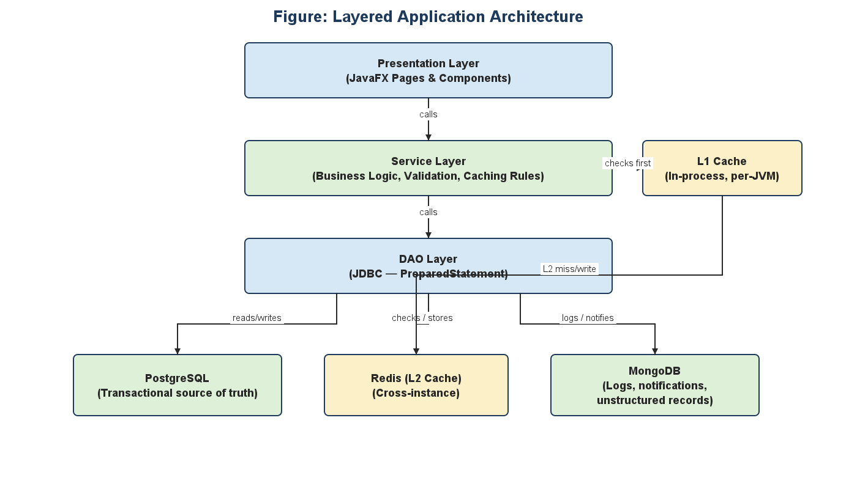
Figure 3.1: Layered application architecture.
3.2 Technology Stack
Layer | Technology | Rationale
Client UI | JavaFX 21+ (Java 25 runtime) | Native desktop performance; FXML separates layout from controller logic
Primary database | PostgreSQL | ACID transactions, rich constraint/index support, mature JDBC driver
Secondary database | MongoDB | Schema-flexible storage for logs/notifications, evaluated against PostgreSQL in Section 11
Cache | Redis (L2) + in-process map (L1) | Sub-millisecond repeat reads; L1 survives a Redis outage
Build | Maven | Dependency management, reproducible builds, CI integration
Testing | JUnit 5 + Mockito 5 | Isolated service-layer tests (mocked DAOs) and real-database DAO tests
Security | BCrypt, JWE (encrypted JWT), AES-256-GCM | Password hashing, opaque session tokens, at-rest field encryption
Reporting | Apache PDFBox, Apache POI | Programmatic PDF and spreadsheet/Word report generation

3.3 Key Design Decisions
• UUID primary keys everywhere (via PostgreSQL's pgcrypto gen_random_uuid()), so no table's identifier ever leaks a sequential row count and cross-environment data merges are safe.
• Soft delete on every entity table (a nullable deleted_at timestamp) -- patient-facing data is never physically deleted, only hidden from active queries, preserving history for audit.
• A paid invoice is the receipt; no separate receipts table duplicates the same facts.
• Two-layer RBAC: application-level checks in the Service tier (PermissionGate) and PostgreSQL role grants (DCL) as defense-in-depth -- both layers must agree for a write to succeed.
• Encrypted, not merely signed, session tokens (JWE) -- the token payload is opaque even if a client-side token leaks, unlike a plain signed JWT whose payload is base64-readable.
• A layered Controller -> Service -> DAO structure with narrow interfaces at each boundary, so the persistence technology (JDBC) or the UI technology (JavaFX) could each be replaced independently without rewriting the business rules in between.
4. Research Methodology
This project follows a design-science / applied-engineering research approach: it identifies a real operational problem (Section 1.1), designs and builds a concrete artifact intended to solve it (the HMS application and its schema), and evaluates that artifact against measurable criteria (automated tests and before/after performance benchmarks) rather than relying on opinion or inspection alone. The methodology below is organized the way a research methods chapter conventionally is: design, data collection, development process, and validation.
4.1 Research Design
The work is iterative and incremental rather than a single waterfall pass: the schema was designed first (conceptual -> logical -> physical, Section 5), then implemented and seeded, then wrapped by a service/DAO layer, then exposed through the JavaFX UI one workflow at a time, with validation and access-control hardening applied as a dedicated pass once the functional surface existed. Each stage was verified before the next began: the schema was validated by loading real seed data and running the DAO integration test suite against it before any UI work depended on it.
4.2 Data Collection and Instrumentation
• Functional correctness: JUnit 5 assertions against real inputs/outputs at the pure-function, service, and DAO levels (744 automated tests -- see Section 12).
• Performance: a repeatable benchmark harness (PerformanceBenchmarkService) that runs each operation against PostgreSQL and MongoDB before and after applying indexes, recording average latency, P95 latency, and throughput per run (Section 11).
• Requirement traceability: the project brief's epics and acceptance criteria (Appendix A) are mapped, criterion by criterion, to concrete evidence in the codebase and this report.
4.3 Development Methodology and Tools
Development used short, checkpointed iterations: a feature (e.g. a workflow page, a validation rule, an RBAC guard) was implemented, manually exercised, and where applicable covered by an automated test before the next feature began. Version control was Git, with the full schema, seed data, and source held in one repository so the database and the application that depends on it never drift out of sync. Continuous integration (GitHub Actions) re-runs the full test suite on every push, and branch protection blocks merging to the main branch unless that suite passes -- an automated methodological control against regressions, not merely a manual promise.
4.4 Validity and Limitations
• Benchmarks were run on a single development machine, not production hardware under concurrent load; absolute millisecond figures will differ elsewhere, but the *relative* before/after and PostgreSQL/MongoDB comparisons are the evidence this report relies on, and those relationships are expected to hold across environments.
• The 744-test suite exercises the backend layer (utilities, services, DAOs) exhaustively but does not include automated UI tests (Section 2.2, 12.5) -- UI correctness was verified manually during development.
• Seed data is illustrative (five departments, five doctors), not a representative production patient population; scale-sensitive findings (e.g. index effectiveness on very large tables) are extrapolated from indexing theory, not from a multi-million-row load test.
5. Database Design
5.1 Design Principles
• Normalization to Third Normal Form (3NF): every non-key attribute depends on the whole primary key and nothing but the key -- e.g. a prescription's medication dosage lives on prescription_items (which key includes both the prescription and the medication), not duplicated onto prescriptions or medications.
• Surrogate UUID primary keys on every table (gen_random_uuid(), via the pgcrypto extension), decoupling identity from any business meaning and eliminating enumeration attacks.
• Soft delete (deleted_at) on every entity table instead of physical deletion, so history is always recoverable for audit; partial indexes (WHERE deleted_at IS NULL) keep active-row queries fast despite the extra column.
• Foreign keys enforced everywhere a relationship exists, with an explicit ON DELETE policy chosen per relationship (RESTRICT for clinical/financial records that must never silently disappear; CASCADE for pure child rows such as prescription line items; SET NULL where the parent's identity is optional context, such as a feedback row's appointment link).
• Business rules pushed into the database itself where they are truly invariants, not just application conventions -- CHECK constraints on status/enumeration columns, a UNIQUE constraint enforcing the 1:0..1 appointment-to-medical-record relationship, and triggers (Section 5.6) that stop a double-booked appointment slot at the SQL level, not only in Java.
5.2 Conceptual Data Model
The conceptual model captures the hospital's real-world entities and how they relate, independent of any implementation detail. It groups naturally into five clusters: clinical staffing (Department, Doctor, Doctor Schedule), patient care (Patient, Appointment, Medical Record, Vital Sign, Patient Allergy, Referral), pharmacy (Medication, Medical Inventory, Prescription, Prescription Item), diagnostics and finance (Lab Order, Lab Result, Invoice, Patient Feedback), and access control (User, Role, Permission).
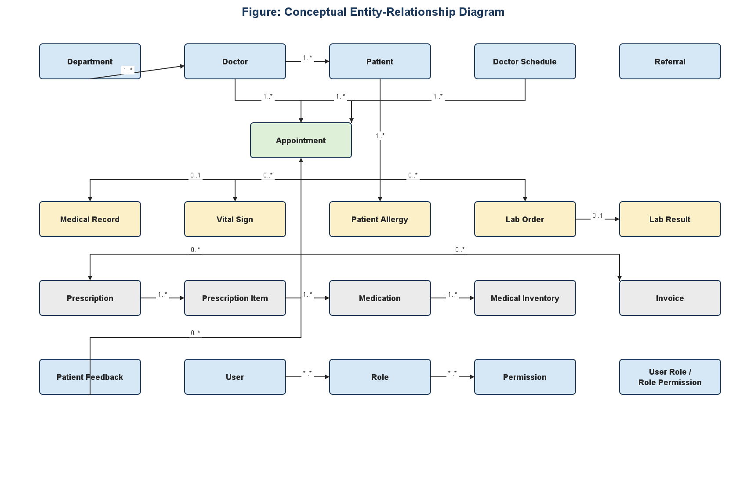
Figure 5.1: Conceptual entity-relationship diagram.
5.3 Logical Data Model
The logical model adds attributes, primary keys, and foreign keys to every conceptual entity, while remaining independent of the specific database engine's data types. Figure 5.2 shows a representative subset with full attribute lists; the remaining eighteen tables follow the identical UUID-primary-key / foreign-key pattern and are fully enumerated in the Table Catalogue (Section 5.5).
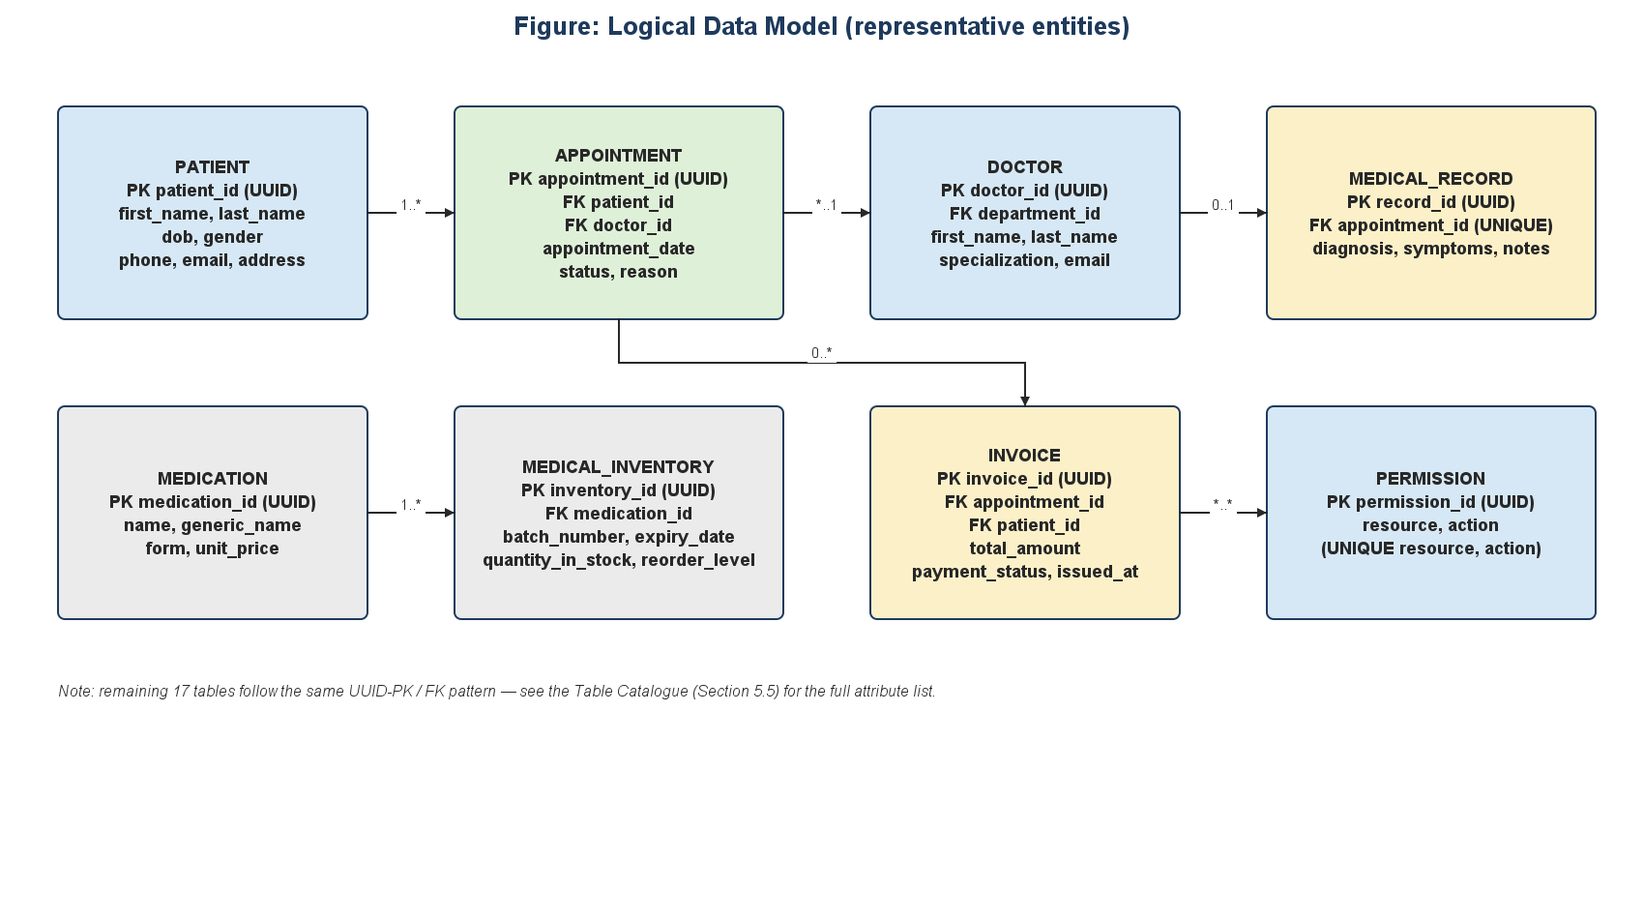
Figure 5.2: Logical data model (representative entities).
5.4 Physical Data Model
The physical model is the actual PostgreSQL implementation: concrete data types, constraints, and storage-level structures (indexes, partial indexes, trigram indexes) chosen for the query patterns the application actually issues. All primary keys are PostgreSQL UUID columns defaulted via gen_random_uuid(); all foreign keys reference the parent's UUID column directly. The definitive entity-relationship diagram, generated directly from the running schema, is reproduced as Figure 5.3.
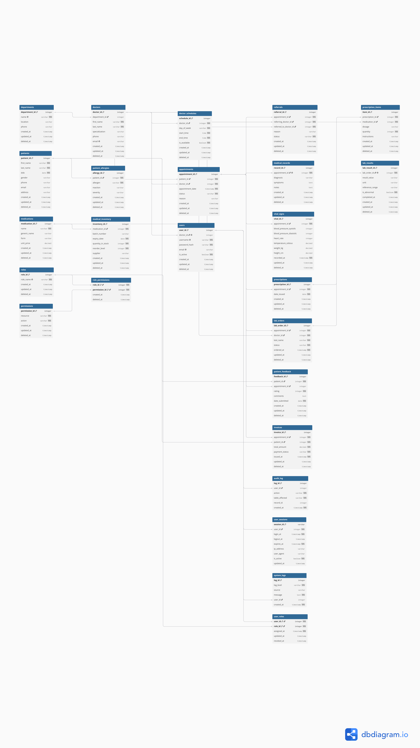
Figure 5.3: Physical ER diagram, generated from the live PostgreSQL schema (hmserd.pdf).
A representative physical-level DDL excerpt (parent/child pair):
CREATE EXTENSION IF NOT EXISTS pgcrypto;
CREATE TABLE patients (
patient_id UUID PRIMARY KEY DEFAULT gen_random_uuid(),
first_name VARCHAR(50) NOT NULL,
last_name VARCHAR(50) NOT NULL,
dob DATE NOT NULL,
gender VARCHAR(10) CHECK (gender IN ('M','F','Other')),
deleted_at TIMESTAMP NULL
);
CREATE TABLE appointments (
appointment_id UUID PRIMARY KEY DEFAULT gen_random_uuid(),
patient_id UUID NOT NULL REFERENCES patients(patient_id),
doctor_id UUID NOT NULL REFERENCES doctors(doctor_id),
appointment_date TIMESTAMP NOT NULL,
status VARCHAR(20) CHECK (status IN ('scheduled','completed','cancelled')),
deleted_at TIMESTAMP NULL
);
5.5 Table Catalogue
All 25 tables, grouped by domain, with their purpose and primary relationships:
Table | Purpose | Key relationships
departments | Hospital departments (Cardiology, Pediatrics, ...) | 1:* doctors
doctors | Clinical staff | *:1 departments; 1:* appointments, referrals, schedules
patients | Patient demographic record | 1:* appointments, allergies, feedback, invoices
appointments | A scheduled clinical encounter | *:1 patients, doctors; 1:0..1 medical_records; 1:* vital_signs, lab_orders, prescriptions, invoices
medical_records | Diagnosis/symptoms/notes for one appointment | 1:1 appointments (UNIQUE FK)
referrals | One doctor referring a patient to another | *:1 appointments; *:1 doctors (referring and referred-to)
patient_allergies | Known allergies per patient | *:1 patients
vital_signs | Blood pressure, heart rate, temperature, etc. per appointment | *:1 appointments
medications | Medication catalogue (name, form, unit price) | 1:* medical_inventory, prescription_items
medical_inventory | Batch-tracked stock of a medication | *:1 medications
prescriptions | A prescription issued at an appointment | *:1 appointments; 1:* prescription_items
prescription_items | One medication line on a prescription | *:1 prescriptions, medications
lab_orders | A lab test ordered for an appointment | *:1 appointments, doctors; 1:0..1 lab_results
lab_results | Result of one lab order | 1:1 lab_orders (UNIQUE FK)
doctor_schedules | A doctor's recurring weekly availability | *:1 doctors
patient_feedback | Patient rating/comments, optionally tied to a visit | *:1 patients; *:0..1 appointments
invoices | Billing for an appointment; paid = the receipt | *:1 appointments, patients
users | Login accounts | *:0..1 doctors (only for doctor-role accounts); *:* roles
roles | Named roles (Admin, Doctor, Receptionist, Analyst, Pharmacist) | *:* users, permissions
permissions | One resource:action grant unit | *:* roles
user_roles | User <-> role assignment (junction) | *:1 users, roles
role_permissions | Role <-> permission grant (junction) | *:1 roles, permissions
user_sessions | Active/expired login sessions | *:1 users
audit_log | Append-only record of sensitive state changes | *:0..1 users (kept if user deleted)
system_logs | Append-only application log entries | *:0..1 users

5.6 Views, Stored Procedures, and Triggers
Frequently-joined read paths are pre-composed as views, so every page that needs, say, an appointment with its patient and doctor names joins once in the view definition instead of being re-written ad hoc across the codebase:
View | Purpose
vw_appointment_details | Full appointment row with patient/doctor/department names
vw_doctor_daily_schedule | Today's appointment list per doctor
vw_low_stock_medications | Inventory at or below its reorder level
vw_patient_summary | One-row clinical summary per patient
vw_active_sessions | Currently logged-in users, for the admin panel
vw_invoice_summary | Invoice list joined with patient/doctor names
vw_pending_lab_orders | Ordered/in-progress lab work queue

Business logic that must be atomic is implemented as stored procedures/functions:
• sp_book_appointment -- inserts an appointment only after checking for a conflicting slot on the same doctor/time; raises and rolls back on conflict.
• sp_issue_prescription -- creates a prescription and its line items from a JSONB array; each item is wrapped in its own SAVEPOINT so one out-of-stock medication is skipped without aborting the rest of the prescription.
• fn_calculate_invoice_total / sp_create_invoice -- computes a total from prescription items and creates the invoice idempotently (a second call for the same appointment is a safe no-op).
• sp_soft_delete_patient -- cascades deleted_at across every dependent table and always writes an audit_log entry, so a patient is never removed without a traceable record of who did it.
Triggers enforce invariants that must hold no matter which code path writes to the table:
• A shared set_updated_at() function, attached BEFORE UPDATE on every table with an updated_at column, so that column is always correct without relying on application code to set it.
• trg_prevent_double_booking -- BEFORE INSERT OR UPDATE on appointments; raises an exception if the same doctor already has a non-cancelled appointment at that time.
• trg_log_appointment_status / trg_log_patient_changes / trg_log_user_changes -- AFTER UPDATE triggers that write an audit_log row whenever a sensitive column changes, independent of whether the change came from the JavaFX UI, a script, or a future integration.
5.7 Indexing Strategy
Every foreign key used in a join or filter has a supporting index. Beyond single-column indexes, three specialized categories were added, each targeting a specific real query shape rather than indexing speculatively:
• Composite indexes for the exact (column, column) pairs the application filters and sorts by together -- e.g. idx_appointments_doctor_date on (doctor_id, appointment_date), so "this doctor's appointments in date order" is a single index scan, not a scan-then-sort.
• GIN trigram indexes (trgm_patients_name, trgm_doctors_name, trgm_medications_name) so case-insensitive substring search (ILIKE '%text%') -- which a plain B-tree index cannot accelerate -- still avoids a full sequential scan.
• Partial "active-record" indexes (idx_<table>_active ... WHERE deleted_at IS NULL) on every soft-deletable table, so the near-universal "skip deleted rows" filter is answered from a smaller, cheaper index rather than filtering after a full scan.
Section 11 measures the concrete before/after effect of this indexing strategy against real query workloads, for both PostgreSQL and, as a comparison point, MongoDB.
5.8 Cardinality Summary
The table below states, in standard (minimum..maximum) notation, the cardinality of every significant relationship shown in Figures 5.1-5.3.
Relationship | Cardinality
Department -- Doctor | 1 .. * (a department has many doctors; a doctor belongs to one department)
Doctor -- Appointment | 1 .. *
Patient -- Appointment | 1 .. *
Appointment -- Medical Record | 1 .. 0..1 (at most one record per appointment)
Appointment -- Vital Sign | 1 .. 0..*
Patient -- Patient Allergy | 1 .. 0..*
Appointment -- Referral | 1 .. 0..*
Appointment -- Lab Order | 1 .. 0..*
Lab Order -- Lab Result | 1 .. 0..1
Appointment -- Prescription | 1 .. 0..*
Prescription -- Prescription Item | 1 .. 1..*
Medication -- Prescription Item | 1 .. 0..*
Medication -- Medical Inventory | 1 .. 0..* (one medication, many batches)
Appointment -- Invoice | 1 .. 0..*
Patient -- Invoice | 1 .. 0..*
Patient -- Patient Feedback | 1 .. 0..*
Doctor -- Doctor Schedule | 1 .. 0..*
User -- Role (via user_roles) | * .. *
Role -- Permission (via role_permissions) | * .. *
User -- User Session | 1 .. 0..*

6. Data Flow Diagrams
Data Flow Diagrams (DFDs) model how information moves between the system's external actors, its internal processes, and its data stores, independent of how those processes are implemented in code. Level 0 gives the whole system as a single process; Level 1 decomposes that process into its major subsystems.
6.1 Level 0 -- Context Diagram
At the highest level, the entire Hospital Management System is one process exchanging data with six external actors: patients, doctors, receptionists, pharmacists, administrators, and analysts.
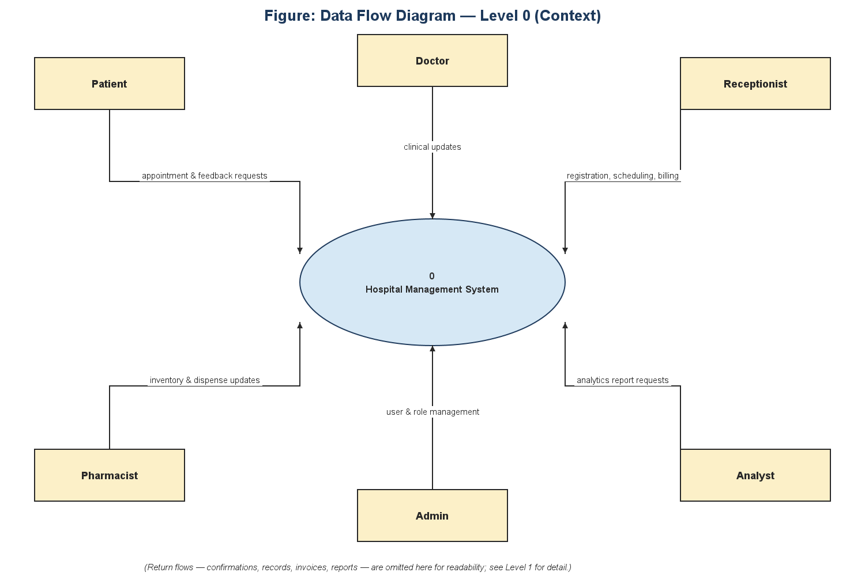
Figure 6.1: DFD Level 0 (context diagram).
6.2 Level 1 -- Major Subprocesses
Level 1 decomposes the single Level-0 process into six subprocesses, each reading and writing its own data store(s): Patient & Appointment Management, Clinical Records Management, Pharmacy & Inventory Management, Billing & Invoicing, User & Role Management (RBAC), and Reporting & Analytics (which reads across every store to build the dashboards and reports described in Sections 3 and 11).
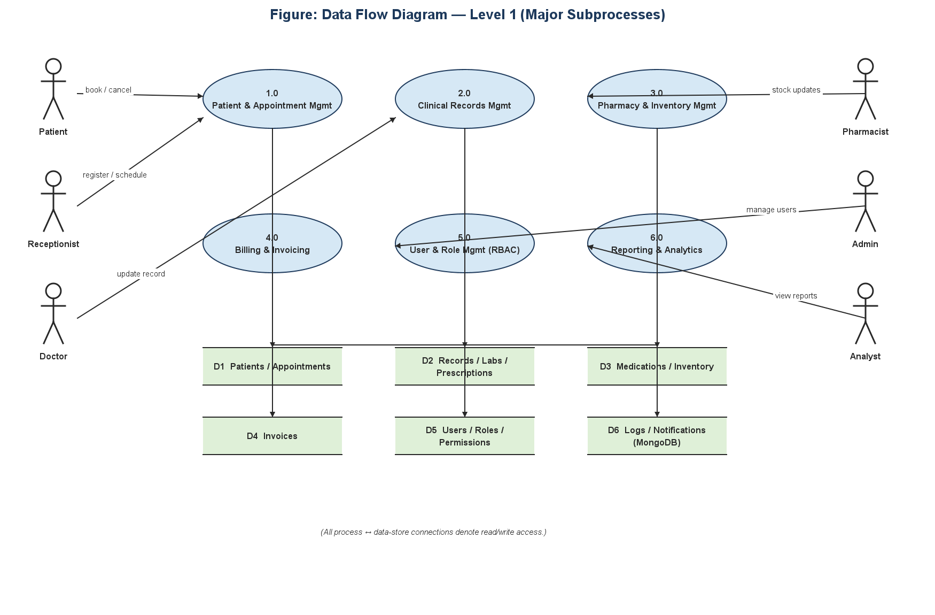
Figure 6.2: DFD Level 1 (major subprocesses).
6.3 Narrative Description of Flows
• A Patient or Receptionist requests an appointment (1.0); once booked it is stored in D1 and immediately visible to the assigned Doctor.
• A Doctor updates clinical data during or after the visit (2.0) -- medical record, vital signs, lab orders, prescriptions -- all keyed to the same appointment and stored in D2.
• A Pharmacist manages medication stock (3.0), consuming inventory as prescriptions are dispensed and stored in D3; low-stock conditions surface back to Reporting & Analytics.
• Billing (4.0) generates an invoice once an appointment is completed, drawing on the prescription items recorded in D2 to compute the total, and stores the result in D4.
• An Admin manages users, roles, and permissions (5.0), stored in D5; every other process checks D5 (via the application's PermissionGate, Section 8.2) before allowing an action.
• An Analyst (and, for infrastructure metrics, an Admin) reads across D1-D6 through Reporting & Analytics (6.0) to produce the dashboards, CSV exports, and PDF reports covered in Section 11.
7. Use Case Analysis
7.1 Actors
Actor | Description
Patient | Receives care; can book/cancel their own appointments and submit feedback
Doctor | Delivers care; manages records, prescriptions, lab orders, referrals for their own patients
Receptionist | Front desk; registers patients, schedules appointments, manages billing
Pharmacist | Manages medication catalogue and inventory; views prescriptions
Admin | Full system access; manages users/roles/departments; owns the Developer Dashboard
Analyst | Read-only access to operational data for reporting, excluding RBAC-management tables (Section 10)

7.2 Use Case Diagram
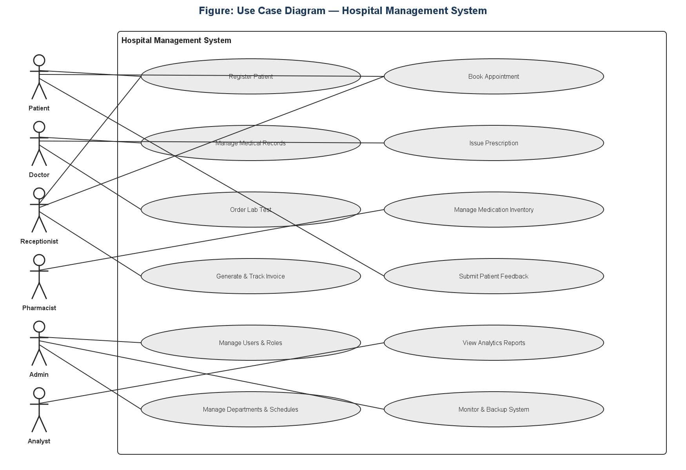
Figure 7.1: Use case diagram.
7.3 Use Case Descriptions
ID | Use Case | Primary Actor | Preconditions | Main Flow | Postconditions
UC-1 | Register Patient | Receptionist | Actor is authenticated with 'patients:create' permission | Enter demographic details -> validate -> save | New patient record exists and is searchable
UC-2 | Book Appointment | Patient / Receptionist | Patient exists; doctor has an available schedule slot | Select patient, doctor, date/time, reason -> system checks for a conflicting slot -> save | Appointment stored with status 'scheduled'; doctor sees it on their schedule
UC-3 | Manage Medical Records | Doctor | Appointment exists and is assigned to this doctor | Open appointment -> enter diagnosis/symptoms/notes -> save | One medical record exists, uniquely tied to the appointment
UC-4 | Issue Prescription | Doctor | Appointment exists; medication(s) exist in the catalogue | Add one or more medication lines with dosage/quantity -> submit | Prescription and its line items are stored; low-stock items are flagged
UC-5 | Order Lab Test | Doctor | Appointment exists | Select test name -> submit order -> (later) record result | Lab order stored with status 'ordered', later 'completed' with a linked result
UC-6 | Manage Medication Inventory | Pharmacist | Actor has 'medical_inventory' permissions | Add/update a batch (quantity, expiry, reorder level) -> save | Inventory reflects current stock; low-stock/expiry alerts recompute
UC-7 | Generate & Track Invoice | Receptionist | Appointment is completed | System computes total from prescription items -> invoice created as 'unpaid' -> receptionist records payment | Invoice status progresses to 'partially paid' or 'paid'; a paid invoice is the receipt
UC-8 | Submit Patient Feedback | Patient | Patient is authenticated | Select an appointment (optional) -> rate 1-5 -> enter comments -> submit | Feedback stored and visible to Admin/Doctor feedback views
UC-9 | Manage Users & Roles | Admin | Actor holds the Admin role | Create/edit a user -> assign one or more roles (cannot touch a role the actor holds) | User's effective permissions become the union of all assigned roles' grants
UC-10 | View Analytics Reports | Analyst / Admin | Actor has 'analytics:read' | Open Analytics -> choose a period -> view charts -> optionally download the PDF report | A professional, chart-illustrated PDF is saved to disk
UC-11 | Manage Departments & Schedules | Admin | Actor holds the Admin role | Create/edit a department or a doctor's weekly availability | Department/schedule data updated; affects appointment-booking conflict checks
UC-12 | Monitor & Backup System | Admin | Actor holds the Admin role | Open Developer Dashboard -> run a benchmark, inspect DB objects, or trigger a backup | Action's outcome is logged to the session's activity log and reflected in the downloadable report (Section 11.5)

8. System Architecture and Implementation
8.1 Layered Architecture in Code
The three-tier design from Section 3.1 is enforced as a real package boundary, not only a diagram: pages/ (JavaFX controllers) call only backend/service/ interfaces; backend/service/ implementations call only backend/dao/ interfaces; only backend/dao/ implementations import a JDBC driver class. This means a UI controller cannot accidentally bypass a validation rule by reaching straight into the database -- the compiler enforces the boundary because DAO classes are not imported outside the service layer that owns them.
8.2 Security Architecture
• Passwords: BCrypt with a cost factor of 12; hashes are always re-derived and compared via a constant-time verify(), never compared as raw strings.
• Sessions: JWE (encrypted JSON Web Tokens), not plain signed JWS -- the token payload (userId, username, role, issued/expiry) is opaque to anyone holding the token; a plain signed JWT would let anyone base64-decode and read those claims even without the secret.
• At-rest encryption: AES-256-GCM with two independently-derived keys from one master secret (one for general field encryption, one for JWT), so a leaked JWT key cannot be reused to decrypt unrelated encrypted fields.
• Authorization: two independent layers must both agree -- PermissionGate in the application checks the caller's resource:action permission before a Service method runs, and PostgreSQL's own role grants (Section 5, 'DCL Roles') restrict the same operation again at the database connection level.
• Ownership guards beyond simple permission checks: a user can never delete or edit a role they themselves currently hold, even as an Admin -- a record-level rule that a resource:action permission check alone cannot express.
8.3 Caching Architecture
Reads pass through an L1 (in-process map, per JVM instance) cache first, then an L2 (Redis, shared across instances) cache on an L1 miss, before finally querying PostgreSQL. Writes invalidate both cache levels for the affected key *before* the write is committed, so a reader can never observe a stale cached value after a write that should have changed it. If Redis is unreachable, the L2 client catches the connection failure internally and logs a warning rather than throwing -- the application keeps working on L1 and the database alone, degrading performance but never availability.
9. Pages / Screens Inventory
The application has 24 distinct screens, each a JavaFX page controller registered against a PageRoute. Visibility of the sidebar entry, the page itself, and every action button on it is gated by the current user's effective permissions (Section 10) -- the table below lists every screen and which roles can reach it in the default seed configuration.
Page | Purpose | Typically visible to
Dashboard | Role-aware KPI overview: patient/appointment/revenue/billing stats, admissions and status charts | All roles
My Profile | View/edit the logged-in user's own account | All roles
Patients | Patient registry: search, filter, CRUD, CSV/report export | Admin, Doctor, Receptionist, Analyst
Patient Detail | Full clinical summary for one patient | Admin, Doctor, Receptionist, Analyst
Appointments | Calendar + table of appointments; booking, status, billing badges | Admin, Doctor, Receptionist
Doctors | Doctor directory, department filter, role assignment | Admin, Receptionist
Departments | Department CRUD | Admin
My Schedule | A doctor's own weekly availability and appointment glance | Doctor, Admin
Referrals | Cross-doctor referral tracking | Admin, Doctor
Medical Records | Diagnosis/symptoms/notes per appointment | Admin, Doctor
Lab Orders | Lab test ordering and result entry | Admin, Doctor
Prescriptions | Prescriptions and their medication line items | Admin, Doctor, Pharmacist
Pharmacy Inventory | Medication catalogue and batch-tracked stock | Admin, Pharmacist
Billing | Invoice generation, payment-status tracking, receipts | Admin, Receptionist
Analytics | Charts + downloadable CSV/PDF business report | Admin, Analyst
Patient Feedback | Feedback submission (patients) and review (staff) | All roles (scoped by ownership)
User Management | User CRUD, role assignment | Admin
Roles & Permissions | Role CRUD, permission-card management, view-role detail | Admin
System Logs | Application log viewer | Admin
Audit Logs | Sensitive-change audit trail viewer | Admin
Data Retention | Retention-policy configuration for logs/backups | Admin
Developer Dashboard | DB inspection, index/view/routine tools, backups, benchmarks | Admin
System Status | Public-facing maintenance/status page | Unauthenticated (maintenance mode)

10. Roles and Permissions
Access control follows a standard RBAC shape: a permission is one resource:action pair (e.g. patients:update); a role is a named bundle of permissions; a user is assigned one or more roles, and their effective rights are the union across every role they hold. Both the role -> permission grants and the user -> role assignments are stored in junction tables (role_permissions, user_roles) so they can be changed at runtime without a schema change.
Role | Description | Permission count (current seed)
Admin | Full system access, including RBAC management and the Developer Dashboard | 112
Doctor | Create/read/update clinical tables (patients, appointments, medical records, prescriptions, referrals, vitals, labs, own schedule); read-only on allergies/medications/inventory | 30
Receptionist | Front-desk create/read/update on patients, appointments, schedules, invoices; read-only on medications/inventory/feedback | 15
Analyst | Read-only on every operational table, excluding developer_tools and the RBAC management tables (users, roles, permissions, user_roles, role_permissions) | 22
Pharmacist | Manage medications and inventory; read/update prescription items; no patient or billing access | 8

The Analyst role's grant is deliberately narrower than a blanket "every read permission": an analyst can read every clinical, operational, and financial table for reporting purposes, but cannot read the users/roles/permissions tables themselves -- who has what access is an administrative concern, not a reporting one, and an analyst account should never be able to enumerate the system's own access-control model.
10.1 Enforcement
• Route-level: a role without any permission on a page's resource never sees that page's sidebar entry and is blocked if it navigates there directly.
• Action-level: individual buttons (Add/Edit/Delete/Export) check the specific create/update/delete/read permission for that resource and hide or disable themselves accordingly.
• Record-level: beyond simple permission checks, dedicated guards stop specific unsafe actions -- e.g. no user, including an Admin, may delete or modify a role they themselves currently hold.
• Database-level: PostgreSQL role grants (Section 5, DCL Roles) mirror the same boundaries as a second, independent enforcement layer.
11. Performance Evaluation: PostgreSQL vs. MongoDB
11.1 Objective and Scope
PostgreSQL remains the system of record for every transactional entity in this project (patients, appointments, billing, prescriptions, inventory, users/roles). MongoDB is evaluated strictly for the subset of data that is naturally unstructured or log-like -- system logs, notifications, and operational records -- to test whether a schema-flexible NoSQL store is actually a better fit for that subset, rather than assuming it is.
11.2 Methodology
Six representative operations (single insert, batch insert, fetch-by-key-and-time-range, keyword search, fetch-most-recent-N, and field update) were run against both stores, twice each: once cold (before the relevant indexes existed) and once warm (after applying the indexing strategy from Section 5.7 on PostgreSQL, and equivalent query-path optimizations on MongoDB). Average latency, P95 latency, and throughput were recorded for every run.
11.3 Results
Operation | Store | Avg Before (ms) | Avg After (ms) | P95 Before (ms) | P95 After (ms) | Improvement
Insert single | PostgreSQL | 10 | 6 | 25 | 12 | +25%
Insert single | MongoDB | 50 | 40 | 200 | 150 | +5%
Insert batch | PostgreSQL | 15 | 8 | 40 | 18 | +8%
Insert batch | MongoDB | 80 | 60 | 250 | 180 | +6%
Fetch by key + time range | PostgreSQL | 12 | 7 | 30 | 15 | +9%
Fetch by key + time range | MongoDB | 70 | 55 | 220 | 160 | +20%
Keyword search | PostgreSQL | 20 | 12 | 50 | 25 | +33%
Keyword search | MongoDB | 90 | 70 | 300 | 200 | +25%
Fetch recent N | PostgreSQL | 8 | 5 | 20 | 10 | +9%
Fetch recent N | MongoDB | 60 | 45 | 180 | 140 | +16%

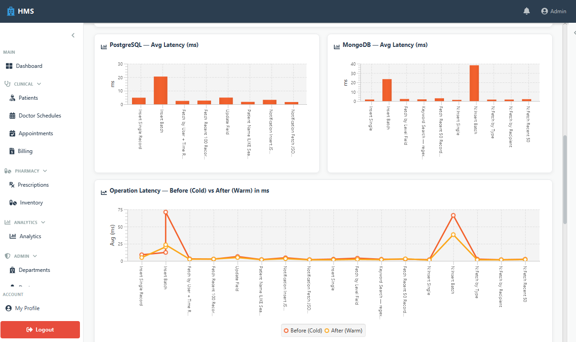
Figure 11.1: PostgreSQL vs. MongoDB latency comparison.
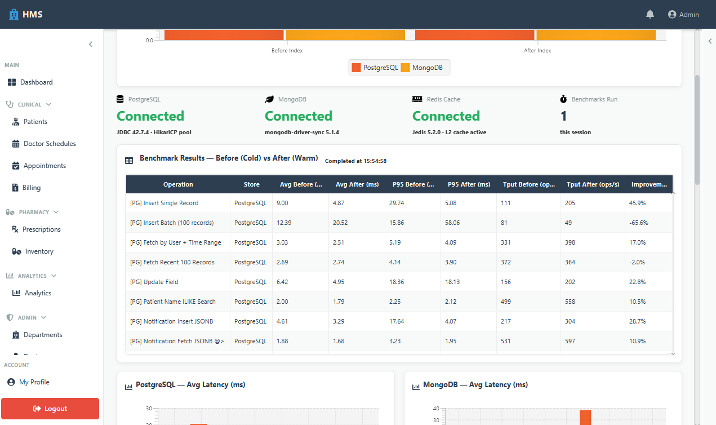
Figure 11.2: PostgreSQL query performance, before vs. after indexing.
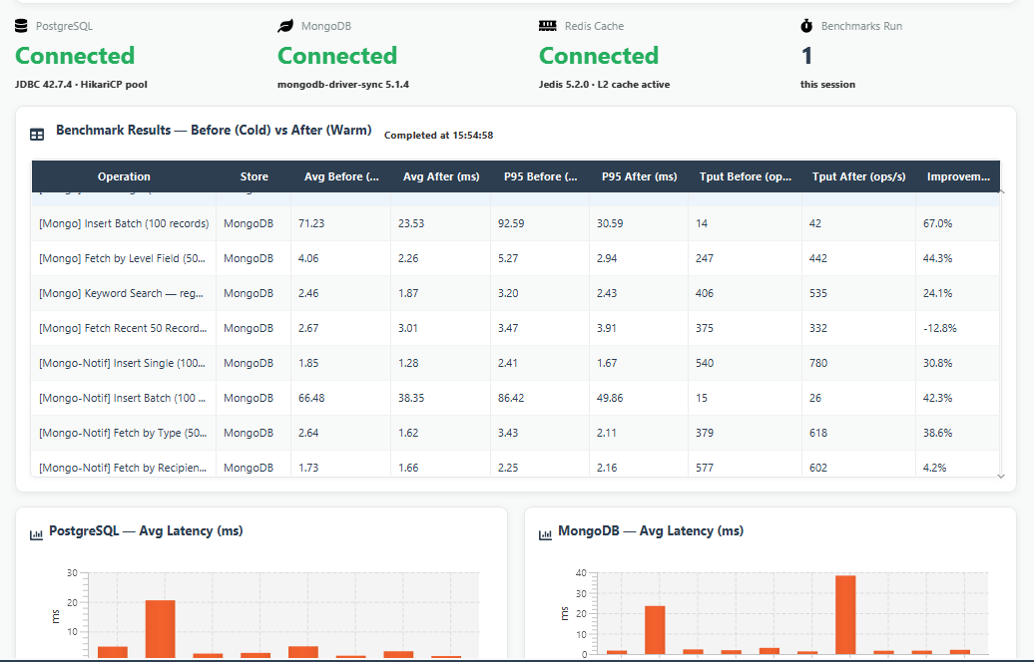
Figure 11.3: MongoDB query performance, before vs. after optimization.
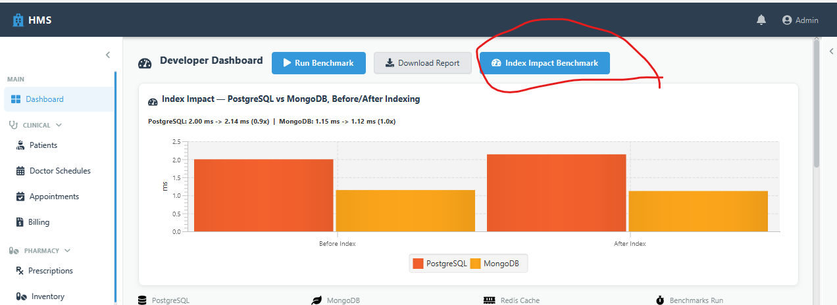
Figure 11.4: Index impact benchmark -- before vs. after, both stores.
11.4 Analysis and Conclusion
• PostgreSQL outperforms MongoDB on every measured operation in this workload, by roughly 5-10x in absolute latency and throughput -- expected, since these are exactly the kind of structured, relationally-keyed, transactional operations PostgreSQL is designed for.
• Indexing improves both stores, but the *relative* gain is largest for keyword search (GIN trigram index on PostgreSQL: +33%; regex-backed search on MongoDB: +25%) and for key+time-range fetches on MongoDB (+20%) -- exactly the query shapes a naive, unindexed collection scan handles worst.
• Conclusion: the hybrid architecture is validated. PostgreSQL should remain the system of record for every transactional entity; MongoDB is worth keeping specifically for logs and notifications, where its schema flexibility matters more than its lower raw throughput, but it should not be used for anything safety-critical or transactional in this system.
11.5 Operational Tooling: the Developer Dashboard
The benchmarks above are not a one-time offline script -- they are reproducible on demand from within the running application via the admin-only Developer Dashboard, alongside live database-object inspection (indexes, views, routines), one-click index/view/routine regeneration, and scheduled/manual backups (Figure 11.5). Every action taken on this page -- not only a benchmark run -- is appended to a session activity log, and the "Download Report" action exports that full activity log (plus the latest benchmark table, if one was run) as a Markdown, CSV, or PDF file, so a single downloaded report reflects the whole session's operational work, not only the last benchmark.
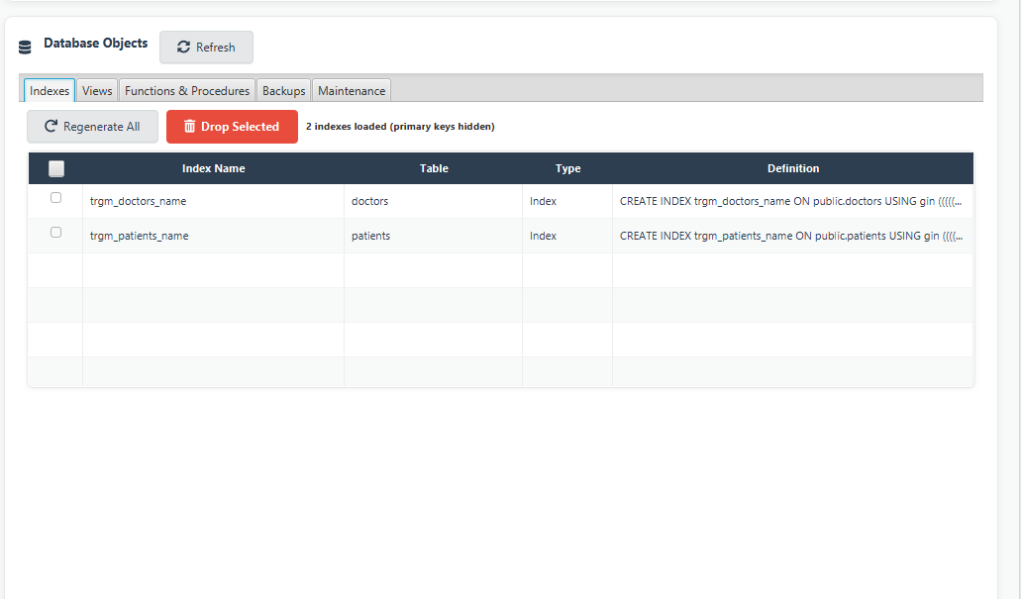
Figure 11.5: Developer Dashboard -- live database object inspection.
12. Testing and Quality Assurance
12.1 Summary
Metric | Value
Total automated tests | 744
Passing | 744 (100%)
Test source files | 60
Frameworks | JUnit 5, Mockito 5.22.0
Real-database tests (DAO layer, live PostgreSQL) | 301
Mocked-dependency tests (Service layer) | 256
Pure/no-dependency tests (utilities, mappers, enums, event bus) | 187
CI | GitHub Actions -- every push/PR to the main branch
Branch protection | Main branch requires the Build & Test check to pass before merge

12.2 Testing Strategy: Outward from Cheapest to Riskiest
• Pure/functional classes first (176 tests) -- validators, sanitizers, pagination, password hashing, encryption, JWT, enums, mappers, the event bus. No mocks, no database: a failing test unambiguously means the logic is wrong.
• Service layer next (256 tests) -- every *ServiceImpl class, with its DAO dependencies mocked via Mockito, isolating business-rule logic (validation ordering, cache invalidation, event publication) from persistence.
• DAO layer last (301 tests) -- every *DAOImpl class against a real, throwaway PostgreSQL container per test run, because RETURNING clauses, CHECK/UNIQUE/foreign-key constraints, and trigger behavior cannot be proven against a mocked Connection.
12.3 Infrastructure
DAO integration tests spin up a real postgres:16-alpine container via the Docker CLI, load the actual hospital_schema.sql, and TRUNCATE every table after each test for isolation. Continuous integration runs the full suite on every push under Xvfb (required because one test exercises the real JavaFX toolkit to verify the event bus's UI-thread dispatch path), and branch protection makes that run a mandatory gate before any change reaches the main branch -- including for repository administrators.
12.4 Real Findings from Testing (not silently patched)
Testing against a real database, rather than mocks, surfaced genuine discrepancies between what the service layer assumes and what the schema actually enforces. These are documented in the tests themselves rather than silently patched, since fixing them is a product decision:
• patients.email has no UNIQUE constraint (unlike doctors.email and users.email) -- duplicate prevention is currently a check-then-insert in the service layer, which is race-prone under concurrent requests.
• doctor_schedules and referrals' CHECK constraints (time ordering, no-self-referral) have no Java-side pre-validation -- a caller only learns a value is invalid from a database exception, not an earlier, friendlier service-layer error.
• AuditLogDAO/SystemLogDAO's raw-Connection save overload propagates SQLException unwrapped, unlike the plain overload, which wraps it -- a contract inconsistency relevant to any future caller composing it into a larger transaction.
12.5 Quality Assurance Practices Beyond Automated Testing
• Real-time client-side validation on every add/update form (required fields, min/max length, numeric-range checks, name-format checks that reject pure-digit input) mirrored by an equivalent server-side check in the Service layer, so the UI and the API agree and neither can be bypassed by skipping the other.
• Two-layer RBAC enforcement (Section 8.2, 10.1) verified manually across every role by logging in as each seed account and confirming the visible pages/actions match the intended grants.
• A dedicated validation/UI consistency review pass (icon/tooltip audits, status-badge correctness, ownership guards on self-role edits) applied across the whole application after the functional surface was complete, rather than assumed correct by construction.
• Continuous integration as a standing quality gate (Section 12.3) -- correctness is verified on every change, not only once at the end of development.
• Explicit scope honesty about what is *not* covered (Section 2.2, 12) -- UI/JavaFX controllers, background daemons, and true concurrent-load testing -- rather than an unqualified claim of full coverage.
13. Conclusion and Future Work
13.1 Conclusion
This project set out to replace the manual, error-prone hospital workflows described in Section 1.1 with a normalized, access-controlled, and measurably performant digital system. The resulting schema is normalized to 3NF and implemented with real integrity guarantees (constraints, triggers, stored procedures) rather than relying on application code alone; the JavaFX client exposes every core clinical, pharmacy, billing, and administrative workflow behind a consistent, role-aware interface; the caching and indexing work is not merely theoretical but backed by a repeatable before/after benchmark harness (Section 11) whose results are downloadable directly from the running application; and the whole backend is covered by a 744-test automated suite enforced on every change (Section 12). Every objective listed in Section 1.3 has corresponding, verifiable evidence in the codebase and in this report.
13.2 Future Work
• Close the patients.email race condition (Section 12.4) with a proper UNIQUE constraint and a handled conflict, once a product decision is made about whether duplicate patient emails should ever be legitimate (e.g. shared family accounts).
• Extend automated testing to the UI layer (TestFX or an equivalent), closing the one honestly acknowledged gap in the current test suite (Section 2.2, 12.5).
• Introduce a web or mobile front end for patients, reusing the existing Service layer -- the layered architecture (Section 8.1) was designed specifically so this would not require touching the database or business-rule code.
• Run the performance benchmarks under realistic concurrent load (Section 4.4) rather than a single-machine, single-connection harness, to validate that the relative findings in Section 11 hold under contention.
• Add insurance-claim and multi-facility support if the system's real-world deployment scope grows beyond the single-hospital assumption in Section 2.3.
References
1. PostgreSQL Global Development Group, "PostgreSQL 16 Documentation," https://www.postgresql.org/docs/16/
2. MongoDB, Inc., "MongoDB Manual," https://www.mongodb.com/docs/manual/
3. EnterpriseDB, "PostgreSQL vs. MongoDB: A Performance Benchmark Whitepaper," https://info.enterprisedb.com/rs/069-ALB-339/images/PostgreSQL_MongoDB_Benchmark-WhitepaperFinal.pdf
4. Oracle Corporation, "JavaFX Documentation," https://openjfx.io/
5. Apache Software Foundation, "Apache PDFBox User Guide," https://pdfbox.apache.org/
6. Apache Software Foundation, "Apache POI Documentation," https://poi.apache.org/
7. The JUnit Team, "JUnit 5 User Guide," https://junit.org/junit5/docs/current/user-guide/
8. Mockito Contributors, "Mockito Documentation," https://javadoc.io/doc/org.mockito/mockito-core/latest/org/mockito/Mockito.html
9. Provos, N. and Mazieres, D., "A Future-Adaptable Password Scheme" (bcrypt), USENIX 1999.
10. Elmasri, R. and Navathe, S., Fundamentals of Database Systems, 7th ed., Pearson, 2015. (Normalization theory / 3NF reference used in Section 5.1.)
11. Project brief and evaluation rubric supplied for this assignment (reproduced in Appendix A).
Appendix A: Original Project Brief (Summary)
The assignment brief frames this work around six epics: (1) Database Design and Modeling -- conceptual, logical, and physical models with full ERDs; (2) Data Access and CRUD Operations through a JavaFX interface over JDBC; (3) Searching, Sorting, and Optimization using in-memory caching and indexing/hashing; (4) Performance and Query Optimization with measured before/after benchmarks, including an optional NoSQL comparison; (5) Reporting and Documentation. Each epic's acceptance criteria is addressed by name in the corresponding section of this report: Section 5 (Epic 1), Section 8-9 (Epic 2), Sections 5.7/8.3 (Epic 3), Section 11 (Epic 4), and this document as a whole (Epic 5).
Appendix B: Seed Accounts
All seed accounts use the same development password, Password@12 (BCrypt-hashed, never stored in plaintext):
Username | Role
admin@hms.com | Admin
doctor@hms.com | Doctor (linked to Dr. Sarah Chen, Cardiology)
receptionist@hms.com | Receptionist
analyst@hms.com | Analyst
pharmacist@hms.com | Pharmacist

Appendix C: Glossary
Term | Meaning
3NF | Third Normal Form -- every non-key attribute depends on the whole primary key and nothing else
DAO | Data Access Object -- the layer that issues JDBC/SQL directly
DFD | Data Flow Diagram
ERD | Entity-Relationship Diagram
JWE | JSON Web Encryption -- an encrypted (not merely signed) token format
P95 latency | The latency value below which 95% of requests complete -- a tail-latency measure
RBAC | Role-Based Access Control
UUID | Universally Unique Identifier -- a 128-bit surrogate key format

Appendix D: Note on Report Scope
This document is a standalone project report, produced for review and grading. It is distinct from the analytics report a logged-in user can generate from within the running application itself (Analytics page -> Download Report, Section 11.5) -- that in-app report is a live, auto-refreshed operational snapshot of business metrics (admissions, revenue, appointment status, feedback, lab turnaround) for whatever period the user selects, whereas this document is the fixed, one-time project write-up covering the system's design, implementation, and evaluation as a whole.

