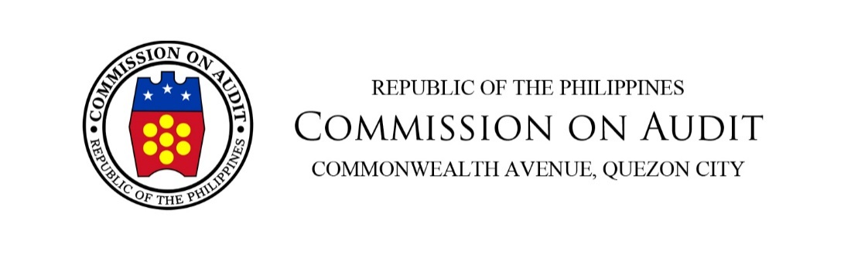
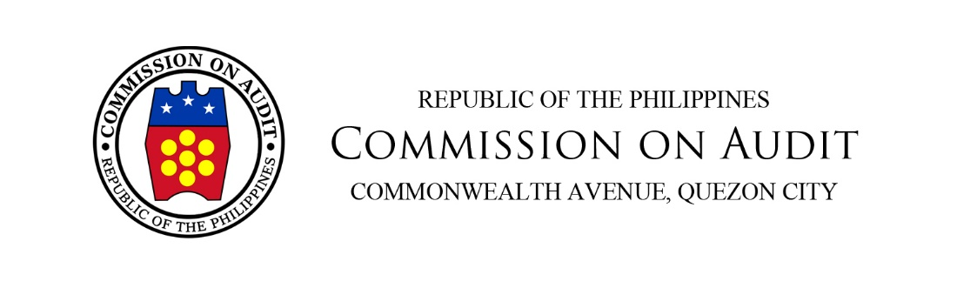
REGIONAL OFFICE NO. I
PROVINCE OF PANGASINAN
PROVINCIAL SATELLITE AUDITING OFFICE
Brgy. Rizal, San Carlos City

Office of the Supervising Auditor

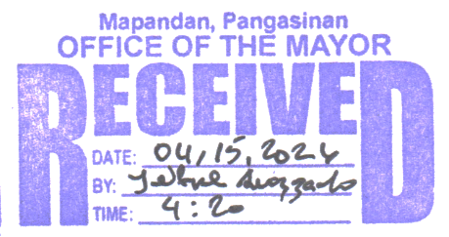
April 07, 2026

HONORABLE KARL CHRISTIAN F. VEGA
Municipal Mayor
Municipality of Mapandan, Pangasinan

Dear Mayor Vega:

Pursuant to Section 2, Article IX-D of the Philippine Constitution and Section 43 of Presidential Decree No. 1445, otherwise known as the Government Auditing Code of the Philippines, we transmit herewith the Management Letter on the Compliance Audit on the required allocation of the Local Disaster Risk Reduction and Management Fund (LDRRMF) under Section 21 of Republic Act (RA) No. 10121, otherwise known as the Philippine Disaster Risk Reduction and Management Act of 2010, of the Municipality of Mapandan, Pangasinan for the calendar year ended December 31, 2025.

The audit was conducted in accordance with the International Standards of Supreme Audit Institutions on compliance auditing (ISSAI 4000). Those standards require that we plan and perform the audit to obtain a reasonable basis for our conclusions.

The audit was carried out to ascertain compliance with Section 21of RA No. 10121 which aims to ensure the proper allocation of the LDRRMF in support of disaster risk reduction and management activities of the Municipality.

We request that the recommendations contained in the report be immediately implemented and we appreciate being informed of the action taken thereon within 60 days from receipt hereof pursuant to Section 100 of the General Provisions of General Appropriations Act of Fiscal Year 2025 (Republic Act No. 12116), using the Agency Action Plan and Status of Implementation form attached to the Management Letter to be submitted to the Audit Team.

We acknowledge the cooperation and support that Management extended to the Audit Team during the audit, which facilitated the completion of this report.


Very truly yours,

EVANGELINE R. PICAR
Supervising Auditor



Republic of the Philippines
COMMISSION ON AUDIT
Commonwealth Avenue, Quezon City

MANAGEMENT LETTER

on the

Compliance Audit on the Required Allocation of the Local Disaster Risk Reduction and Management Fund under Section 21 of Republic Act No. 10121, otherwise known as the Philippine Disaster Risk Reduction and Management Act of 2010

of the

MUNICIPALITY OF MAPANDAN
Province of Pangasinan

For the Year Ended December 31, 2025

REGIONAL OFFICE NO. I
PROVINCE OF PANGASINAN
PROVINCIAL SATELLITE AUDITING OFFICE
Brgy. Rizal, San Carlos City

Office of the Auditor – Audit Team No. 7

April 06, 2026

HON. KARL CHRISTIAN F. VEGA
Municipal Mayor
Municipality of Mapandan
Province of Pangasinan

Management Letter on the Compliance Audit on the Required Allocation of the Local Disaster Risk Reduction and Management Fund under Section 21 of Republic Act No. 10121, otherwise known as the Philippine Disaster Risk Reduction and
Management Act of 2010, of the Municipality of Mapandan, Pangasinan
For the Calendar Year Ended December 31, 2025

Dear Mayor Vega,

- We have audited the compliance of the Municipality of Mapandan, Pangasinan on the required allocation of Local Disaster Risk Reduction and Management Fund (LDRRMF) under Section 21 of Republic Act (RA) No. 10121, otherwise known as the Philippine Disaster Risk Reduction and Management Act of 2010, covering the period January 1, 2025 to December 31, 2025.

- We conducted our audit in accordance with the International Standards of Supreme Audit Institutions on compliance auditing (ISSAI 4000). Those standards require that we plan and perform the audit to obtain a reasonable basis for our conclusions.

- The audit was conducted to ascertain compliance with Section 21 of RA No. 10121 or the "Philippine Disaster Risk Reduction and Management Act of 2010.”

- Section 21 of RA No. 10121 provides that:

[N]ot less than five percent (5%) of the estimated revenue from regular sources shall be set aside as the LDRRMF to support disaster risk management activities such as, but not limited to, pre-disaster preparedness programs including training, purchasing life-saving rescue equipment, supplies and medicines, for post-disaster activities, and for the payment of premiums on calamity insurance…
Of the amount appropriated for LDRRMF, thirty percent (30%) shall be allocated as Quick Response Fund (QRF) or stand-by fund for relief and recovery programs in order that situation and living conditions of people in communities or areas stricken by disasters, calamities, epidemics, or complex emergencies, may be normalized as quickly as possible...

- We wish to bring to your attention our audit observations and recommendations which were communicated through Audit Observation Memorandum to the concerned officials of the Municipality. Their responses were incorporated in this Management Letter, where appropriate.

Basis for the Conclusion

- The Municipality did not fully allocate the required LDRRMF for CY 2025 due to the improper exclusion of the estimated receipts from Economic Enterprises amounting to ₱7,600,000.00 from the computation of regular income, resulting in an under-allocation of ₱380,000.00. Consequently, the mandatory allocations for the QRF of 30 percent and the remaining 70 percent for Mitigation Fund were likewise under-allocated by ₱114,000.00 and ₱266,000.00, respectively.

Conclusion on the Subject Matter

- Based on the audit work performed, the Audit Team found that, due to the significance of the matter noted in the Basis for the Conclusion paragraph, the required allocation of the LDRRMF of the Municipality of Mapandan for Calendar Year 2025 is not in compliance, in all material respects, with Section 21 of RA No. 10121.

Detailed Observations and Recommendations

- The Municipality was unable to fully allocate the required LDRRMF for CY 2025 due to the improper exclusion of the estimated receipts from Economic Enterprises amounting to ₱7,600,000.00 from the computation of regular income which is not in accordance with Paragraphs 1 and 2, Section 21 of RA No. 10121, resulting in an under-allocation of ₱380,000.00. Consequently, the mandatory allocations for the QRF of 30 percent and the remaining 70 percent for Mitigation Fund were likewise under-allocated by ₱114,000.00 and ₱266,000.00, respectively, thereby diminishing the Municipality’s financial capacity and readiness to implement disaster prevention, mitigation, preparedness, response, and rehabilitation programs.

- Paragraphs 1 and 2, Section 21 of RA No. 10121 provide that:

[N]ot less than five percent (5%) of the estimated revenue from regular sources shall be set aside as the LDRRMF to support disaster risk management activities such as, but not limited to, pre-disaster preparedness programs including training, purchasing life-saving rescue equipment, supplies and medicines, for post-disaster activities, and for the payment of premiums on calamity insurance…

Of the amount appropriated for LDRRMF, thirty percent (30%) shall be allocated as Quick Response Fund (QRF) or stand-by fund for relief and recovery programs in order that situation and living conditions of people in communities or areas stricken by disasters, calamities, epidemics, or complex emergencies, may be normalized as quickly as possible...

- As provided above, the LDRRMF shall cover the 30 percent lump-sum allocation for QRF and the 70 percent allocation for Mitigation Fund to support disaster risk reduction and management activities of the local government units (LGUs).

- To remove ambiguity in the computation of the LDRRMF, the Bureau of Local Government Finance (BLGF), through Memorandum Circular No. 002-2019 dated January 3, 2019, categorically clarified that the basis for computing the five percent LDRRMF shall be the estimated revenue from regular sources, and not the actual collections thereof.

- Further, the Local Government and Regional Coordination Bureau of the Department of Budget and Management (LGRCB-DBM), in its letter dated November 16, 2018, expressly states that references to BLGF Memorandum Circular No. 16-2015 were intended solely to guide LGUs in identifying which potential revenues may be classified as “regular,” and not to deviate from the statutory basis of computation prescribed under RA No. 10121 and other applicable rules and regulations.

- In addition, Annex D of Local Budget Memorandum (LBM) No. 90 dated June 13, 2024, which governs the preparation of the FY 2025 Annual Budgets of LGUs, explicitly includes receipts from Economic Enterprises as part of regular income that shall be considered in the computation of the LDRRMF, as presented below.

Regular Income
A. Local Sources
1. Tax Revenue
a. Real Property Tax (RPT)
i. Basic RPT
b. Business Tax
c. Other Local Taxes
Total Tax Revenue
2. Non-Tax Revenue
a. Regulatory Fees
b. Service/ User Charges
c. Receipts from Economic Enterprise
d. Other Receipts
Total Non-Tax Revenue
Total Local Sources
B. External Sources
1. Shares from National Tax Allotment (formerly Internal Revenue Allotment)
2. Share from GOCCs (PAGCOR and PCSO)
3. Other Shares from National Tax Collections
a. Share from Ecozone
b. Share from EVAT
c. Share from National Wealth
d. Share from Tobacco Excise Tax
4. PhilHealth Payments
TOTAL REGULAR INCOME

- Examination of the CY 2025 Annual Budget of the Municipality disclosed that the estimated income from Economic Enterprises amounting to ₱7,600,000.00 was excluded from the computation of regular income used as the basis for computing the five percent LDRRMF. As a result, the LDRRMF was computed based on regular income of only ₱186,180,162.24 instead of ₱193,780,162.24. Consequently, the required five percent LDRRMF was understated, resulting in an under-allocation of ₱380,000.00, as presented below.

Particulars | Per Annual Budget (₱) | Should be (₱) | Over  (Under) (₱)
Total Tax Revenue | 7,100,000.00 | 7,100,000.00 | 0.00
Total Non-tax Revenue | 6,391,000.00 | 6,391,000.00 | 0.00
Share from National Tax Allocation | 171,997,074.00 | 171,997,074.00 | 0.00
Total Income from Economic Enterprises | - | 7,600,000.00 | (7,600,000.00)
Tobacco Excise Tax (Supplemental Budget No.1) | 692,088.24 | 692,088.24 | 0.00
Total | 186,180,162.24 | 193,780,162.24 | (7,600,000.00)
Multiply by: | 5% | 5% | 5%
LDRRMF | 9,309,008.11 | 9,689,008.11 | (380,000.00)

- Further, due to the understated LDRRMF, the mandatory allocations for the QRF and Mitigation Fund were likewise understated by ₱114,000.00 and ₱266,000.00, respectively, computed as follows:

Particulars | QRF(₱) | Mitigation  Fund (₱)
Under-allocation of LDRRMF | 380,000.00
Multiply by: | 30% | 70%
Under-allocation | 114,000.00 | 266,000.00

- The foregoing condition is not in accordance with Paragraphs 1 and 2, Section 21 of RA No. 10121.

- The deficiencies were attributable to the inability of the Municipality to exercise due diligence and ensure strict compliance with established budgetary laws, rules, and regulations, particularly the mandatory inclusion of estimated income from Economic Enterprises as part of regular income in the computation of the LDRRMF.

- The officials concerned misapplied the provisions of applicable budget guidelines and were unable to consider relevant clarificatory issuances of the BLGF and the DBM, which categorically provide that all estimated revenues classified as regular income shall form part of the basis for computing the five percent LDRRMF.

- It should be noted that the approval of the Annual Budget of the Municipality by the Sangguniang Panlalawigan does not validate nor cure the deficiency, as compliance with statutory requirements on budget preparation and fund allocation rests primarily with the Municipal Government officials who prepared, reviewed, and recommended the budget. Reliance on post-approval review does not relieve Management of accountability for ensuring that the budget fully complies with existing laws, rules, and regulations.

- As a result of the improper computation of the LDRRMF, the Municipality was deprived of funds legally mandated for disaster risk reduction and management activities, leading to the underfunding of programs for disaster preparedness, prevention, mitigation, response, and recovery. Consequently, its financial capacity and readiness to effectively respond to disasters and emergencies were diminished.

- We recommended that Management direct the Municipal Budget Officer and the Municipal Disaster Risk Reduction and Management Officer and other concerned officials to strictly observe and properly apply existing laws, rules, and regulations in determining regular income as basis in the computation of the LDRRMF, particularly the mandatory inclusion of estimated income from Economic Enterprises, in the preparation of future annual budgets.

- Management acknowledged the audit recommendation and assured strict compliance in determining regular income as basis in the computation of LDRRMF as prescribed by law for accurate and complete allocations. Particular attention will be given to the proper inclusion of estimated income from Economic Enterprises in the preparation of future annual budgets to ensure accurate and complete allocations for disaster risk reduction and management initiatives.

Status of Implementation of Prior Year’s Audit Recommendations

- No compliance audit was conducted in the previous year.

Acknowledgment

- We wish to express our appreciation to the Management and staff of the Municipality of Mapandan, Pangasinan for the cooperation and assistance extended to the Audit Team during the audit.

- We request that appropriate actions be undertaken on our audit recommendations and that we be informed of the actions taken thereon by accomplishing the attached Agency Action Plan and Status of Implementation (AAPSI) form and submit the same (in hard and electronic copies) within 60 days from receipt hereof.

Very truly yours,

COMMISSION ON AUDIT
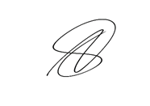
By:

NIXON E. DE NIEVA
Audit Team Leader

CC: The Regional Director, DILG Regional Office No. I, City of San Fernando, La Union
The Regional Director, BLGF Regional Office No. I, City of San Fernando, La Union
The Regional Director, DBM Regional Office No. I, City of San Fernando, La Union
The Presiding Officer, Sangguniang Bayan, Municipality of Mapandan, Pangasinan

MUNICIPALITY OF MAPANDAN
Province of Pangasinan

AGENCY ACTION PLAN AND
STATUS OF IMPLEMENTATION
Compliance Audit Observations and Recommendations
For the Calendar Year 2025
As of ____________________

Ref. | Audit Observations | Audit Recommendations | Agency Action Plan |  |  |  |  | Status of Implementation |  | Reason for Partial/Delay/ Non-Implementation, if applicable |  | Action Taken/ Action to be Taken
Ref. | Audit Observations | Audit Recommendations | Action Plan | Person/Dept. Responsible | Target Implementation Date
 |  |  |  |  | From | To

Agency Sign off:

______________________________ ____________
Name and Position of Agency Office Date

Note: Status of Implementation may either be (a) Fully Implemented, (b) On-going, (c) Not Implemented, (d) Partially Implemented or (e) Delayed

