Introduction to Prosthetics
Course Calendar Syllabus
APPH 6975
FALL 2012

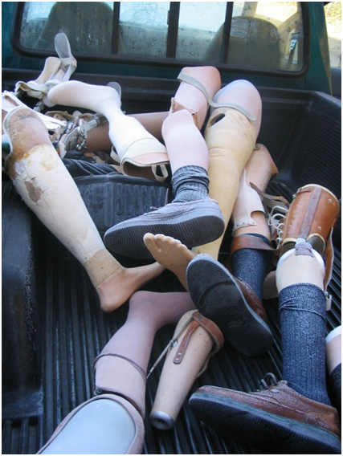

Master of Science in Prosthetics and Orthotics Education Program
School of Applied Physiology
Georgia Institute of Technology
Introduction to P&O Processes and Clinical Methods
APPH 6975
Time: To be determined

Course Instructor
Robert Kistenberg, MPH, CP, FAAOP
MSPO Program
School of Applied Physiology
Georgia Institute of Technology
robcp@gatech.edu
cell: 404 325 2800
office: 404 894 6269
Office Hours: by appointment

Location of Class:
a.) Lecture: 555 14th Street Room 1529

Relationship to the MSPO Curriculum: This course will develop the student’s theoretical knowledge about prostheses which will be fundamental when applied in subsequent core courses in Prosthetics specifically: APPH 6984 Transtibial Prosthetics, APPH 6985 Transfemoral Prosthetics & APPH 6981 Upper Limb Prosthetics

Honor Code: In addition to information about the Honor Code at Georgia Tech, http://www.honor.gatech.edu, now is a good time to familiarize yourselves with the American Board for Certification’s Code of Professional Responsibility. http://www.abcop.org/assets/pdf/code_rules_complaint.pdf

Honor Pledge: All students are required, when requested, to attach the following statement to any material turned in for a grade in any course in the MSPO education program. “On my honor, I pledge that I have neither given nor received inappropriate aid in the preparation of this assignment.”

Course Description:
This course introduces the history of artificial limbs and utilizes and evolutionary approach to expose the students to the different socket designs, materials, interfaces, suspension and components used in making contemporary prostheses.

Course Objectives: At the conclusion of this course, the student will be able to:

- Recount the evolution of prosthetics
- Distinguish between different socket designs, prosthetic limb structures and components
- Identify the different mechanisms by which prostheses are suspended and when these suspension mechanisms are indicated and contraindicated
- Differentiate between prosthetic feet, their categories, indications and contraindications
- Identify different classes of prosthetic liners, describe their properties as well as their indications and contraindications

Performance Measurement (i.e. Grading)
The course grade will be determined according to the following point totals (subject to change).

Course Grade | Percentage
A | 90-100%
B | 80 – 90%
C | 70 – 80%
D | 60 – 70%
F | < 60%

Name of Assignment | Total
Midterm Exam | 100
Final Written Exam | 100
Final Practical Identification Exam | 50
Quizzes 4 @ 25 | 100
Student Presentations | 50
Total | 400

Student Presentation

Students will be required at the end of the semester to present on a topic related to prosthetics. The presentation will be powerpoint and must be submitted to the course instructor 2 days prior to the presentation due date. Presentations will be 10 – 12 minutes in length and will be graded on verbal presentation, content, adherence to time requirements and professionalism.

MAIN TEXTBOOKS:
Smith, D., Bowker, G., Michael, J: Atlas of Amputations and Limb Deficiencies Surgical, Prosthetic and Rehabilitation Principles. Rosemont, Ill. 3rd ed. AAOS (2004)

Lusardi MM, Nielsen CC. Orthotics and Prosthetics in Rehabilitation. 2nd Edition. Boston: Butterworth Heinemann; 2007. ISBN 0-7506-7479-2

ADDITIONAL READINGS:

Articles and reference materials will be posted throughout the semester.

Master of Science in Prosthetics and Orthotics Program
School of Applied Physiology
Georgia Institute of Technology
APPH 6975 Introduction to Prosthetics
Fall 2013 Course Calendar
Week | Date | Time | TOPIC | Assignments
1 |  |  | Class Introduction; Lec: History of Prosthetics | Atlas Ch 1: History of Amputation surgery and prosthetics
2 |  |  | Lec: Lower Extremity Socket & Shank Evolution | Atlas Ch 39: TT Amputation Prosthetic Management 503 – 508,  Ch 43: TF Amputation Prosthetic Management 541 - 551
3 |  |  | Lec: Lower Extremity Socket Materials | Lusardi Ch 2: Materials and Technology
4 |  |  | Lec: Lower Extremity Suspension Mechanisms | Atlas Ch 33: Prosthetic Suspension and Components 409 - 415,  Ch 43: TF Amputation Prosthetic Management 551 – 555
5 |  |  | Lec: Prosthetic Feet | Atlas Ch 33: Prosthetic Suspension and Components 415 - 420,  Lusardi Ch 24: Prosthetic Feet
6 |  |  | Lec: Prosthetic Knees | Atlas Ch 33: Prosthetic Suspension and Components 420 - 425,  Lusardi Ch 28 : TF Prostheses 748 - 753
7 |  |  | MIDTERM EXAM
8 |  |  | Lec: Upper Extremity Prosthetics | Atlas: Ch 14: Partial Hand Amputation: Prosthetic Management
9 |  |  | Lec: Upper Extremity Socket Designs
10 |  |  | Lec: Terminal Devices, Wrists and Elbows | Atlas Ch 9: Body Powered Components
11 |  |  | Lec: Harnessing and Cabling | Atlas Ch 10: Harnessing and Controls
12 |  |  | Lec: Upper Extremity Suspension Mechanisms
13 |  |  | Lec: Upper Extremity Control Mechanisms | Atlas Ch 12: Control of Limb Prostheses
14 |  |  | Lec: The Future of Prosthetics
15 |  |  | Student Presentations
16 |  |  | FINAL EXAM

