Georgia Institute of Technology
School of Modern Languages
Arabic Language

Arabic Art, Science, Technology and Culture

Class 2301-D

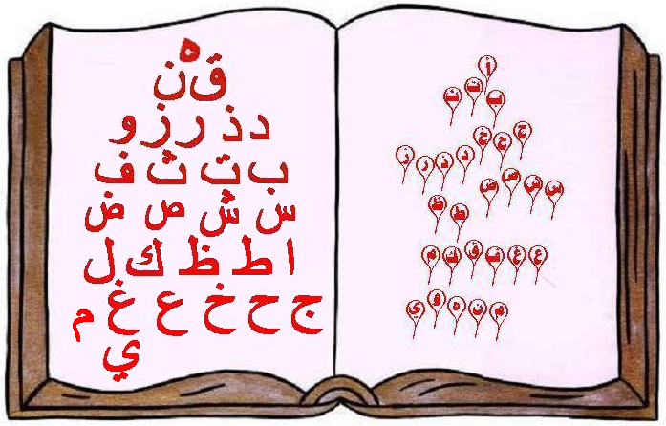
ARBC 2301-G
Arab Art, Science, Technology and Culture during the Renaissance period
(700-1300AD)
Instructor:
Ragheda NasserEddine  Email: ragheda.eddine@modlangs.gatech.edu  Office: Swann 232 Tel: (404) 385-7276 | 
Course Text books & Materials:
Required books:
- Lewis, Bernard: The Arabs in History, Oxford University press,  ISBN 0-190280310-7  - Al-Hassan, Ahmad Y. and Donald Hill: Islamic Technology: An illustrated history, Cambridge: Cambridge Univ. Press, 1986. (Engineering bookstore)  Recommended books:  - Lewis, Bernard ed. Islam and the Arab world:: Faith, People, Culture , London, Thames and Hudson: 1992. (Reserve, GT Library)  - Turner, Howard R.: Science in Medieval Islam, An Illustrated Introduction, University of Texas press, Austin. (Reserve, GT Library)  - Hitti, Philip: Islam a way of life: University of Minnesota press, Minneapolis. (Reserve, GT Library)  Other Helpful books:  - Ahmed M. Mukarram and Sayed Muzaffar Husain: Encyclopedia of Islam, 2005.  - Brice, William C.: An Historical Atlas of Islam, 1981.  - Al Faruqi, Ismail R. and Lois Lamya: The cultural Atlas of Islam.  - Savory, M. Editor: Introduction to Islamic Civilization.  - Hourani, Albert: A history of the Arab Peoples, Faber & Faber 1991.ISBN:0-571-16663-6  Various DVDs and documentaries.  - We will be using T-Square to post Syllabus and announcements.  - We will be using the e-mail feature at Oscar and T Square to send messages to the students. | 
Course Description:
This course is devoted to study and research the Arabs Science and technology during the Arabs’ golden age or the Renaissance period (700- 1300 AD) based on the Arabs translating and developing the Greek science, philosophy, and mathematics. The impact of these inventions and contributions on modern Science and Technology will be among the issues studied.
In this course we will identify the major elements of the Arabic Renaissance, the accomplishments of the Arabic Scientists, Philosophers and Scholars (Olamaa) to the main fields of Science, Mathematics, Technology, Medicine, Astronomy and Art, via research, discussions and visual study. The course begins by developing an understanding of the identity of the Arabs and their culture, before and after the rise of Islam, including the Renaissance period.
We will discuss and analyze chosen articles, documents, books, documentaries and movies that trace and examine the Arab contribution to modern science and technology. We will look specifically at major examples of Arab science and technology. At the end of this course the students will prepare and present a research project, focusing on the elements of the Arabic culture and the major Arab accomplishments and discoveries in the different fields of Science, Art and Technology.

Main objectives of ARB-2301:

ML PERFORMANCE GOAL #1: PROFESSIONAL COMMUNICATION
ML Learning Outcome 1 : Demonstrate oral and aural proficiency in the target language
ML Learning Outcome 2: Demonstrate effective presentation skills in the target language

ML Learning Outcome 3: Demonstrate writing proficiency in the target language

ML Learning Outcome 4:

Demonstrate proficiency in comprehension of authentic written texts in the target Language
ML PERFORMANCE GOAL #2: INTERCULTURAL SKILLS AND KNOWLEDGE
ML Learning Outcome 5: Demonstrate in-depth knowledge of a specific target-language country or region | Students will successfully analyze the Arab culture and major accomplishments in the fields of Science, Math, Art and Technology during the period (700-1200AD)
ML Learning Outcome 6:
Demonstrate the ability to analyze an issue from target-culture perspective(s)
ML Learning Outcome 7:  Demonstrate critical reflection on cultural complexity and context | Students will critically analyze their own lack of knowledge about the constructive role of Arabs on  Modern Science, Math, Art and Technology.

Main Goals:
The main goals of this course are:
- To identify the identity of Arabs and the components and characteristics of the Arabic culture..
- To explore the major Arab accomplishments in Science, Technology Mathematics, Astronomy, Medicine, Philosophy, Music, Architecture and Art.
- To indicate the constructive role of Arabs on modern sciences, technology and life today.
Course Requirements:
You are expected to:
- Attend class regularly well prepared.
- Complete all assignments and class functions required on due time.
- Participate in all class work and activities including discussions, analysis, presentations, taking notes and elaborating on the main ideas and information discussed in class.
Evaluation:
You will be evaluated by the following means, which make up the listed percentage of your final grade:
Attendance …………………………………………………………………………. 15%
Participation & Performance …………………...………………………………. 15%
Papers ………………….……………………….…………………………………. 30%
Final Exam (Paper 20% Presentation 20%)..…………………………………..…40%
Your class performance will be graded daily based on the following criteria:
15.0 = Exceptional and impeccable performance in every aspect.
14.0 = Application of what was required as assignment.
13.0 = Excellent performance in all discussions and activities.
12.0 = Moderate performance in all discussions and activities.
11.0 = Occasional performance of activities.
10.0 = Failure of performance of activities.
0.0 = Unexcused absence or no participation in class activities.
Tardiness results in the loss of points (e.g. each 5 minutes late = .5 reduction)
The following explains the grade distribution of class participation portion of the student’s grade. The instructor will monitor class participation daily and record it weekly.
The “A” student  - initiates and maintains interaction with fellow students and the instructor  - shows leadership in class discussions and small group activities  - shows preparedness for class every day  - tries to elaborate on answers,  The “B” student  - shows willingness to participate  - cooperates fully in discussions / group activities  - answers readily when called upon  - elaborates somewhat on answers | The “C” student  - participates more passively than actively  - is a follower more than a leader  - is often unprepared for class  - gives slightly more than one-word answer  The “D” student  - participates grudgingly  - hardly contributes anything to class or small group activities  - does not prepare for class  - speaking is limited to one-word answers
The “F” student
- refuses to participate in class activities
- is disruptive (prevents others from hearing, etc.)
- is always unprepared for discussion
- does not speak as participate in class
Grading Policy:
Students in this class are expected to abide by the Georgia Tech Honor Code and avoid any instances of academic misconduct, including but not limited to:
- Processing, using, or exchanging improperly acquired written or oral information in the preparation of a paper
- Substitution of material that is wholly or substantially identical to that created or published by another individual or individuals.
- False claims of performance or work that has been submitted by the student.
  - Attendance and Late Arrivals: You are allowed to take three (3) absences without questions. For example, you might use them in such cases when you become sick or have to go to a job interview. If you have 4 absences or more, you will get (0) points for any class you have missed starting at the fourth absence regardless of the reasons. Penalty will be charged for late arrivals in class (0.5 points per 5 minutes.) However, extra credits will be awarded to students who have less than 3 absences.
0 absences = 2% extra credit of your final grade
1 absence = 1.5% extra credit of your final grade
2 absences = 1% extra credit of your final grade
3 absences or more = 0% extra credit

- Missing the Deadlines of turning in papers and performing presentation: It is your responsibility to turn in all papers on time as indicated on your semester schedule or as indicated by your instructor. There may be no individual warning about your missing deadlines, etc. No credit will be given for any paper turned in late. However, in case of the absences on the due date, you may send your paper by e-mail (this option is not available for students who attended the class.) If you have to miss presentations due to predetermined circumstances, notify the instructor before it happens. (with prior notification, you can reschedule your presentation due to legitimate excuses; you must submit written proof that explains why you’re missing that was genuinely necessary. Without any prior notification or written proof, there will be a penalty of 30%.

The following are examples of excuses that we will NEVER accept:
  - I was too busy with the requirements of my other courses, my job, etc.
  - I want to maintain a good GPA
  - If I do not get a higher grade, I will lose my scholarship or I will be forced out of school.
  - I did not know that this requirement existed or did not know the deadline or misread my schedule.
  - I did my homework, but I forgot to hand it in.
  - I forgot to tell you that I hat a preplanned trip on the day I missed my class.
  - I am from another school and the grading policies were different there.
If you cannot accept all of these policies above, please withdraw from this course. If you accept the policies, please sign the student information form and return it to the instructor. Once the final grade is issued, it will not be changed unless there are computational errors. If you are having difficulties with the class requirements or missing many of the requirements, please come to see me BEFORE the final grade is issued (hopefully before the final exam week,) NOT after it.

