SYLLABUS – ARCH 6069 ADVANCED ARCHITECTURAL DESIGN I

Course Description ARCH 6069 Advanced Architectural Design I
Arch 6069 Advanced Architectural Design is the first of two upper-level studios in the Master of Architecture curriculum, and the beginning of an academic year focused on professional studies. The studio will focus on developing building design proposals for sites in a complex urban “corridor” within the city of Savannah, Georgia. Each studio section will engage a different program and a different site, while sharing general goals of demonstrating critical research methods, material and tectonic inquiry, environmental awareness and response, and overall design development of the architectural project.

Learning objectives and outcomes
1. To be able to formulate a clear and credible architectural proposal that responds to an urban site and its surrounding context.
2. To be able to prepare a comprehensive program for an architectural project.
3. To analyze, prepare and critique a program using research methods and the study of architectural precedents.
4. To understand an urban site condition and its public domain.
5. To understand urban form and its constituent parts.
6. To demonstrate competence in the representation of an architectural project: drawing of 2D plans, sections and elevations, construction of 3D spatial views (renderings), and making physical models.
7. To demonstrate a fundamental knowledge of construction systems and material assemblies through the making of appropriate diagrams, drawings, and models.
8. To understand the selection of materials based on knowledge of program type, use groups, and construction types (as per applicable building codes).
9. To demonstrate knowledge of basic life safety standards in the design of the architectural project.
10. To understand and integrate fundamental concepts of sustainability in response to environmental conditions and forces.

Student Performance Criteria

Understanding -the capacity to classify, compare, summarize, explain and/or interpret information
Ability -proficiency in using specific information to accomplish a task, correctly selecting the appropriate information, and accurately applying it to the solution of a specific problem, while also distinguishing the effects of its implementation

Realm A: Critical Thinking and Representation
A1. Communication Skills Ability
A2. Design Thinking Skills Ability
A3. Investigative Skills Ability
A4. Architectural Design Skills Ability
A5. Ordering Systems Ability
A6. Use of Precedent Ability

Realm B: Building Practices, Technical Skills and Knowledge
B1. Pre-Design Ability
B2. Site Design Ability
B3. Codes and Regulations (Life Safety) Ability
B8. Building Materials and Assemblies Ability

Realm C: Integrated Architectural Solutions
C1. Integrative Design Ability

Procedure
- Savannah, Georgia will serve as the location for the development of architectural proposals for five different project sites.
- Each studio section will engage a different program. Each program will be developed and written by the students as a collective effort, using a method of analysis and/or research –including use of precedent, to be determined by the instructor. Evidence of the program-writing process should be made available as part of the final review.
- The programs will aim to share –as much as possible, a comparable level of complexity. Programs should contain 15,000 sq. ft. (+/-) of conditioned space.
- A field trip to Savannah is planned for Sept. 5-7. In advance of the trip, each studio section will conduct a two-week phase of research, organized according to the studio agenda.
- After the field trip to Savannah, each studio section will plan to hold at least 2 formal reviews for critical evaluation of the projects. One review (schematic design) must be held before the “Drop” deadline for the semester –October 10.
Final review dates are set by the School office.

Student Production and Evaluation
In order to evaluate the progress of each student in terms of learning objectives and outcomes, and to assess the overall quality of architectural designs as both a demonstration of skill and critical thinking/intellectual probity, the studios will share a list of minimum requirements for the final review.

These may include:
- Area plan / Context plan
- Site plan (1/16”)
- Floor plans (1/8”)
- Sections (1/8”)
- Elevations (1/8”)
- Wall section and/or detail drawing (showing material specificity)
- Views of the project –interior/exterior
- Diagrams (conceptual to site to systems, et al.)

Each project should demonstrate evidence of:
- Life safety and egress
- Environmental response and concepts of sustainability
- Understanding of the building code and legal constraints (site)
- Integration of structure and enclosure / material assemblies
- Basic coordination of drawings for presentation

At the end of the semester, after final reviews, each student is required to leave their final drawings and models on their desks.

Grading Criteria
Attendance, participation, timely completion of work, the depth of engagement in studio issues, and the making of progress in your work provides the foundation for your grade. Conceptual and project development and refinement, drawing and model making requirements, and craftsmanship matter greatly and factor equally in the evaluation of your performance. Remember, grades are earned by you –not given by your instructor.

Generally, your work will be evaluated on: 1) clarity and consistency of thinking; 2) quality of representation; 3) motivation, focus and process as demonstrated by lucid, relevant production. Specifically:

A grade of “F” indicates a failure to meet the general studio requirements (and/or including attendance), and minimum requirements concerning completion and presentation of assignments. In the case of an “F”, the studio will need to be repeated.

A grade of “D” means that your studio performance is poor (including failure to meet deadlines), you have not met the basic requirements of the studio (and/or including poor attendance), and/or your work is not plausible. In the case of a “D”, the studio will need to be repeated.

A grade of “C” denotes marginal to average performance--one which meets the basic goals of the studio requirements with acceptable, plausible work that is presented in a complete manner and does not contain egregious errors of judgment or omission. This is in addition to consistent attendance, engagement in studio culture, and timely completion of work.

Above and beyond the requirements set forth for a grade of “C”, a grade of “B” denotes performance of good quality and work that has aesthetic merit and technical competence, although some problems are noted. Your work reflects a solid commitment to the learning process and an understanding of the issues.

Above and beyond the requirements set forth for a grade of “B”, a grade of “A” denotes performance of superior quality, and work that has high aesthetic merit and technical competence. Your process and work demonstrate exploration on conceptual, formal, technical and/or representational levels; there is clear evidence of architectural insight. This grade is reserved for work that is exemplary.

Your instructor will notify/counsel any student concerning any necessary action to be taken concerning the semester Drop Day. Please refer to the Institute handbook regarding disputes concerning grades.
Studio Culture
Each student is responsible for the production of his or her own work. This applies to team projects as well as individual projects. Criticism is central to the learning experience of the studio, whether in one-on-one scenarios or as informal group discussions. Students are expected to be prepared for desk crits as instructors will make every attempt to see as many prepared students as possible with supporting documents to refer to. This studio emphasizes the daily process of making and reflection, and support will be given to students to develop a strong working process. During this semester, each student should rigorously explore the project’s conceptual foundations through reading, writing, drawing, diagramming and model-making, to support constructive, critical debate. Creative production (intellectual and expressive growth) is a result of both personal initiative and time management, and equally important is finding the pleasure in the process.

General Design Studio Procedures & Requirements
- Each design assignment includes explicit due dates and minimum requirements which must be met. Project presentation requirements generally include explanatory descriptions of the project (analytical and conceptual diagrams, axonometrics, models, site models, written texts) technical descriptions (site plan, plans, sections, elevations, construction details), and experiential representations (perspectives, renderings).
- In addition, student work is evaluated in terms of design process and methodology (which must be explicitly recorded) and in terms of the quality of execution of the work.
- The course includes seminars and lectures on issues of topical relevance, to be determined by the instructor. When readings are assigned, students are responsible for the readings and are expected to actively participate in the seminar discussions.
- At the end of each design project, students make public, oral presentations of their design work and engage in class wide discussion of the design approaches manifested in the work. Participation in these "juries" is required.
- At the end of each academic term, the design instructors formally review the compiled work of each student for that term for purposes of grading. Students are responsible for preserving their work (drawings, models, etc.) and for digitally documenting it on a CD for submission to the instructor before the end of the term. Original work may also be retained by the Program for purposes of accreditation.

- Students will receive a written evaluation of their work and course standing at the mid-term.
- Attendance to all design studio sessions and seminars is required. Each student is given two unexcused absences from class. The 3rd (or more) unexcused absence may result in a deduction from your course grade. Excused absences include documented family or health crises, or sanctioned institute events.

- Students with disabilities requiring special accommodations must obtain an accommodations letter from the ADAPTS Office [www.adapts.gatech.edu] to ensure appropriate arrangements.
- Georgia Tech aims to cultivate a community based on trust, academic integrity and honor. Students are expected to act according to the highest ethical standards. For policy information on Georgia Tech's Academic Honor Code, please see [http://www.catalog.gatech.edu/genregulations/]. For policy information regarding Student Bill of Academic Rights please see [http://www.catalog.gatech.edu/rules/22.php]
- All cell phones should be silenced during class and when entering the classroom.
- In case of emergency (i.e. fire, accident, criminal act), please call the Georgia Tech Police at 404-894-2500. Please note that Perry Minyard, IT Support Administrator, 404-894-1184 is also a firefighter and an Emergency Medical Technician (EMT) certified in performing CPR.
- Students using the COA Shop must comply with all shop rules. Access to the Shop facilities is limited to qualified students who have completed the College Materials and Processes class.
- Spraying of any aerosol material in the College of Architecture is prohibited with the exception of the designated "spray booth" in the COA Shop. Prohibited areas of use include all exterior stairwells, balconies, and terraces.
- Noise should be kept to a minimum. In respect of others, music may be listened to only through headphones, including evenings and weekends.

ARCH 6069: Advanced Architectural Design Studio (Typical Studio Section Project Assignment).

Constructing and Construing: Exploring Tectonics in the City of Savannah

“Architecture is an art because it is interested not only in the original need for shelter but also in putting together, spaces and materials, in a meaningful manner. This occurs through formal and actual joints. The joint, that is the fertile detail, it is the place where both the construction and the construing of architecture takes place.”

Marco Frascari, “The Tell-the-Tale Detail” (Via 7, 1984)

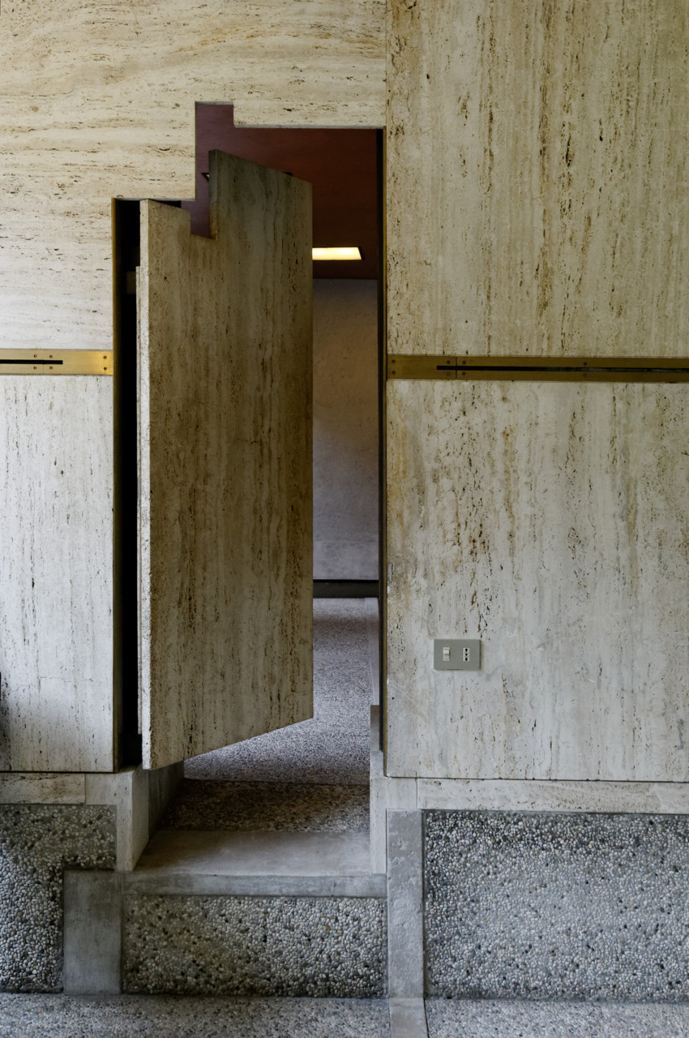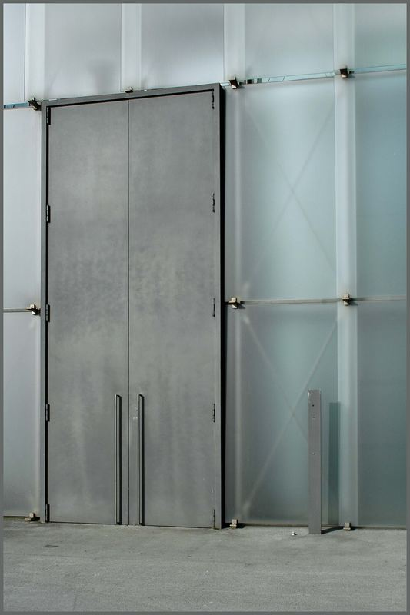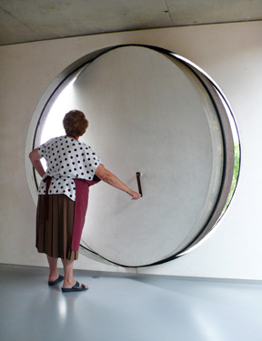
Carlo Scarpa Peter Zumthor OMA, Rem Koolhas
Querina Stampalia, Venice, Door Kunsthaus Bregenz, Austria, Door Villa in Bordeaux, Door

construe (kənˈstruː)
vb (mainly tr) , -strues, -struing or -strued
1. to interpret the meaning of (something): you can construe that in different ways.
2. (may take a clause as object) to discover by inference; deduce
3. (Grammar) to analyze the grammatical structure of; parse (esp a Latin or Greek text as preliminary to translation)
4. (Grammar) to combine (words) syntactically
5. (also intr) to translate literally, esp aloud as an academic exercise
6. something that is construed, such as a piece of translation
[from Latin construere to pile up; see construct]

Through the means of writing a program (for a boutique hotel, bar, spa and garden) and identifying the appropriate site for this hotel in the complex MLK Corridor of Savannah, the studio will pursue the art of architecture –as described by Frascari in his essay on architect Carlo Scarpa’s work. This entails:
(1 putting together spaces and materials, in a meaningful manner
(2. the craft of making formal and actual joints

We will begin with a 2 week research project: prepare a thoughtful and rigorous analysis of Savannah as an organization of territories, a construction of the public realm, and an assemblage of buildings.

We will write the detailed hotel program, using research and analysis of precedent.

Exploring Tectonics: Researching Savannah

This first phase of the studio will focus on the city of Savannah, using different lenses of inquiry and different scales of analysis and representation. The task is to organize in teams, and to prepare a presentation for the class that organizes in graphic form a 3-pronged analysis of Savannah with a focus on the given MLK corridor context.

The overarching question is: How is the MLK corridor to be understood at the scale of the city and the scale of the street? In turn, how do the answers guide architectural design at the scale of the building? This investigation introduces basic concepts of urban design as being related to the conceptual structure of architecture –as being an essential part of the city.

The urban design component of the studio as a precursor for building design has three distinct yet interrelated foci:

1. The organization of territory
2. The design of the public domain
3. The buildings themselves

Following from these categories, three teams of 3 students will engage the following 3 prongs of research + analysis:

1. political / social history (subdivision and ownership of land, boundaries, impact of early settlement, war, race relations and legal decisions)

2. physical history (infrastructure, building fabric, historic / significant buildings)

3. existing conditions (buildings, streets, alleys, parks, etc.)

Categories of Analysis (diagramming material)

- Comparison of scale and form using figure/ground: Savannah to Philadelphia, Manhattan, Amsterdam, Paris, etc.
- Comparison of the scale of streets (section)
- Subdivision of property (tax maps)
- Public and Private ownership
- Institutional (Government, Religious) and Private
- Growth and Transformation of the territory and city (GIS, historical maps)
- The River and the City
- Climate and Topography
- Demographics and Trade
- Impact of Tourism

Each team will prepare both a power point presentation and hard-copy plots for exhibition in Hinman on Wednesday, September 3, at 2pm.

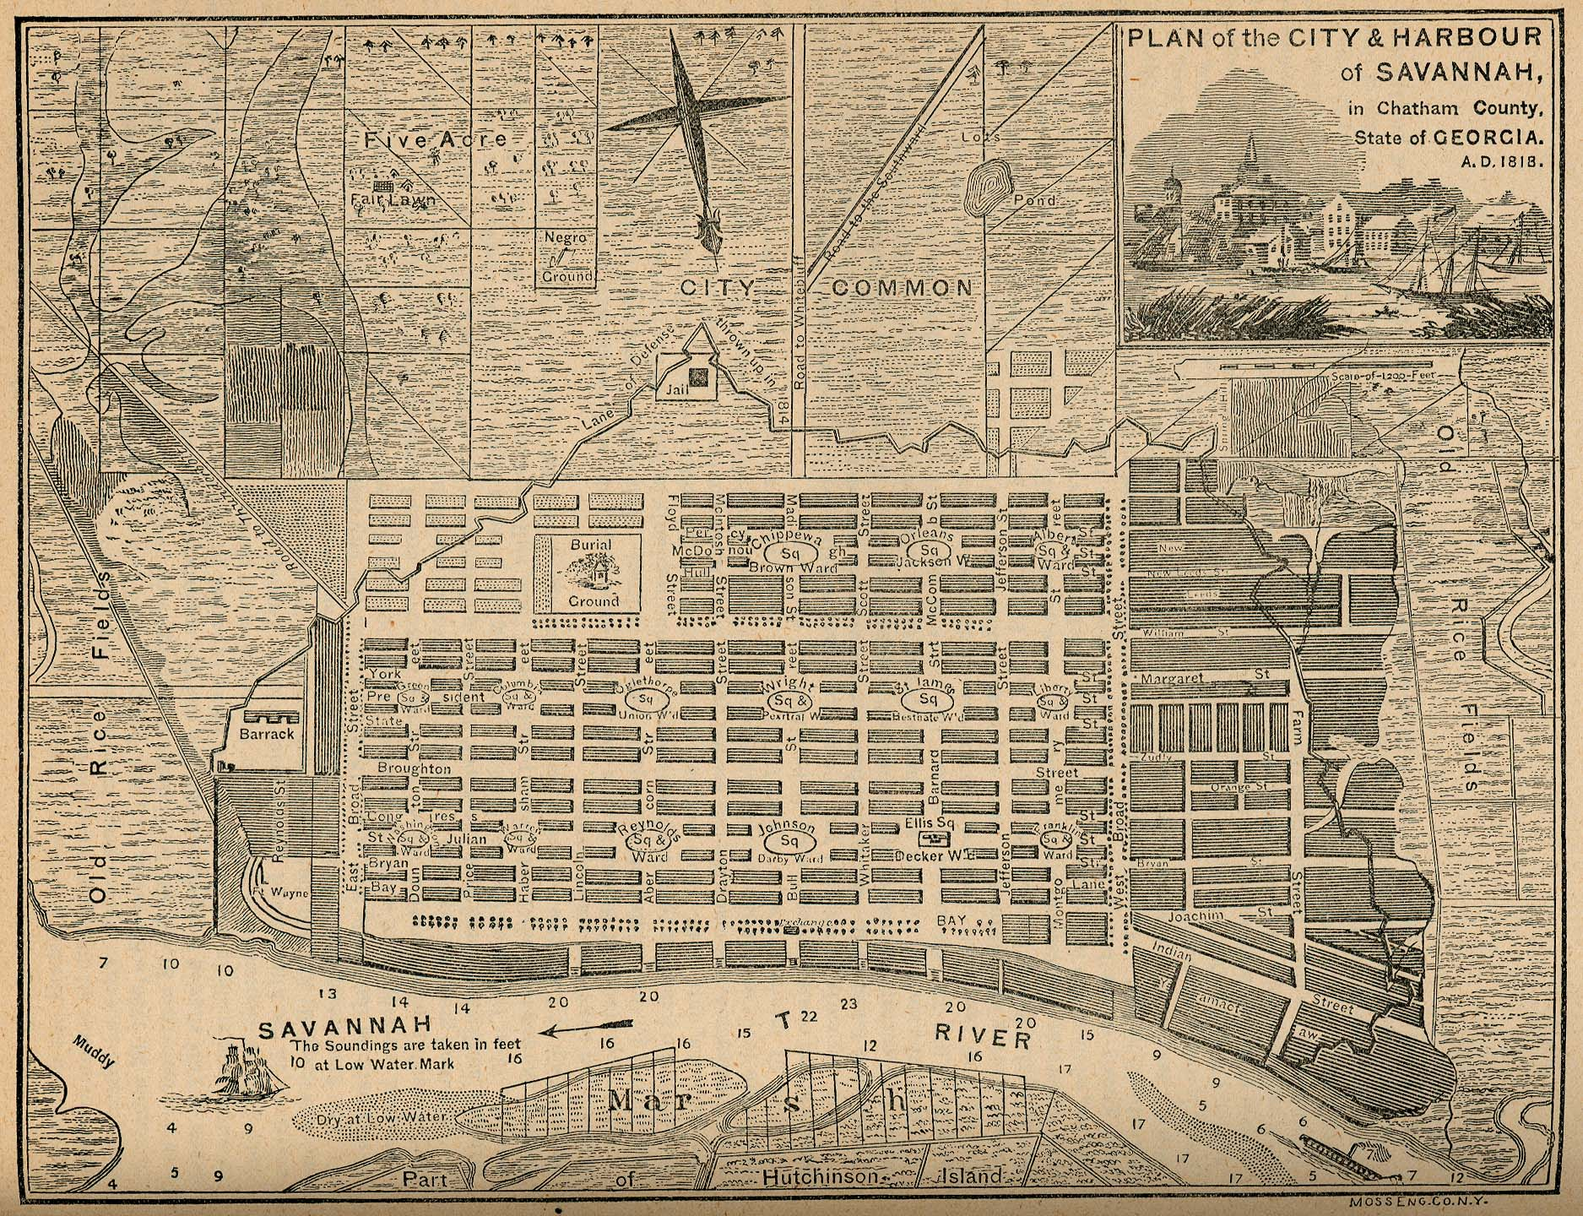

Draft Schedule

Wk1 PART ONE: Savannah Analysis + Research

Wk2 Pinup of Pre-Design Analysis + Research

Wk3 Savannah Field Trip
Site reconnaissance by section / Group touring

Wk4 Program Writing and Sites Research

Wk5 Final Program and Sites Review / Schematic Design Commences

Wk6 Desk Crits

Wk7 Desk Crits and Pin-up Review

Wk8 Midterm Reviews

Wk9 Fall Break

Wk10 Desk Crits – Project Development

Wk11 Desk Crits – Project Development

Wk1 Development Reviews

Wk13 Desk Crits

Wk14 Penultimate Reviews

Wk15 Project Production

Wk16 JURY WEEK Wk17 Finals Week

