COA ____ : Analog and Digital Design Computation
Mario Carpo, PhD
Athanassios Economou, PhD

College of Architecture
Georgia Institute of Technology
Fall 2010

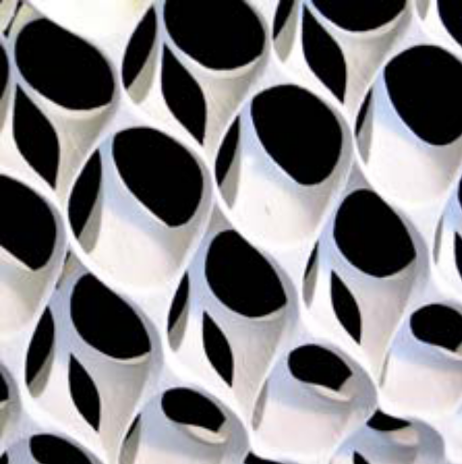

Analog and Digital
Design Computation

A series of lectures on the history and logic of formal systems in architectural design.

The course is divided into three modules; the first module provides a selected overview of formal approaches in architecture design focusing on aspects of notation as it pertains to notions of identicality, variability, authorship, and differentiality and how all these are related to modes of making – hand, machine and digital.

The second module suggests a working distinction of the underlying logic of formal systems in architectural design in terms of analog vs. digital systems -and both as diverse from visual vs. symbolic. A brief account of a purely visual approach emphasizing shape rules, shape relations and algebras of transformations is given too.

The third module consists of a hands-on research project that focuses on a formal analysis of an architect or theoretician whose work is, has been, or was, particularly significant in the history of the digital turn (built or otherwise). Suggested architects include: Gehry, Lynn, Cache, Spuybroek, Roche, Gramazio and Kohler, SHoP, Heatherwick, Diller and Scofidio, Scott-Cohen and others. The work will be collected and presented in the manner of a research paper. The paper will account for 80% of the total grade. 20% of the grade will be based on class participation.

Schedule

Module 1: Cultures (MC)

W1 T The technology and cultures of identical copies
Reading: Mario Carpo, 2010. The Alphabet and the Algorithm

H Hand-making, Machine-Making, Digital Making: timelines
hand-making and artisan variability; machine-making and identicality; digital making and "differentiality"
Reading: Mario Carpo, 2010. The Alphabet and the Algorithm

W2 L Pre-mechanical variability (or "drift") in the production and reproduction of objects and media objects. Variability and authorship in the scribal age.
Reading: Mario Carpo, 2010. The Alphabet and the Algorithm

L The problem of identical copies in the manual transmission of texts and images. The role of the diagram in Antiquity and in the Middle Ages.
Reading: Mario Carpo, 2010, The Alphabet and the Algorithm

W3 L The early-modern rise of identical copies and the rise of the "Albertian paradigm.
Reading: Mario Carpo, 2010. The Alphabet and the Algorithm

L The invention of architectural allography, of architectural design and of the modern architect as an author
Reading: Mario Carpo, 2010. The Alphabet and the Algorithm.

W4 L Aspects of digital variability in the "digital revolution" from 1993 to 2009
Reading: Mario Carpo, 2010, The Alphabet and the Algorithm

L From digital tectonics and form-making to information management and BIM.
Reading: Mario Carpo, 2010. The Alphabet and the Algorithm

W5 L Problems of the present: the unmaking of the "Albertian paradigm". New digital craftsmanship, new digital master-builders.
Reading: Mario Carpo, 2010. The Alphabet and the Algorithm

L New agencies: authorship and interactivity. Implications for architectural design, and for contemporary architectural theory and practice.
Reading: Mario Carpo, 2010. The Alphabet and the Algorithm

Module 2: Logic (AE)

W6 L Design and descriptions; Discursive and presentational systems; Visual computation vs. numerical (symbolic) computation
Reading; William Mitchell: The Logic of Architecture, MIT Press

L Design worlds; Point, line, plane, solid worlds. Algebras of design
Reading: George Stiny, 2006. Shape, MIT Press

W7 L Types and vocabularies; Visual tokens and grammatical rules
Reading: George Stiny, 2006. Shape, MIT Press

L Critical languages; Reasoning; first order predicate calculus; Design machine
Reading: William Mitchell: The Logic of Architecture, MIT Press

W8 L Design operations: Unary operations. Transformations: Isometries; similarities; affinities; linearities; topologies. Parametric variations
Reading: Lionel March, 1974. Geometry of the Environment, MIT Press

L Binary operations. Boolean operations; Union; subtraction; intersection.
Reading: George Stiny, 2006. Shape, MIT Press

W9 L Generative descriptions; Production systems. Recursion and embedding relation;
Reading: George Stiny, 2006. Shape, MIT Press

L Visual computation: Background.
Decompositions; Emergence, ambiguity
Calculating with shapes; Shape rules: taxonomies; Spatial relations and shape rules; Addition rules; Subtraction rules; Identity; Sums of transformations
Reading: George Stiny, 2006. Shape, MIT Press.

W10 L Algebras of design Uij; Vij; Wij;
for Uij/ Vij/ Wij {s, ≤, +, -, T};
Reading: George Stiny, 2006. Shape, MIT Press

L General form of visual computation: For shapes, A, B, C and A → B; Evolving computation: C’ = C - T(A) + T(B)
Reading: George Stiny, 2006. Shape, MIT Press

Module 3: Seminar – Case Studies (MC+AE)

W11 Case Studies - Gehry
Case Studies – Lynn

W12 Cache – Case Studies
Office DA – Case Studies

W13 Roche – Case Studies
Gramazio and Kohler – Case Studies

W14 SHoP – Case Studies
Heatherwick – Case Studies

W15 Diller and Scofidio – Case Studies
Scott-Cohen – Case Studies

W16 Final review

Final project

During the course of the semester each student will choose an architect or theoretician whose work is, has been, or was, particularly significant in the history of the digital turn, and will study his or her body of work (built or otherwise). The scope of the research may focus on one particular item (media object, building, work of art, or book) or a set of items that are conditioned by similar characteristics. Each student will present in turn, and fine-tune the ambit of her or his enquiry based on the feedback received during discussion with the instructors. Recommended authors include: W. Ivins, M. McLuhan, R. Evans, N. Goodman, G. Lynn, G. Deleuze, B. Cache, F. Migayrou, L. Spuybroek, C. Eastman.

Examples of eligible subjects include: Gehry, Lynn, Cache, Spuybroek, Roche, Gramazio and Kohler, SHoP, Heatherwick, Diller and Scofidio, Scott-Cohen, Office DA; Rhino, Digital Project; City Engine; etc (Students may suggest other names or subjects).

General Information

1. Students with disabilities requiring special accommodations must obtain an accommodations letter from the ADAPTS Office [www.adapts.gatech.edu] to ensure appropriate arrangements.

2. Georgia Tech aims to cultivate a community based on trust, academic integrity and honor. Students are expected to act according to the highest ethical standards. For policy information on Georgia Tech's Academic Honor Code, please see [http://www.catalog.gatech.edu/rules_regulations/#18].

3. All cell phones should be turned off during class and when entering the Library.

4. In case of emergency (i.e. fire, accident, criminal act), please call the Georgia Tech Police at 894-2500. Please note that Perry Minyard, IT Support Administrator is also a firefighter and an Emergency Medical Technician (EMT) certified in performing CPR.

