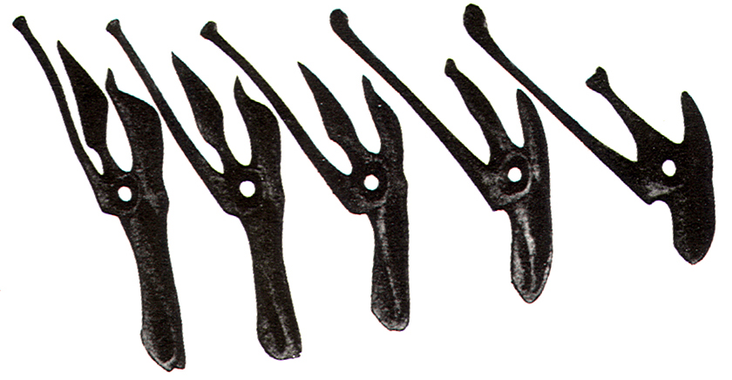

Precise | Parametric | Permutations

Fabrication Workshop
College of Architecture
Georgia Institute of Technology

Potential Instructors:
Tristan Al-Haddad
Daniel Baerlecken
Athanassios Economou
Russell Gentry
Gernot Riether
Lars Spuijbroek

Time: TBD Location: TBD
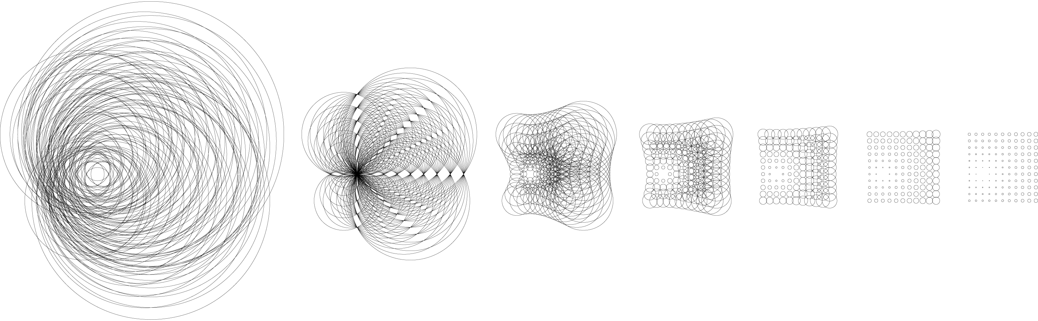

The designer moreover, is using the computer not merely as a tool of representation but as a ‘collaborative partner’ within the design process itself, to such an extent that our whole notion of design needs to be reconfigured.
Neil Leach

…the historical processes of homogenization and routinization have promoted the ‘hylomorphic schema’ as a paradigm of the genesis of form. Conversely, it is partly thanks to the new theories of self-organization that the potential complexity of behavior of even the humbler forms of matter-energy has been revealed. We may now be in a position to think about the origin of form and structure, not as something imposed from the outside on an inert matter, not as a hierarchical command from above as in an assembly line, but as something that may come from within the materials, a form that we tease out of those materials as we allow them to have their say in the structures we create.
Manuel DeLanda

I explore the concept of the virtual as a space of potentialities, distinct from the tangible, measurable world of actual space. Temporal techniques such as digital generative and transformational methods contain an element of the virtual: this is what allows them to give rise to unexpected results. The translation of a design from virtual to actual space is called actualization, and always entails discovery because the actual, by nature, is never the same as the virtual. Working with virtuality produces what I call formations - projects that incorporate feedback from their users and environments, continuing to change even after they are built. Formations do not conform to traditional concepts of architectural type and program, as the effects and modes of occupation of such formations shift constantly.
Ali Rahim

What you have got to realize is that every point of curvature is a structural possibility. What are required are new strategies for recognizing structural possibilities.
Cecil Balmond

Course Description and Objectives

Technology has always been an active agent present within architectural practice and theoretical discourse acting either consciously or subconsciously. Advances in mathematics, manufacturing, descriptive geometry and countless other disciplines have driven many, if not most, of the major paradigmatic movements within architectural history. One thinks of The Futurist, The Constructivist, and The Modernist most notably within the early part of the twentieth century. The Metabolist, The Deconstructivist [whether consciously or not], and the… ‘Blobbist’… dominated the discourse of the second half. Today, the impact of digital technologies and a rediscovery of computational design methodologies and theoretical thought can hardly be denied within contemporary practice and discourse. Digital technologies are now empowering young architects with an explosion of geometric and spatial possibilities; possibilities that would have previously been nearly impossible to describe [draw] and realize [build]. These possibilities have pushed the avant-garde away from the modernist paradigm of standardization and are now affording the possibility of a regression towards the non-standard, the variable, the mutable, the adaptive, the flexible. While these technologies afford designers tremendous potentialities we can no longer accept these technologies as infinite. Digital technologies, and parametric modeling in particular, allow architects to interrogate complex systems by aggressively pushing the possibilities of formal variation while simultaneously defining the systems limits; thus rapidly testing many possible variations in order to generate recursive feedback loops within the design process, one which has become an evolutionary process of design.

Architecture has always been about the design of structures, i.e. parts and relationships, or deep logics. Parametric design processes reemphasize this paradigm within the digital realm. The studio will be working with bottom-up design systems where languages of making inform formal decision making. Understanding how localized rules can create global configurations will be one of the dominate challenges for the studio. Students will work in teams to research flexible analog making techniques along with a specific material order in order to develop their own parametrically driven flexible design system. This system will then be tested against various architectural situations as building assemblies in order to make the system more robust and to find the limits at which it must undergo a fundamental phase-change. Each team will ultimately construct a full-scale prototype of their design system in full-scale materials.

Programmatically each project may vary dramatically. Whether one is designing a column, a wall, or a span condition will be unimportant in early design exercises. Ultimately each design system should be capable of intelligent adaption to accommodate multiple programmatic functions and experiential conditions. Each team will be expected to design and construct something on the order of a ‘small pavillion’ or ‘architectural fragment’, the meaning of which will be explored in the studio.

Course Content

- Contemporary Design Practice
- Computational Geometry
- Advanced Computational Tools + Parametric Design Strategies
- Digital Fabrication Techniques [CAD/CAM + CNC]
- Materiality
- Building Assemblies + Detailing
- Full-Scale Fabrication Techniques

Pedagogical structure

One of the primary issues in architectural education and practice deals with systems of notation and the relationship between the notation of the thing to be made and the thing itself. Historically we have called this orthographic projection and building. However, digital technologies are now closing the gap between the representation and the artifact. Digital modeling and CNC [Computer Numerical Control] technologies now allow for direct [or semi-direct] translation of the representation to the artifact. The studio will focus on learning new methodologies and technologies dealing with computational design through a series of lectures and design exercises. Students will learn the fundamentals of parametric modeling using Rhino 3D with the Grasshopper DAG plug-in and CAM techniques in various CAM packages and various CNC machines.

The studio will build on previous courses to cement fundamental CAD/CAM [Computer Aided Design/Computer Aided Manufacturing] skills and reconsider the role of digital medium in the design and construction process. Digital modeling and fabrication techniques will be used in conjunction with traditional fabrication techniques to investigate materiality, geometry, configurations, and structural performance in the design and construction of the given architectural system. The studio will be structured around a group of lectures in contemporary design theory and practice with an emphasis on computationally driven design, technical tutorials on advanced computational tools, one-on-one desk crits, and group pinups with both internal and external critics. The students will learn both traditional fabrication techniques and contemporary CNC [Computer Numerical Control] fabrication techniques. Students will focus on the production of mockups at a variety of scales in order to investigate digitally designed proposals. Student should have a strong background, or interest, in large scale construction processes and should also be well versed in 3D CAD systems and physical model making. Instruction will be organized around readings, lectures, working sessions, and design reviews.

Schedule

- PART I: Material Research

  - WEEK 1
    - M Studio Overview | Exercise One Introduction
    - W Seminar │Materials Laboratory│Site Visit
    - F Desk crits
  - WEEK 2
    - M Desk crits
    - W Desk crits | Seminar
    - F PIN-UP
  - WEEK 3
    - M Desk crits
    - W Desk crits | Seminar
    - F REVIEW: Material Research

- PART II: Fabrication research

  - WEEK 4
    - M Exercise Two Introduction
    - W Seminar│Fabrication Laboratory │Site Visit
    - F Desk crits
  - WEEK 5
    - M Desk crits
    - W Desk crits | Seminar
    - F PIN-UP
  - WEEK 6
    - M Desk crits
    - W Desk crits | Seminar
    - F REVIEW: Fabrication Research

- PART III: Representation research

  - WEEK 7
    - M Exercise Three Introduction
    - W Desk crits | Seminar
    - F Desk crits
  - WEEK 8
    - M Desk crits
    - W Desk crits | Seminar
    - F PIN-UP
  - WEEK 9
    - M Desk crits
    - W Desk crits | Seminar
    - F MIDTERM REVIEW: Representation Research

- PART IV: Design System Development

  - WEEK 10
    - M Final Project Introduction
    - W Desk crits | Seminar
    - F Desk crits
  - WEEK 11
    - M Spring Break
    - W Spring Break
    - F Spring Break
  - WEEK 12
    - M Desk crits
    - W Desk crits | Seminar
    - F PIN-UP
  - WEEK 13
    - M Desk crits
    - W Desk crits | Seminar
    - F Desk crits
  - WEEK 14
    - M Desk crits
    - W Desk crits | Seminar
    - F PIN-UP
  - WEEK 15
    - M Desk crits
    - W Desk crits | Seminar
    - F Desk crits
  - WEEK 16
    - M Desk crits
    - W Desk crits
    - F FINAL REVIEW

Grades and Evaluations

Exercise One (Materials): 10%

Exercise Two (Fabrication): 20%

Exercise Three (Representation): 20%

Final Project Presentation: 20%

Final Constructed Prototype: 30%

Attendance, participation, timely completion of work, the depth of engagement in studio issues, and the making of progress in your work provides the foundation for your grade. Conceptual and project development and refinement, drawing and model-making requirements, and craftsmanship matter greatly and factor equally in the evaluation of your performance. Remember, grades are earned by you –not given by your instructor. The following grading scale has been established by Georgia Tech and may be reviewed at the following link:
http://www.registrar.gatech.edu/students/gradingsystem.php

A = Excellent
B = Good
C = Satisfactory
D = Passing
F = Failure

Bibliography

Advances in Architectural Geometry Conference Proceedings. Vienna Austria, 2008.

Aish, Robert. “From Intuition to Precision.” AA Files 52. London: Architectural Association, 2005.

Al-Haddad, Tristan and Russell Gentry. “PerFORMance: Integrating Structural Feedback into Design Processes for Complex Form-Active Surfaces,” Digital Architecture and Construction. Southampton: WIT Press, 2006.

Al-Haddad, Tristan. Force + Feedback + Fabrication. Saarbrucken: VDM Verlag Dr. Mueller, 2009.

Aranda, Benjamin, and Chris Lasch. Tooling. New York: Princeton Architectural Press, 2005.

Balmond, Cecil, and Jannuzzi Smith. Informal. Munich; New York: Prestel, 2002.

Balmond, Cecil. “The Digital and The Material,” Contemporary Techniques in Architecture. London; New York: Wiley-Academy, 2002.

DeLanda, Manuel. “Material Complexity,” Digital Techtonics. Chichester, West Sussex, U.K.; Hoboken, NJ : Wiley-Academy, 2004.

Deleuze, Gilles. The Fold : Leibniz and The Baroque. Minneapolis: University of Minnesota Press, 1993.

Evans, Robin. The Projective Cast: Architecture and Its Three Geometries. Cambridge, Mass: MIT Press, 1995.

Frampton, Kenneth. Studies in Tectonic Culture : The Poetics of Construction in Nineteenth and Twentieth Century Architecture. Cambridge, Mass: MIT Press, 1995.

Haeckel, Ernst. Art Forms in Nature. Munich: Prestel Verlag, 1998.

Hauer, Erwin. Erwin Hauer: Continua-Architectural Screen and Walls. New York: Princeton Architectural Press, 2007.

Hensel, Michael, Achim Menges, and Michael Weinstock. Emergence : Morphogenetic Design Strategies. New York: Wiley, 2004.

Johnson, Steven. Emergence: The Connected Lives of Ants, Brains, Cities, and Software. New York: Scribner, 2001.

Kolarevic, Branko. Architecture in the Digital Age : Design and Manufacturing. New York: Spon Press, 2003.

Kolarevic, Branko. Manufacturing Material Effects: Rethinking Design and Making in Architecture. New York: Routledge, 2008.

Leach, Neil, David Turnbull, and Chris Williams. Digital Techtonics. Chichester, West Sussex, U.K.; Hoboken, NJ : Wiley-Academy, 2004.

Lynn, Greg, and Mario Carpo. Folding in Architecture. Chichester, West Sussex ; Hoboken, NJ: Wiley-Academy, 2004.

Lynn, Greg, and Neil Leach. “The Structure of Ornament,” Digital Techtonics. Chichester, West Sussex, U.K.; Hoboken, NJ : Wiley-Academy, 2004.

Lynn, Greg. “The Folded, The Pliant, and The Supple,” Folds, Bodies, & Blobs, collected essays. Bruxelles: La Lettre Volee, 1998.

Meredith, Michael, From Control to Design: Parametric/Algorithmic Architecture. Verb Monographs.

Moussavi, Farshid. The Function of Ornament. Barcelona: Actor, 2006

Otto, Frei, and Bodo Rasch. Frei Otto, Bodo Rasch: Finding Form : Towards an Architecture of the Minimal. [Germany]: Axel Menges, 1995.

Pearce, Peter. Structure in Nature is a Strategy for Design. Cambridge: MIT Press, 1978.

Pottmann, Helmut. Architectural Geometry. Exton, PA: Bentley Institute Press, 2007.

Rahim, Ali. Catalytic Formations: Architecture and Digital Design. New York: Taylor & Francis, 2006.

Rahim, Ali. Contemporary Techniques in Architecture. London: New York: Wiley-Academy, 2002.

Rajchman, John. Constructions. Boston: MIT Press, 1998.

Reiser, Jesse. Atlas of Novel Tectonics. New York: Princeton Architectural Press, 2006.

Shea, Kristina. “Directed Randomness,” Digital Techtonics. Chichester, West Sussex, U.K.; Hoboken, NJ: Wiley-Academy, 2004.

Spuybroek, Lars. Nox: Machining Architecture. New York: Thames & Hudson, 2004.

Stiny, George. “Design Machines,” Environment and Planning B, Volume 8, Issue 3.

Terzidis, Kostas. Algorithmic Architecture. Boston: Architectural Press, 2006.

Turko, Jeff. “Virtually Crash Testing the Box,” Contemporary Techniques in Architecture. London: New York: Wiley-Academy, 2002.

Wise, Chris. “Drunk in an Orgy of Technology.” Emergence: Morphogenetic Design Strategies. New York: Wiley, 2004.

