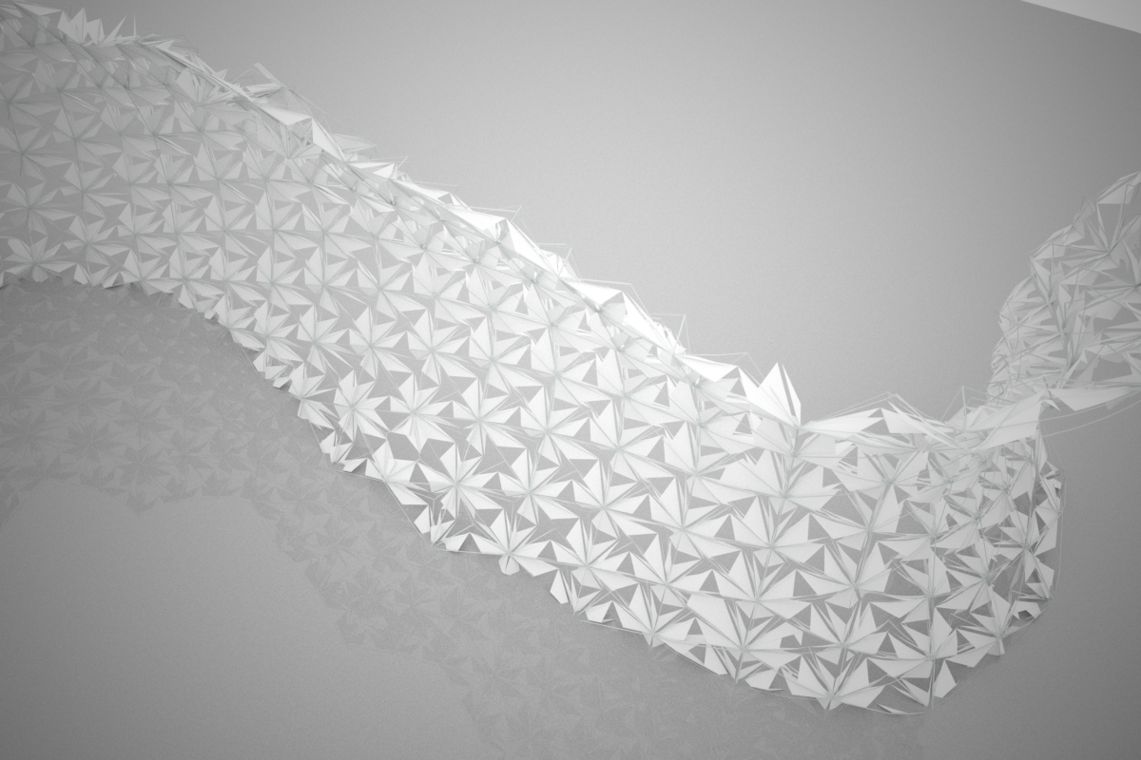

Parametric Design

Syllabus:
1.0 Who should take this class?
2.0 Course description
3.0 Objectives
4.0 Instructional methodology
5.0 Grading
6.0 Resources
7.0 Grading Policy and homework submission
8.0 Class Modules
1.0 Who should take this class? This class is open to students with good understanding of 3D modeling. It caters for those who wish to go beyond geometric modeling to explore building parametric design representations to generate alternative design solutions. Skills acquired in this class can be utilized for solving design studio problems.

2.0 Course description: The class focuses on exploring concepts and mechanisms for creating custom parametric models. This includes: regulating hierarchies of relationships, imposing constraints, applying rules, and driving objects’ geometric properties through parameters. The objective of the class is to gain an adequate level of understanding of how to, when to, and why designers may choose to explore custom parametric design objects vs. non-parametric ones. In this class, Design is being viewed as a process of breaking problems down and building parametric structures. The class is lecture/tutorial based. In parallel to lectures, students will be introduced to basic literature on modeling and parametric design. Software packages used in this class include:
-Digital Project V1, R4 for parametric modeling.
-AutoCAD and Rhino for drafting.
-Excel and Notepad for volume-editing of user parameters and data sheets.
Prior knowledge of the software packages mentioned above is not required.
3.0 Objectives:
1. Learn the overall structure of a parametric modeling system: sketcher; parts; products, and assemblies; relationships; constraint and rule language; and re-building tree.

2. Gain experience in the embedding of design knowledge into a parametric model, dealing with simple objects first, then more complex ones.

3. Development of assemblies and the composition of rules regarding assemblies as well as individuals.

4. Development of methods to apply geometric rules over an assembly of objects using grids and orthogonal surfaces, part-to-assembly propagation, and assembly-to-part propagation.

5. Learn to effectively use one parametric modeling tool and to generalize from this one to others.

6. Explore methods of automation using spread sheets and smart geometric object structures (parts or assemblies).

7. Learn how to develop parameterization schemes and observe potentials and limitations of each.

8. Explore building design systems to generate alternative design solutions for a given design problem.

9. Perform basic single objective optimizations for design through examining user-defined performance aspects, and performance indicators.

4.0 Instructional methodology: This is a “learn by doing” class. Students will explore the above mentioned objectives and concepts through tutorials and homework assignments of increasing levels of complexity. There will be in-class thinking sessions of how to approach a problem and devise various parameterization schemes.

5.0 Grading: The class grade is divided among three components: Homework assignments, final project, and final project presentation. The grade weights are as follows:
-14 homework assignments weighing 70 points (5 points each).
-Final project weighing 25 points.
-Final presentation weighing 5 points.
Letter grades are given as follows:
A (90 +)
B (80 +)
C (70 +)
D (60 +)
F (below 60)
6.0 Resources: Class materials: Students will have access to lecture materials including Pdf and CAD files. Below are some useful links:
http://www.gtwiki.org/mwiki/r3doc/English/online/DigitalProjectHome/_book.htm
http://paramod2.blogspot.com/search?q=digital+project
http://www.gehrytechnologies.com/index.php?option=com_content&task=view&id=133&Itemid=301

7.0 Grading Policy and homework submission: An accepted homework submission is one that is delivered via T-Square before the specified deadline. Once submitted on time, homework assignments will be graded based on the criteria mentioned with each homework assignment description. Late submissions will receive zero points, but submittal is still required. All homework assignments including the final project submissions are to include: CAD files, and A3 Sheets (in Pdf file format) showing student’s work.

8.0 Class Modules: The class is divided into 14 lecture-based modules, during which students will work on homework assignments in preparation for a final project. Modules start on Thursdays. Students are given homework assignments on Tuesday of every week. Assignments are always due the following Tuesday by 3 pm. This will give students time to review homework requirements and come with questions on Thursdays or during office hours, and then use the weekend to complete their work before submission on the following Tuesdays. Some homework assignments may extend over 2 weeks. Announcements will be made when/if needed.

Module 1: Introduction Module (January 14th and 19th)
Lecture A: What is parametric design?
Topics:
-History and background of Solid and parametric modeling.
-Parametric Vs non parametric CAD systems.
-Use of parametric design in architecture.
-Quick Demo of Sketcher.
Lecture B: Digital Project Introduction:
Topics:
-Interface, Customization, and navigation.
-Workbenches (various types).
-File structure (Parts and Products).
-Geometric data structures (sets, bodies, and part bodies).
-Parameters and constraints (Sketcher).
Homework 1:
Register a user account at: http://www.gtwiki.org/mwiki/index.php?title=Main_Page

Module 2: Parametric Drafting (January 21st and 26st)
Lecture A: Sketcher Workbench A:
Topics:
Interface:
-Reference Plane
-Interface
-Navigation
-Drawing tools
-Transformations
-Derived geometric objects.
-Editing Geometry (Chamfer, fillets, extends, trims, break)
-Drawing aids (Axis lines, grids and snaps)
Geometric Patterns:
-Modeling geometric patterns with transformations and iterations.

Lecture B: Sketcher Workbench B:
Topics:
Creating Smart Patterns: (Rebuild Lecture A)
-Break down the pattern into Sketches.
-Generate Axis lines.
-Rebuild geometry on various sketches.
-Create Parameters
-Relationships
-Define Constraints.
-Design Tables (Excel Sheets or txt files).

Homework 2:
-To Do: Create a parametric pattern of your choosing, and generate variations using Design Tables. A list of suggested patterns will be given in class.
-To Submit: CAD files and A3 Sheet in PDF showing pattern variations.
-Grading Criteria: File structure, completion, and complexity.

Module 3: 0D and 1D Parametric objects (January 28th and February 2nd)
Lecture A: Designing for variations:
Topics:
In class work session: Draft the plan of an architectural work from a selected list and generate variations using design tables. Consider pointers from homework 2 such as:
-Structuring your drawing on various sketches.
-Utilizing Axis lines and grids.
-Parameterizing geometry and relating parameters with one another.
-Using Constraints.

Lecture B: Adding a parametric design extension:
Topics:
In class work session: Add/Design a parametric extension to the given plan (in 2D). The extension includes: A bed space, living space, bathroom, and balcony. Your design is to follow the same design language of the existing architectural work.

Homework 3:
-To Do: Generate alternative configurations of your design extension.
-To Submit: CAD files and A3 Sheet in PDF showing the original design variations of your design extension, and diagrams showing your underlying logic, driver geometry and used parameters.
-Grading Criteria: File structure, completion, and complexity.

Module 4: 2D and 3D Parametric Objects (February 4th and 9th)
Lecture A: Geometry Workbench A:
Topics:
Basis concepts:
-Objects containers:
-Geometric Sets, Ordered Geometric Sets, Bodies, Part Bodies.
-Objects types and their tools:
-Wireframes and Surfaces.
-Solids
Wireframes and Surfaces:
Parametric Meshes: Creating parametric meshes in various methods.

Lecture B: Geometry Workbench B:
Topics:
Solids:
-Sketch Based Features
-Surface Based Features
-Dress-up features
-Transformations
-Derivatives
-Boolean Operations
-Parameters and Design Tables.
Swiss Re Tower Diamond Patterns
Homework 4:
-To Do: Generate tutorial from lecture A or B of Module 4 using an alternative method.
-To Submit: CAD files and A3 Sheet in PDF showing your model.
-Grading Criteria: File structure, completion, and complexity.

Module 5: Design by Repetition (February 11th and 16th)
Lecture A: Repeating Patterns:
Topics:
Pattern Reuse:
-Circular
-Rectilinear
-User defined
Creating a parametric staircase:
-Basics of rules.
Lecture B: Designing with Patterns.
Topics:
Designing an office building

Homework 5:
-To Do: Create a model for a building of two zones (offices and apartments, similar to Lecture B tutorial) and add a skin to the building. Skin is to include a Surface, and a diamond wireframe pattern.
-To Submit: CAD files and A3 Sheet in PDF showing pattern variations.
-Grading Criteria: File structure, completion, and complexity.

Module 6: Design by Population (February 18nd and 23rd)
Lecture A: Power-Copy A
Topics:
Context-Free Power-Copy:
-Generating ribs for your homework 5 model.
-Creating panels on a parametric mesh.
Lecture B: Power-Copy B
Topics:
Context-Driven Power-Copy:
-Generating ribs for your homework 5 model.
-Creating panels on a parametric mesh.
Homework 6:
-To Do: Using parametric mesh (like in homework 4), build a panel feature as a repeatable Power Copy, and populate it on a surface (similar to this module’s tutorials).
-To Submit: CAD files and A3 Sheet in PDF showing your design and how it populates on a surface, and adapts to its changes. Also show a diagram of how your power copy is built.
-Grading Criteria: File structure, completion, and complexity.

Module 7: Controlling Design Behavior (February 25th and March 2nd)
Lecture A: Knowledge Advisor Workbench A
Topics:
Create a grid of points to drive a column structure and elevator shafts:
-Pattern Reuse
-Rules
-Checks and Reactions

Lecture B: Knowledge Advisor Workbench B
Topics:
Using the model from Module 6 lecture (A or B) to control Power Copy (Ribs) dimensions with:
-Rules
-Checks and Reactions.
-Design Tables
Homework 7:
-To Do: Using parametric mesh (different from homework 6), build a pyramid geometric object as a repeatable Power Copy where you control the pyramid faces vertical angle based on the indexing of the pyramid whether odd or even. For example, if the pyramid is located at an odd index in the grid, then its angle is 50, if it is even then the angle is 20. You will need to use either a combination of Checks and Reactions, or just rules.
-To Submit: CAD files and A3 Sheet in PDF showing your design. Also show a diagram of what conditions or geometric parts control which behavior of which parts.
-Grading Criteria: File structure, completion, and complexity.

Module 8: Documentation (March 4th and 9th)
Lecture A: Drawing Generation Workbench
Topics:
Views, Callouts, Sections, and Sheets

Lecture B: Photo Studio Workbench
Topics:
Materials, Camera, Animation and Rendering

Homework 8:
-To Do: Generate Documentation for one of your earlier homework submissions along with rendered images: 2 orthogonal projection views such as plans, sections or elevations, and 2 rendered perspectival views (one exterior, and one interior).
-To Submit: CAD files and A3 Sheet in PDF showing your illustration.
-Grading Criteria: File structure, completion, and complexity.

Module 9: Relating Parametric Objects (March 11th and 16th)
Lecture A: Product Workbench A
Topics:
Building an office building as a series of parts and products 1
-Import Site Model from Rhino.
-Building Various Parts to include driver geometric objects.
-Structuring project file into various geometric sets.
-Building Grids, and planes and basic geometric objects.

Lecture B: Product Workbench B
Building an office building as a series of parts and products 2
-Model Slabs.
-Elevator Shafts as patterns.
-Apply basic rules to control number of elevator shafts based on slab area.

Homework 9:
-To Do: model a wall with a number of windows that change their count based on the wall’s length.
-To Submit: CAD files and A3 Sheet in PDF showing your wall, and a diagram of how it is built.
-Grading Criteria: File structure, completion, and complexity.

Module 10: Recap (March 18th and March 30th) This Module has Spring Break from 22nd to 26th
Lecture A: Thinking Session on the 18th
Topics:
Develop a window that exhibits some sort of behavior in response to a moving point object. Examples will be shown in class. We will use this lecture to think of how to plan it, and build it. Your window should be built as a Power Copy, and populated on a Rectilinear Pattern grid.

Lecture B: Work Session on the 30th

Homework 10:
-To Do: same as the description in lecture A.
-To Submit: CAD files and A3 Sheet in PDF showing your window design and how it populates on a surface, and adapts to the moving point. Also show a diagram of how your Power Copy is built.
-Grading Criteria: File structure, completion, and complexity.

Module 11: Building Information Modeling (April 1st and 6th)
Lecture A: Background
Topics:
What is BIM? Why is it useful?
Architectural object containers:
-Grids.
Architecture drivers
-Points, Axes, Intersections.
Interface and tools:
-Slabs, Walls, Columns, Beams, etc.

Lecture B: Workflow
Topics:
Import AutoCad drawings and use of Architecture and Structure Workbench to build geometry, and export Data Sheets.

Homework 11:
-To Do: Build a BIM model of your homework 3 submission (with or without your design extension).
-To Submit: CAD files and A3 Sheet in PDF showing your BIM model, its components, one 3D view and one orthogonal projection view (plan, elevation, or section).
-Grading Criteria: File structure, completion, and complexity.

Module 12: Cube Optimization (April 8st and 13th)
Lecture A: Basics in Optimization Workbench
Topics:
Create a cube (6 separate faces) and run a basic single objective optimization. Our optimization will try to keep the volume of the cube within a certain range while changing its height and width.

Lecture B: Optimization for rapid prototyping.
Topics:
Using the cube from Lecture A, and add fabrication ribs using patterns and power copy functionality. Then optimize the cost of fabrication by manipulating number of ribs, and thickness of ribs based on spacing.

Homework 12:
-To Do: Reproduce the tutorial in lecture B with a different ribbing pattern, and laser-cut, then assemble your design.
-To Submit: CAD files and A3 Sheet in PDF showing your Digital model of the cube, and the pictures of your laser-cut model. Make sure to include diagrams of your model components (what drives what).
-Grading Criteria: File structure, completion, and complexity.

Module 13: Performance and Optimization (April 15th and 20th)
Lecture A: Performance and Performance Indicators
Topics:
What is a System?
Aspect, and Technical Systems.
Performance, and Performance Indicator
Example.
Lecture B: Workflow
Topics:
Final project discussion and planning. Final project description will be given in due time.

Homework 13: Concept 1.
-To Do: Describe your concept in any form (hand sketches, CAD, Text, etc). Your concept should illustrate how you plan to build your final project. Concept stage is not final, but will push you to think about your design approach; and how you are going to structure your file, parameters, relationships, etc. No CAD work needed for this homework.
-To Submit: One A3 Sheet in PDF showing your concept description. No CAD images needed.
-Grading Criteria: File structure, completion, and clarity.

Module 14: Final Project Work Week (April 22nd and 27th).
Lecture A: Work Session.

Lecture B: Work Session.

Homework 14: Concept 2.
-To Do: This is a concept development stage. Submit an updated, revised, or a new approach to your concept (if your earlier one did not work well after trying to model it). If your earlier concept did not need changes or edits, then update your earlier A3 sheet with images of your initial modeling attempts.
-To Submit: One A3 Sheet in PDF showing your concept description.
-Grading Criteria: File structure, completion, and clarity.

Final Presentation Day (May 6th)
Presentation location, requirements and other details will be given in due time.

