Georgia Institute of Technology
Wallace H. Coulter Department of Biomedical Engineering
New Course Syllabus

Course Title: Fundamentals of BioID Process | Instructor: Lewis Franklin Bost, MBA
Course Number: BMED 6501 | Credit Hours: 3
Co-requisites: Graduate Enrollment in BioID Program

Course Description: The development and commercialization of medical products entails multiple stakeholders and unique regulatory requirements for engineering design, clinical testing and FDA pre-market notification or approval of safety and effectiveness. This course will provide the framework in the design and commercialization process of medical products including requirements and interdependencies of the key stakeholders including: medical professionals (users), patients, engineering development personnel, regulatory requirements, intellectual property protection, commercialization strategy, project funding, clinical validation studies, manufacturing, distribution, reimbursement and post marketing surveillance requirements.

Catalogue Description: Instruction in the design and commercialization process for medical products.

Course Objectives:
- Describe the medical and clinical relevance of healthcare product opportunities and problems.
- Determine and optimize the interdependencies of key stakeholders and their influences and contributions to commercializing solutions to unmet clinical needs to improve patient care and healthcare delivery.
- Evaluate, in the context of medical product development and commercialization requirements, economic and societal impacts, political/legislative influences, regulatory standards and compliance requirements, environmental and sustainability, business ethics, health and safety.
- Provide a basis for application of this knowledge to the student’s BioID master’s clinical project in translating an unmet clinical need into a potentially commercial medical device or treatment technique.

Biomedical Innovation and Development Process
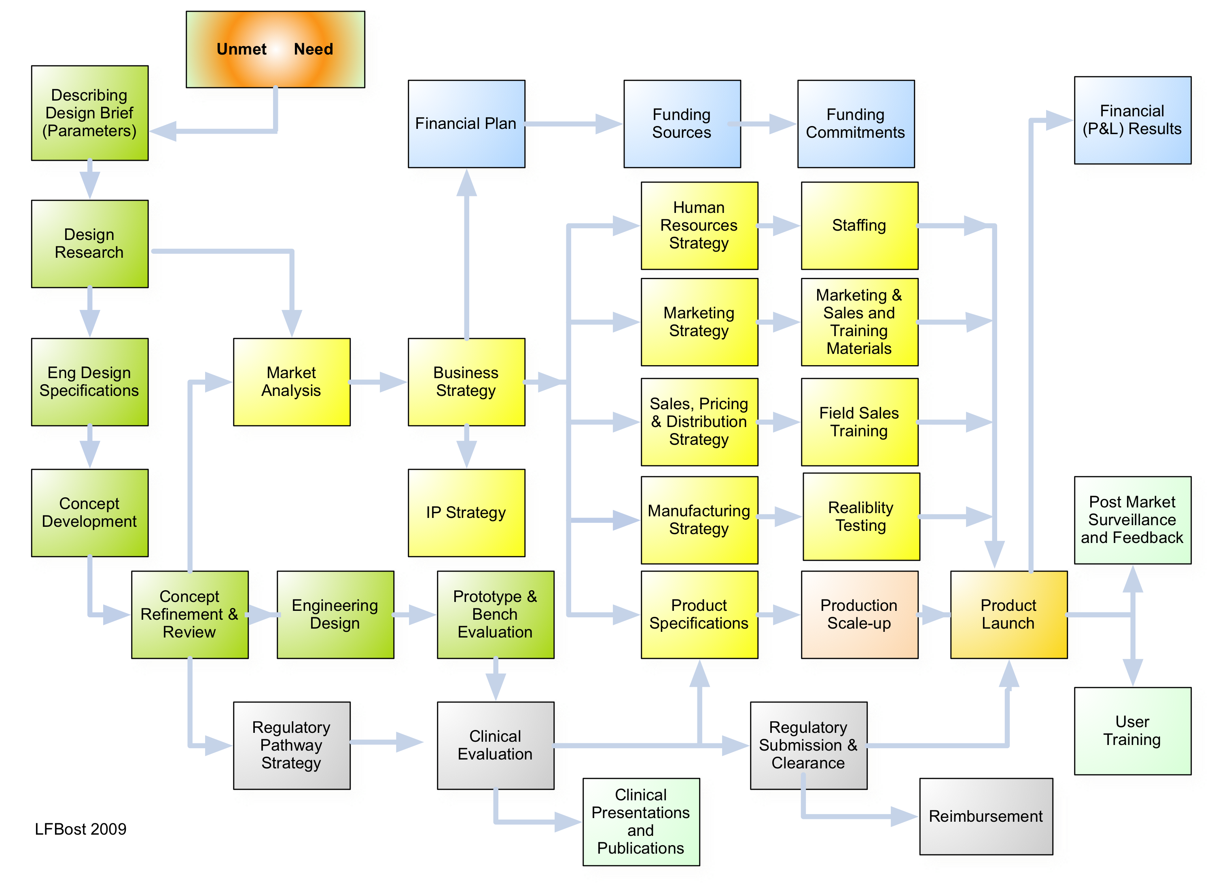
Course Format:
Instructional methods include: weekly lectures with in-class exercises and discussions. There will be two (2) class sessions of 1.5 hours each per week for the 16-week semester. Readings will be assigned in the designated textbooks, supplemented with reading from reference material and contemporary case information on medical device issues in the news. Grading will be from a combination of a mid-term, final exam and presentation of a team-project conducted during the semester.

Grading:
- Class Assignments (30%)
- Individual Project (20%)
- Exams (30%)
- Class Participation (20%)

Class Materials:
Required Textbooks:
- P.H. King and R.C. Fries, Design of Biomedical Devices and Systems, Second Edition 2009, CRC Press (ISBN: 987-1-4200-6179-6)
- Zenios, Stefanos, Makower, Josh and Yock, Paul. Biodesign, The Process of Innovating Medical Technologies, Cambridge University Press 2010. (ISBN: 978-0-521-51742-3)

Recommended Reference Materials:
- Singhose, William, Jeff Donnell, and David Frakes. Introductory Biomechanical Design Tools. Lulu, 2010.
- Magrab, Edward B., et al. Integrated Product and Process Design and Development: The Product Realization Process. 2nd ed. Boca Roton: CRC Press
- Kahn, Kenneth D., ed. The PDMA Handbook of New Product Development. 2nd ed. Hoboken: John Wiley & Sons, Inc., 2005. Print.
- Peters, Tom. Design: Innovate. Differentiate. Communicate. The Essentials Series. Ed. Slind, Micheal. Strand Dorling Kindersley Limited, 2005. Print.

Course Topics Lectures and Presentations

Week 1. Introduction to Biomedical Innovation and Development Processes
  - Unmet Need to Commercialization – critical elements
  - Design and Development - An Iterative Process
Week 2. Stakeholders and Interdependencies
- Research, Engineering, Design and Development
- Healthcare Professionals – Clinicians, Surgeons, Nurses, Technicians
- Project/Business Planning Strategies – Timelines, Funding, Marketing
- Legal and Regulatory - Intellectual Property, Regulatory, Liability
- Manufacturing, Vendors, Production, Quality Control
Week 3. Unmet Need Finding - Defining User Needs and Opportunities
  - Observation and Identification
  - Voice of the Customer
Week 4. Ethnographic Research –
- Defining User Profiles and Persona
Week 5. Defining the Project in a Project/Design Brief
  - Functional and Performance Requirements
  - Design Constraints & Other Requirements
  - Identifying and Prioritizing Stakeholder “Needs” vs. “Wants”
Week 6. Medical Design Research and Investigation Techniques
  - Medical Publication Sources, Medical and Surgical Technique Videos
  - Competitive Research
Week 7. Engineering Design Specifications with Defined Metrics
  - Functional Specifications
  - Performance Specifications
  - Design Constraints – target costs, materials, manufacturing
  - Other Requirements – sterile product, biocompatibility
Week 8. Human Factors Engineering in Medical Devices
  - Medical Device Adverse Event – misuse, injury, death
  - Human Factors in Design Guidance from the FDA
Week 9. Development Strategy and Planning
  - Project Planning
  - Intellectual Property Planning
  - Regulatory Review and Strategy
  - Reimbursement Strategy
  - Marketing, Sales and Distribution Strategy
  - Competitive Landscape Analysis
  - Project Financial Planning
  - S.W.O.T. (Strengths, Weaknesses, Opportunity, Threat) Analysis
Week 10. Concept Generation and Alternative Analysis
  - Ideation Techniques
  - Intellectual Property re
  - Competitive Research
Week 11. Prototyping, Material and Processes
  - Concept Communication with Study Models
  - Proof-of-Concept prototypes
  - Alpha Prototypes
  - Beta Prototypes
  - Pre-production units
Week 12. The Complete “Product”
  - Device of Product
  - Packaging of sterile and non-sterile medical devices
  - Product Use Instructions (PUI) and user training
Week 13. Design Verification for Medical Products
  - Protocol Development for functional and performance evaluation
  - Testing Procedures
Week 14. Design Validation - User Evaluations and Clinical Studies
- Study Design, Protocol Development, Informed Consent
- FDA Study review on study design, sites and patient numbers
- Medical Institutional Review Board (IRB) requirements and processes
Week 15. Design and Development is a Constant Iterative Process
- Define, Ideate, Prototype, Obtain User Feedback – in rapid process
- Decision Gates in Development Process
Week 16. Biomedical and Professional Ethics
- Codes – engineering, medical professionals, medical industry associations
- Current events and violations – consequences for individuals, companies and other stakeholders

Attach here - Course General Guidance

