CEE 4803: Applied Geotechnique, Elective Class

Catalog Description
Geotechnical principles for soil and rock mechanics are applied to the construction of civil engineering projects, including the evaluation of geomaterial properties, critical state soil mechanics, shallow foundations (footings and mats), piling and deep foundations, soil liquefaction, and ground modification techniques. Actual case studies are presented for the various sections to illustrate predictive methodologies and the inherent uncertainty involved in working with natural materials.

Credit hours:
3-0-3. Recommended Prerequisite: CEE 4405 Geotechnical Engineering

Class/Laboratory Schedule
Three 1-hour lectures (or two 1.5-hour lectures) per week.

Class/Laboratory Schedule
Professor Paul Mayne, PhD, P.E., Mason 241: Email: paul.mayne@gatech.edu
Phone: 404-894-6226; Website: http://geosystems.ce.gatech.edu/Faculty/Mayne/

Textbook(s) and/or Other Required Materials
Class notes posted on course website (T-square), approximately 40 MB PDF file.

Grading
Two Midterms (25% each), Final Exam (30%), plus 7 homework assignments (total 20%).

Educational Objectives
The course is intended to introduce undergraduates to the use of geotechnical principles applied to the analysis and design of civil engineering projects. Students will demonstrate an ability to utilize concepts learned in geotechnical engineering to design shallow foundation systems, driven pilings, drilled and augered elements, ground modification, understand the framework of critical state soil mechanics, and evaluate the potential for soil liquefaction during earthquakes.

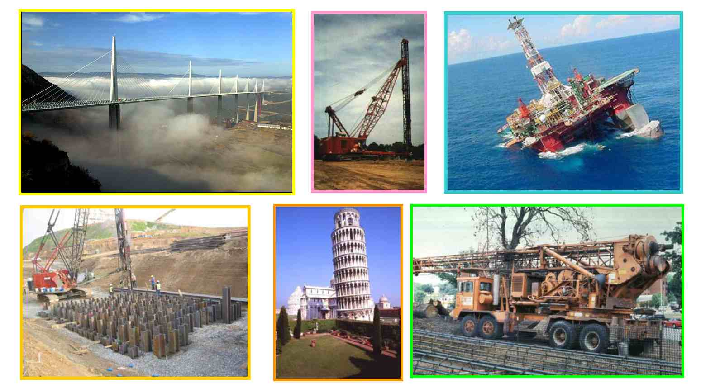

Foundation systems for bridges, buildings, and civil engineering structures

Topics Covered

- Critical-State Soil Mechanics
  - Consolidation behavior of soils (review)
  - Shear strength of soil (review)
  - Effective stress framework of CSSM: state parameters, soil constants.
- Site Characterization
  - Methods for drilling and sampling of geomaterials (soils and rocks)
  - In-situ geotechnical testing
  - Geophysical exploration methods (invasive and non-invasive)
  - Soil parameter determination
- Shallow Foundation Systems (spread footings; mats/rafts)
  - Limit equilibrium approach
  - Theorems of plasticity (upper and lower bound solutions)
  - Applications to foundation bearing capacity; case studies
  - Stresses beneath surface loaded areas
  - Elastic continuum solutions for displacements
  - Settlement calculations; case study presentations
- Liquefaction of Soils
  - Ground motions and cyclic shear stresses imposed by earthquakes
  - Soil resistance and normalized resistances
  - Evaluating liquefaction potential of soils
- Piling Foundation Systems
  - Types of deep foundations; Methods of installation
  - Axial capacity interpretation of full-scale load test data
  - Evaluation of side and base resistances; Axial load transfer
  - Pile displacement evaluation using randolph model
  - Nonlinear load-displacement-capacity response
  - Lateral and moment loading-deflection behavior of deep foundations
- Ground Modification
  - Site improvement by preloading, surcharging, and wick drains
  - Vibroflotation, dynamic compaction, stone columns, and geopiers
  - Transformation by in-situ vitrification, plasma magmavication

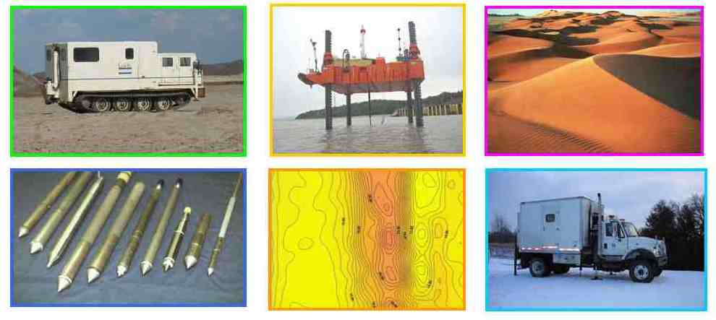

Site characterization, geostratigraphy, and in-situ testing of geomaterials

