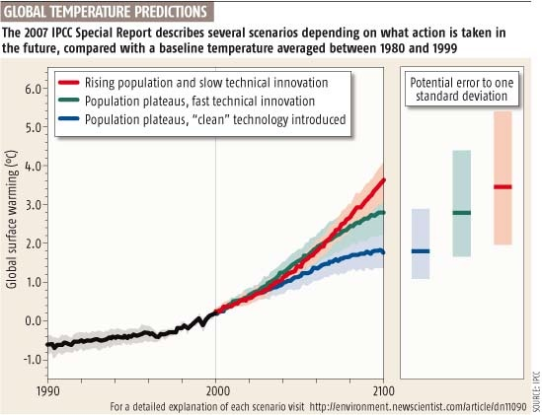
CP 4813BD / CP 8823BD
Introduction to Climate Change Planning
William J. Drummond and Jan L. Youtie
Spring 2011

Course Syllabus

Instructors: William Drummond
204 East Architecture Phone: 404-894-9840
Email: bill.drummond@arch.gatech.edu
Office hours: Tuesday and Thursday 1:00 to 2:00

Jan L. Youtie
Enterprise Innovation Institute
Phone: 404-894-6111
Email: jan.youtie@innovate.gatech.edu

Course description

“We, the human species, are confronting a planetary emergency – a threat to the survival of our civilization that is gathering ominous and destructive potential even as we gather here. But there is hopeful news as well: we have the ability to solve this crisis and avoid the worst – though not all – of its consequences, if we act boldly, decisively and quickly.”

Al Gore
Nobel Lecture, Oslo, 10 December 2007

City planners, civil engineers, corporate executives, and individual concerned citizens can make important contributions to attacking the problem of climate change. Planners, in particular, can have significant influence on the design of buildings, the structure of the transportation network, and the spatial pattern of land uses.

Over the last decade state and local governments have taken the lead in developing innovative policies in response to the threat of climate change. At present 32 states have developed climate action plans, and other six states are in the process of developing plans. The mayors of over 900 cities have signed the U.S. Mayors’ Climate Protection Agreement and committed to “strive to meet or beat the Kyoto Protocol targets.” More than 100 of these cities have developed climate action plans.

The purpose of this course is to equip students with the knowledge and methods necessary to assume leadership positions in developing the next generation of state, local, corporate, and enterprise climate action plans. The course will be divided into five major sections.

The introduction to the course will place climate action planning within the larger framework of planning for sustainability. Students will encounter a selection of sustainability readings and discuss the relationship between sustainability, sustainable development, and climate change.

The second section of the course (about two weeks) will review our basic scientific understanding of the causes of climate change and the role of human actions. The course will not attempt a comprehensive treatment of climate change science but will be limited to consideration of the science necessary to address the causes and effects of climate change with an emphasis on opportunities for policy intervention.

The third portion of the course (four weeks) will focus upon the methodology for developing greenhouse gas (GhG) inventories. GhG inventories are the fundamental tool for establishing baseline levels of emissions and monitoring progress toward emission reductions. We will consider the major sources of GhGs (electricity, buildings, transportation, and industry) and discuss different approaches to benchmarking emissions.

The next, fourth, course section (five weeks) will survey a broad array of state, local, federal, and corporate policy actions for reducing greenhouse gas emissions. These will include, but not be limited to, policies related to energy, transportation, buildings, and land use. State and local policies for adaptation to climate change will also be addressed.

Finally, the last section of the course (two weeks) will address the process of developing a climate action plan. Topics will include public participation; development of scenarios, goals, and objectives; creation of the plan; communication of the plan to the public; and plan implementation.

Learning Objectives

Students successfully completing the course will:

- Place climate change planning within a broader framework of sustainability and sustainable development,

- Know the basic science of climate change with a deeper understanding of points of leverage for policy intervention,

- Master the methods for conducting greenhouse gas inventories for emissions from multiple sources including transportation, electricity, residential buildings, commercial buildings, industrial buildings, and industrial processes,

- Survey the range of policy options for mitigating greenhouse gas emissions at the federal, state, and local levels of government as well as corporations and non-profits, and

- Understand and be competent to implement the climate change planning process in order to develop climate action plans or climate change components of comprehensive plans.

Course readings

Many of the course readings will be posted as pdf files on the course Tsquare site. There is one required textbook for the course:

Randolph, J., & Masters, G. M. (2008). Energy for Sustainability : Technology, Planning, Policy. Washington, D.C.: Island Press.

Students with Disabilities

Students with disabilities needing academic accommodation should provide documentation to the Access Disabled Assistance Program for Tech Students (http://www.adapts.gatech.edu/) and bring an ADAPTS accommodation letter to the instructor indicating the nature of accommodations required. This should be done within the first week of class or as soon as possible after a new disability condition arises. All effort will be made to provide reasonable accommodation.

Grading

Students’ grades will be based upon six components:

- Review of state climate action plan
Each student will conduct an analysis and review of an existing state climate action plan. The initial (draft and ungraded) reviews will be conducted during the first two weeks of class so that all students will be familiar with an actual plan.
The draft reviews will be about 1,500-2,000 words (five to eight pages) and will cover these topics:
  - Inventory methodology for energy elements
  - Inventory methodology for non-energy elements
  - Targets for reduction
  - Policies for reduction
  - Public participation
  - Readability, attractiveness, and clarity of presentation
  - Other positive points of interest
  - Other negative points of interest
  - Implementation of recommendations subsequent to plan
Draft review due date: February 8
Final review due date: April 21
- Quiz on basic science concepts, terms, units, and calculations
Planning for climate change requires a basic understanding of climate change science and energy science. These topics will be covered in the first several weeks of class and the assigned readings. To ensure that all students have acquired this required basic knowledge there will be a 30-minute quiz focusing on basic terminology, processes, and measurement units.
Quiz date: February 3
- Midterm exam
The midterm exam will cover all the material in the first half of the course including climate science, energy science, sustainability, inventory methods, carbon footprinting, and emissions benchmarking. It will consist of short answer questions, definitions, and basic calculations.

Midterm date: February 24
- Analysis of local climate action plan (Graduate students only)
Each student will conduct a review of a local government climate action plan. The length (1,500 words) and evaluation criteria will be the same as those for the state climate action plan. There will not be a required draft for this review.
Review of local climate action plan due date: March 25
- Climate action plan project
The class will be divided into small groups, each of which will work on analyses and reports that could contribute to the development of a climate action plan. Each group will prepare a short report (1,000 words or 3-4 pages) and make a PowerPoint presentation to the class. Each group project will receive an overall grade, but individual group members grades may be adjusted to reflect an especially noteworthy (or less than noteworthy) contribution.
Group report and PowerPoint due date: April 28
- Class discussion and participation
This is an active-learning, participatory class. All students are expected to complete the readings and attend class prepared for discussion. At the completion of the small group projects each group member will evaluation the performance of all of his or her group members, including himself or herself.
Graduate courses at Georgia Tech have higher expectations and a more rigorous workload than undergraduate courses. In this course graduate students have an additional requirement: an analysis of a local government climate action plan. In addition, undergraduate students are graded on a scale with other undergraduate students, and graduate students are graded on a scale with other graduate students. Graduate students must register for the graduate version of this course (CP 8823BD) rather than the undergraduate version (CP 4813BD).

Due to the additional requirement for graduate students the grade weighting of course components differs for graduates and undergraduates, as shown by the following table:
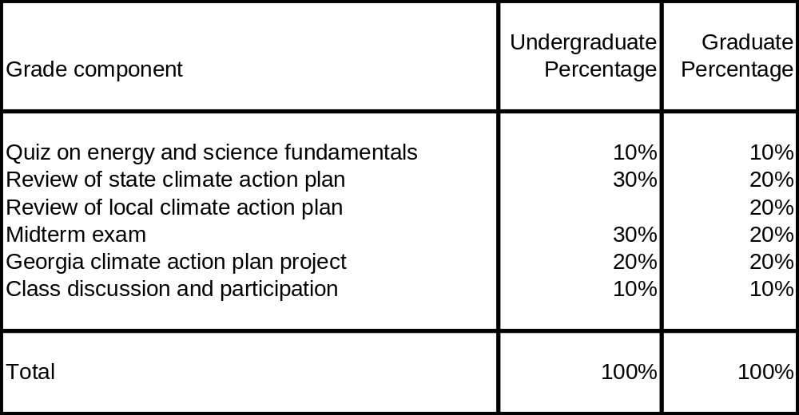

Course Schedule

