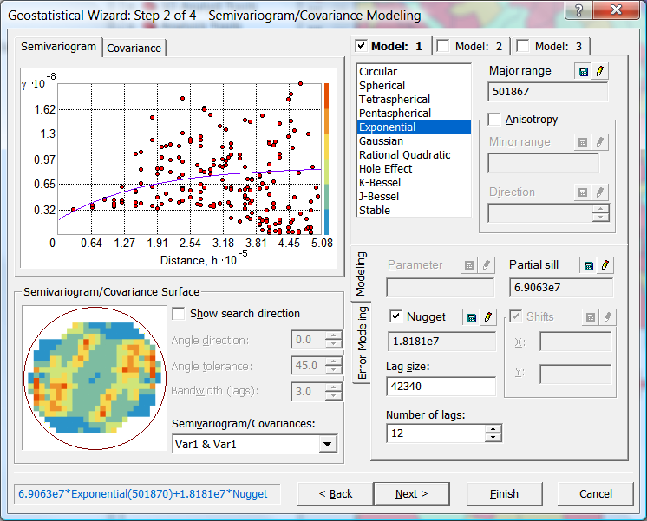
CP 6551: Socioeconomic GIS
William J. Drummond
Fall 2011

Course Syllabus

Instructor: William Drummond Office Hours: Tu/Th 1:00 – 2:00
204 East Architecture and other times Phone: 404-894-9840 by appointment
Email: bill.drummond@coa.gatech.edu

Course description

CP 6551 is an advanced GIS course that focuses on the collection, management, analysis, and display of socioeconomic data. It is a companion course to Environmental GIS (CP 6541) and Transportation GIS (CP 6542). It requires successful completion of a first GIS course (such as CP 4510 or CP 6514) or a year of experience in working with GIS.

Socioeconomic GIS addresses human activity patterns over space and time within the context of general end-values such as sustainability, economy, equity, and livability. In particular, the course includes GIS-based consideration of demographics (age, race, sex, ethnicity), economics (income and employment), and housing (both individual units and community characteristics). Within each of these areas the major sources of spatial and attribute data are identified, basic and advanced data management techniques are considered, and appropriate geostatistical models are presented.

Teaching methods

The major teaching methods for this class include lectures, in-class labs, class discussions, required readings, exams, and a major project using socioeconomic GIS data and analysis methods.

All students are expected to attend all class sessions, and the required readings should be done before the first class of the week in which they are assigned. Some classes, or portions of classes, will be focused on class discussion of the readings and lecture materials, and every student will be expected to participate in discussion.
Learning Objectives

Students successfully completing the course will:
- Appreciate the fundamental advantages and disadvantages of working with socioeconomic spatial information compared to other fundamental types of GIS data such as environmental or transportation,
- Be familiar with the major sources of socioeconomic GIS data, including the Census of Population, American Community Survey, County Business Patterns, and local government parcel databases,
- Be capable of creating the most appropriate database structures for manipulating different types of socioeconomic GIS attribute data,
- Understand the concept of spatial autocorrelation and its implications for statistical analysis of spatial data,
- Calculate a variety of spatial descriptive statistics including Moran’s I, LISA, and Gettis-Ord measures of hotspot and coldspot clustering,
- Interpolate surfaces with methods such as inverse distance weighting and kriging, and
- Apply the major families of socioeconomic causal analysis including OLS regression, spatial dummy variables, spatial polynomial regression, spatial error regression, and spatial lag regression.

Students with Disabilities

Students with disabilities needing academic accommodation should provide documentation to the Access Disabled Assistance Program for Tech Students (http://www.adapts.gatech.edu/) and bring an ADAPTS accommodation letter to the instructor indicating the nature of accommodations required. This should be done within the first week of class or as soon as possible after a new disability condition arises. All effort will be made to provide reasonable accommodation.

Grading

The Georgia Tech Honor Code is in effect throughout this course. You should review this code and make sure you understand your responsibilities. If you have any questions, please contact the instructor.

Test, exam, and assignment grades may be curved upward or downward depending on the actual distribution of grades in a particular test, exam, or assignment. Each student’s final grade in the class will be based upon these components:

Midterm exam: 30 percent
Final exam: 30 percent
Class project and presentation 30 percent
Class participation 10 percent

Course readings

Students are expected to purchase two textbooks. The required texts are:

Unlocking the Census with GIS
By Alan Peters and Heather MacDonald
ISBN: 1589481135
Using ArcGIS Geostatistical Analyst: ArcGIS 9
By Editors of ESRI Press
ISBN: 1589481062

Course online materials

This class will utilize the College of Architecture online folder system rather than Tsquare. You are encouraged to use notepad to create a batch file named mapqrs with the following contents, and save it on your GT/COA desktop:
net use q: \\coa.ad.gatech.edu\gtfs\Courses
net use r: \\gtcoa.coa.ad.gatech.edu\GISData
net use s: \\coa.ad.gatech.edu\gtfs\Courses\CP-6551-C-201108
This file will establish the q, r, and s drives that we will be using for GIS data and other materials throughout the course. You may also manually map drives using Windows Explorer. When you are off-campus, you may need to connect via a VPN before mapping these drives.
Access 2007 Tutorials

- Choose between Access and Excel
- Get to know Access 2007
- Up to speed with Access 2007
- Take charge of your database with the Navigation Pane
- Design tables for a new Access 2007 database
- Build relationships for a new Access 2007 database
- Create queries for a new Access 2007 database

- Queries I: Get started with queries
- Queries II: Create basic select queries
- Queries III: Use expressions and other criteria
- Queries IV: Use functions and calculated fields in your queries
- Queries V: Use "And", "Or", and "In" to set multiple conditions
- Queries VI: Use wildcards in queries and parameters
- Queries VII: Query multiple sources for data
- Demo: Set the relationship between two tables
CP 6551: Socioeconomic GIS
William J. Drummond
Fall 2011

Course Project

The assignment for this course is to produce a GIS project based upon the socioeconomic data and spatial analysis capabilities we have learned throughout the course. Your project can be in any substantive area of interest, such as transportation, environment, land use, economic development, real estate, or any other area utilizing socioeconomic data and analysis. If you wish, you may combine this project with work for another class. However, you must turn in all your final products for both classes to both instructors so the effort made for each course can be individually assessed.

This is a demonstration project whose basic purpose is to show the relevance of socioeconomic GIS for actual policy decisions or research investigation in your area of interest. You may use real data, hypothetical data, or a combination of the two. If you use any hypothetical data, the data should be realistic so that the demonstration is convincing. Do not plan to use a dataset any larger than that needed for a successful demonstration. Most SEGIS projects can be adequately completed with small datasets. Your written report course project should include 8-10 pages of project report text (about 2500 to 3000 words) and a set of well-formatted maps integrated with the project text. Your project report should include (at a minimum) the following information:

Problem description
Data sources and description
Analysis techniques used
Analysis results with printed maps
Discussion of the significance of the results

During the courses final class period each student will give a 5-minute PowerPoint presentation on his or her project. The presentation will emphasize the analysis techniques and final results with a maximum of five PowerPoint slides.
The project report will be due at the final exam period.
Course schedule (version 1)
