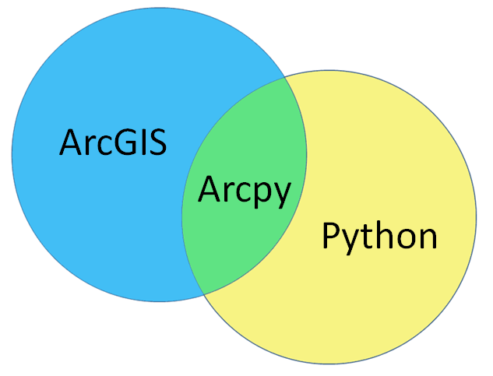
Course Syllabus

Instructor: William Drummond
Office: 204 East Architecture
Phone: 404-894-9840
Email: bill.drummond@design.gatech.edu
Office hours: 11:00 – 12:00 Monday and Wednesday

Course description

The purpose of CP 6581 is to provide graduate students with the specialized programming skills needed to conduct advanced spatial data analysis. It focuses on Python programming with major attention on the Arcpy library, which is the main programming interface for the ArcGIS environment. It also addresses basic online GIS and Javascript programming to embed GIS functionality in Web pages.

The course has a pre-requisite of CP 4510 or CP 6514, “Introduction to GIS.”

Learning objectives
By the end of the course students will

- Develop specialized programming skills in the Python language
- Apply those skills to standard GIS tasks with the Arcpy geoprocessing library
- Utilize the Google Maps API
- Process vector and raster data structures through direct programming
- Understand basic Javascript programs to enable Web-based GIS functionality

Course readings

The course has two required textbooks:
Python Scripting for ArcGIS
by Paul A. Zandbergen
ISBN: 978-1589483712
Getting to Know Web GIS, 2nd edition
by Pinde Fu
ISBN: 978-1589484634

Additional readings will be posted online at the course tsquare site and/or the Courses directory of the College of Design server.

Course grading
The Georgia Tech Honor Code is in effect throughout this course. You should review this code and make sure you understand your responsibilities. If you have any questions, please contact the instructor.

Student grades will be based upon two tests, a final exam, and a course project that will consist of a project report and an E-sized poster. Details on the course project are provided below.
__________________________________________________

Component Percentage of final grade
__________________________________________________

Test 1 20%
Test 2 20%
Final exam 25%
Course project report 25%
Course project poster 10%
__________________________________________________

Course Project

The assignment for this course is to produce a GIS project based upon the programming skills we have been learning throughout the semester. Your project can be in any area of interest, such as transportation, environment, land use, economic development, real estate, or any other substantive area. If you wish, you may combine this project with work for another class. However, you must obtain prior approval from both instructors and turn in all your final products for both classes to both instructors, so the effort made for each course can be individually assessed.

This is a demonstration project whose basic purpose is to show the application of programming skills for GIS geoprocessing and presentation. The programming work will consist of two main components: spatial data geoprocessing and project presentation through custom menus. You may use real data, hypothetical data, or a combination of the two. If you use any hypothetical data, the data should be realistic so that the demonstration is convincing. Do not plan to use a dataset any larger than that needed for a successful demonstration. Most class projects can be adequately completed with small to moderate datasets.

On the due date listed in the syllabus you will turn in a short project prospectus. It should include:

- The main question your project is intended to answer. State this in one sentence as a question. Often, as in many GIS projects, the question will begin with “Where…”.
- A single paragraph, ½ page, description of your project. Explain why the topic is important and what you hope to explain, learn, and/or accomplish?
- A listing of the required GIS datasets and their sources (Census Bureau, R drive, etc.)

Your written report course project is due at the date listed in the course schedule. It should include (not counting code) about 2,400 to 3,000 words (8-10 pages) of project report text, set of well-formatted maps integrated with the project text, and a complete, fully documented and commented, program listing as an appendix. Your project report should include (at a minimum) the following information:

- Problem description
- Data sources and description
- Analysis techniques used
- Analysis results with printed maps
- Discussion of the significance of the results
- Documented and commented programming code (as appendix)

Students with Disabilities/Academic Integrity and Conduct

Academic Integrity and Conduct
Georgia Tech aims to cultivate a community based on trust, academic integrity, and honor. Students are expected to act according to the highest ethical standards. All Georgia Tech students should familiarize themselves with and abide by the Georgia Tech Honor Code http://www.catalog.gatech.edu/rules/18/.
Student work that presents the ideas or words of others as the student’s own adversely impacts the whole school and may lead to immediate dismissal. Academic dishonesty, including cheating, plagiarism, commissioning academic work by others, or performing academic work on behalf of another student, is strictly prohibited. All persons in the classroom are expected to behave with courtesy towards others and in a way that does not interfere with the regular conduct of the class. Cell phones are to be turned off when students enter the classroom and should remain off for the duration of class: http://www.catalog.gatech.edu/rules/19/

Special Needs
Any student with a disability, that may require accommodation, should contact Office of Disability Services at 404-894-2563 or visit http://disabilityservices.gatech.edu to make an appointment to discuss his or her special needs and obtain an accommodations letter. He or she should also schedule an appointment to speak with the course instructor.

Course schedule (version 2)
