GEORGIA INSTITUTE OF TECHNOLOGY
College of Computing
CS 6457 VG : Video Game Design and Programming

Instructor(s):
Jeff Wilson – jeff.wilson@imtc.gatech.edu
Maribeth Gandy – maribeth.gandy@imtc.gatech.edu

Description:
Techniques for electronic game design and programming, including graphics, game engines, motion generation, behavioral control for autonomous characters, interaction structure, social and interface issues of multi-user play, and the business aspects of game development.

Course Requirements:

Project

The majority of a student’s work will involve a group project designing and creating a video game using a commercial game engine. Student groups must make several presentations of their progress to the class.

Assignments

Assignments are in the form of milestones, which ensure that certain technology requirements are met for the group projects. These milestones will involve both individual and group deliverables.

Class Participation

Students are expected to attend class as well as participate in class discussions and activities.

Graduate Student Grading

The graduate students projects will have higher expectations in terms of technical sophistication, in one or more areas of their choosing. For example, they could design and implement more sophisticated AI, or leverage more advanced graphics and simulation effects.

Grading:

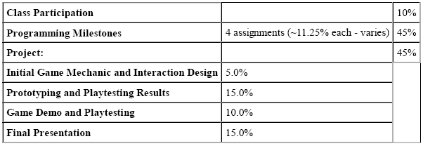
Course Outline

