Syllabus, Fall 2012
HISTORY OF ECONOMIC THOUGHT
W. A. Schaffer Fall 2012
Econ 4620A MWF 2, IC 111
TEXTS: (1) Todd G. Buchholz, New Ideas from Dead Economists, Revised Edition, New York: Plume (Penguin Putnam, Inc.), 1999. (2) Robert L. Heilbroner, The Worldly Philosophers, Updated Seventh Edition, New York: Simon and Schuster, Inc., 2003. (3) Selections from the Wealth of Nations and other readings (library-site files).
Course Description
This course traces the history of Western economic thought from ancient to modern times, with an emphasis on developments since Adam Smith published the Wealth of Nations in 1776. We attempt to understand the interactions of scholars in building a discipline called "economics," the influence of technological change and the social, business, and political environments on economics, and the influence of economists on society. In addition, we examine the progress of the principles of economics from their formative stages to modern times.
Process
We will discuss the Buchholz and Heilbroner texts throughout the semester; they provide a simple unifying theme. The Greeks, the Schoolmen, the Mercantilists, and the Physiocrats will be addressed through readings available in electronic files from the on-line reserves of the Georgia Tech Library and through other sites on the Web. We will work through major points in Adam Smith's Wealth of Nations in some detail, drawing on annotated material available on reserve and as an electronic file. We will use supplementary readings (on library reserve) to address Smith's contemporaries, Karl Marx, a host of early thinkers, and the economists leading us into the last century in developing economics as a science.
We will have three short quizzes and a final exam on which to base your grade. The three highest scores will each count for one-third of your final grade. No makeups will be offered (In effect, the final exam is a makeup.). The quiz grades will be curved, the course grade will not be. While these will include mostly multiple-choice and short discussion questions, they will be designed to determine whether or not you have read and assimilated the two assigned books and the assigned readings. This means they could be picky. Note that the quizzes will focus on all materials assigned as well as on classroom discussions.
Attendance is not required. It is, of course, desired. You are expected to keep up with all schedule changes and with discussions in class, some of which may appear on quizzes without printed support.
You may use any legally and honorably obtained source you wish in studying for this course. You are, in fact, encouraged to talk about our topic with friends, other students, professors, and even parents. Our goal is to become conversant on the history of economics.
Tentative Schedule

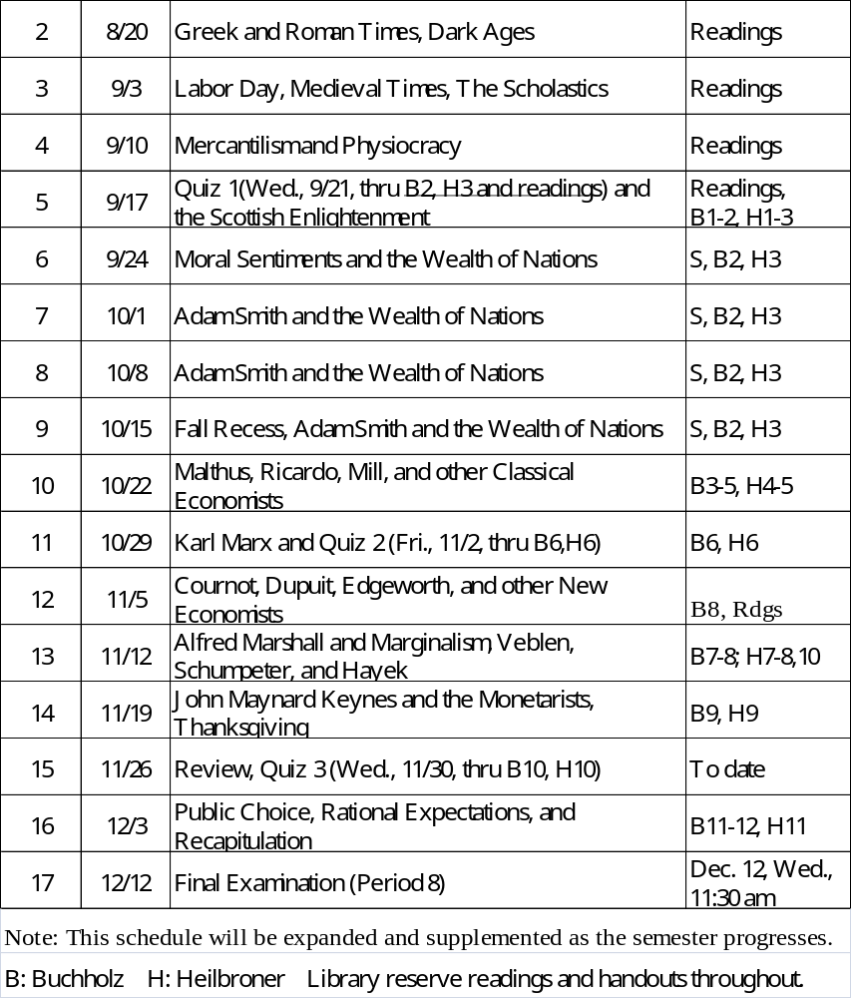 Abbreviations: B for Buchholz, H for Heilbroner, S for Smith. Library reserve readings and handouts throughout.
References

I have chosen two books as common texts for the course. Both are simple, entertaining, and easy to read. But I encourage you to read other books and develop an appreciation for the evolution of economics as a discipline. The following are some of the books which I have read in preparing for this course; all are in the Georgia Tech Library. I may refer to these and others in class.

Backhouse, Roger E. The Ordinary Business of Life. Princeton University Press, 2002.
Blaug, Mark. Economic Theory in Retrospect. Fifth Edition. Cambridge: Cambridge University Press, 1997. (First Edition published by Richard D. Irwin, Inc., 1962).
Cameron, Rondo. A Concise Economic History of the World. Third Edition. Oxford: Oxford University Press, 1997.
Ekelund, Robert B., Jr., and Robert F. Hébert, A History of Economic Theory and Method, Fourth Edition. McGraw-Hill, 1997.
Gordon, Scott. The History and Philosophy of Social Science. London, Routledge, 1993.
Gray, Alexander, Sir. The Development of Economic Doctrine. Second Edition. London, Longman, 1980.
Heilbroner, Robert. Teachings from the Worldly Philosophers (Norton, 1996)
Herman, Arthur. How the Scots Invented the Modern World. Three Rivers Press, 2001.
Nelson, Robert H. Economics as religion: from Samuelson to Chicago and beyond. Pennsylvania State University Press, 2001.
Roll, Eric, Sir. A History of Economic Thought, Fourth Edition. London, Faber, 1973.
Rothchild, Emma. Economic Sentiments: Adam Smith, Condorcet, and the Enlightenment. Cambridge: Harvard University Press, 2001.
Spiegel, Henry William. The Growth of Economic Thought, Revised and Expanded. Durham, N.C., Duke University Press, 1983.
Schumpeter, Joseph A. History of Economic Analysis. New York, Oxford University Press, 1954.
Smith, Adam. An Inquiry into the Nature and Causes of the Wealth of Nations. (edited by Edwin Cannan) New York, Modern Library, 1937.
Strathern, Paul. A Brief History of Economic Genius. New York, Texere LLC, 2002.

Some Starting Websites for the History of Economic Thought

http://cepa.newschool.edu/het/home.htm History of Economic Thought: Front Page. This site, maintained by the New School, is almost a complete course in itself.

http://www.bibliomania.com/NonFiction/Smith/Wealth/index.html Adam Smith: The Wealth of Nations (Bibliomania.com has many other texts on line, free of charge.).

http://cac.psu.edu/~jdm114 Dead Economists Society. John McGinnis at Penn State provides access to a number of economics books.

http://netec.wustl.edu/~adnetec/WebEc/webecb.html WebEc: Methodology and History of Economic Thought. Site at Helsinki mirrored at Washington University.

http://slutsky.ecn.bris.ac.uk/het Bristol Resources for the History of Economics.

http://timer.kub.nl/economics/econ_history.html TIMER, The Interactive Management and Economics Resources, is a site maintained by Tilberg and Purdue Universities.

http://www.oswego.edu/~economic/histecon.htm A nice set of links to other sites.

http://digital.library.upenn.edu/books The On-Line Books Page at the University of Pennsylvania. Links to books everywhere.

http://socserv2.socsci.mcmaster.ca:80/~econ/ugcm/3ll3/index.html McMaster University Archive for the History of Economic Thought The History of Thought Archive, maintained by Rod Hay, represents an attempt to gather all material for the study of the history of economics at one site. This includes both primary texts and studies of those texts and of their authors. There are mirrors of this site at Bristol (maintained by Tony Brewer) and Melbourne (maintained by Robert Dixon). Paulette Taieb's site at Paris contains many texts in French. New texts are added continuously. Check back frequently. We have also included a list of other interesting archives.

http://www.cpm.ll.ehime-u.ac.jp/AkamacHomePage/Akamac_E-text_Links/Akamac_E-text_Links.html Mirror of MacMaster Archive with some additions by Michio Akama.

http://phoenix.liunet.edu/~uroy/eco54/histlist/index.html Guide to Online Materials on the History of Economic Thought , with economists listed alphabetically, economists grouped by area of contribution, and important websites. Maintained by Udayan Roy at Long Island University. Significant details. Last updated on August 14, 2000.

http://iserver.saddleback.cc.ca.us/div/sbs/econ/econquiz Trivia quiz on the dismal science.

http://www.econ.duke.edu/Economists Portraits of Well-known Economists. This collection of portraits of economists was presented in 1997 as a gift to the Department of Economics of Duke University by Professor Warren J. Samuels of Michigan State University. Free use of these portraits in Web documents, and for other educational purposes, is encouraged: users are requested to acknowledge that the images come from "The Warren J. Samuels Portrait Collection at Duke University."

http://www.marxists.org/archive/marx The Marx/Engels Internet Archive is a repository for almost everything about Marx.

http://dialspace.dial.pipex.com/town/terrace/adw03/peel/peelhome.htm This web site covers many social, political, and economic issues in the period 1830-50 and was written for A Level History students studying this period.

Instructor:
William A. Schaffer, Professor Emeritus
678-517-9726 (C)
Office hours: MWF 3-4 (after class) or on request anytime.
william.schaffer@econ.gatech.edu

