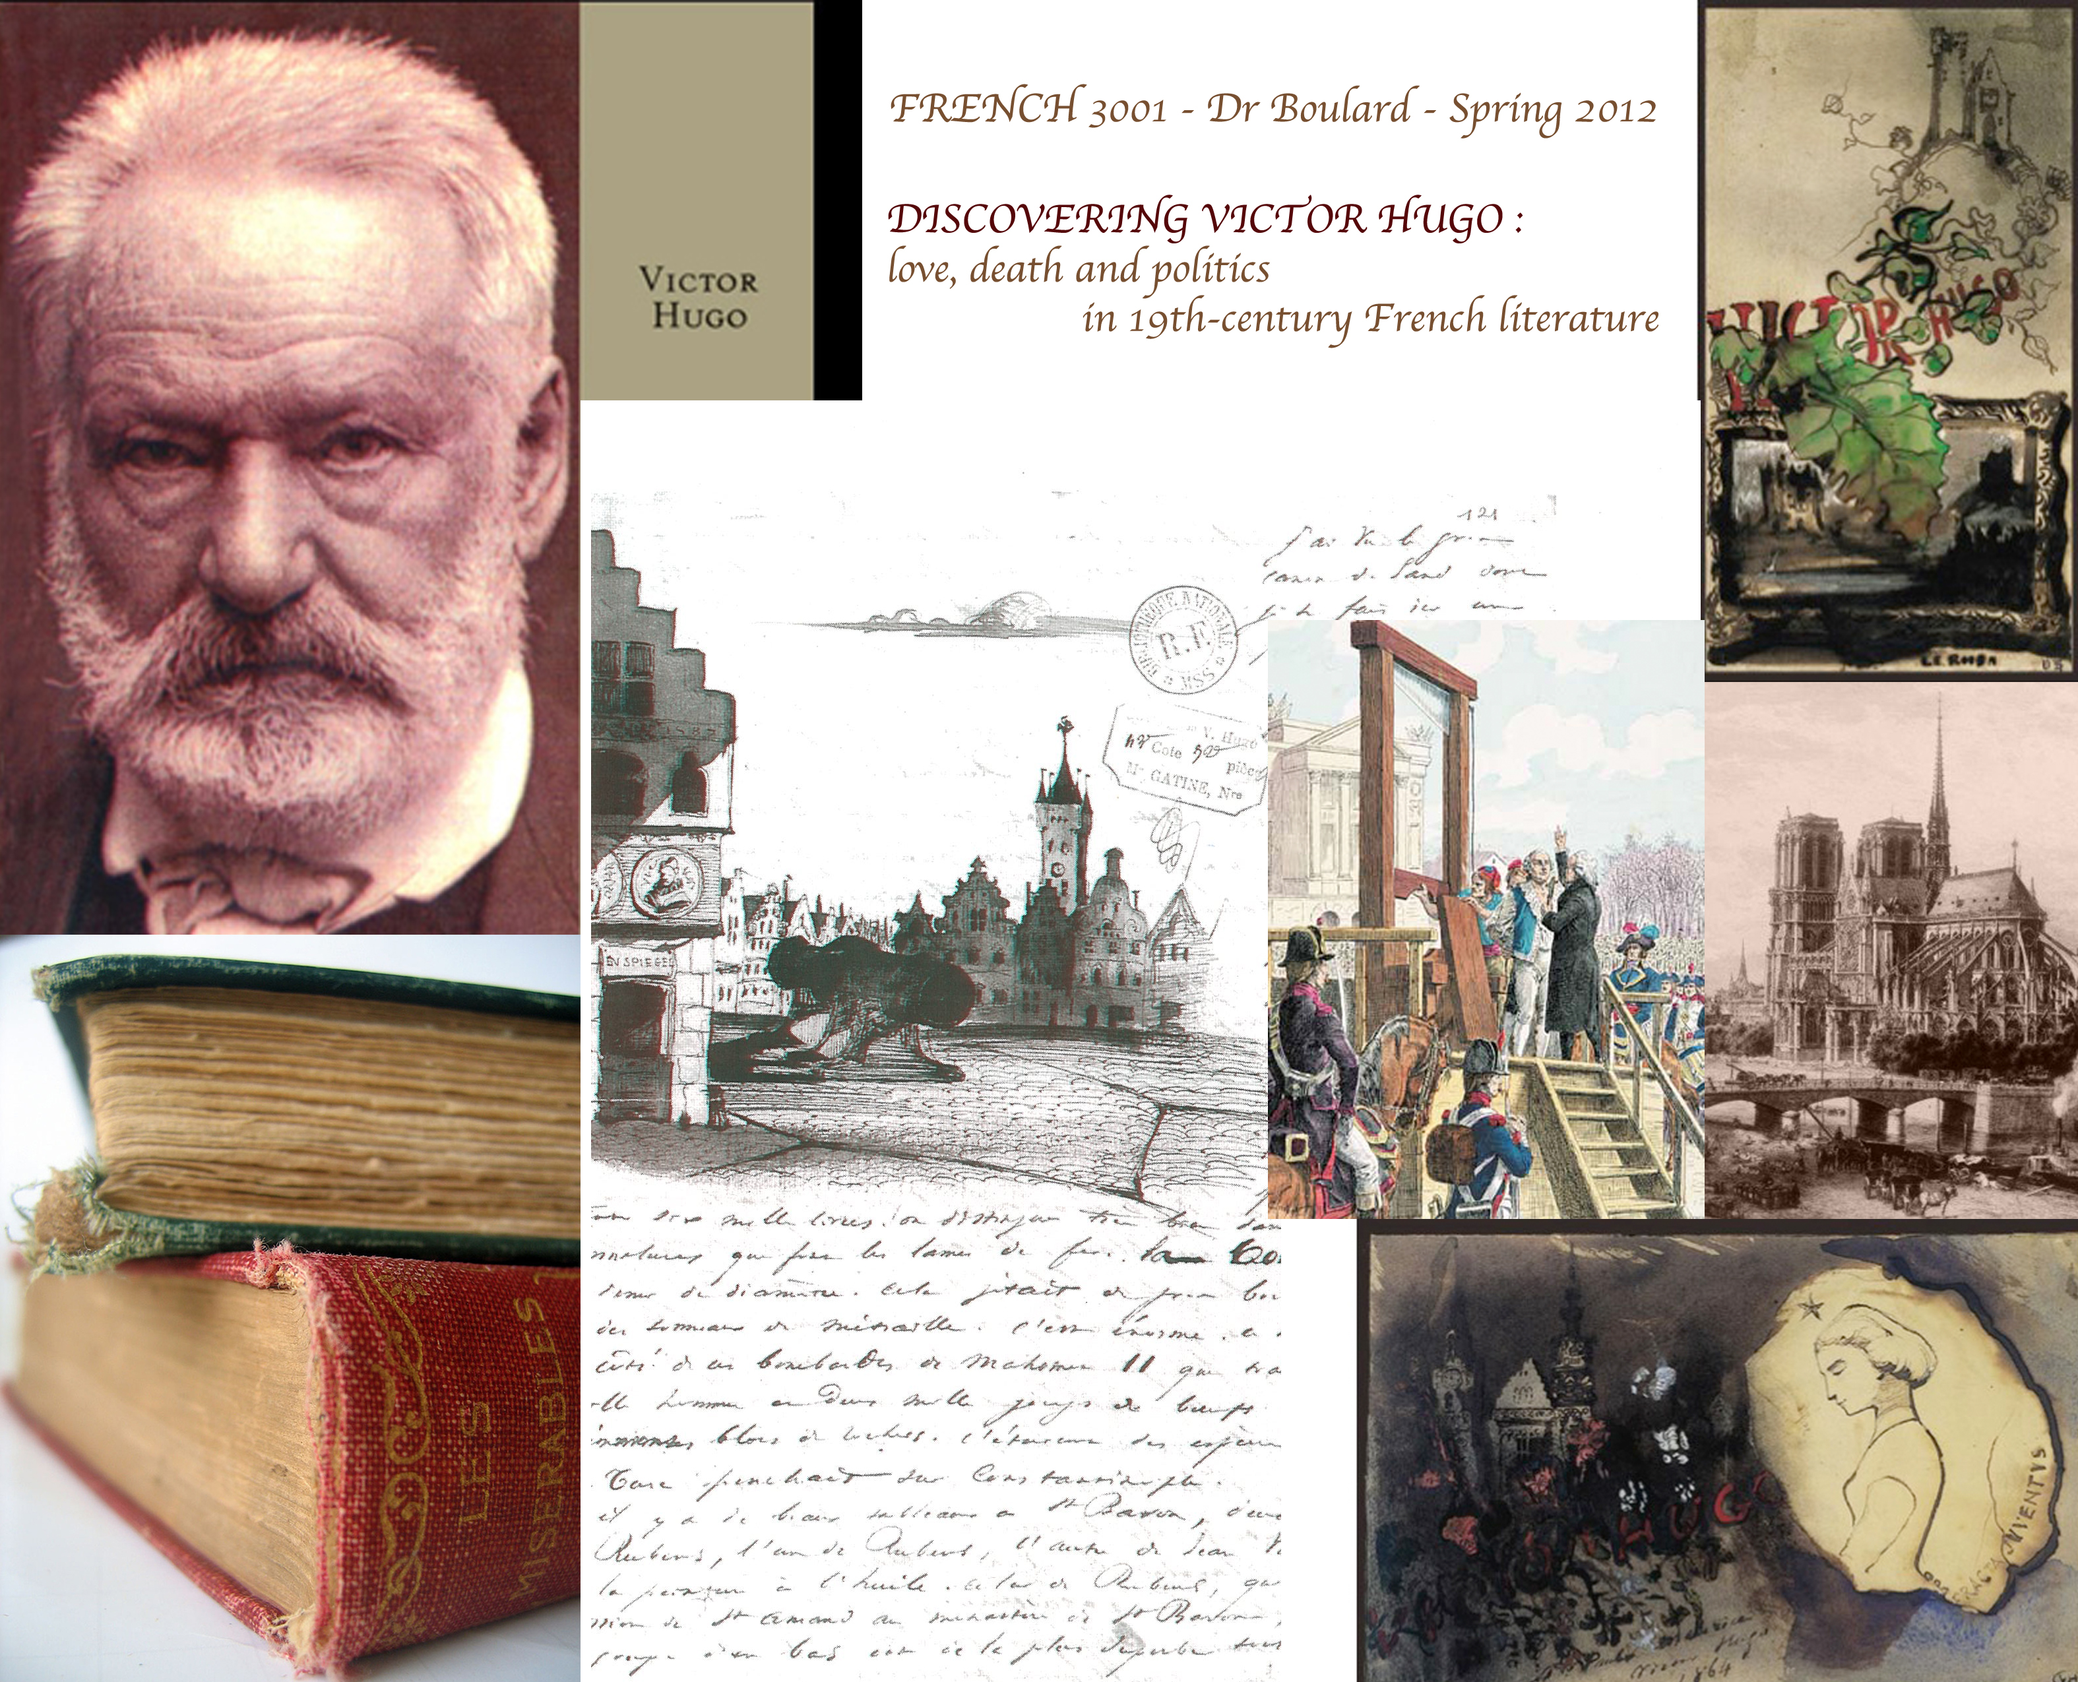

FRENCH 3001B - SPRING 2012
T-Th: 1:35pm-2:55pm - Swann 106
Instructor: Dr Boulard
Office: Swann 225
Office hours: Tuesdays, 11-12pm and by appointment

Tel (office): 404-385-0197
Email address: stephanie.boulard@modlangs.gatech.edu

Course description
DISCOVERING VICTOR HUGO :
love, death and politics in 19th-century French literature

“For with love there is no middle course: it destroys, or else it saves. All human destiny is contained in that dilemma, the choice between destruction and salvation, which is nowhere more implacably posed than in love. Love is life, or it is death. It is the cradle, but also the coffin. One and the same impulse moves the human heart to say yes or no. Of all things God has created it is the human heart that sheds the brightest light and, alas, the blackest despair.”
― Victor Hugo
This class explores nineteenth-century French literature and culture through the most famous figure ever of 19th-century French Literature and definitely the most important of the French Romantic writers: Victor Hugo. Victor Hugo led an extraordinary life during a crucial turning point in world history and his works reflect the important historical events, social changes, and artistic movements contributing to the development of French culture during the 19th century.
Topics include the cultural role of romantic theater and the impact of two hugolian plays (Hernani and Ruy Blas) on French Literature; the poeticized images of love, pain, and politics in Les Contemplations and Les Châtiments (1853; “The Punishments”); and the ambitions and success and failures of the French revolution seen from 19th-century writers with Hugo's last novel, Quatre-vingt-treize (1874; Ninety-three), centered on the tumultuous year 1793 in France which portrayed human justice and charity against the background of the French Revolution.
Topics also include popular culture, the relation between the arts, irony, and modernity.
Other authors studied in this class include major French writers and poets such as Baudelaire, Dumas, Zola, Gautier…

This course will consist essentially of readings and discussions + 2-3 screenings related to the topic.
Relevant literary and critical texts will sometimes accompany the literary text.
The course will be conducted in French only. Students are expected to read the texts BEFORE class at least twice.

Course objectives

ML PERFORMANCE GOAL #1: PROFESSIONAL COMMUNICATION
ML Learning Outcome 1 : Demonstrate oral and aural proficiency in the target language | Students will demonstrate oral proficiency at the advanced high or superior level on the ACTFL scale.
ML Learning Outcome 2: Demonstrate effective presentation skills in the target language | Students will demonstrate the ability to present in class for 10-15 minutes without notes on an everyday topic.
ML Learning Outcome 3: Demonstrate writing proficiency in the target language | Students will produce compositions and long papers at the Intermediate High level on the ACTFL scale. They will acquire the basic concepts and terminology of textual analysis. By learning to identify and interpret the various elements that enter into the composition of a literary text and to perceive their relationships, students acquire a fuller understanding and appreciation of the art and significance of literature.
ML Learning Outcome 4:  Demonstrate proficiency in comprehension of authentic written texts in the target Language | Students will demonstrate analysis and critique of authentic texts related to familiar topics. Gain proficiency in the fundamental language skills that enable students to read and understand prose of moderate difficulty and mature content, and formulate and express critical opinions and judgments in correct oral and written French
ML PERFORMANCE GOAL #2: INTERCULTURAL SKILLS AND KNOWLEDGE
ML Learning Outcome 5: Demonstrate in-depth knowledge of a specific target-language country or region | Students will successfully analyze the literature and cinema of the 19-th century France. Discover and learn about 19th-century literature through the works of Victor Hugo.
ML Learning Outcome 6:  Demonstrate the ability to analyze an issue from target-culture perspective(s) | Develop the ability to read and analyze critically and to discuss perceptively representative works of French literature.
ML Learning Outcome 7:  Demonstrate critical reflection on cultural complexity and context | Students will be aware of the cultural context of the works read & studied in class. Students will analyze how their own background and experiences influence reading and comprehension of cultural products from the target cultures.

Course material

List of Texts
Victor Hugo, Les Contemplations (extraits – in t-square)
Victor Hugo, Les Châtiments (extraits –in t-square)
Victor Hugo, Hernani
Victor Hugo, Ruy Blas
Victor Hugo, Quatrevingt-treize
Victor Hugo : extraits textes, lettres, journal (t-square)

And other extracts from major 19th century French authors:

- Alexandre Dumas
- Théophile Gautier
- Baudelaire
- Emile Zola
- Adèle Hugo
Textes analytiques de : Jean Gaudon, Jean-Marie Gleize, Anne Ubersfeld, Henri Meschonnic, Michael Rifaterre, Pierre Albouy, Laurent Jenny. Etc.

List of films (all subtitled in English – screenings in class or outside of class):
- Adele H, Francois Truffaut
- Danton, Andrzej Wajda’s
- Napoleon, Abel Gance
- Ruy Blas – La Folie des grandeurs, Oury
- Ruy Blas, Cocteau
You are expected to take notes during the screenings and be ready for discussion.

Resources:
- 3 books (Required): 1) V. HUGO: Quatrevingt-treize collection Livre de Poche ; 2) V. HUGO Ruy Blas ; 3) V. HUGO Hernani (The books are available at Barnes&Noble@Georgia Tech Bookstore)
- 1 dictionnary English-french (The dictionnary should be available at Barnes&Noble@Georgia Tech Bookstore)
- Selected texts in pdf format provided by your instructor
- Other books are going to be placed on reserve at the Georgia Tech Library

COURSE REQUIREMENTS

- Assignments:

A: LECTURE ::
The main assignment of this class is reading. Venez préparés ! Il est conseillé de prendre des notes au cours de votre lecture, surtout si vous lisez en avance.
Reading means: 1) read the text at least twice before coming to class, select the key terms establish the structure of the story
2) do some research on themes, history points, and take notes – see DOSSIER / QUESTIONS de preparation (pour les mardi)
3) research the vocabulary that may be problematic – use your dictionary for significations – see FICHES DE VOCABULAIRE (pour les jeudi)
You will need to spend 6 hours a week on your homework. I would urge you to read the material under study and complete the assignments as advised in the calendar. You will be responsible to print out your own copy of the texts on t-square.

B: DEVOIRS/Questions::
En dehors de la lecture, vous aurez en général quelque chose à préparer pour chaque cours : résumés, questions de réflexion, relevés de vocabulaire autour d’un thème, exposés, analyses d’un thème, explications de texte (écrit ou à l’oral)…. Je mettrai sur t-square les devoirs pour chaque semaine.

Questions: I will post questions every week to guide you in your reading. ALL questions have to be prepared before coming to class on TUESDAYS. Among all the questions that you will have to prepare, you will have to choose 1 question and post your answer on the t-square forum [10 lines minimum] before Tuesday. [ie. Monday night 10pm deadline] If you fail submitting your answer in t-square, you will have to give your homework printed with ALL questions answered in class. This type of assignment is to provide students with another way of participation and engagement, as well as to supplement the discussion in class. It is your responsibility to check t-square often.

These questions will sometimes be graded for grammatical correctness, length and depth of thought. [I will let you know] Please type and staple your assignments (12 - New Roman - double spaced). You will lose 5 points for submitting late homework. Homework that is more than one class day late will not be accepted. If you know that you cannot come to class or if your printer is out of order, please email your homework before class convenes. All homework is to be completed before coming in to class.

Vocabulary: “Fiche de vocabulaire”: Vous aurez des fiches de vocabulaire pour chaque JEUDI et devrez donner 1) une courte définition écrite en français et 2) une traduction écrite en anglais pour les mots sélectionnés. Ensuite, mémorisez cette liste. Imprimez. Bring it to class! You will have to present on one word or more in class = be able to explain in FRENCH with words/ drawings/ images. Sometimes you will have to print a copy for me (part of your assignment), one for yourself. Use them as flashcards! Review them regularly. Vocab will be part of quizzes and exams!

All homework is to be completed before coming in to class. Please type and staple your assignments if needed (double spaced). You will lose 5 points for not doing so. Late homework is not accepted in this class. If you know that you cannot come to class or if your printer is out of order, please email your homework before class convenes.

Evaluations:

A: QUIZZES:: You will have during the semester a few quizzes in order to check that you are doing your readings and preparing the questions at home.

B: ORALS:: You will have two short orals: 1) oral performance – during the “theater section”: you will choose a scene that you like from Hernani or Ruy Blas and will play the scene in class by groups of 2-3. You will have to memorize the scene and find an original way to act it. This should enable you to understand more deeply the play and staging, while practicing pronunciation, - it should also be fun… ☺
2) powerpoint presentation: during the “novel section” you will do a short powerpoint présentation by group of 2 on themes, historical events or vocabulary studied in class. See topics & suggestions that will be posted in t-square.
Note: Your powerpoint will have to include 1) various images related to your topic; 2) one short video clip? If you can (from youtube, dailymotion or from a DVD related to the topic); 3) at least one short extract or quotes from Hugo’s works to illustrate your topic. Use books, DVDs and documents placed on reserve at the Gatech Library!

- Final Exam = final paper : Deadline: 10 avril (choix du sujet) 4 mai 2012 (email submission)
Pour votre projet final - à rendre le 4 mai 2102 par email, vous avez plusieurs possibilités, y compris : 1) un travail de recherche sur une des périodes historiques envisagées ; 2) une explication de texte perfectionnée d’un texte (poème / extrait de roman); 3) une analyse thématique perfectionnée ; 4) une analyse développée d’un sujet de réflexion ou 5) une comparaison analytique de deux éléments du cours (2 poemes, 1 extrait de texte / 1 film, etc). Il faut préciser votre sujet avant le 10 avril 2012.
Je posterai avant le spring break des exemples de sujets sur t-square.

Grade Distribution:

- Devoirs maison (questions/ vocabulaire /mini exposes): 20%
- la participation active (volontaire) en classe, la préparation pour chaque cours (reading discussion, vocab, etc.) + post on t-square forum, etc.= 20%
- les quiz = 20%
- les 2 présentations orales = 20%
- Final paper = 20%

COURSE POLICIES

MY OFFICE:
I want to hear from you! ☺ DO NOT hesitate to come and see me as often as you want! You can also take an appointment if office hours are not convenient for you. If you ever feel uncomfortable about something in class, if you want me to focus on one aspect of your learning, let me know. I will focus on that one point with you. Never hesitate to come and talk to me. I’ll be happy to see you and to help you. Write down any questions that you may have. You can ask them in class or e-mail them to me also. I will make sure your questions, concerns or suggestions get the attention they deserve. Never hesitate when you have questions: I am available!

Participation:
The success and interest of this course rely on the respectful and thoughtful participation of each and every member of the class. I hope that you will all find your own way to engage with the material that has been selected for your experience of French literature as well as with your peers. Note that your active participation in classes is crucial and will help to determine your final grade.

Absences:
You are required to attend class T-Th each week.
Remember that regular attendance is required. Absences will be recorded and unexcused absences or repeated tardiness will have a decidedly negative effect on your final grade.
Each absence after the third absence will result in an automatic reduction of your final grade. Regular lateness will also result in the reduction of your final grade. You are allowed 3 unexcused absences without penalty. EACH additional absence will result in the subtraction of 1 point from your course grade (on a 100 scale). For perfect attendance, 1 point will be added to the final grade. Please arrive to class on time…3 tardies of more than 5 minutes = 1 absence. If I already called the roll, you will be marked absent, unless you tell me after class, in which case you will be marked late. Do make sure you arrive on time. Not only do you lose points for coming in late, but also, you lose participation points!
If you know that you cannot come to class, email it to me before class convenes and you won't lose points on the assignment. If you are sick, please bring a note from the doctor or GT Health Services and you won't lose points on either the assignment or presence in class. No work can be made up unless in the case of serious medical condition. Please coordinate your activities with the syllabus ahead of time. If you are going to have to miss a class due to a college sanctioned activity, you are responsible for completing assignments and taking exams ahead of time. Please, turn your cell phones or beepers off while in class.

HONOR CODE:
As such, all work that you submit for this course must be your own: papers, presentations, exams, etc. The claiming of someone else’s work as your own will not be tolerated. When working on homework, you may not work with other students, and doing such is a violation of the GT Academic Honor Code unless otherwise indicated by your professor. For instance, you may work with a classmate for your in-class presentation. Submitting any work other than your own is also a violation of the Academic Honor Code. Do not plagiarize! Plagiarizing is defined by Webster’s as “to steal and pass off (the ideas or words of another) as one's own: use (another's production) without crediting the source.” If caught plagiarizing, you will be dealt with according to the GT Academic Honor Code. Cheating off of another person’s test or quiz is unethical and unacceptable. Cheating off of anyone else’s work is a direct violation of the GT Academic Honor Code, and will be dealt with accordingly. For any questions involving these or any other Academic Honor Code issues, please consult with me or click www.honor.gatech.edu.

Students with Disabilities/accommodations:
If you have specific physical, psychiatric or learning disabilities and require accommodations, please let me know in the first week the semester so that your learning needs may be appropriately met. Please also contact the ADAPTS office for classroom and academic accommodations. If you need an accommodation, please contact Tameeka Hunter, Disabilities Services Specialist and Program Coordinator, at: tameeka.hunter@vpss.gatech.edu or (404) 894–256.

Calendrier, programme du cours et devoirs :

- This calendar is aimed at making your learning easier. I spread the homework as evenly as possible to ensure a regular learning process (please set aside two hours to work on your French for each hour of class time). I urge you to do the homework and the readings (!!!) as advised rather than waiting for due dates, which would put unnecessary pressure on you. If done on a regular basis, it will seem like very little. Moreover, you will learn faster because you will come to class prepared, which in turn will help you participate and feel more comfortable in the classroom. I would advise setting aside one hour a day to work on your French (eyes on the clock, don't cheat).
- Preparing in advance will also enable you to identify potential problems. Write down any questions that you may have. Either ask them in class or e-mail them to me. Never hesitate when you have questions: I am available!
- If you ever feel uncomfortable about something in class, if you want me to focus on one aspect of your learning, let me know. I will focus on that one point with you. Never hesitate to come and talk to me. I want to hear from you.
- The course syllabus can and may be modified at any time according to the needs of the class.
All homework is to be done BEFORE coming to class

Cours | Devoirs

Mardi 10 janvier – POESIE  Introduction : présentation du cours  Lecture de poèmes  Etude : Les Châtiments, « Souvenir de la nuit du 4 » | Pour le jeudi 12  Lecture : Feuille de poèmes donnée en cours  Vocabulaire : recherche mots difficiles  Questions : Préparer les questions du document.
Jeudi 12 janvier – POESIE  Les Châtiments  Etude : Fin de « Souvenir de la nuit du 4 » +  « L’exil » | Pour le 17/01  Lecture : Les Châtiments : « Fable ou histoire » ;  Les Contemplations : DOSSIER I [t-square]  Questions : Répondre aux questions DOSSIER I
Last day to register, make schedule changes | and/or drop courses without a "W" grade
Mardi 17 janvier – POESIE  Les Châtiments : « Fable ou histoire »  Les Contemplations  DOSSIER I | Pour le 19/01  Lecture : Les Contemplations : DOSSIER II [t-square]  Vocabulaire : Faire FICHE DE VOCABULAIRE I  Questions :
Jeudi 19 janvier – POESIE  Les Contemplations  DOSSIER I  « Réponse à un acte d’accusation » | Pour le 24/01  Lecture : Les Contemplations : DOSSIER II [t-square]  Questions : Répondre aux questions DOSSIER II
Mardi 24 janvier – POESIE  Les Contemplations  DOSSIER II | Pour le 26/01  Lecture : Les Contemplations : DOSSIER II [t-square]  Vocabulaire : Faire FICHE DE VOCABULAIRE II  Questions :
Jeudi 26 janvier – POESIE  Les Contemplations  DOSSIER II | Pour le 31/01  Lecture : Hernani ACTES I & II + DOSSIER THEATRE I [t-square]  Questions : Répondre aux questions DOSSIER I
INSCRIPTIONS DES GROUPES | ORAL THEATRE [t-square]
Mardi 31 janvier – POESIE/THEATRE  Les Contemplations - conclusion  Hernani – Préface + Acte I & II  La Bataille d’Hernani | Pour le 2/02  Lecture : Hernani + DOSSIER THEATRE I [t-square]  Vocabulaire : Faire FICHE DE VOCABULAIRE III  Questions : recherche historique
Jeudi 2 février – THEATRE  Hernani – Acte II | Pour le 7/02  Lecture : Hernani ACTES III & IV + DOSSIER THEATRE I [t-square]  Questions : Répondre aux questions DOSSIER I
Choisir votre/vos partenaire(s) de théâtre | Préparation de l’oral I
Mardi 7 février – THEATRE  Hernani – III & IV | Pour le 9/02  Lecture : Hernani  Vocabulaire : Faire FICHE DE VOCABULAIRE IV  Questions : Répondre aux questions DOSSIER I [t-square]
Jeudi 9 février – THEATRE  Hernani – Verdi  => ORAL I Mise en scène I | Pour le 14/02  Lecture : Hernani – ACTE V  Questions : Répondre aux questions DOSSIER I [t-square]
Mardi 14 février – THEATRE  Hernani – Acte V  => ORAL I Mise en scène I | Pour le 16/02  Vocabulaire : Faire FICHE DE VOCABULAIRE V
Jeudi 16 février – THEATRE  => ORAL I Mise en scène I | Pour le 21/02  Lecture : Ruy Blas ACTES I & II + DOSSIER THEATRE II [t-square]  Questions : Répondre aux questions DOSSIER II [t-square]
INSCRIPTION GROUPES | POWERPOINTS [t-square]
Mardi 21 février – THEATRE  Ruy Blas – Préface + Acte I & II | Pour le 23/02  Lecture : Ruy Blas ACTE III + DOSSIER THEATRE II [t-square]
Jeudi 23 février* – THEATRE  Ruy Blas – Acte III | Pour le 28/02  Lecture : Ruy Blas ACTES IV + DOSSIER THEATRE II [t-square]
Mardi 28 février*– THEATRE  Ruy Blas – Acte IV  FILM | Pour le 1/03  Lecture : Ruy Blas ACTES V + DOSSIER THEATRE II [t-square]  Vocabulaire : Faire FICHE DE VOCABULAIRE VI
Choisir votre/vos partenaire(s) de théâtre | Préparation de l’oral I
Jeudi 1 mars* – THEATRE  Ruy Blas - ACTE V | Pour le 6/03  Lecture : relire ! Ruy Blas ACTES I-III + DOSSIER THEATRE II [t-square]  Questions : Répondre aux questions DOSSIER II [t-square]
Mardi 6 mars – THEATRE  Ruy Blas – Discussion Acte II & III  => ORAL I Mise en scène II | Pour le 8/03  Lecture : relire Ruy Blas ACTES III-V DOSSIER THEATRE II [t-square]
CHECK POSSIBLE SCREENING | OUTSIDE OF CLASS
Jeudi 8 mars – THEATRE  Ruy Blas – Discussion Actes IV & V  => ORAL I Mise en scène II | Pour le 13/03  Lecture : Quatrevingt-treize PARTIE I  Questions : DOSSIER 93 - I
Mardi 13 mars – ROMAN  Quatrevingt-treize PARTIE I | Pour le 15/03  Lecture : Quatrevingt-treize PARTIE I  Vocabulaire : Faire FICHE DE VOCABULAIRE VII
Jeudi 15 mars – ROMAN  Quatrevingt-treize PARTIE I  = > ORAL II Powerpoints | Attention !! Il faut lire pendant le SPRING BREAK !  Pour le 27/03  Quatrevingt-treize PARTIE II en entier !
CHECK TOPICS FOR FINALS | T-SQUARE
Mardi 20 mars – SPRING BREAK
Jeudi 22 mars – SPRING BREAK | Pour le 27/03  Quatrevingt-treize PARTIE II en entier !  Questions : DOSSIER 93 - II
Mardi 27 mars – ROMAN  Quatrevingt-treize PARTIE I & II | Pour le 29/03  Lecture : Quatrevingt-treize PARTIE II  Vocabulaire : Faire FICHE DE VOCABULAIRE VIII
CHECK POSSIBLE SCREENING | OUTSIDE OF CLASS
Jeudi 29 mars – ROMAN  Quatrevingt-treize PARTIE II  = > ORAL II Powerpoints | Pour le 3/04  Lecture : Quatrevingt-treize PARTIE III – LIVRES 1 & 2  Questions : DOSSIER 93 - III
Mardi 3 avril – ROMAN  Quatrevingt-treize PARTIE II & III | Pour le 5/04  Lecture : Quatrevingt-treize  Vocabulaire : Faire FICHE DE VOCABULAIRE IX
Jeudi 5 avril – ROMAN  Quatrevingt-treize PARTIE III  = > ORAL II Powerpoints | Pour le 10/04  Lecture : Quatrevingt-treize PARTIE III – LIVRES 3, 4, & 5  Questions : DOSSIER 93 - IV
THINK ABOUT YOUR FINAL TOPIC | T-SQUARE
Mardi 10 avril – ROMAN  Quatrevingt-treize PARTIE III  DEADLINE :  Submit your choice for final topic ! | Pour le 12/04  Lecture : Quatrevingt-treize  Vocabulaire : Faire FICHE DE VOCABULAIRE X
Jeudi 12 avril – ROMAN  Quatrevingt-treize PARTIE III  = > ORAL II Powerpoints | Pour le 17/04  Lecture : Quatrevingt-treize PARTIE III – LIVRES 6 & 7  Questions : DOSSIER 93 - V
CHECK POSSIBLE SCREENING | OUTSIDE OF CLASS
Mardi 17 avril – ROMAN  Quatrevingt-treize PARTIE III | Pour le 19/04  Lecture : Quatrevingt-treize  Vocabulaire : Faire FICHE DE VOCABULAIRE XI
Jeudi 19 avril – ROMAN  Quatrevingt-treize PARTIE III  = > ORAL II Powerpoints | Pour le 24/04  Lecture : Quatrevingt-treize
Mardi 24 avril – ROMAN
Quatrevingt-treize – Discussion finale

= > ORAL II Powerpoints
Jeudi 26 avril – ROMAN  Last class ☹  FILM | Pour le 4/05  Final project due
4 mai  Final project due | Bonnes vacances ! ☺

