Spring 2009
Financial Markets: Trading and Structure
Syllabus

Instructor: Jonathan Clarke
Office: 411 COM
Email: Jonathan.Clarke@mgt.gatech.edu
Phone: 404-894-4929
Office Hours: Tuesday and Thursday 3:00 to 4:00

Classroom: Ferris-Goldsmith Trading Floor

Overview:
The course focuses on liquidity, market structure and trading. In equity markets around the world, investors are increasingly concerned with controlling transaction costs, and innovative trading technologies have been introduced. In this context, attention is given to the efficiency of trading systems and market centers, the impact of computer technology on markets and trading, the role of intermediaries, and regulatory actions on market structure issues. The course examines a number of alternative market structures in terms of their economic and operational underpinnings. Simulation software is used to provide hands-on experience in making tactical trading decisions in different market structures.

Computer Simulations:
Simulation software (TraderEx) will be used in the course for in-class demonstrations and homework assignments. When using the simulation, you will enter orders and/or quotes into a computer-driven market that generates order flow and that responds directly to your orders. You will see your results in real-time and analyze them after play. Auction, dealer, and hybrid markets are simulated. The simulation should deepen your awareness of what trading involves and sharpen your trading skills.

Course Materials:

- Texts:
The Equity Trader Course, Robert Schwartz and Reto Francioni, John Wiley & Sons, 2006.
- Power Point Presentations will be posted on T-square
- Additional readings will be posted on T-Square

Tentative Grading Scheme:

Assignment | Fraction of your grade
Final Exam | 25%
Project | 25%
Assignment 1 | 10%
Assignment 2 | 10%
Assignment 3 | 10%
Assignment 4 | 10%
Assignment 5 | 10%

Students are expected to adhere to the Georgia Tech Honor Code. Substantial documentation on the code is available at: www.honor.gatech.edu. Please feel free to ask me if you need additional clarifications about this issue

Assignments:
All projects and assignments are individual work. Students must submit a 5 page maximum typed written report on the cases before the start of the class on the due date. Exhibits, such as charts, graphs, and tables do not count towards the five page limit. Each assignment will be graded on a ten point scale.

A description of the final project is attached to the end of the syllabus.

Class Etiquette:
I want this course to be as interactive as possible. Feel free to stop me during lectures with your questions and comments. I ask that you follow some simple courtesy rules during class: arrive on time, do not leave during class, do not use laptops, and make sure cell phones are turned off.
Class Schedule

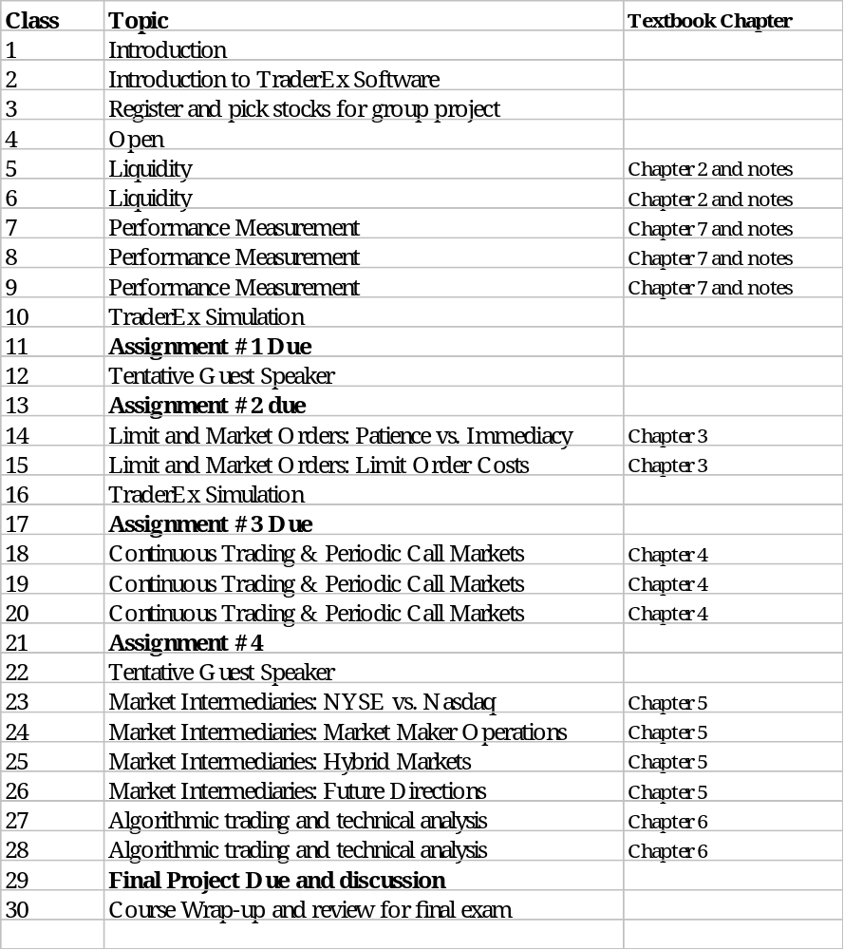
*This syllabus is tentative and subject to change
Peer Review Form For Group Projects

Name ______________________Date _________Group name or # _____________

Rate each member of your group; do not rate yourself. Base your assessments on your interactions in the classroom and during group meetings. Each question is worth 0-10 points. Each member of your group can receive 0-40 points. I will make adjustments to the case grade based on your comments. You will be penalized 1 point (out of a possible 10) for any dimension in which your average score is 3 or less.

Dimensions | Points | Description of Behavior
Attendance | 0-3  4-7  8-10 | Absent quite often; group had to work around this member  Absent occasionally, but did not inconvenience the group  Routinely present; the group could count on this member to be present
Preparation | 0-3  4-7  8-10 | Was not prepared for meetings based on previous agreements  Was prepared for meetings based upon what the group had agreed  Was prepared for group meetings, offered unique insights
Cooperation | 0-3  4-7  8-10 | Highly uncooperative  Moderately cooperative  Highly Cooperative
Fair Share | 0-3  4-7  8-10 | Frequent free rider; did not do fair share of the work  Ordinary group member; did acceptable amount of work  Did more than fair share of the work

Note: Do not include yourself on this form
NAME | ATTEND-  ANCE | PREPA-  RATION | CO-  OPERATION | FAIR SHARE | TOTAL

Comments (feel free to use the back)
Did any member(s) make exceptionally strong contributions? Describe.

Did any member(s) fail to make appropriate contributions? Describe.
Trading Simulation Report
You are the portfolio manager for “Tech Funds,” hereafter referred to as the “fund.” The fund’s starting value is $1,000,000 and you will manage the fund from 1/14/2008 to 4/4/2008. At the of this time period, the Board of Directors of the fund will evaluate how well you followed the fund’s guidelines and how well you met the fund’s goals. Most of the evaluation will be based on how well you justify your trading activity with written explanations that relate financial theory to your actual trades. The written assignment is given on the next page.

Your Goal
Maximize the fund’s value (i.e., earn a return as large as possible) subject to the following constraints.

Constraints
1. You must read the OTIS trading rules and adhere to their restrictions. By 1/15/08, you
should have registered online at http://wharton.pearsoncmg.com/otis/

2. No more than 100 transactions may be made during the course of the competition.

3. The fund must have initiated at least one long position in an instrument by 1/21/08.

4. The fund must have initiated at least one short position in an instrument by 1/28/08.

5. By 2/5/2008, the fund must have at least 80% of its assets “at risk” (i.e., invested in instruments other than cash). This condition must be met throughout the remainder of the trading period.

Failure to meet the above rules on trading will result in a penalty to your grade.

6. All transactions must be well-motivated and may not be arbitrary. Remember that all transactions should be justifiable in a written report.

7. The fund may not engage in insider or otherwise illegal or unethical trading. The fund manager may not manipulate the “market” and must adhere to limits and rules set by Otis.

Written Report

The objective for this written assignment is to evaluate your portfolio in the context of subjects and material covered in this course. Your grade on this assignment will be based on your discussion of your portfolio and trades, and the extent to which you followed the original assignment’s constraints and guidelines on trading. Your written analysis should be limited to five pages. You may add other tables and figures to help make your points.

In your written analysis, you should consider the following issues.
􀂃 What was your portfolio performance on a risk adjusted basis?
􀂃 What was the source of your portfolio’s performance – systematic or unsystematic risk?
􀂃 What trades did you get right?
􀂃 What trades would you do differently?
􀂃 Given what you know about market efficiency, were your profits/losses due to skill, luck, balance of risk and return, insider information, …? You must be able to justify your response.

Do not answer these questions one-by-one. Rather, your well-written analysis will address these issues collectively. Your analysis should be well-organized with an introduction, body, and conclusion. There should be a central thesis or theme to your write-up. Also, do not write a list of sentences for every trade that you made. You may want to pick out several trades that stand out and talk about others as a group. You might want to discuss your overall portfolio, identifying only a handful of trades as specific examples. The “meat” of your written report should relate portfolio management principles (risk, return, and diversification) to how your portfolio actually performed.

