BUSINESS AND THE ENVIRONMENT

Professor: L. Beril Toktay, College of Management
Office: COM 446
E-mail: beril.toktay@mgt.gatech.edu
Phone (404) 385 0104
Time: TTh 3 - 4:30pm
Location: COM 202

Course Description:

Environmental product differentiation opens new markets. Green procurement and total quality environmental management significantly reduce input and operating costs. Product innovation and eco-entrepreneurship are ways of doing well while doing good. These are some of the opportunities.

The cost of landfilling in the US is increasing rapidly. Communities are demanding higher standards of air, water and soil quality. European and Japanese legislation on product take-back and waste exports concerns many US manufacturers. Rising fuel prices make fuel-efficiency a competitive factor. Global warming is changing the way governments and businesses need to think about carbon. These are some of the challenges.

This course takes a holistic view of the interaction of businesses with the environment. It outlines reasons why businesses would want to care about environmental issues, introduces environmental assessment and management tools, and visits topics from various business functions. The main topics that will be covered are:

- Relevant domestic and international environmental legislation
- Environmental assessment and management tools
- Corporate environmental programs
- Sustainable development
- Environmental marketing
- Environmental operations
- Environmental stewardship
- Closed-loop supply chains

Current issues such as global warming, energy and e-waste will be discussed in the context of a number of cases.

Who Should Take this Course?

If you’ve ever asked “What do I need to know about environmental issues to make my company more successful?” this course is for you. And if you haven’t, maybe this is the right time! There are many reasons to care about how businesses interact with the environment – from the basic (cost reduction, compliance) to the inspiring (entrepreneurial opportunities), and this course will get you started on identifying and capitalizing on these opportunities.

Readings
The course pack includes required readings and case studies. There are no required textbooks for this course, but below are a partial list of reference books and popular environmental books that we will draw on in class.
Silent Spring, Carson
Ecology of Commerce, Hawken
In Earth's Company, Frankel
Enviro-Capitalist: Doing Good While Doing Well, Anderson and Leal
Cannibals with Forks, Elkington
Capitalism at the Crossroads, Hart
Industrial Ecology, Graedel and Allenby
Environmental Economics: An Elementary Introduction, Turner, Pearce and Bateman
Measuring Corporate Environmental Performance, Epstein
The Skeptical Environmentalist, Lomborg
Mid-course Correction, Anderson

Guest speakers
We will have a number of guest speakers throughout the semester who will share with us the opportunities and challenges their company was involved with regarding environmental issues.

Flow of the Course

The course consists of four modules, as depicted below. A detailed outline of the sessions follows.

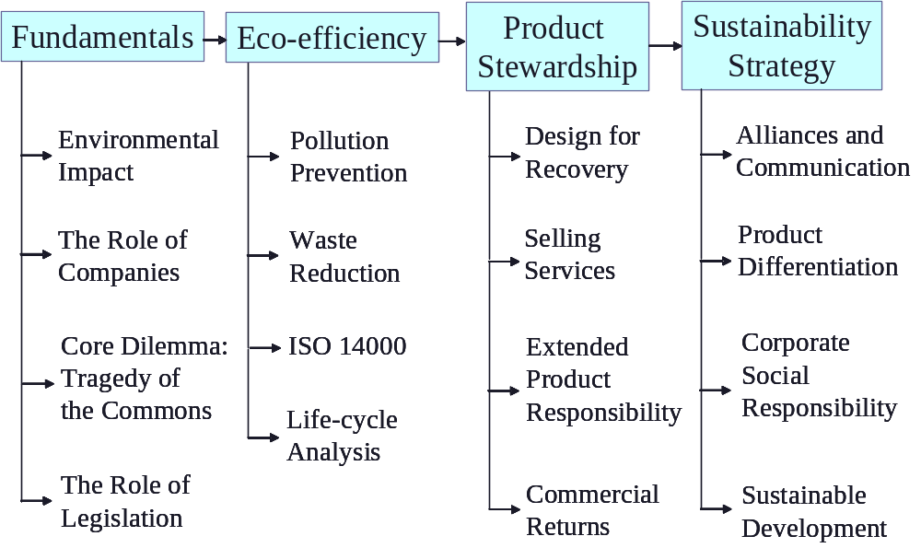

Course Outline

# | Date | Topic | Format
1 | 1/8 | Introduction | Lecture
Module 1 : Fundamentals
2 | 1/10 | Tragedy of the Commons | Fish Banks, Ltd. Simulation
3 | 1/15 | Tragedy of the Commons | Simulation debrief
4 | 1/17 | Environmental Impact & Measurement | Lecture and discussion
5 | 1/22 | Corporate Environmentalism | Lecture and discussion
6 | 1/24 | Environmental Regulation | Lecture and discussion
7 | 1/29 | Environmental Assistance | Guest speaker: PJ Newcomb, P2AD
Module 2: Eco-Efficiency
8 | 1/31 | Pollution Prevention & Waste Reduction | Case - Allied Signal: Managing the Hazardous Waste Liability Risk
9 | 2/5 | ISO 14000 | Case - International Hardware Products: Considering an ISO 14001 EMS
10 | 2/7 | Life-Cycle Analysis | Lecture and discussion
11 | 2/12 | Environmental Risk Assessment | Case - Environmental Risk Management at Chevron Corporation
12 | 2/14 | Corporate Environmental Programs | Scott Vitters, The Coca-Cola Company
13 | 2/19 | Student presentations | Groups TBD
14 | 2/21 | Student presentations | Groups TBD
Module 3: Product Stewardship
15 | 2/26 | End-of-Use Management | Guest speaker: John Wuichet, Army IM Agency
16 | 2/28 | Extended Producer Responsibility | Lecture and discussion
17 | ¾ | Design for Environment | Case – Xerox: Design for the Environment
18 | 3/6 | Dematerialization | Case – Interface's Evergreen Services Agreement
19 | 3/11 | Commercial Returns | Case - Managing Product Returns at HP
20 | 3/13 | Asset Recovery | Guest speaker: Steve Hyser, Canvas Systems
Module 4: Dimensions of Sustainability Strategy and Implementation
21 | 3/25 | Communication | Case – McDonald’s and the Environment
22 | 3/27 | Environmental Product Differentiation | Case - Environmental Product Differentiation by the Hayward Lumber Co.
23 | 4/1 | Sustainability in the Supply Chain | Case – Walmart’s Sustainability Strategy
24 | 4/3 | Corporate Social Responsibility | Case – The Body Shop International
25 | 4/8 | Sustainable Development | Case – Sustainable Development at Shell
26 | 4/10 | Energy: Regulation and Innovation | Guest speaker – TBD
27 | 4/15 | Alliances and NGOs | Case – Fedex and ED: Building a Hybrid Delivery Fleet
28 | 4/17 | Renewable Energy | Case – Hydro: From Utsira to Future Energy Solutions
Your turn!
29 | 4/22 | Final Project Presentation | Groups TBD
30 | 4/24 | Final Project Presentation | Groups TBD

Group project
The project is an exciting opportunity to work closely on a current business issue. There are two options for the group project. The first is to work with companies/associations on a current issue that they are grappling with. Because this type of project involves representing Georgia Tech vis-à-vis external parties, you should choose this type of project only if you are committed to putting in the time and effort to do a first-rate, professional job. The second is to identify the key challenges regarding sustainable development in a firm of your choice, and then write an insightful critique and action plan for this firm. A first-rate job in this type of project will go beyond library and web research and include information from interviews with one or more managers, industry analysts, government entities, NGOs, or other experts.

Here is more information about project types and available projects.

Company-based projects.
Lehigh Technologies: Marketing study for engineered rubber powders
CARE: Feasibility study (economic, legal and process) for renovation waste diversion from landfills
ISPA: Developing an anti-trust proof template for intra-industry collaboration for waste reduction and landfill diversion

Investigative reporting project.
Each group will assume the role of investigative journalists, providing a briefing about a specific firm’s actions or opportunities regarding economic, environmental and social performance. The content and style of managerial publications such as Business Week and Fortune should serve as a guide for the written report. Your team should choose a company of moderate size with at least $25 million in revenue to ensure a rich, interesting set of issues. For larger firms, focusing on a single line of business should help you to focus your report, and move beyond vague generalities.

The issues that should be addressed in the report include, but need not be limited to:
- Which aspects of sustainable development should most concern the managers of this firm?
- What is the regulatory, competitive and social context within which they operate?
- How are they dealing with these (and what has been right or wrong) relative to competitors?
- What are the strengths and weaknesses of the chosen managerial philosophy, approach or systems?
- How might the firm improve its application of sustainable development over the short- and long-term?

Your observations and critique will form the basis for a presentation to the rest of the class during the last week of the semester. The best presentations will be those that demonstrate how integration among environmental, social, and business goals can be achieved (or failed attempts at same).
Deliverables
The deliverables of the project are a final report, an in-class presentation, and a presentation to stakeholders, where applicable. There are no restrictions on report length, but it should be professional, and include an executive summary. You may also choose to deliver other supporting material (spreadsheets, etc.) to the stakeholders where suitable.
Due Dates
January 19: Finalize project teams and choices.
February 19 and 21: In-class mid-stream project presentations.
April 22 and 24: In-class final presentations.
April 28: Final report due.

Individual Assignments
There are three individual assignments. Two of them are due early in the semester, to get you into the material quickly and to avoid conflict with deliverables in other classes. Each write-up should be under 4 pages.
Assignment 1: Fishbanks debrief (due at the beginning of Session 3). In the Fishbanks game, you most likely experienced overshoot and collapse of the fishery. Overshoot is the harvesting of resources at rates much higher than the maximum sustainable rate and collapse happens when the process of overshooting lowers the limit, and it takes a long time for the system to recover. These phenomena have not only happened repeatedly (and are still happening) in fisheries world-wide, but are widespread in many other natural systems. Inspired by, but not limited to, your experience with Fishbanks, please answer the following questions:
- What are the causes of overshoot? of collapse?
- What are other examples of overshoot and collapse?
- Provide well-reasoned arguments on the pros, cons and likely success of several different potential approaches to avoiding these phenomena.

Assignment 2: Competitive advantage in the context of global warming (due at the beginning of Session 7). The business articles in Sessions 5 and 6 were written before concerns about global warming reached the level they did today. Some ideas in these articles nevertheless apply to the global warming context, while others need to be refined and rethought. Based on these articles, our class discussions, other relevant material and your own thinking, pick a specific firm, and provide a well-reasoned analysis of what you believe their business risks and opportunities are in the context of the global warming debate, and how various aspects of their business strategy should be reshaped, if at all.

Assignment 3: Walmart’s Sustainability Strategy case analysis (due at the beginning of Session 23.) Your assignment consists of answering the case discussion questions. Please prepare a thorough analysis using the information contained in the case, outside information that you generate, and pertinent material from our class.

Grading
Your grade will be based on three items, weighted as follows:
- Three assignments: 10% each
- Group project: 45%
- Class participation: 25%

On the individual assignments and group project, your grade is based on three components: (25%) breadth and depth of research (the quantity and quality of material you find concerning your topic); (50%) quality of analysis; (25%) and quality of writing (including proper citations) and quality of presentation for the group project. Please provide proper citations for any outside materials used to avoid accidental plagiarism. If you’re not sure about what plagiarism is or how to include proper citations, you can find out from the web (e.g. gervaseprograms.georgetown.edu/hc/plagiarism.html).
List of readings and discussion questions

Session 2:
Fishbanks game instructions. Please think about your strategy ahead of time and bring a calculator.

Session 3: Assignment 1 due.

Session 5:
It’s Not Easy Being Green, HBS Article, Number 94310
The Challenge of Going Green, HBS Article, Number 94410
Beyond Greening: Strategies for a Sustainable World, HBS Article, Number 97105

Session 6:
Green and Competitive, HBS Article, Number 95507
Note on Contingent Environmental Liabilities, HBS Note 794-098

Session 7: Assignment 2 due.

Session 8:
Allied Signal: Managing the Hazardous Waste Liability Risk, HBS Case 793044

- How have the government’s hazardous waste regulations affected Allied Signal?
- Does Allied Signal’s hazardous waste management strategy make sense? Why or why not?
- What organizational capabilities are necessary to implement such a strategy?
- Going forward through the mid-1990’s, should Callahan recommend any changes to this system?

Session 9:
- International Hardware Products, Inc., World Resources Institute.

Session 11:
- Environmental Risk Management at Chevron Corporation, HBS Case 799062

- Is Chevron using the right tools for managing environmental business risk? Why do these tools differ from those used to manage other types of business risk?
- Should Chevron make company-wide use of quantitative risk management tools like DEMA?

Session 16:
- The WEEE Challenge, ECCH Case Number 304-624-1
- Supply Loops and Their Constraints: The Industrial Ecology of Recyling and Reuse, Geyer and Jackson, California Management Review, Vol 46, No. 2.

Session 17:
- Xerox, Design for the Environment, HBS Case 794022

  - How did Xerox develop an objective of 0% product waste and 0% factory waste? Is it an appropriate goal?
  - What must Xerox do to its product delivery system if the goal is to be achieved? What changes will Xerox have to make in goals and incentives to achieve this?
  - Without legislation, will this ever pay off for Xerox? Will it, in fact, be possible for Xerox to achieve?
  - Should Xerox price remanufactured products at a discount?

Session 18:
- Interface’s Evergreen Services Agreement, HBS Case 603112
- A Roadmap for Natural Capitalism, HBR Article 99309

  - What is the environmental – waste reduction- argument for servicizing?
  - Should Interface move into services? Are they ready for it?
  - What does the Evergreen Services Agreement offer? Why are negotiations breaking down?
  - How should Hendrix resolve his dilemma? Should he discontinue ESA? Restructure it?

Session 19:
- Managing Product Returns at HP, ECCH Case 602-039-1

  - How do we reduce the instances of product returns?
  - Does it make sense to engage in remanufacturing related activities?
  - What can be done to maximize value recovery?
  - How do we market the remanufactured products?

Session 21:
- McDonald’s and the Environment (A), HBS Case 391108

- What are McDonald’s goals in announcing the packaging change?
- Who are McDonald’s key audiences? What groups will influence McDonald’s customers and how?
- What should McDonald’s message be? What attempt should McDonald’s make to explain or justify its controversial decision? its apparent “about-face”?
- How does a company cultivate an image as an environmental leader, and what responsibilities or obligations ensue from being “green”? What are McDonald’s responsibilities as compared to those of packaging suppliers, competitors, or the industry as a whole?

Session 22:
- Environmental Product Differentiation by the Hayward Lumber Company, Delmas, Plambeck, Porter, Stanford GSB Case, OIT 38
- Choosing the Right Green Marketing Strategy, Ginsberg and Bloom, MIT Sloan Management Review 46:1 (2004)
- Environmental Product Differentiation: Implications for Corporate Strategy, California Management Review 40:4 (1998)

- What is HLC’s environmental strategy?
- What are challenges HLC faces in introducing green construction materials? Should they operate differently to overcome these challenges?
- When do you think environmental product differentiation pays off? Does HLC’s business satisfy those conditions?

Session 23: Assignment 3 due
- Walmart’s Sustainability Strategy, Stanford Case OIT-71

- At a high level, how is Walmart creating value from its sustainability strategy?
- Critique the success of two of the networks. What explains the success (or lack thereof) these networks?
- How is Wal-Mart motivating its suppliers to share information about and reduce the environmental impacts of products and processes?
- How can Wal-Mart stimulate the development of disruptive, breakthrough innovation? Do you see any trade-off against continuous improvement?

Session 24:
- The Body Shop International, HBS Case 392 – 032

- How has The Body Shop become such an outstanding success while defying proven industry norms and strategies? What are the most important sources of success?
- How do you evaluate Anita Roddick’s management philosophy and style?
- What lessons are there to learn from The Body Shop as a corporate model and from Roddick as a model of management? To what degree is the approach generalizable?
- How sustainable is The Body Shop’s success? In particular, what should Roddick do about the emerging problems and expected difficulties of developing its operations in the US?

Session 25:
- Sustainable Development at Shell (A) HBS Case 303-005

- What were the circumstances at Shell leading up to the push for a sustainable development strategy?
- What is your analysis of Shell’s sustainable development strategy? What are its strengths and weaknesses?
- What are the strengths and weaknesses of SDMF? of the KPI program?
- What lessons have you learned from Shell’s sustainable development strategy development and its accompanying challenges?

Session 27:
- Fedex and Environmental Defense: Building a Hybrid Delivery Fleet, Stanford Case SI-82

- The Toyota Prius and Honda Insight were introduced in the late 90’s. Why was there no hybrid delivery truck on the market when ED approached FedEx in 2000? In general, why might a firm overlook an opportunity to simultaneously increase its profit and provide public environmental benefits?
- What performance measures should Environmental Defense use to define success? What should FedEx use? What should Eaton use?
- Compute the maximum price FedEx should be willing to pay for a hybrid delivery truck. Should FedEx contract with hybrid supplier(s)? If so, how?
- How should FedEx modify its strategy and operations to fully benefit from the conversion to a hybrid fleet?

Session 28:
- Hydro: From Utsira to Future Energy Solutions, Ivey Case 9B06M044

- Has the Utsira project been successful?
- How might the potential commercialization of this project contribute to sustainable development at Hydro for its customers?
- What is Hydro’s role in selling a system of this nature? How can the company capture and sustain value?
- How attractive are the two potential markets, namely remote communities and grid balancing, for commercializing the system? What criteria are important for each market?
- How should Fjermestad Hagen and Nakken proceed? What action should they take?

