MSE 8803E – Structure and Defects
Course Objective
Lecture
Instructor Office Phone E-mail
Office Hour
Teaching assistant
Homework
Exam/grading
References
School of Materials Science and Engineering Georgia Institute of Technology
Fall Semester 2008
To provide students with a fundamental understanding of crystal structures, symmetry, defects, and microstructure in crystalline materials, and their influence on materials properties.
10-11 M W F in Love 299
Meilin Liu Love 258 894-6114 meilin.liu@mse.gatech..edu M W F 3-4 |  | Naresh Thadhani Love 166 894-2651 naresh.thadhani@mse.gatech.edu arun.gokhale@mse.gatech.edu | Arun Gokhale Love 265 894-2887
TBD

Problems will be assigned periodically and solutions will be posted a week later. Homework will not be collected or graded.
5 Exams, 20% each Exam 1 – Crystal Structure and Symmetry Exam 2 – Point defects Exam 3 – Dislocations Exam 4 – Surfaces, Interfaces, and Microstructures Comprehensive examination
- Lecture notes – to be distributed in class or posted on web
- Physical Ceramics, Y. M. Chiang, D. Birnie, and W. D. Kinggery, Wiley, 1997.
- Crystallography, Walter Borchardt-Ott, Springer-Verlag, 1993, QD 905.2.B713
- The Chemistry of Imperfect Crystals. Vols. 2&3, F.A. Kroger, North Holland/American Elsevier, 1974, QD478.K76.
- Defect Crystal Chemistry and its Applications, R.J.D. Tilley, Blackie, 1987, QD921.T53
- Introduction of Dislocations, 4th Edition, D. Hull and D.J. Bacon, Pergamon Press
- Elementary Dislocation Theory, 1992 Edition, Johannes Weertman and Julia R. Weetman, Oxford University Press

MSE 8803E: Topical Outline
Geometric Principles
Representative Structures of Important Materials Metals and Alloys Semiconductors, Polymers Ceramics (AX, AX2, ABX3, AB2X4 compounds: Perovskite, Spinel, Garnet, etc.)
Crystal Symmetry - Point Groups Space Groups
Exam 1: Crystal Structure and Symmetry (20%)

11
Aug-18 to Sept-12
Sept-15
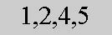
10
Sept-17 to Oct-8
Oct-10
Defect Notations Equilibrium Defect Concentrations Defect Reactions Mass-Action Law/Electroneutrality Ionic/Electronic Disorders Brouwer’s Approximation Non-stoichiometry: Solid-Gas Interactions Effect of Doping: Donors and acceptors Temperature Effect Charged Surfaces & Space Charge Region, Complex Defects
Exam 2: Point Defects (20%)
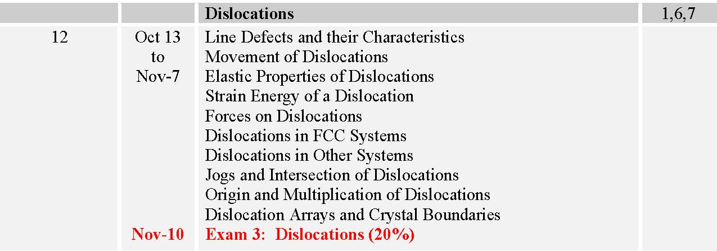
10
Nov-12 to Dec-5
Structure of Grain Boundaries and Interfaces Geometric Topological Aspect of Grain Structures Mathematical Correlation of Microstructures in terms of correlation functions, near neighbor distributions, morphological orientation distributions, size and shape distributions, metric and topological attributes, etc. Modeling and simulations of microstructural geometry, solutions to inverse problems Effects of microstructural geometry on important classes of material properties

