URBAN MYTHOLOGIES IN RUSSIAN LITERATURE

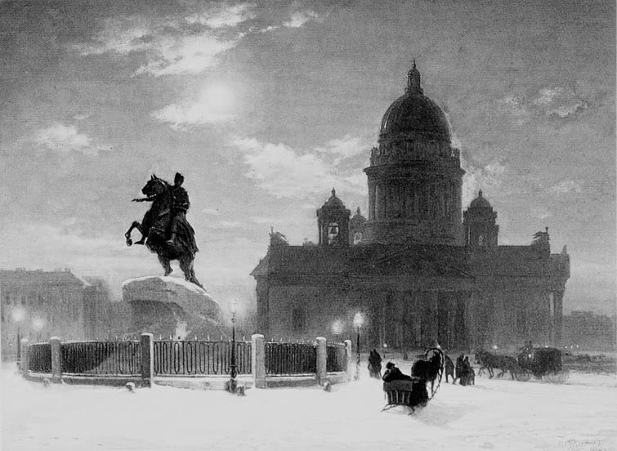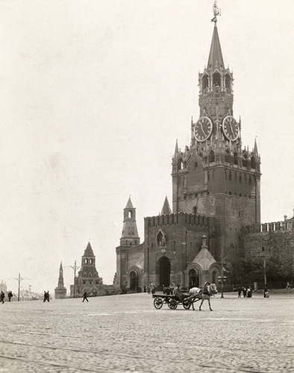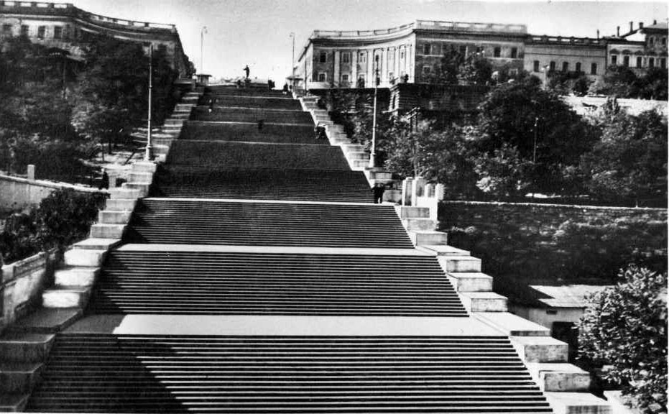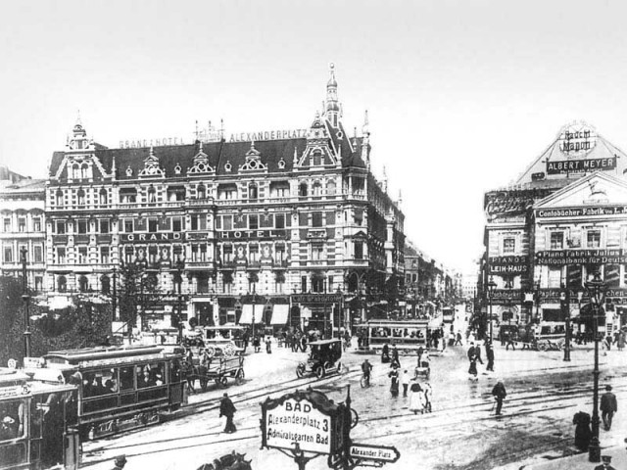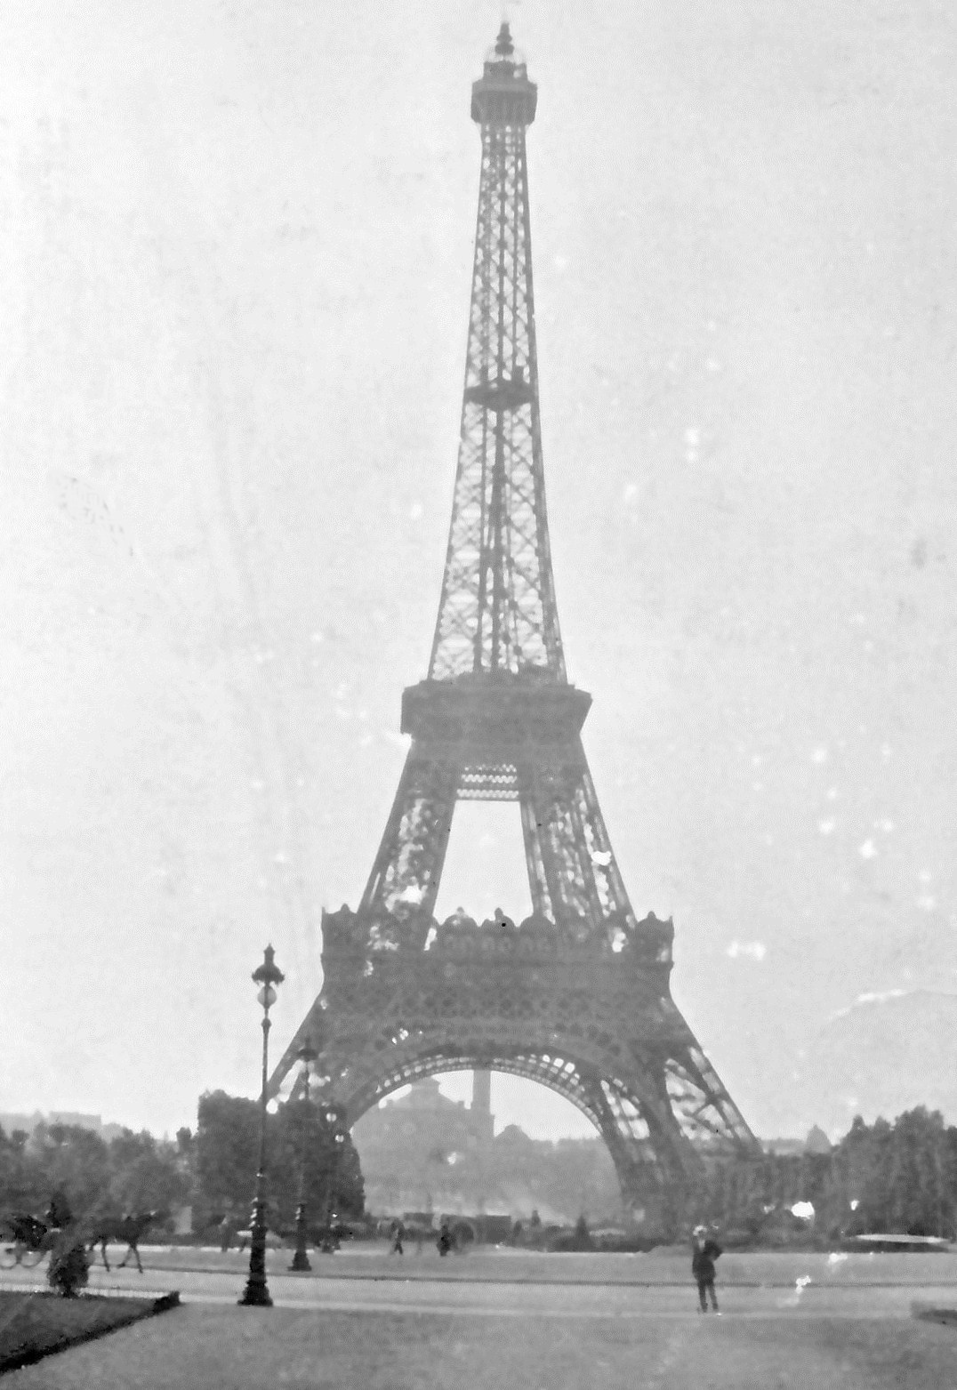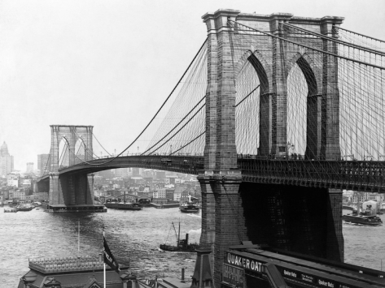

Description

This course is a journey through almost two centuries of Russian urban narratives, both at home and abroad, across different genres, artistic media and historical periods. We will “visit” six cities that have influenced Russian culture and urban mythology (St. Petersburg, Odessa, Moscow, Berlin, Paris, New York) and try to construct a narrative that would bridge these heterogeneous geo-poetic locales. As we explore the “mappings” of these six cities across generations of Russian writers, we will delve into the gigantic repositories of urban impressions that they impose and, through a set of mythopoetic topoi that they generate, try to outline their place in the twentieth-century Russian literary imagination. Primary and secondary readings will be drawn from a variety of authors, including Alexander Pushkin, Nikolai Gogol, Fedor Dostoevsky, Anna Akhmatova, Joseph Brodsky, Isaac Babel, Mikhail Bulgakov, Vladimir Nabokov, Viktor Shklovsky, Ivan Bunin, Gaito Gazdanov, Nina Berberova, Vladimir Korolenko, Eduard Limonov, Sergei Dovlatov, Wladimir Kaminer and others. Literary texts will be accompanied by occasional film screenings. All readings and discussions are in English.

General Requirements and Assignments

Class attendance, active participation (only 3 unexcused absences are allowed) 20%
Weekly reading responses, posted on the class forum by 9 pm on the day before class 20%
Midterm paper (5-6 pages), due on Sept. 24, by 5pm 20%
Final presentation (last week of classes) 10%
Final paper (8-10 pages) or pre-approved project, due on Dec. 10, by 5pm 30%

SCHEDULE AND READINGS

Aug 20 Introduction (course overview). Is Russian literature rural or urban? “Russian” cities at home and abroad: native and foreign cityscapes. Petersburg vs. Moscow. The “Petersburg period” of Russian history and the “Petersburg text” of Russian literature. Petersburg and Odessa. The “Odessa School” of Russian literature (the “South-West”). Russia abroad: a survey of Russian cultural outposts (Berlin, Paris, New York) and “waves” of Russian literary emigration. The language of the city. City as text. City as myth.

- Michel de Certeau. “Walking in the City,” in his The Practice of Everyday Life. Tr. by Steven Rendall. Berkeley: U of California P, 1984. Pp. 91-110.
- SUGGESTED: Mircea Eliade. “The Structure of Myths,” in Myth and Reality. Tr. by Willard R. Trask. New York: Harper & Row, 1963. Pp. 1-20.

ST. PETERSBURG

The Classical Period

Aug 22 Alexander Pushkin. “The Bronze Horseman”∗

- Yuri Lotman. “The Symbolism of St. Petersburg,” in his Universe of the Mind. A Semiotic Theory of Culture. Tr. by Ann Shukman. Bloomington, IN: Indiana UP, 1990. Pp. 191-202.
- Alexandre Benois’s illustrations to Pushkin’s “The Bronze Horseman”
- SUGGESTED: Solomon Volkov. St. Petersburg: A Cultural History. New York: Free Press, 1997; chapter 1 (on reserve)

Aug 27 Nikolai Gogol. “Nevsky Prospect” and “The Overcoat”

- SUGGESTED: Boris Eikhenbaum. “How Gogol’s ‘Overcoat’ Is Made,” in Gogol’s “Overcoat”: An Anthology of Critical Essays. Ann Arbor, MI: Ardis, 1982. Pp. 21-36.
- SUGGESTED: The Overcoat (1926), a film by Grigory Kozintsev & Leonid Trauberg: https://www.youtube.com/watch?v=JlE0ROQieac, and The Overcoat (1959), a film by Aleksei Batalov: https://www.youtube.com/watch?v=YYXAlAHW9TU&wide=1

Aug 29 Fedor Dostoevsky. “White Nights”

- Mstislav Dobuzhinsky’s illustrations to Dostoevsky’s “White Nights”
- SUGGESTED: Le Notti Bianche (1957), a film by Luchino Visconti (on reserve)

Sept 3 Fedor Dostoevsky. Notes from Underground+

Fin-de-Siècle Petersburg Culture

Sept 5 Andrei Bely. Petersburg (“Prologue”); Poems by Alexander Blok (“Night. A street light, a drugstore…,” “The Lady Nobody Knows,” “Twelve”*), Anna Akhmatova (“The Stray Dog Cabaret,” “To Alexander Blok”) and Osip Mandelshtam (“Leningrad”*); Osip Mandelshtam. “The Noise of Time” (excerpts, TBA) and “The Egyptian Stamp.”

- Explore the website “Mapping Petersburg” (by Olga Matich et. al): http://stpetersburg.berkeley.edu/
- SUGGESTED: Solomon Volkov. St. Petersburg: A Cultural History. New York: Free Press, 1997; chapter 3 (on reserve)

The Great Patriotic War and the Siege of Leningrad

Sept 10 Lidia Ginzburg. Blockade Diary; Anna Akhmatova. “Poem Without a Hero”; Olga Bergholtz. “Conversation with a Neighbor”

- SCREENING: Blockade (2005), a film by Sergei Loznitsa
- Dmitry Shostakovich. Symphony No. 7 (“Leningrad”): http://www.youtube.com/watch?v=sxpYqpSV-vU
- SUGGESTED: Leningrad in Battle (1943), a film by Roman Karmen et. all: https://www.youtube.com/watch?v=MMD98yupwjA

Late-Soviet Petersburg/Leningrad: Nostalgia, Remembrance and Exile

Sept 12 Joseph Brodsky. Essay “A Guide to a Renamed City” and poems “A Halt in the Desert,” “I was born and grew up in the Baltic marshland…,” “Plato Elaborated,” “The Fifth Anniversary”; Lev Loseff’s poems “The Last Romance,”* “The Flat,” “Untitled,” “June 1972”

- Photographs by Boris Smelov: http://www.photographer.ru/gallery/182.htm
- SUGGESTED: Boris Smelov Retrospective. Bielefeld: Kerber Verlag, 2009 (on reserve)
- SUGGESTED: A Room and a Half (2009), a film by Andrei Khrzhanovsky (on reserve)

ODESSA

Sept 17 Isaac Babel. “Odessa,” “The Aroma of Odessa,” “The Public Library,” “Nine,” “At Grandmother’s,” “The Awakening,” “How Things Was Done in Odessa,” “The Story of My Dovecote,” “Di Grasso”

- Rebecca Jane Stanton. “City Through the Looking-Glass: Literary Odessa,” in her Isaac Babel and the Self- Invention of Odessan Modernism. Evanston, IL: Northwestern UP, 2012. Pp. 17-40.
- A selection of songs about Odessa (TBA)

Sept 19 Yuri Olesha. No Day Without a Line (“Odessa”)

- SCREENING: Man with a Movie Camera (1929), a film by Dziga Vertov

MOSCOW

Sept 24 Mikhail Bulgakov. The Master and Margarita (7-94)

- SUGGESTED: Katerina Clark. “Moscow, the Lettered City,” in her Moscow, the Fourth Rome: Stalinism, Cosmopolitanism and the Evolution of Soviet Culture, 1931-1941. Cambridge, MA: Harvard UP, 2011. Pp. 78- 104.

Sept 26 Mikhail Bulgakov. The Master and Margarita (95-170)
Oct 1 Mikhail Bulgakov. The Master and Margarita (171-298)

Oct 3 Mikhail Bulgakov. The Master and Margarita (299-363)

- SUGGESTED: Karl Schlögel. “Navigation: Margarita’s Flight” (Chapter 1), in his Moscow, 1937. Tr. by Rodney Livingstone. Cambridge: Polity, 2012. Pp. 10-32.

Oct 8 Mikhail Bulgakov. The Master and Margarita (364-396)

BERLIN

The Interwar Period: 1920-1930s

Oct 10 Vladimir Nabokov. “Beneficence,” “A Guide to Berlin,” “Cloud, Castle, Lake”; Marina Tsvetaeva’s poem “For Berlin”

- Alexander Dolinin. “‘The Stepmother of Russian Cities’: Berlin of the 1920s through the Eyes of Russian Writers,” in Cold Fusion: Aspects of the German Cultural Presence in Russia. New York – Oxford: Berghahn Books, 2000. Pp. 225-240.
- SUGGESTED: Berlin: Symphony of a Metropolis (1927), a film by Walter Ruttman: https://www.youtube.com/watch?v=j76FNxsJlt8

Oct 17 Viktor Shklovsky. Zoo, Or Letters Not About Love

The Fall of Berlin: May, 1945

Oct 22 The last days of WWII: songs, photographs, posters, graffiti, folklore and propaganda (TBA)

- SUGGESTED: The Fall of Berlin (1945), a documentary by Yuli Raizman: https://www.youtube.com/watch?v=Rc0CGr3MKcY

The New “Immigrant Chic”: 1990-2000s

Oct 24 Wladimir Kaminer. Russian Disco (“Father’s Advice,” “The Sweet Homeland Far Away,” “The Everyday Life of a Work of Art,” “Relationships in the Berlin Hothouse,” “Suleyman and Salieri,” “No Flies in Berlin,” “A Lost Day,” Business Camouflage,” Nuts from Around the World,” “The Russian Disco,” “The Columbo of Prenzlauer Berg,” “Berlin Guidebooks,” “Berlin Portraits,” “Learning German,” “Why I Still Haven’t Applied for German Citizenship”)

- Songs by ROTFRONT: “Berlin – Barcelona,” “B-Style,” “Emigrantski Ragamuffin,” “James Bondski,” “Live Is Life” (video), “Money,” “Real Berlin Wedding,” “Revolution Disco,” “Sigareta,” “Sovietoblaster,” “VisaFree,” “Vodka & Garlic”; Explore ROTFRONT website: http://rotfront.com/

PARIS

The First Wave of Russian Emigration (1920-1930s)

Oct 29 Ivan Bunin. “In Paris”; Vladislav Khodasevich. “In Front of the Mirror”*; Marina Tsvetaeva. “The Readers of Newspapers”* and “In Paris”*; Gaito Gazdanov. Night Roads (7-89);

Oct 31 Gaito Gazdanov. Night Roads (90-169)

- Explore Gazdanov’s Paris on the “Taxi Library” website: http://www.taxi-library.org/gaito-gazdanov/gg1.htm

Nov 5 Gaito Gazdanov. Night Roads (170-239)

Nov 7 Nadezhda Teffi. “Points of View,” “The Shopgirl’s Tale,” “A Wise Man,” “The Magpie”; Nina Berberova. “The Black Pestilence”

NEW YORK

New World Encounters

Nov 12 Vladimir Korolenko. In a Strange Land (1-106)

Nov 14 Vladimir Korolenko. In a Strange Land (107-214)

New York Travelogues (1900-1930s)

Nov 19 Maxim Gorky. City of the Yellow Devil (excerpt); Sergei Esenin. An Iron Mirgorod; Vladimir Mayakovsky. My Discovery of America (“New York”) and “The Brooklyn Bridge”*; Ilf and Petrov. American Road Trip (“New York”)

- SUGGESTED: Olga Peters Hasty & Susanne Fusso (eds.). America through Russian Eyes, 1874-1926. New Haven, CT: Yale UP, 1988 (“Introduction”)
- SUGGESTED: Leon Trotsky’s My Life: An Attempt at an Autobiography (“New York”)

The Third Wave of Russian Emigration (1970-1980s)

Nov 21 Eduard Limonov. It’s Me, Eddie: A Fictional Memoir (“The Hotel Winslow and Its Denizens,” “I Am a Busboy,” “I Make Money,” “My Friend New York,” “Epilogue”); Vladimir Lobas. Taxi from Hell: Confessions of a Russian Hack (“Introduction,” “A Perfectly Decent Man Only Yesterday,” “The ABC of a New Profession”)

- Night on Earth (1991), a film by Jim Jarmusch (Episode 2: “New York”): https://www.youtube.com/watch?v=a1CCup5QRJw

Nov 26 Sergei Dovlatov. A Foreign Woman

- SUGGESTED: Written by Sergei Dovlatov (2011), a documentary by Roman Liberov (on reserve)

Conclusions

Dec 3 Conference: student projects and presentations (1)

Dec 5 Conference: student projects and presentations (2)
REQUIRED EDITIONS

- Fedor Dostoevsky. Notes from Underground. Tr. by Richard Pevear and Larisa Volokhonsky. New York: Vintage, 1994.

- Mikhail Bulgakov. The Master and Margarita Tr. by Richard Pevear and Larisa Volokhonsky. New York: Penguin, 1997.

- Viktor Shklovsky. Zoo, Or Letters Not About Love. Tr. by Richard Sheldon. Chicago, Dalkey Archive Press, 2011.

- Gaito Gazdanov. Night Roads. Tr. by Justin Doherty. Evanston, IL: Northwestern UP, 2009.

ML PERFORMANCE GOAL #1: PROFESSIONAL COMMUNICATION
ML Learning Outcome 1 : Demonstrate oral and aural proficiency in the target language
ML Learning Outcome 2: Demonstrate effective presentation skills in the target language

ML Learning Outcome 3: Demonstrate writing proficiency in the target language

ML Learning Outcome 4:

Demonstrate proficiency in comprehension of authentic written texts in the target Language
ML PERFORMANCE GOAL #2: INTERCULTURAL SKILLS AND KNOWLEDGE
ML Learning Outcome 5: Demonstrate in-depth knowledge of a specific target-language country or region | Students will demonstrate the ability to analyze the historical and cultural roots of issues related to the representation of urban space in Russian literature and culture
ML Learning Outcome 6:  Demonstrate the ability to analyze an issue from target-culture perspective(s) | Students will reflect on the ways in which issues of navigating, mapping and representing cityscapes are shaped within Russian discourse
ML Learning Outcome 7:  Demonstrate critical reflection on cultural complexity and context | Students will develop the ability to make sophisticated comparisons between various poetic geographies as they have inspired the Russian literary and cultural canon.

 Readings marked with an “*” are available in two English translations.
 This and other books below, which are not included in the course packet, are available for purchase from the GA Tech Bookstore.

