RUSSIAN LITERATURE BEHIND BARS

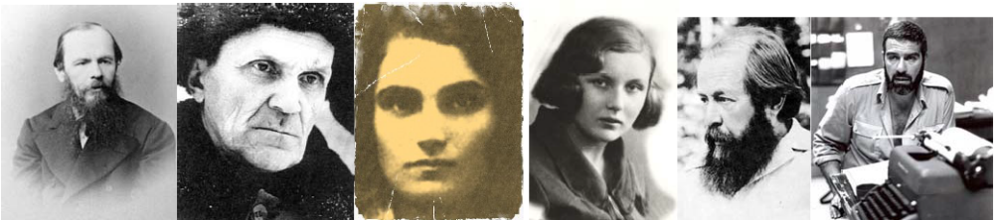

Description

For as long as modern Russian literature has existed, incarceration has consistently been one of its central themes. In the nineteenth century, Dostoevsky described the prison world he got to know first-hand as “a world apart, unlike everything else, with laws of its own, its own dress, its own manners and customs” (The House of the Dead). However, it was not until the October Revolution and Stalin’s purges of the 1930-1950s that political imprisonment became so firmly engraved onto these dark pages of Russian history that it formed a separate genre: Gulag memoirs. This course explores the representations of prison and hard-labor camp experience in Russian literature and culture across different artistic forms and media (folklore and songs, poetry, fiction, memoirs, diaries, personal correspondence, film, drawings, craftwork and
criminal tattoos). By looking at different aspects of life in the Soviet Gulag through the lens of a variety of first-hand accounts, students will be encouraged to compare the Gulag’s legacy to other historical and geographical contexts from around the world (for example, to Holocaust memoirs or Latin American narratives of the “disappeared”) and to think more broadly about prison as a semiotic space, and about imprisonment - as an existential experience. Throughout the seminar, we will address the function of art as a means of survival and analyze what permutations our life’s key concepts and dichotomies undergo in a world behind bars. All readings and discussions are in English.

Requirements and Assignments

- Class attendance and participation (only 3 unexcused absences allowed) 20%
- Two class presentations, including one on the topic of your final project 20%
- Weekly reading responses• posted on T-Square by 9 pm on the day before class 20%
- Midterm paper (5-7 pages), due on Feb. 24 by 5 pm 10%
- Final paper (10-12 pages) or pre-approved creative project, due on Apr. 28 30%
Summary Schedule

Week 1 Introduction. Imprisonment in world culture. Prison as a semiotic space. Human rights in Russia: past, present and future. The history and prehistory, culture and literary legacy of the Gulag. The canon of Gulag literature and the genre of documentary prose (memoir, autobiography, diary).

Week 2 Imprisonment and hard labor in nineteenth-century Russia – 1: The Decembrist uprising (selected readings)

Week 3 Imprisonment and hard labor in nineteenth-century Russia – 2: Dostoevsky’s The House of the Dead

Week 4 The birth of the Gulag: Solovki

Week 5 Gulag narratives as a genre (the case of Evgenia Ginzburg)

Week 6 Russian prison poetry

Week 7 Women’s narratives

Week 8 Soviet prison culture and folklore (songs, jokes, drawings, artwork, tattoos)

Week 9 The “new prose”: Varlam Shalamov’s Kolyma Tales (selected stories)

Week 10 Fiction of the Thaw period: Alexander Solzhenitsyn’s One Day in the Life of Ivan Denisovich

Week 11 Gulag theater: Tamara Petkevich’s Memoir of a Gulag Actress (excerpts)

Week 12 Gulag in a global context: Holocaust memoirs and Latin-American narratives of the “disappeared”

Week 13 Foreigners in the Gulag

Week 14 Late-Soviet hard-labor camps through the eyes of a guard: Sergei Dovlatov’s The Zone

Week 15 Gulag and the West: history and patterns of international perception (then and now)

ML PERFORMANCE GOAL #1: PROFESSIONAL COMMUNICATION
ML Learning Outcome 1 : Demonstrate oral and aural proficiency in the target language
ML Learning Outcome 2: Demonstrate effective presentation skills in the target language

ML Learning Outcome 3: Demonstrate writing proficiency in the target language

ML Learning Outcome 4:

Demonstrate proficiency in comprehension of authentic written texts in the target language
ML PERFORMANCE GOAL #2: INTERCULTURAL SKILLS AND KNOWLEDGE
ML Learning Outcome 5: Demonstrate in-depth knowledge of a specific target-language country or region | Students will demonstrate the ability to analyze the historical and cultural roots of issues related to prison narratives and political incarceration and exile in Russia and the Soviet Union
ML Learning Outcome 6:  Demonstrate the ability to analyze an issue from target-culture perspective(s) | Students will reflect on the ways in which issues of imprisonment and political resistance are framed within Russian/Soviet (and anti-Soviet) discourse
ML Learning Outcome 7:  Demonstrate critical reflection on cultural complexity and context | Students will develop the ability to make sophisticated comparisons of perspectives and practices of the Russian peniteniary system, human rights movement, and political resistance and compare them to American and other non-Russian geo-political contexts

• Reading responses are intended to facilitate our discussion in class before we even meet and, ideally, continue it after we part until the next session. They do not have to be too long or polished, but they need to be as much to the point as possible. Simply pick one or several aspects of the current reading and raise a question about it or discuss it in whatever light you may find appropriate (or do both).

