RUSSIAN CULTURE IN EXILE / РУССКАЯ КУЛЬТУРА В ИЗГНАНИИ

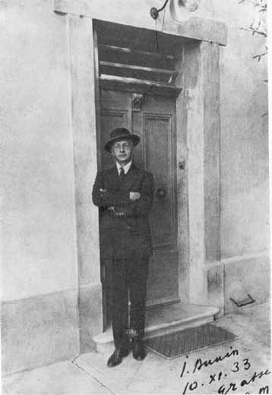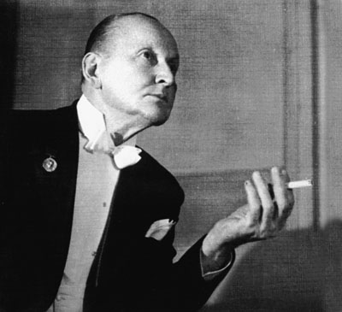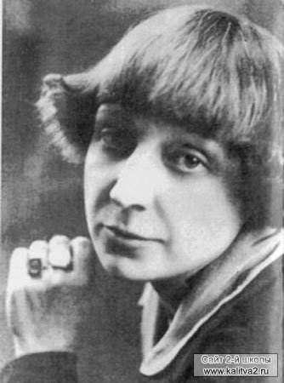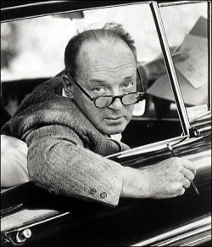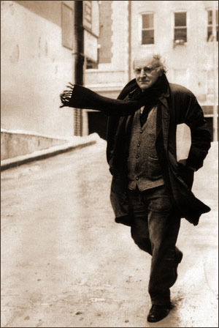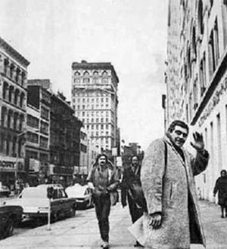

Description

The seminar “Russian Culture in Exile” is a journey through almost a century of Russian literature and culture abroad on both sides of the Atlantic, across different geographies, genres, generations and artistic forms (prose, poetry, memoirs, essays, songs, film and arts). Each class will be devoted to a specific theme or geographical locus of Russian culture abroad. As we discuss works by individual authors, we will look for answers to the following overarching questions: What is the nature of writing in exile and how is it different from writing in the familiar linguistic and cultural milieu? What challenges (linguistic, cultural, social and professional) does an émigré writer face, and what benefits does exile offer? Can nostalgia be a source of creative inspiration and how is it “translated” into the artistic sphere? What is the target audience of an émigré writer, and what are the patterns of his or her assimilation to, or dissociation from, the culture of the host country? Special attention in this course will be paid to the improvement of language skills (grammar, vocabulary and phraseology). All discussions, readings, written assignments and class presentations are in Russian.

Requirements and Assignments

- Class attendance and participation (only 3 unexcused absences allowed) 20%
- Two class presentations, including one on the topic of your final project 20%
- Weekly reading responses• posted on T-Square by 9 pm on the day before class 20%
- Midterm paper (5-7 pages), due on Feb. 24 by 5 pm 10%
- Final paper (10-12 pages) or pre-approved creative project, due on Apr. 28 30%

Summary Schedule

Week 1 Introduction. Exile, emigration and émigré identity. Exile in world culture. “Émigré” literature and the genre of travelogue. Historical and political contexts of Russian emigration in the twentieth century. Geography of the Russian diaspora.

Week 2 The First Wave of Russian emigration between the World Wars (1920-1930s): I van Bunin, Georgii Ivanov, Marina Tsvetaeva, Alexander Vertinsky

Week 3 Berlin (1): Vladislav Khodasevich, Vladimir Korvin-Piotrovsky, Viktor Shklovsky

Week 4 Berlin (2): Vladimir Nabokov

Week 5 Paris (1): Marina Tsvetaeva, Alexander Shteyger, Vladislav Khodasevich

Week 6 Paris (2): Nadezhda Teffi and Gaito Gazdanov

Week 7 Emigration as a literary device: feuilletons by Teffi and an essay by Khodasevich

Week 8 The Second Wave of Russian emigration during after WWII (1940-1950s): Ivan Elagin, Nikolai Morshen, Olga Anstei

Week 9 The Third Wave: Joseph Brodsky, Alexander Galich, Lev Loseff, Zinovy Zinik

Week 10 New York (1): Lidia Alekseeva, Vladimir Gandelsman, Marina Georgadze, Sergei Dovlatov

Week 11 Emigration as an “outpost” of Russian and Soviet culture: Dovlatov’s novel The Outpost

Week 12 The Fourth Wave of Russian Emigration in the post-Soviet period (1990s – present): Irina Mashinskaya, Polina Barskova, Elena Suntsova and others

Week 13 Bilingualism and biculturalism (1): Vladimir Nabokov and Joseph Brodsky

Week 14 Bilingualism and biculturalism (2): Garry Shteyngart, David Bezmozgis, Lara Vapnyar, Vladimir Nikolaev and others

Week 15 Conference “Literature and Exile”: student presentations

ML PERFORMANCE GOAL #1: PROFESSIONAL COMMUNICATION
ML Learning Outcome 1 : Demonstrate oral and aural proficiency in the target language | Students will demonstrate oral proficiency at the intermediate high or advanced level through class discussion and debate
ML Learning Outcome 2: Demonstrate effective presentation skills in the target language | Students will demonstrate the ability to make coherent formal research presentations of 10 minutes without written text and to engage audience into discussion
ML Learning Outcome 3: Demonstrate writing proficiency in the target language | Students will regularly produce coherent analytical writing on class-related topics
ML Learning Outcome 4:  Demonstrate proficiency in comprehension of authentic written texts in the target Language | Students will demonstrate ability to understand and analyze authentic literary and popular texts on topics related to class discussion
ML PERFORMANCE GOAL #2: INTERCULTURAL SKILLS AND KNOWLEDGE
ML Learning Outcome 5: Demonstrate in-depth knowledge of a specific target-language country or region | Students will demonstrate the ability to analyze the historical and cultural roots of issues related to Russian literature created outside of its native linguistic and cultural milieu
ML Learning Outcome 6:  Demonstrate the ability to analyze an issue from target-culture perspective(s) | Students will reflect on the ways in which issues of exile and diaspora formation are framed within Russian/Soviet(and post-Soviet) discourse
ML Learning Outcome 7:  Demonstrate critical reflection on cultural complexity and context | Students will develop the ability to make sophisticated comparisons and judgments regarding the linguistic, cultural, social and professional identity of Russian émigré artists in different geo-political and historical environments.

• Reading responses are intended to facilitate our discussion in class before we even meet and, ideally, continue it after we part until the next session. They do not have to be too long or polished, but they need to be as much to the point as possible. Simply pick one or several aspects of the current reading and raise a question about it or discuss it in whatever light you may find appropriate (or do both).

