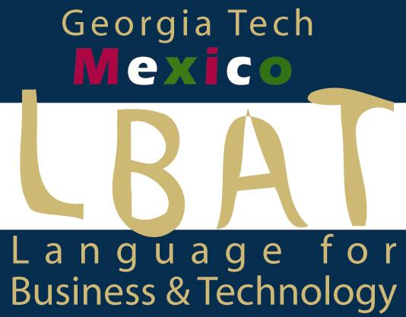
LBAT Mexico
Programa, Espanol 3690
(taught simultaneously with SPAN 3691 and 3692)

Week 1: Reseña crítica 1: Santo Luzbel
Excursión 1 y trabajo escrito: Museo de la Medicina
Excursión 2 y trabajo escrito: Templo mayor
Excursión 3 y trabajo escrito: Museo Nacional de la Antropología, Sala Mexica
Week 2 Reseña crítica 2: El crimen del Padre Amaro
Excursión 4 y trabajo escrito: Basílica de Guadalupe
Grabación 1 (field interviews)
Week 3: Reseña crítica 3: Como agua para chocolate
Excursión 5: Castillo de Chapultepec: De los Insurgentes a la Revolución
Excursión 6: Recorrido artístico (Secretaria, Colegio San Ildefonso, Palacio Nacional, Bellas Artes, Museo Diego Rivera)
Grabación 2 (field interviews)
Week 4: Reseña crítica 4: Ley de Herodes
Reseña crítica 5: Rojo Amanecer
Excursión 7: La Plaza de Tres Culturas
Excursión 8: Reforma
Grabación 3 (field interviews)
Week 5: Reseña crítica 6: Amores perros
Excursión 9: AMEXTRA y proyecto de Valle de Chalco
Grabación 4 (field interviews)
Proyecto Documental
Week 6: Reseña crítica 7: Abel, De nadie o Sleep Dealer
Presentación de documentales

Método de Evaluación
Reseñas criticas 50 Grabaciones 20

Resúmenes de excursiones 20 Documental 10

This course, taught in conjunction with SPAN 3691 and 3692 focuses on important social-cultural themes of the Mexican community: religion and belief systems, memory, family and migration and government corruption. You will view one film per week for which you will write a 3-page critical analysis. The theme of each film will be carried through and enhanced by the week's scheduled excursions for which you will submit one learning report per week (see description in LBAT program manual). In addition, you will conduct and submit one videotaped interview in the local community on a topic related to the week's theme. Please see Interview Guidelines in LBAT program manual. You may use segments of your videotaped interviews in the development of your final documentary project (Please see documentary guidelines, LBAT program manual).

ML PERFORMANCE GOAL #1: PROFESSIONAL COMMUNICATION
ML Learning Outcome 1 : Demonstrate oral and aural proficiency in the target language | Students will demonstrate oral/aural proficiency at Intermediate Level through presentations, community interviews and documentary production
ML Learning Outcome 2: Demonstrate effective presentation skills in the target language | Students will demonstrate the present and engage audience in a narrated ten-minute documentary production and lead follow-up discussion
ML Learning Outcome 3: Demonstrate writing proficiency in the target language | Students will demonstrate increased precision, flexibility, detail and color in written language use for the purpose of summary, narration, critical analysis and indirect discourse
ML PERFORMANCE GOAL #2: INTERCULTURAL SKILLS AND KNOWLEDGE
ML Learning Outcome 5: Demonstrate in-depth knowledge of a specific target-language country or region | Students will demonstrate in-depth cross-cultural analysis of key issues in Mexico's social, economic and political development and their implications for international commerce and sustainability
ML Learning Outcome 6:  Demonstrate the ability to analyze an issue from target-culture perspective(s) | Students will analyze in detail contemporary issues of their region of focus as reflect in film, visual installation and community perspectives
ML Learning Outcome 7:  Demonstrate critical reflection on cultural complexity and context | - Students will demonstrate the ability to identify ethnocentric attitudes and behaviors  - Students will demonstrate in written and oral production consistent avoidance of stereotype, hypergeneralization and five major cross-cultural observation and interpretation pitfalls  - Students will display ability to use context-appropriate cultural protocols

