BMED 8813 (eventually BMED 7013)
BME Integrative Core: Biomedical Problem Solving through Modeling and Simulation
Offered biannually starting Fall 2011 term
Instructors: Eberhard Voit, Melissa Kemp, Wendy Newstetter
Learning Objectives:
- Understand and articulate fundamental issues of modeling in biology
- Be able to critically read, evaluate, and review a modeling paper
- Be able to pose a well-developed research question that can be addressed through an mathematical modeling / quantitative analysis approach
- Have an understanding and appreciation for the value and limitations of mathematical modeling and/or quantitative approaches to biomedical research and engineering

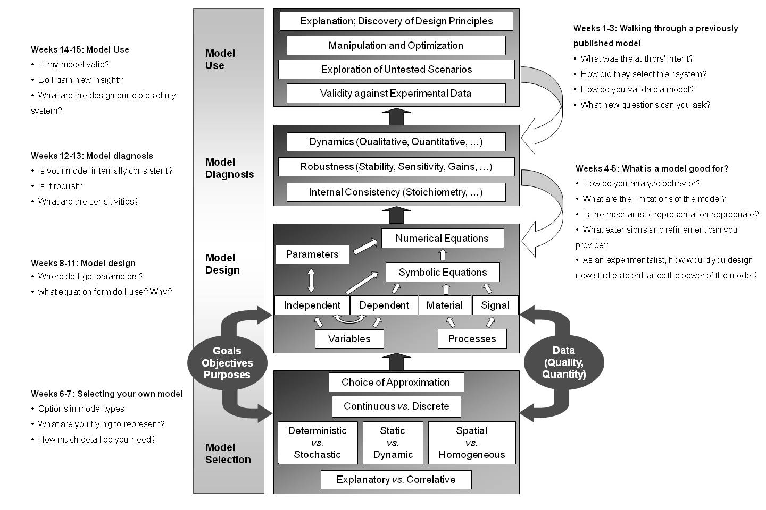
The format for this class departs from convention in computational modeling courses and is designed to be accessible to BME and non-BME majors who wish to gain a fundamental understanding of how to approach biological question using computational tools. Our approach is to introduce the material in a top-down manner first, through the use of literature-available models, then build back up through application of gained knowledge to a new modeling topic. The syllabus is best represented by annotation to this figure:

