Fundamentals of Maneuver Warfare
NS 4333

Fall Semester 2017

Instructor: Major Craig Thompson
Office: NROTC Bldg, Room 211K
Office Hours: By appointment
Phone: (404)894-8137
E-mail: cthompson90@gatech.edu
Class Period: T/TH 0935-1055

Classrooms: Room 212, Okeefe

Course Description: This course analyzes the United States Marine Corps as the overarching case study for the advent of maneuver warfare. This is a history and doctrine-based course. The object is to educate you in the characteristics, requirements, and problems of maneuver warfare, not to train you in the staff planning process or require you to merely learn a list of facts, figures and dates. The value of the study of history is not simply to learn what has happened in the past, but as practitioners of maneuver warfare, to use the lessons of the past as the basis for making practical judgments about the present and future. Although this course focuses on maneuver warfare, it is worthwhile to point out that maneuver warfare is merely a subset of warfare in general. While it exhibits certain unique characteristics, it also shares many characteristics with the broader field. The case studies in this course have much to say about warfare overall. Some students will not have yet taken “The Evolution of Warfare.” This course demonstrates some of the more fundamental warfare lessons that will be new to some students and review for others.

The course will take place in three phases:

Phase I: Foundations (XX Aug – XX Sep): This phase will provide a foundation for the remainder of the course. Students will learn current Marine Corps warfighting doctrine and the fundamentals of Marine Corps operations.

Phase II: Investigation of Maneuver Warfare and Case Studies (XX Sep – XX Nov): Students will be introduced to different Marine Corps cultural concepts regarding the conduct and nature of warfare and military theory as it relates to Maneuver Warfare. Furthermore, through historical case studies, students will be introduced to different technological and doctrinal innovations that have had an impact on significant military history and Marine Corps operations.

Phase III: Current Application (XX Nov – XX Nov): Students will discuss operations in the past decade and relate those lessons to the current conduct of U.S. military efforts abroad.

Methodology: This course will be taught by instructor lecture, panel & seminar, practical application, discussion, and student presentations. It is designed in a discussion seminar/lecture format, which works well for this presentation subject matter, and provides the best learning opportunities. Your participation and completion of the reading assignments is key to learning the most from this course. You will get out of this class knowledge in the approximate measure of effort you put into it. This course consists of cumulative lessons-- each study
building on concepts from early classes. It is important for students to attend all class sessions to maximize comprehension of the core competency objectives.
Professional Core Competencies: (New PCCs are still being developed)
- ACADEMIC STANDARDS
  - Demonstrate a proficiency of the English language through usage, both spoken and written.
- LEADERSHIP AND MANAGEMENT
  - Comprehend the relationship between authority, responsibility, and accountability within a task-oriented organization.
  - Apply leadership and management skills to prioritize among competing demands.
    - Demonstrate the ability to establish meaningful goals and objectives.
    - Apply techniques of prioritization and time management to resources and personnel.
  - Apply leadership skills to achieve objectives.
    - Comprehend the different leadership styles and how they apply to different situations and groups.
    - Comprehend basic principles of human behavior and group dynamics.
    - Comprehend the difference between informal and formal groups.
    - Comprehend the contribution of formal group organization and standard procedures to mission accomplishment.
  - Comprehend the importance of planning and supervision to mission accomplishment
    - Comprehend the importance of planning and forecasting.
    - Comprehend the relationship between goal setting and feedback and apply this understanding to the establishment of control systems.
    - Know the important reasons for development and constant re-evaluation of alternatives in decision making.
- NAVAL HISTORY
  - Know the effect developing states and terrorist movements have had on the interests, policies, and strategies of the United States.
  - Comprehend the relationship between technological progress and the evolution of military strategies, policies, doctrines and tactics.
- NAVAL WARFARE
  - Comprehend the spectrum of warefare.

Course Objectives:
- To introduce the students to a warfighting and maneuver warfare.
- Comprehend baseline USMC doctrine.
- To develop the students critical thinking skills as they pertain to maneuver warfare.
- Comprehend the major cultural, technological, and doctrinal transformations in maneuver warfare.
- To develop fundamental USMC officer skills of writing, analytical thinking, professional writing, and public speaking.
- To impart to the student the lessons learned with the development of warfare with an emphasis on leadership remaining forward thinking and not stagnate.
- To give the student a baseline of understanding of today's conventional and irregular warfare and the historical context as to how maneuver warfare has evolved throughout history.
- Comprehend the importance of leaders remaining vigilant with development of warfare as it is related to doctrine, training, organization, material (equipment), and leadership.
Textbooks:
- The Maneuver Warfare Handbook, William S. Lind
- MCDP 1 Warfighting
- MDCP 1-0 Marine Corps Operations
- Handouts and supplemental readings will be distributed as required by the instructor.

Expectations:
1. THINK!!
2. Complete the assigned readings.
3. Be prepared to participate in class, this will be an interactive learning environment.
4. Learn the material; come to the instructor if you have any questions regarding expectations, the material, or assignments.

Attendance:
- You are required to attend class.
- If you are unable to attend class you will brief the instructor prior to missing the class.
- If you are on special orders, guard etc. you are required to bring a copy of those orders to the instructor in order to receive an excused absence.
- If you are late for class you must speak to the instructor before leaving the class that session.

Assignments:
- All assignments will be turned in at the beginning of each class. Should the student not turn in the assignment at the beginning of class and has not previously spoken to the instructor the student will lose 10% on the assignment and an additional 10% for each day the assignment is late.
- All assignments will be turned in as a hard copy; no digital submissions will be accepted.

Grading Policy:
Quizzes: 15%
Essays: 15%
Student Presentations: 20%
Midterm: 25%
Final Exam: 25%

Grading Scale:
  - A
  - B
  - C
  - D
>60 F

Quizzes, Exams, Essays, Presentations and Participation:
- Participation: Students will complete all required readings and will come to class prepared to discuss and/or take a quiz on material assigned. This class will be interactive, collaborative, and will require daily participation from each student.
- Quizzes: Quizzes will be taken at random to evaluate student’s knowledge and comprehension of the assigned readings. There will be up to 5 quizzes in all with the top 3 making up the quiz grade for the academic term.
- Essays: Each student will be assigned up to 3 essays; these assignments will be evaluated based on the students understanding of the material, critical analysis, and ability to communicate in written form. All coursework turned into the instructor will be in Naval Letter Format and utilize Courier New 10pt font.
- Midterm: The midterm will cover Phases I & II of the curriculum. Students can expect a mixture of true/false, multiple choice, fill-in, and short answer questions.
- Student Presentations: Students will be assigned a topic for their group presentation. Students will form groups of 2-4 individuals and provide a 30 minute presentation on the assigned topic. Students are encouraged to utilize multiple multimedia methods (Power Point, Sand Table, White Board) but are required to provide the instructor with a printed outline of the presentation at the beginning of class. Students will be graded based on content, presentation quality, and knowledge of the topic. Students will cite sources utilized in the presentation.

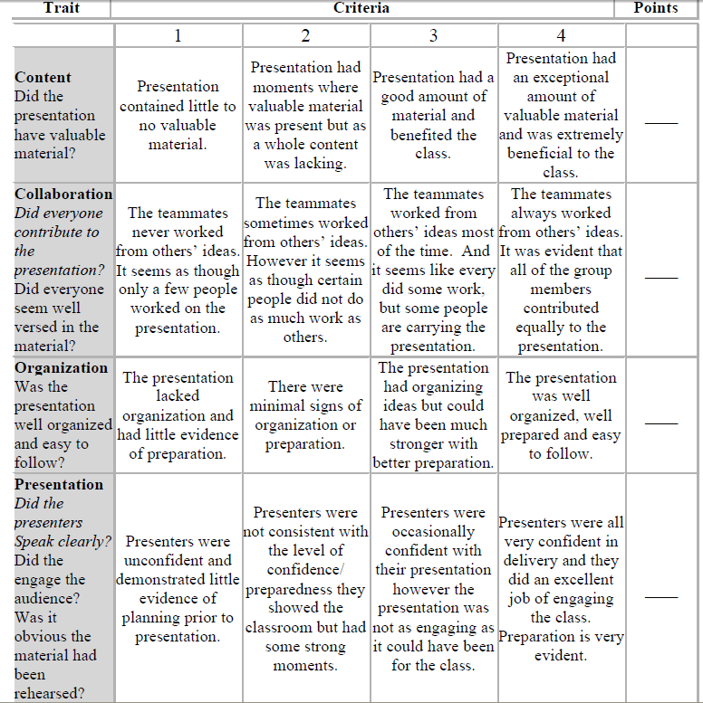

- Final Exam: The final exam will cover Phases III and IV of the curriculum. Students can expect a mixture of true/false, multiple choice, fill-in, short answer questions, and essay questions.
- Honor Code: As future Naval Officers, only conduct of the highest moral grade is acceptable. Any behavior that is morally questionable will greatly affect your ability to lead. Violations of trust will be dealt with severely.

1. Plagiarism. Plagiarism, as defined in the 1995 Random House Compact Unabridged Dictionary, is the "use or close imitation of the language and thoughts of another author and the representation of them as one's own original work." Plagiarism can also consist of using another author's production without crediting the source. If caught plagiarizing, you will be dealt with according to the GT/MHC Academic Honor Codes. In addition, if you are a part of NROTC Atlanta, you will be brought before a Performance Review Board.
2. All writing assignments will be individual effort.
3. No old course work will be utilized for requirements of this course.
4. For any questions involving these or any other Academic Honor Code issues, please consult me or www.honor.gatech.edu.

Sign______________________________ Date___________
C. A. Thompson
MAJ/USMC
Assistant Professor of Naval Science

Sign______________________________ Date___________
B. V. REINHOLD
CAPT/USN
Professor of Naval Science

