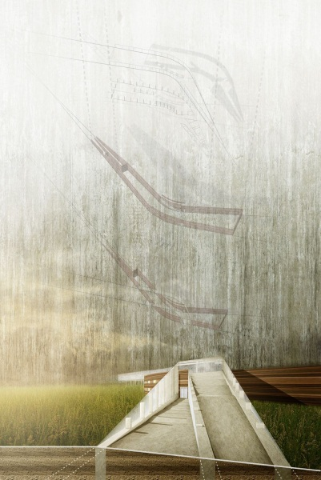 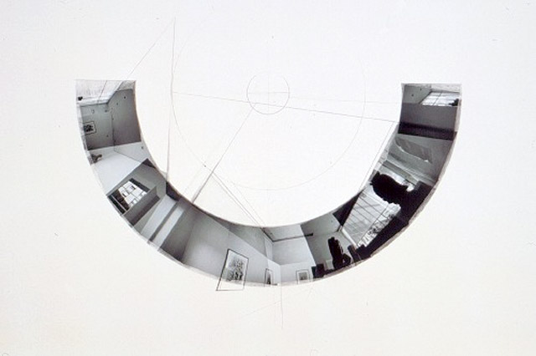

**ARCH 6010 Architecture Modeling and Media I**

College of Desgin | School of Architecture

Hinman Research Building, Main Floor

Instructors: Charles Rudolph [charles.rudolph@coa.gatech.edu](mailto:charles.rudolph@coa.gatech.edu) office: COA West mezzanine #4

**INTRODUCTION**

This course is comprised of introductory approaches to two and three dimensional modeling and representation in architecture using both manual and digital media and techniques. Students are introduced to the discipline –and the culture, of drawing through exercises and critical discussion. Through a series of highly articulated exercises, students build skills in both analog and digital drawing and making that are fundamental for architectural design. Each exercise is aimed a developing each student’s ability to combine and apply analytical and representational skills through a series speculative instrumental and conceptual contexts. The course is a companion to the Core I Design Studio. Drawing, model-making, and free-hand sketching *remain* necessary skills for architectural design, even in the age of digital media. The goal of the studio is to build visual acuity, compositional rigor and spatial sensibility that will support the later command of the most sophisticated digital media.

**Course Procedure and Organization**

Because of the accelerated nature of the Summer Studio, the course is organized around daily meetings. The instructor will introduce the assignment of the week and will demonstrate the key moves necessary to complete the assignment. For most of the assignments PDF files will be available to the students demonstrating the process used. The instructor and the Graduate Teaching Assistant will be there to assist the students and to answer questions. As the semester progresses and the overlap between the course and the studio intensifies, some of the questions and issues arising from the assignment will be clearly related to the production of Studio work.

The particular challenge of teaching and of being a student in this course is related to the different levels of expertise that the students possess. This is especially evident at the beginning. Some of you may find at times some of the assignments and some of the instruction difficult, while others may find the same material easy and redundant.

Learning Outcomes:

**Learning objectives include:**

* Introduce the discipline –and the culture, of architecture through exercises and critical discussion
* Build skills in both technical and free-hand drawing and making that are fundamental for architectural design
* Develop ability to apply representational skills in a speculative design context

The goal is to have all students reach a similar level of competency and understanding at the end of the semester. Please be patient, ask for help and help each other. Please do not hesitate to ask questions!

The class assignments are due on the date posted in the individual assignment sheets. The course will have a folder dedicated to it in the School intranet system. Your completed work will be submitted in that folder unless otherwise specified. Students are required to submit the original files of their work, in the software assigned for each exercise. For instance, if you are asked to create a movie of the shadows created on a particular building (using 3dStudio), you will have to submit both the movie and the original file from which the movie was created

**Course Requirements**

Regular attendance is mandatory. The successful completion of this course entails the successful completion of the ten assignments in the syllabus. There is no final exam. Instead, as final exam I will consider your final studio presentation and the demonstration of the different skills and insights you have culled from this course. The final assignment is considered to be part of your final studio presentation. The assignments form part of your final grade in the following manner: 0 = 10% + 1st = 15% + 2nd=15% + 3rd = 5% + 4th = 5% + 5th = 5% + 6th = 5% + 7th = 10% and the final assignment, is 30% of your grade.

Schedule 9am-12noon 1-4pm 5-7pm

**Week 1 Space(Material): Line, Surface, Form**

June 27 M Orientation Events studio setup /drawing

28 T mass/tone drawings figures / trees

29 W body/gesture drawings exterior views

30 TH perspective drawings interior/exterior views tba

July 1 F Assignment 1: *An architectural landscape* (model/drawings)

Reading: E. Robbins, “Why Architects Draw”

P. Zumthor, “A Way of Looking at Things”

C. Moore, G. Allen, “Dimensions”

**Week 2 Surface (Light): Texture and Tone**

4 M *Holiday*

5 TCharcoal drawings of Assignment 1 models (exterior in light)

6 W Charcoal drawings of Assignment 1 models (interior in light)

7 TH drawing workshop tba

8 F Assignment 2: Composite interior and exterior drawing Reading: R. Evans, “Figures, Doors, Passages”

G. Bachelard, “The Oneiric House”

J. Whiteman, “Still Movement: E.E. Cummings and Louis Kahn”

**Week 3 Composition (Order): Collage and Assemblage**

11 M Pinup of Assignment 2, Part 2 digital workshop tba

12 T Visual Arts Charrette Project mixed media works

13 W Field Trip to High Museum Diagram lecture/workshop

14 TH digital workshop tba

15 F Assignment 3: *Collage and Assemblage Project*

Reading: T. Vidler, “Diagrams of Diagrams: Architectural Abstraction and Modern Representation”, V. Berkel + Bos (U.N. Studio), “Diagrams”

B. Nicholson, “Collage Making”

**Week 4 Space (Description and Precision): Expression in Architectural Drawing**

18 M Pinup of Assignment 3 visual arts workshop (Duncan)

19 T Assignment 4: FASET Pavilion digital workshop tba

20 W conceptual diagrams modeling and color workshop

21 TH research digital workshop tba

22 F Assignment 4, Phase 1: *Tectonic Models and Drawings*

Reading: C. Rowe, R. Slutzky, “Transparency: Literal and Phenomenal”

K. Frampton, “R’appel a l’ordre: A case for the Tectonic”

A. Loos, “Ornament and Crime”

**Week 5 Space as Drawing: Synthesis and Representation**

25 M Pinup of Assignment 4, Phase 1 visual arts workshop

26 T develop drawings/models digital workshop

27 W presentation techniques workshop production

28 TH synthetic drawings and models production

29 F Last day of class

**Week 6 Aug 1M-3W Independent Work**

August 4 TH ***FINAL PROJECT REVIEW Guest Critics to be invited***

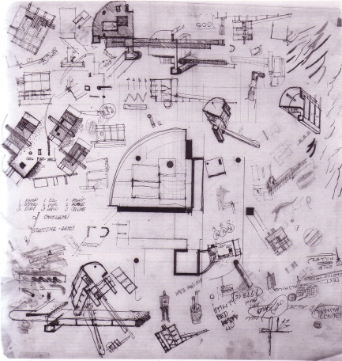 

John Hejduk, Sketchbook Page, Wall House, 1967 **ARCH xxxx Visual Arts Workshop Summer 2011**

**Week 1** **Tools Used**: charcoal and pencil, model-making materials

**Assignments:** Still-life drawings, body and gesture studies, interior sketch perspective drawings, outdoor drawings (trees, perspectives), model-making exercise (abstract forms) and final perspective drawing depicting the forms and assigning scale through figures. Shade and shadow.

**Skills:** sketching, line and tone drawing, fundamentals of perspective, shade and shadow

* Visual Arts Evaluation of all assignments
* Design Studio Evaluation of weekend assignment (model and drawings)

**Week 2** **Tools Used**: model-making materials, pencil

**Assignments:** Model of hypothetical site using “kit of parts” (walls, columns, beams). Model of “wall project” that utilizes original site model, orthographic drawings of model(s), shade and shadow of orthographic drawings, axonometric drawing

**Skills:** Model-making, drawing: orthographic projection, shade and shadow, axonometric

* Visual Arts Evaluation of presentation drawings (shade and shadow) sketch exercises
* Design Studio Evaluation of all assignments

**Week 3** **Tools Used:** Pen and pencil (diagrams / sketching), Photography, Mixed media (collage), model-making materials, photoshop, CAD

**Assignments:** Introductory CAD drawing (line weights/layers), diagram sketching, photo documentation and presentation, model-making as critical analysis, mixed media presentation of Charrette Project

**Skills:** Fundamentals of diagram-making, models-as-diagrams, site sketching, “assemblage” and mixed media presentation

* Visual Arts Evaluation of one-day Charrette Project
* Design Studio Evaluation of all assignments

**Week 4 Tools Used:** Pen and pencil, CAD, Photoshop, model-making materials

**Assignments:** Site and program analysis, precedent research, conceptual models, diagrams, digital and analog drawings, tectonic “studies” via mixed media drawing or assemblage

**Skills:** Critical analysis (program/site), tectonic exploration of conceptual schemes, digital drawing

* Visual Arts Evaluation of mixed media drawings
* Design Studio Evaluation of Analytical team and individual work

**Week 5** **Tools Used:** Combination of all media

**Assignments:** Final Project Assignment for campus pavilion for FASET, models at 3 scales (including detail), drawings (digital and analog)

**Skills:** Demonstration of synthesis of 3 and 2-dimensional representations, perspective drawing, analytical work.

* Visual Arts Evaluation of Final Representations (Drawings and Mixed Media)
* Design Studio Evaluation of Final Presentation Materials and Methods

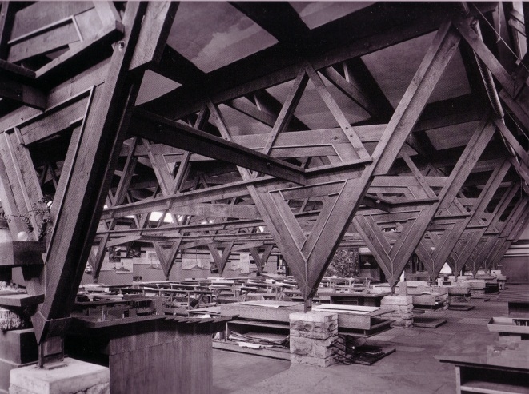 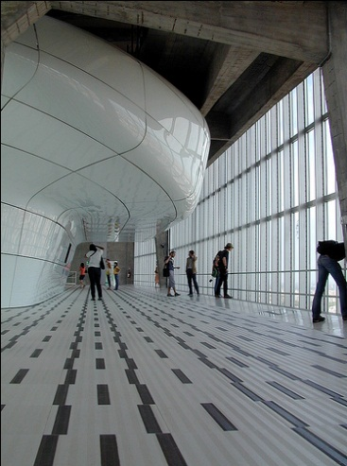

Drafting Room, Taliesin (East), Wis. (Frank Lloyd Wright, Architect) Installation in Pirelli Tower (Gio Ponti, Architect) Milan, Italy

**PROCEDURES**

* The studio meets Monday-Friday: 9-12pm, 1-4pm, and 5-7pm. Fridays are unsupervised sessions in studio. The evening period is for scheduled films, workshops (tba) and studio work.
* The course calendar contains all of the class meetings, assignment dates, due dates, etc. While you should always consult the calendar, there can be changes along the way.
* The instructors will work together with all students on the assignments and exercises. You may receive varied kinds of criticism. It is important to “filter” the criticism and to respond in your work.
* The hours in studio that we spend together each week is precious time. Attendance to all sessions is mandatory. If you must miss a studio class, please inform the instructors in advance.
* The studio should be a place where we can work and think calmly and creatively. Please feel free to make it YOUR environment, with the only proviso being to respect those around you.
* Purchase supplies and set up your desk space during the first week of studio. While you need not have all of the supplies to begin the first project, we encourage you to organize your space and be ready to work on Tuesday.
* A key item on the list is the SKETCHBOOK. Sketchbook assignments will be made weekly and twice during the term the books must be submitted for review by the instructors. It is simply a tradition for architects and designers to record their thoughts and ideas in a visual journal. We want you to start immediately!

NOTE: You should be aware of your personal possessions and valuables at all times. You should keep your architectural materials/valuables secure in a locker when you are away from the studio.

* Our standard procedure for discussing work is in the form of the “Desk Crit”, which happens as frequently as possible. You are ultimately responsible for the quality of these discussions, as they are based upon evidence of the ongoing development of your work.
* Scheduled REVIEWS and pinups will take place opposite the studio in the jury space. We encourage the entire class to participate fully in these sessions. MONDAYS are review days throughout the five week studio.
* Lectures, slide talks, and/or films might occur during the schedule as a break from studio work. Room locations will be announced. Because we have the luxury to do so in summer, we may hold impromptu sessions.
* If we embark on field trips, we request that you coordinate the logistics of mass transit, carpooling, etc. Information about these trips will be made available as we go.
* It is recommended that each student document his/her work as they progress through the term. At semester’s end, each student is **required** to submit a CD with high-quality JPEG images of **all** projects.

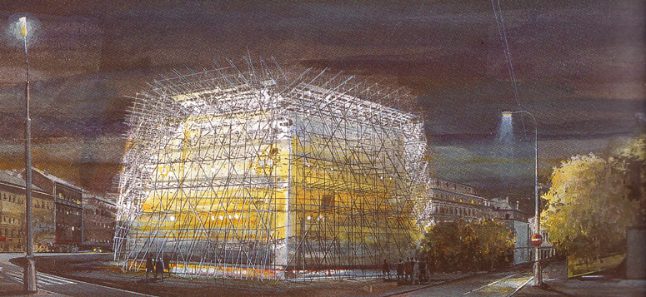

Atelier Jean Nouvel, Drawing of “Incongrous Monument”, Quartier Schmikov Project, Prague, Czech Republic

**EVALUATION**

Students will be evaluated after each week’s work. Grades will be given after Monday’s reviews. A final grade will reflect an average of each week’s grades, plus the grade on the final review work.

*Your performance will be evaluated according to these criteria:*

* *Intellectual engagement, overall consistency and enthusiasm of effort*
* *completion and quality of assignments and projects*
* *clarity and rigor of investigation and demonstration of disciplinary skills*
* *attention to quality and craft demonstrated in the work*

Please be reminded that grades are earned and not given, and that:

**A grade of “A” reflects- excellent work**: Outstanding work through consistency of effort, intellectual rigor and probity, careful attention to quality and craft demonstrated throughout.

**A grade of “B” reflects- above average work**: Overall consistency of effort, adequate intellectual engagement, completion of assignments, adequate but not exceptional rigor and attention to quality and craft.

**A grade of “C” reflects- average work**: Overall inconsistency, recurring problems of completion, low level of intellectual engagement, lack of rigor and attention to quality and craft.

**A grade of “D” reflects- below average work**: Poor effort overall, repeated failure to complete projects and assignments, no intellectual engagement, unacceptable attention to rigor, quality or craft.

**A grade of “F” reflects- inadequate, failing work.** Failure to meet minimum requirements, serious deficiencies.

# **Academic Integrity and Conduct**

Georgia Tech aims to cultivate a community based on trust, academic integrity, and honor. Students are expected to act according to the highest ethical standards. All Georgia Tech students should familiarize themselves with and abide by the Georgia Tech Honor Code <http://www.catalog.gatech.edu/rules/18/>.

Student work that presents the ideas or words of others as the student’s own adversely impacts the whole school and may lead to immediate dismissal. Academic dishonesty, including cheating, plagiarism, commissioning academic work by others, or performing academic work on behalf of another student, is strictly prohibited. All persons in the classroom are expected to behave with courtesy towards others and in a way that does not interfere with the regular conduct of the class. Cell phones are to be turned off when students enter the classroom and should remain off for the duration of class: <http://www.catalog.gatech.edu/rules/19/>

# **Special Needs**

# Any student with a disability, that may require accommodation, should contact Office of Disability Services at 404-894-2563 or visit <http://disabilityservices.gatech.edu> to make an appointment to discuss his or her special needs and obtain an accommodations letter. He or she should also schedule an appointment to speak with the course instructor.

# **Emergencies**

In case of emergency (e.g., fire, accident, or criminal act), please call the Georgia Tech Police at 404-894-2500. Please note that Perry Minyard, IT Support Administrator for the College of Architecture, is also a firefighter and an Emergency Medical Technician (EMT) certified in performing CPR.

# **Ownership**

Physical copies of student work submitted to the school to satisfy course requirements—including, but not limited to digital files, papers, drawings, and models—become the property of the school. It is assumed as no obligation to safeguard such materials and may, at its discretion, retain them, return them to the student, or discard them.

# **Archiving**

In some courses, selected students may be required to submit physical examples of their work or digital examples (on a clearly labeled CD), no later than one week after the end of term, to their instructors or administration for archiving. By enrolling, each student grants a license to reproduce and display his or her work. This is a chance for students to have their work shown online and potentially featured in forthcoming publications.

# **College of Design Facility Rules and Guidelines**

Please consult the Georgia Tech Student Handbook regarding the use of facilities and all Institute policies. Aerosol sprays of any kind are strictly banned from the studio and surrounding areas. A new spray painting booth is now in operation in the College of Design shop, on the ground floor of the East Architecture Building.

Shop Use: All students using shop facilities must first have completed an orientation. Safety first, always! Noise should be kept to a minimum. Music may be listened to only through headphones, including evenings and weekends.

Studio Housekeeping: Students should feel free to organize their space creatively and expressively, but with respect to others around them. Try to prevent clutter from becoming a nuisance, distraction, or a hazard. The cleaning staff makes every effort to determine what is and is not trash, but their job can be made easier if you keep drawings and models off of the floor.