**ARCH 6028**

**CORE I Architectural Design Studio Fall 2018**

School of Architecture | College of Design | Georgia Institute of Technology | Hinman Research Building

Studio MF 1:10-5:10pm W 1:10-3:10pm

Instructors: Charles Rudolph, Associate Professor

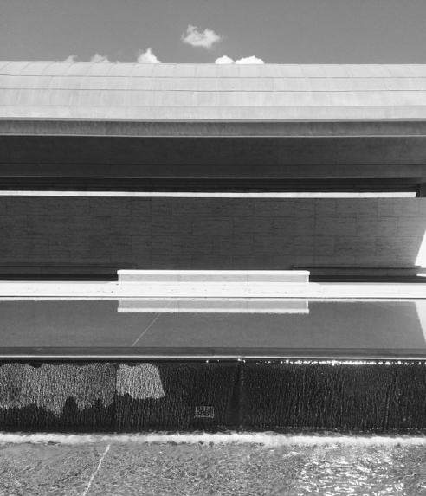 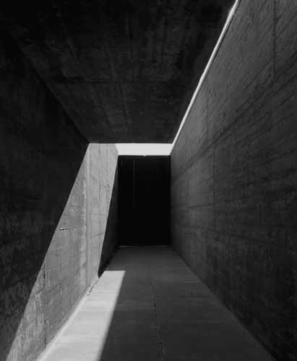

Kimball Art Museum Louis Kahn, Architect Swimming Pools at Leca de Palmiera, Portugal

Alvaro Siza, Architect

**COURSE SYLLABUS**

**COURSE DESCRIPTION**  
ARCH 6028 is the first of three introductory-level studios in the Master of Architecture curriculum, and the beginning of an academic year focused on developing the skills, tools and overall confidence in critical thinking and making necessary as a foundation for contemporary architectural practice. The Core I studio will focus on the development of your competence as architectural designers through the practice of a design process that is rooted in abstraction, ideation, and iteration. The iterative process will employ both analog and digital tools, and the exercises will be explored using various media and techniques of representation: drawings, sketches, models, and constructions.

Each student brings a different academic background, knowledge base and cultural experience to the program, yet we all must learn to converse with –and within, the language of our discipline. Architectural representation (drawings and models of spaces, buildings, environmental conditions) functions as that language. It is based in abstraction, whether in two or three dimensions, on paper or in the computer, as a construction detail or as a city plan.

The architect is trained to imagine and visualize a transformed physical reality by constructing, evaluating, and manipulating abstract representations of this reality. To command this eye-to-hand (and eye-to-machine) skill with confidence requires time, patience, and –perhaps most importantly, thoughtfulness and care. A student’s individual “embodied knowledge” that they bring with them can only be allowed to influence his/her work to the degree that they command the representational media. The goal of the studio is to build visual acuity and spatial sensibility that will support the later command of advanced tools and media.

The work will be challenging and at times perhaps frustrating. However, breakthroughs will happen and confidence will be gained if you enter into this course (and program) with equal parts enthusiasm, intellectual adventure, and –dare I say it, a sense of humor.

**Learning objectives include:**

* Introduce the discipline –and the culture, of architecture through exercises and critical discussion
* Build skills in both technical and free-hand drawing and making that are fundamental for architectural design
* Develop ability to apply representational skills in a speculative design context
* To develop a broad understanding of analog architectural tools and their relationship to form, space and concepts.
* To develop cognitive and perceptual sensitivity to visual qualities and the conceptual understanding of visual structures, toward an awareness of visual culture and architecture’s participation in it.
* To develop critical thinking through analysis of your own work and the work of others.
* To develop a methodology of iterative making and to understand its role in creating and developing synthetic ideas.
* To develop the ability to critically describe the environment through visual observation, techniques of representation, and verbal/written description.
* To develop an understanding of architectural program relating activity and use to space and form.
* To develop a precise vocabulary to communicate visual and spatial ideas.
* To develop honesty, clarity and confidence in the presentation of your work.

**COURSE ORGANIZATION**

This semester will be an introduction to first principles of visual awareness and architectural thinking, organized in four modules, beginning with a pair of abstract exercises requiring translations from images into drawings, and drawings into physical models. Following the first two exercises, the third will involve a given “kit” of architectural parts which will be used to explore a given program (spaces and thresholds). The second part of exercise three involves a surprise conversion of the program, and the introduction of an abstract site. The final exercise will envision a small intervention on a given “real” site, where the iterative working process and skills/tools gained over the term will be combined in synthesis.

MODULE ONE: **Abstraction – Translation - Iteration** Exercise 1: *Point / Line / Plane*

MODULE TWO: **Analysis – Projection – Iteration** Exercise 2: *Painting as Site*

MODULE THREE: **Site – Sequence – Iteration** Exercise 3: *Kit of Parts*

MODULE FOUR: **System – Tectonics – Iteration** Exercise 4: *Musician’s House*

*Digital: of, relating to, or being data in the form of especially binary units –digital images, a digital readout; especially: of, relating to, or employing digital communications signals –a digital broadcast*

*Analog: something that is comparable to or representative of another (as opposed to the original itself),*

*a description of a continuously variable condition (as opposed to a discrete or digital set of conditions).*

As digital tools provide the powerful means for controlling and communicating our work, and are standard throughout the design and construction industry, learning them is essential. In the second part of the course, digital drawing will be introduced. This course is designed to provide the opportunity to gain familiarity with -to question and to explore, the role of hand / analog / non-digital tools and media in the architectural design process.

**ARCH 8855 CORE I Architectural Design Studio Fall 2018**

School of Architecture / College of Design / Georgia Institute of Technology

Hinman Research Building Studio MF 1:25-5:25pm W 1:25 – 3:25pm

Instructors: Charles Rudolph, Associate Professor

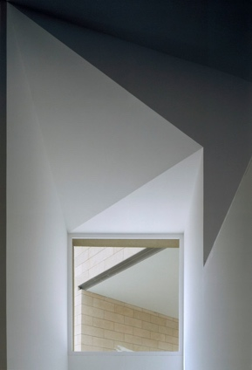 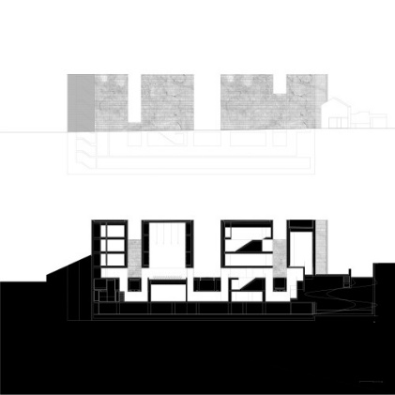 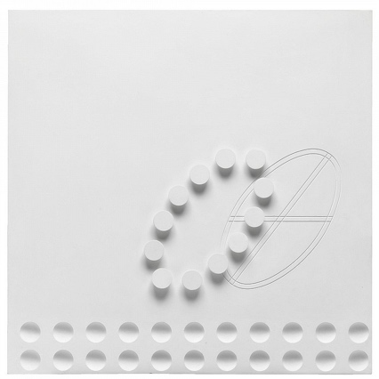

Alvaro Siza,museum interior Aires Mateus Architects, section / elevation Fausto Melotti, white relief

Course Schedule

***MODULE ONE ABSTRACTION - ITERATION***

W1 M20Aug Studio Meeting. Materials list. Course Overview

Exercise #1A: Point / Line / Plane photo exercise

W22 Exercise #1A Due 2pm in studio

Exercise #1B: Photo - to - Drawing Translations

F24 Exercise #1B work

W2 M27 Exercise #1B Due 2pm in studio

Exercise #1C: Drawing – to – Model Translations

W29 Exercise #1C Models discussion in studio. Begin “Critical Model”.

F31 Exercise #1C: Critical Models

W3 M 3 September LABOR DAY HOLIDAY

***MODULE TWO ANALYSIS - ITERATION***

W5 Exercise #1C: Point – Line – Plane DUE. Pinup with Guest Critic

Exercise #2A: Painting as Site (Analysis + Projection). Line drawings.

F7 Lecture: Cubism and architectural space. Verification of Student Participation (Due 4p)

W4 M10 Exercise #2A Due 2pm in studio. Pinup and discussion.

Exercise #2B: Spatial Reliefs. White poster board.

W12 Exercise #2B work

F14 Field Trip: High Museum. Leave from studio (take trolley together to MARTA)

W5 M17 Exercise #2B Due 2pm.

Exercise #2C: Horizontal and Vertical Cuts. Orthographic drawings with pencil.

W19 Work Day / Crits

F21 Exercise #2C Final Model + Drawings Work

***MODULE THREE SITE – SEQUENCE - ITERATION***

W6 M24 Exercise #2C: Painting as Site (Analysis + Projection) DUE 2pm

Exercise #3A: Kit of Parts (Landscape Model)

W26 Crits in studio

F28 Field Trip: Emory Campus (tbc). Depart from Hinman. Carpool.

W7 M1October Ex #3A Due 2pm. Discussion with guest critic.

Ex #3B: Plan, section and elevation drawings

W3 Drawing Workshop

F5 Ex #3B Due 2pm

Ex #4A: Frontality + Rotation (Musician’s Wall House)

W8 M8-9 FALL BREAK

W10 Ex #4A: Pinup with Models in studio

F12 Ex #4A work

W9 M15 Ex #4A Models Due.

Ex #4B: Structure and Detail. Detail model @ ½” = 1 foot

W17 Digital Workshop I

F19 Field Trip to an Architect’s House. Depart from Hinman. Carpool.

***MODULE FOUR SYSTEMS – TECTONICS – ITERATION***

W10 M22 Ex #4B Working models and sketches pinup

W24 Digital Workshop II

F26 Ex #4B work

W11 M29 Ex #4A + B REVIEW

Ex #5: Final Drawings and Models Work

W31 Digital Workshop III

F2 November Crits in studio

W12 M5 Ex #5 Drawings Review with Guest Critic

W7 Digital Workshop IV

F9 Crits in studio

W13 M12 Studio Crits

W14 Final Studio Class

**F16 FINAL STUDIO REVIEWS**

**S17 FINAL STUDIO REVIEWS**

W14 **M19 FINAL STUDIO REVIEWS**

W21 Recess –Campus Open

TH 22 –F23 THANKSGIVING HOLIDAY (Campus Closed)

W15 M26 – W28 In-Studio Portfolio Work

F30 All –School Portfolio Competition and Celebration

W16 M3 December Exit Interviews signup. All Studios: Clean Up Day

Final Instructional Day

TH6 Reading Period (no exams) prior to Finals Dec.7-13

15 December End of Term

**GENERAL STUDIO REQUIREMENTS AND RESOURCES**

Studio Culture

<http://www.arch.gatech.edu/studentlife/studio>

Each student is responsible for the production of his/her own work. This applies to team projects as well as individual projects. Criticism is central to the learning experience of the studio, whether in one-on-one scenarios or informal group discussions. Students are expected to be prepared for desk crits as instructors will make every attempt to see as many prepared students as possible on a given studio class day. Creative production is a result of both personal initiative and time management. Students are expected to work on assignments in Hinman, as the collaborative and collegial experience amplifies the learning experience and is a hallmark of an architectural education. We hope you will foster and encourage an environment of collegiality, respect and deep interest in your shared learning experience.

Master of Architecture Handbook

<http://www.arch.gatech.edu/graduate/handbooks/march>

Readings

Required reading materials will either be provided as hard copy or will be placed in a studio folder or uploaded to a common folder. Instructors may make readings available on other electronic sites and may distribute other readings in their section seminars. Reasonable time will be given to complete readings prior to discussion.

Studio Attendance

Attendance is mandatory throughout the studio class period (MF 1:25-5:25pm) as well as workshops (W 1:25-3:25pm). Studio sessions begin promptly and end as determined by each instructor. This may at times fall beyond 5:25pm, due to the time spent with each student at the desk crit.

Each student is required to attend regularly scheduled class meetings and to participate in all class discussions and group meetings. Each student is also expected to attend scheduled reviews and pinups, and to complete project requirements as per the Schedule. Students are required to remain in studio for the full duration of the scheduled class time. Arriving late, or leaving early, will not be tolerated without prior approval. You must address any scheduling conflicts with your studio instructor at the beginning of the semester.

Studio is a laboratory course. Not all classes will include direct instructional time; independent work will be assigned. There will be periods of studio, and full studio sessions, through the semester where you are expected to attend and to complete your assigned work, without direct instruction. These are independent working periods, often prior to major pin-ups or reviews, and are critical to the progress of your work.

Missing three studio classes, excused or unexcused, or any single major review, will result in a meeting with your Instructor and the Architecture Program Office to determine a course of action.

Missing more than three studio classes without an approved excuse will result in a letter grade reduction.

Studio Work and Documentation

The work produced in studio is the property of Georgia Tech and may be collected for archival purposes or for representation in the accrediting process. The faculty strongly recommends that each student document his/her work upon completion (electronically) and that they submit a copy of work to their instructor at the end of the semester. Individual instructors may require a digital copy of all final work prior to the issuance of a grade.

# Academic Integrity and Conduct

Georgia Tech aims to cultivate a community based on trust, academic integrity, and honor. Students are expected to act according to the highest ethical standards. All Georgia Tech students should familiarize themselves with and abide by the Georgia Tech Honor Code <http://www.catalog.gatech.edu/rules/18/>.

Student work that presents the ideas or words of others as the student’s own adversely impacts the whole school and may lead to immediate dismissal. Academic dishonesty, including cheating, plagiarism, commissioning academic work by others, or performing academic work on behalf of another student, is strictly prohibited. All persons in the classroom are expected to behave with courtesy towards others and in a way that does not interfere with the regular conduct of the class. Cell phones are to be turned off when students enter the classroom and should remain off for the duration of class: <http://www.catalog.gatech.edu/rules/19/>

# Special Needs

Any student with a disability, that may require accommodation, should contact Office of Disability Services at 404-894-2563 or visit <http://disabilityservices.gatech.edu> to make an appointment to discuss his or her special needs and obtain an accommodations letter. He or she should also schedule an appointment to speak with the course instructor.

Correspondence

Your Georgia Tech email address is considered your official address. Please use it and not third-party services. Email is a form of official correspondence. Failure on your part to receive email sent, or failure on your part to send email, does not constitute an acceptable excuse for failure to complete required work or attend required class. When in doubt, contact your Instructor in person, in addition to confirming receipt of any time-sensitive or urgent correspondence.

Environmental Concerns:

Aerosol sprays of any kind are strictly banned from the studio and surrounding areas. A spray painting booth is in operation in the COA shop, on the lowest floor of COA East. Use no high-VOC solvents or other noxious or hazardous chemicals in studio.

Shop Use

All students using shop facilities must first have completed an orientation. Students must comply with all shop procedures or they will lose shop privileges.

Phones and Digital Media in Studio

During class hours, students should cease or strictly limit their use of devices for personal matters and/or entertainment purposes. All electronic devices should be muted. If you must take or initiate a telephone call or other message, step outside of studio.

Music in Studio

Headphones must be used during studio hours. After studio hours, headphones should be used in consideration of others.

Media in Studio

Be judicious of your time and attention, and be considerate of others. Viewing entertainment media during studio hours is not permitted. Instructors maintain the right to limit or remove media that is distracting to the work of the studio.

Studio Housekeeping

Keep your assigned areas clean of debris and trash. Do not store materials on the floor. Keep all common areas clear of your personal belongings. Please be mindful that you are sharing space with others, and that their personal work environment is as important as your own.

**COURSE GRADING**

Attendance, participation, timely completion of work, the depth of engagement in studio issues, and the making of progress in your work provides the foundation for your grade. Conceptual rigor, project development and refinement, drawing and model-making requirements, and craftsmanship all matter greatly and factor in the evaluation of your performance. Grades are earned by you –not given by your Instructor.

A grade of “F” represents “failing” work. This grade reflects a failure to meet the studio requirements, including attendance, minimum requirements concerning presentation and fulfillment of studio requirements. In case of an “F”, the studio will need to be repeated.

A grade of “D” represents “unsatisfactory” work. This grade reflects that you have significant attendance problems, poor studio performance, failure to meet deadlines, non-fulfillment of the basic requirements of the studio, and/or your project is not plausible. In case of a “D”, the studio will need to be repeated.

A grade of “C” represents “satisfactory” work. This grade reflects that you have met the basic requirements of the studio, and your project is plausible, even if substantially under-developed.

A grade of “B” represents “good” work. This grade reflects that you have met the full requirements of the studio, and that your project is developed to the point where evaluation can be made relative to the studio’s essential themes and criteria.

A grade of “A” represents “excellent” work. This grade reflects that your project represents both a clear understanding of studio themes and criteria, and is a self-motivated exploration beyond the basic course requirements. Projects that receive grades of “A” are exemplary projects in terms of concept, production, and craft.

Midterm grades will be assigned following the Midterm Review. Receipt of a passing grade at Midterm does not guarantee a passing Final grade. Before initiating any grade dispute, contact the Program Office and review Institute policies.

**General Institute Standards and Guidelines**

Course Catalog: <http://www.catalog.gatech.edu/index.php>

Counseling: <http://www.counseling.gatech.edu/>

Rules and Regulations: <http://www.catalog.gatech.edu/rules/1.php>

Disabled Assistance: <http://www.catalog.gatech.edu/genregulations/assist.php>

<http://disabilityservices.gatech.edu/>

Academic Honor Code: <http://www.honor.gatech.edu/content/2/the-honor-code>

Code of Conduct: <http://www.policylibrary.gatech.edu/student-affairs/code-conduct>

Student Bill of Rights: <http://www.catalog.gatech.edu/rules/22.php>

Please note that GT is a Tobacco Free Campus.

END