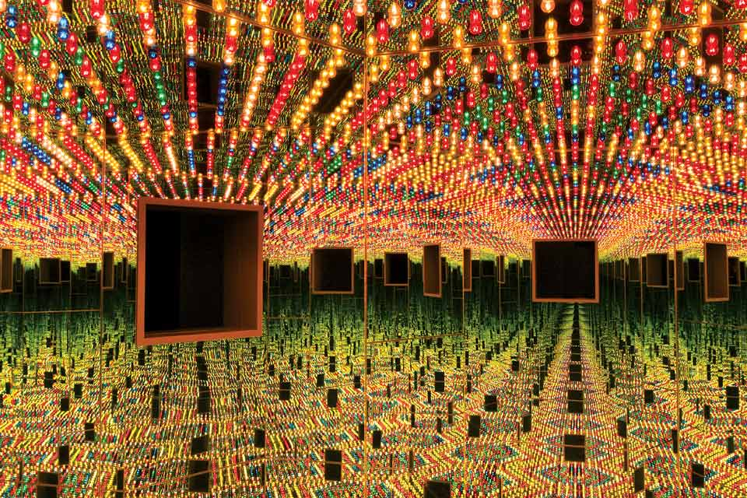**Georgia Institute of Technology | College of Design | School of Architecture | Fall 2018**

**Yayoi Kusama, Infinity Mirrors, Cleveland Installation, 2018**

**ARCH 6039 Advanced Architectural Design Studio 1**

**THE CRITICAL IMAGINATIVE:** Technology, Typology and the City

**M/F 1:10-6:10, W 1:10-3:10 = 12 contact hours per week**

Professors: Bell, Cottle, Gamble (coordinator), Pearsall

**Keywords:** Imagination, Technology, Urban Site/Public Space, Typology/Programming, Representation

**Mode of Representation:** Drawing**,** Digital and Physical Models, Limited Drawing Types

**Course Objectives**

ARCH 6039 Advanced Architectural Design Studio is the first of four upper-level options studios in the Master of Architecture curriculum within the School of Architecture.

The studio will focus on issues related to architectural production via three key themes: The City, Technology, and Typology. Methods of analysis and design as research will preface each studio’s foray into one collective exercise on the theme of **Structure/Urban Systems** and one instructor specific exercise on the theme of **Architectural Typology/Technology,** all of which will be further defined by your studio instructor and via a series of studio wide discussions.

Students are challenged to reflect, via their architectural projects, on the forces that are rapidly and radically transforming our profession. *Our collective charge is to stoke the creative/architectural imagination by framing critical approaches to particular problems of contemporary architectural practice.*

**Course Procedure and Organization**

A common project for all studios of three weeks’ duration at the outset of the term facilitates the integration of students from diverse backgrounds and experiences to establish an *espirit de corps* and a shared sense of identity.

The common project is designed to allow assessment of student’s variable skill and abilities in order to calibrate subsequent instruction and establish a high benchmark of expectations for both the quality of engagement and the quantity of work demanded of graduate study.

For the remainder of the term, each instructor articulates a distinct and provocative studio agenda. All studios share common performance indicators pertaining to the play of architectural convention and invention, analytical and integrative engagements of program and site, and thoroughness of project communication.

The studio will meet Monday and Friday from 1:10-6:10 p.m. with a requisite workshops and peer review sessions Wednesday 1:10-3:10 p.m. Other co-requisite courses may also be referenced in the studio: Media and Modeling, History of Urban Form, Structures, and Environmental Systems. All Lectures and Symposia are an essential component of your graduate education, constitute 1 credit hour *and are required*.

**Learning Objectives**

While each instructor proposition is distinct, all studios share common performance indicators and learning outcomes. The question is what should you as students know at the end of the course that you did not at the beginning? To this end, the objective of the studio is to develop each student’s abilities in these areas:

**Analysis:** Students will demonstrate the ability to analyze a fundamental architectural issue, which may include social, economic, and political dimensions, evaluate evidence derived from precedents and readings, and construct an argument that will serve as parameters for the design of an architectural proposition. In essence each student is charged to develop a critical framework and the demonstrate the ability to apply that framework toward a highly imaginative design intervention.

**Representation:** Students will demonstrate the ability to push the limits of conventional architectural representation in two directions: towards clear communication via drawing and models, technical data and design concepts; and toward the evocative description of time, temperature, and other attributes of spaces. Convention and invention related to modes of representation should be clearly articulated.

**Structure and Assembly:**Students should develop their projects in relationship to the larger urban milieu and apply the basic principles utilized in the appropriate selection of structural orders and material assemblies, based on their inherent characteristics and performance, be they unique or prototypical.

**Project Outline and Deliverables**

**A New Nexus for the Beltline**

**3 weeks**

P1 3 weeks Analysis: Natural Elements, Site Ecology, Structure as a design driver

[diagramming, drawing, model making]

Synthesis: Model

[digital diagramming, focused drawing with emphasis on axon and section in time]

Common

Deliverables Site Analysis

Structure and Systems Models and Drawings

Model and Section/Orthographic Drawings @ 1/8” = 1’-0”

**Instructor Defined: Type and Technology: 11 weeks**

P2a 2 weeks Analysis: Precedents and their transformations per instructor

[digital diagramming, drawing + modeling]

P2b 8 weeks Synthesis: building type and systems development/customization

[digital diagramming, modeling analog and digital, limited drawing]

Common

Deliverables Overall Site Model

Plan, Elevation 1”=8’

3 Sections with corresponding plan details @ 1” = 8’ minimum 1 model and 2 drawings

Detail Sections | Privileged Representation

Regardless of project complexity, the ground floor must be fully articulated/resolved

Studios complete a week earlier in order to produce portfolio pages.

**Course Schedule**

(subject to change by studio instructor)

**Week 1**

M20 Aug Convocation/Site Visit

W22 Problem One Intro/Lottery

F24 Desk Work/Portfolios

**Week 2**

M27 Pin-up

W29 Desk work

F 31 Desk work/Group Discussions

**September**

**Week 3**

M03 *Labor Day Holiday*

W05 Desk work

F07 Project 1 due

**Week 4**

M10 **Introduce Problem 2**

W12 Desk work

F 14 Workshop Gamble

**Week 5**

**M17** Pin-up

W19 Desk Work

F21 Desk work/Group Discussions

**Week 6**

M24 Pin-up

W26 Desk work

F28 Workshop Bell

**Week 7**

M01 Oct Pin-up

W03 Deskwork

F 05 Desk work/Group Discussions

**Week 8**

M8 Fall Break

W10 Desk Work

F12 Workshop Pearsall

**Week 9**

M15 Pin-up

W17 Desk work

F19 Desk work/Group Discussions

**Week 10**

M22 **All Studio Review Midterm**

W24 Desk work

F26 Workshop Cottle

**Week 11**

M29 Group Reviews

W31 boo Desk work

F01 Nov Desk work/Group Discussions

**November**

**Week 12**

M05 Group Reviews

W07 Desk work

F09 Desk work/Group Discussions

**Week 13**

M12 Group Reviews

W14 Desk work

F16 Final Review

**Week 14**

M19 Portfolio

W22 Holiday

F 24 Holiday

**Week 15**

M26 Portfolio Work

W28 Desk work/Studio Clean up

F30 **Portfolio Party**

**Course Requirements**

Each student is expected to attend regularly scheduled class meetings and seminar meetings, and to complete reading assignments and participate in class discussions. Each student is also expected to attend scheduled juries and pinups, and to complete project requirements per the schedule. Attendance is mandatory throughout the studio class period and work performed in the studio will be for studio only.

Studio sessions begin promptly and end as determined by each instructor. This may at times fall beyond the 6:30 pm hour, due to the time spent with each student at the desk crit. You must address any scheduling conflicts with your studio instructor at the beginning of the semester. Please note the meeting dates for the 1pm seminar in the schedule. All-section lectures are designated; all other seminars are by section only and are organized by the instructor. If a class must be missed, you must have an approved University excuse prior to the absence. Missing three classes without an approved excuse will result in a letter grade reduction. Missing more than three classes, excused or unexcused, will result in a meeting with your instructor and the Architecture Program Office to determine a course of action.

**Studio Culture and Production**

No Social Media or Texting during studio – phones should be put on vibrate. Each student is responsible for the production of his/her own work. This applies to team projects as well as individual projects. Criticism and peer review is central to the learning experience of the studio, whether in one-on-one scenarios or as informal group discussions. Students are expected to be prepared for desk crits as instructors will make every attempt to see as many *prepared* students as possible. During this semester, each student should rigorously explore the project’s conceptual foundations through reading, writing, drawing and model-making. Creative production (intellectual and expressive growth) is a result of both personal initiative and time management, and leads to reward. Your instructors hope that you find *pleasure in doing*.

NOTE: The work produced in studio is the property of Georgia Tech and may be collected for archival purposes or for representation in the accrediting process. The faculty strongly requires that each student document his/her work upon completion (electronically or with slides) and that they submit a copy of work to their instructor at the end of the semester.

# Academic Integrity and Conduct

Georgia Tech aims to cultivate a community based on trust, academic integrity, and honor. Students are expected to act according to the highest ethical standards. All Georgia Tech students should familiarize themselves with and abide by the Georgia Tech Honor Code <http://www.catalog.gatech.edu/rules/18/>.

Student work that presents the ideas or words of others as the student’s own adversely impacts the whole school and may lead to immediate dismissal. Academic dishonesty, including cheating, plagiarism, commissioning academic work by others, or performing academic work on behalf of another student, is strictly prohibited. All persons in the classroom are expected to behave with courtesy towards others and in a way that does not interfere with the regular conduct of the class. Cell phones are to be turned off when students enter the classroom and should remain off for the duration of class: <http://www.catalog.gatech.edu/rules/19/>

# Special Needs

Any student with a disability, that may require accommodation, should contact Office of Disability Services at 404-894-2563 or visit <http://disabilityservices.gatech.edu> to make an appointment to discuss his or her special needs and obtain an accommodations letter. He or she should also schedule an appointment to speak with the course instructor.

**Readings**

Required reading materials will either be provided as hard copy or will be placed or on T-Square/Canvas. Instructors may make readings available on other electronic sites and may distribute other readings in their section seminars. Reasonable time will be given to complete readings prior to discussion. Please understand that we are lucky to have a library in our building! Take advantage of this resource. Lectures and Events The 13th hour of Studio is the School of Architecture Lecture Series and students are required to attend. The lecture time is 1:30pm on Fridays.

**Grades and Evaluation**

Attendance, participation, timely completion of work, the depth of engagement in studio issues, and the making of progress in your work provides the foundation for your grade. Conceptual and project development and refinement, drawing and model making requirements, and craftsmanship matter greatly and factor equally in the evaluation of your performance. Remember, grades are earned by you –not given by your instructor.

A grade of “F” indicates a failure to meet the studio requirements, including attendance, minimum requirements concerning presentation and fulfillment of studio requirements. In case of an “F”, the studio will need to be repeated.

A grade of “D” means that you have significant attendance problems, your studio performance is poor, including failure to meet deadlines, the basic requirements of the studio, and/or your project is not plausible.

In case of a “D”, the studio will need to be repeated.

A grade of “C” means that you have not met the basic requirements of the studio, but your project is plausible even if substantially undeveloped.

A grade of “B” means that you have met the basic requirements of the studio and that your project is developed to the point where evaluation can be made according to the studio’s themes and criteria.

A grade of “A” means that your project represents both a clear understanding of studio themes and criteria, and a self-motivated exploration beyond the basic course requirements. Projects that receive grades of “A” are exemplary projects in terms of concept, production, craft.

Midterm grades will be assigned and your instructor will notify/counsel any student concerning any necessary action to be taken concerning the semester Drop Day. Please refer to the Institute handbook regarding disputes concerning grades.

Georgia Tech aims to cultivate a community based on trust, academic integrity and honor.  Students are expected to act according to the highest ethical standards.  For policy information on Georgia Tech's Academic Honor Code, please see [[http://www.catalog.gatech.edu/rules_regulations/#18](https://murmur.coa.ad.gatech.edu/exchweb/bin/redir.asp?URL=http://www.catalog.gatech.edu/rules_regulations/%2318)].

Students are asked to complete the online course evaluation of all courses at Georgia Tech at the end of the term.

**Studio and Building Rules**

Please consult the Georgia Tech Student Handbook regarding the use of facilities and all Institute policies.

**Course Bibliography** (Additional Readings per Instructor)

**Technology**

Heidegger, Martin. 1977. *The Question Concerning Technology and Other Essays*, William Lovitt (trans). New York: Harper Rowe.

Ford, Edward. 2003. *The Details of Modern Architecture*. Cambridge: MIT Press.

Frampton, Kenneth. 1995. *Studies in Tectonic Culture: The Poetics of Construction in Nineteenth and Twentieth Century Architecture.* Cambridge: MIT Press.

Moussavi, Farshid and Michael Kubo. 2006. *The Function of Ornament*. Barcelona: Actar.

Ortega y Gassett, José. 1962. History as a System and other Essays. New York: W.W. Norton.

Pallasmaa, Juhani. 2007. *The Eyes of the Skin.* New York: Wiley.

**Drawing and Representation:**

Lewis, Paul, Mark Tsuramaki and Paul Lewis. 2016. *Manual of Section*. New York: Princeton Architectural Press.

Evans, Robin. “*Figures, Doors and Passages,”,* originally published in Architectural Design, April 1978, republished in *Translations from Drawing to Building and Other Ess*ays. 1997. London: Architectural Association Publications.

Olgiati, Valerio and Markus Breitschmid. 2018. *Non-Referential Architecture*. Basel: Simonett & Baer.

Venturi, Robert and Denise Scott-Brown. 1966. *Complexity and Contradiction in Architecture*. New York: The Museum of Modern Art. Second Edition, 1985

Zumthor, Peter. 2006. *Atmospheres.* Basel” Birkhauser.

**Urbanism:**

de Certeau, Michel. 1984. *The Practice of Everyday Life.* Berkeley: University of California Press.

Mostafavi, Mohsen/Gareth Doherty (eds). 2010. *Ecological Urbanism*. Lars Muller Publishers, 2010.

Hough, Michael. 1995. *Cities and Natural Process.* New York: Routledge.

“Sustainable Cities: The Sanborn Principles for Sustainable Development.”<http://www.donaldaitkenassociates.com/sanborn_daa.html>

Moore, Steven. 2001. *Technology and Place: Sustainable Architecture and the Blueprint Farm.* Austin: U of Texas Press.