**ARCH 6049: D+R Studio I**

**School of Architecture | College of Design | Georgia Institute of Technology | Hinman Research Building**

**Instructor: John Peponis:**

**Studio MF 1:10-6:10pm W 1:10-3:10pm**

***Architecture and language; syntaxes of inhabited space***

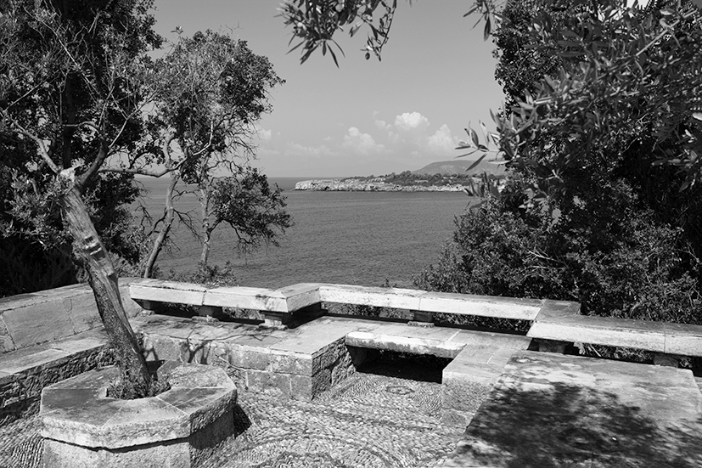

*Νow tell me, do Ι appear to act reasonably in fixing my habitation, and taking infinite delight in such a retreat? If you are not too much wedded to the city, you will be impatient to retire hither also. Ι wish you may; that amidst so many pleasing circumstances which attend my villa, it might still boast of a superior recommendation in the happiness of your company.*

Course Objective

The studio will examine in some depth the relationship of architecture, particularly siting, aspect, prospect, views, movement and interfaces, to feelings associated with site and environment and feelings associated with human co-presence. For this purpose, the program (see below) will be approached taking Pliny’s description of his Villa at Laurentinum (1st century AD) as a statement of the client’s values and attitudes. The description is offered in a letter to his friend Gallus, and is a classic testimony of how architecture and site become extensions of the self through the intense enjoyment of inhabitation.

Research question

How does architecture shape the world described by language? How does language communicate the salient syntax of architecture? Are there different architectural connotations associated with the sentences: “We walked from the terrace to the sea, at the edge of the olive grove”; and “our path from the terrace to the sea traversed the olive grove”?

The spatial relationships created by architecture partake in the feelings and understandings associated with everyday life. To reflect on these we use language. The dialogue between description, depiction and direct experience is fundamental to the pursuit of insights and the elaboration of intentions in architecture.

The careful reading of Pliny’s text and parallel study of the designs that it has inspired will allow us to engage drawings and text as media that express, in different ways, our imaginative understanding of architecture and its effects. The aim is to grasp the subtler spatial meanings associated with the syntax of space and to inform subsequent design moves.

The study of Pliny will be formatted as triptychs bringing together: diagrams of spatial relationships; images of place; and, extracts of text. The triptychs will inform design intentions relative to the site and program.

Site and Program

The program is a center for resident visiting scholars, workshops and/or symposia. The design will incorporate the home of Patrick Leigh Fermor in Mani, Greece - now a property of the Benaki museum. The program is to be fully developed as part of each project within the general parameters of the studio.

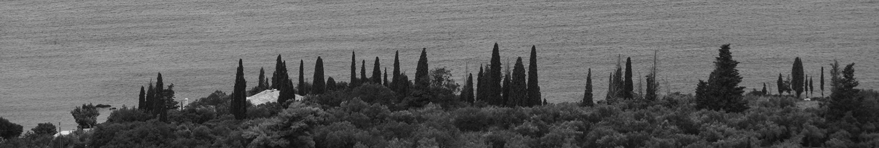

External Contributors / Critics

Maria Kokkinou (Kokkinou + Kourkoulas Architects); Andreas Kourkoulas (Kokkinou + Kourkoulas Architects - Architecture, National Technical University of Athens); Richard Martin (Classics, Stanford U); Anastasia – Erasmia Peponi (Classics, Stanford U); Wilfried Wang (Architecture, U Texas, Austin)

Organization of the studio

The studio will pursue five tasks:

1. A reading of Pliny’s letter to Gallus;
2. A study of the design variations inspired by Pliny’s letter;
3. The development of a design that responds to:
   1. A functional and organizational program (see below).
   2. The architectural sensibilities expressed in Pliny’s letter and extended through a study of the site.

Tasks 1 and 3 underpin all work throughout the semester. The pursuit of task 2 may take a limited time interval and bridge between tasks 1 and 3. However, you should consider whether there are advantages to including work completed for exercise 2 in the final presentation.

Comments on tasks 1, 2 and 3a are offered below. Task 3b will be addressed in the studio throughout the semester.

1. Reading Pliny

In the first exercise we pursue the question: what of architecture and the experience of architecture is described in language and how. Following the precedent of du Pre (1994) and Philipp (2000) John Boyle’s translation of Pliny’s letter to Gallus will be taken as the core text. In addition, we will consult the LOEB edition (Pliny, 1931).

Three kinds of questions should be addressed: First, how are the parts of the house *arranged* relative to each other and how does Pliny describe their arrangement, through the deployment of motion verbs and prepositions but also through the overall structure of text. Second, how are the parts of the house *named, qualified and differentiated* from each other, including the deployment of adjectives. Third, how are some parts or spatial relationships *highlighted* by accounts their use *over time* and their *inscription* into portraits of life?

The default presentation is in triptychs, linking diagrams or drawings of spatial relationships, images, and extracts of text. However, you should also experiment with the use of physical models/constructions.

1. Getting into the variations of Pliny’s villa

The second exercise involves an analysis of a sample of five designs chosen from those presented in the literature; for example: Scamozzi, 1615; Felibien, 1699; Krubsacius, 1760; Haudebourt, 1838; Canina, 1840; Schinkel, 1841; Huet, 1981; Krier, 1981. Preliminary questions to be asked include: How are the interfaces between interior spaces, enclosed open spaces, and external open spaces constructed? What are the main paths of movement and how do they extend along or across other spaces? What are the main visual horizons, or stable visual references of everyday life? How are they related to locally elaborated spatial relationships?

However, the purpose of the second exercise is to go beyond the idea that architecture illustrates or complies with a written description. We need to ask what architecture adds to writing and how do designs convey the overall feeling emerging from reading Pliny. We also need to ask what are the imaginative qualities that it eliminates. In order to do this we can construe a dialogue between Pliny’s text and a new text written by an architect interlocutor. The prior triptychs are now extended into polyptychs that include analyses of the designs and new text describing the salient feelings that they bring forth.

3a. Site and program

The program is a center for resident visiting scholars, workshops and/or symposia. The design will incorporate the home of Patrick Leigh Fermor in Mani, Greece - now a property of the Benaki museum. The program is to be fully developed as part of the project, within the general parameters of the studio. For example, options may include: (1) Accommodation for 7-10 extended stay scholars (a couple of months) and 3-5 short stay scholars (a week), with facilities for study, socialization, meetings and symposia. Some of the latter may be open to members of the public or visitors by prior arrangement. (2) Accommodation for 5 faculty members and 15-20 students, with facilities for study, seminars and workshops. The existing house could be used as a communal resource including library, lounges and study rooms. Provisions must be made for a small group of resident administrative staff, including a resident director and two service personnel. It would be desirable that part of the accommodation could be used as a branded

hotel during the tourist season (beginning of May to end of September, or part thereof) to provide revenue for the maintenance of the center.

Learning Objectives

* To Understand that design is a form of research in itself, driven by its own internal logic.
* To Formulate a clear and credible architectural proposal that responds to an urban site and its surrounding context.
* To Analyze, prepare and critique a program using research methods and the study of architectural precedents.
* To demonstrate a fundamental knowledge of construction systems and material assemblies through the making of appropriate diagrams, drawings, and models.

A well-tempered footprint

You are free to advocate your own approach to the site. However, the default premise for the studio is that the relation of architecture to landscape, and the scale of landscape is fundamental. This means that your footprint should be economically considered and tuned to the landscape: a light touch. In his discussion of the relationship of buildings to topography, Leatherbarrow (2000) focusses on three architects. Richard Neutra, Aris Konstantinidis and Antonin Raymond. You may feel compelled to look at these, as well, of course, at the way in which Frank Lloyd Wright handles the relationship of architecture to site.

James Ackerman (1990) suggests that there have been two kinds of villas, compact-cubic and open- extended. This is a choice that be better addressed explicitly.

Final presentation

Your projects stage the enjoyment of creative work and socialization in the context of the pleasures associated with residence at a particular place. The design of society, feeling and place should be treated as facets of the same problem. The boards and/or models of the final presentation should be conceived as statements of architectural intention that address all the stakeholders of your program and not only the technical advisors of the client. Formats explored while dealing with tasks 1 and 2 should be developed for the final presentation. Finding appropriate ways for bringing together description (language), depiction (image) and representation (architectural drawings) is an essential part of the studio.

A set of standard architectural line drawings (plans, sections, elevations) should be appended to your presentation as a supplementary document.

# Academic Integrity and Conduct

Georgia Tech aims to cultivate a community based on trust, academic integrity, and honor. Students are expected to act according to the highest ethical standards. All Georgia Tech students should familiarize themselves with and abide by the Georgia Tech Honor Code <http://www.catalog.gatech.edu/rules/18/>.

Student work that presents the ideas or words of others as the student’s own adversely impacts the whole school and may lead to immediate dismissal. Academic dishonesty, including cheating, plagiarism, commissioning academic work by others, or performing academic work on behalf of another student, is strictly prohibited. All persons in the classroom are expected to behave with courtesy towards others and in a way that does not interfere with the regular conduct of the class. Cell phones are to be turned off when students enter the classroom and should remain off for the duration of class: <http://www.catalog.gatech.edu/rules/19/>

# Special Needs

# Any student with a disability, that may require accommodation, should contact Office of Disability Services at 404-894-2563 or visit <http://disabilityservices.gatech.edu> to make an appointment to discuss his or her special needs and obtain an accommodations letter. He or she should also schedule an appointment to speak with the course instructor.

# Emergencies

In case of emergency (e.g., fire, accident, or criminal act), please call the Georgia Tech Police at 404-894-2500. Please note that Perry Minyard, IT Support Administrator for the College of Architecture, is also a firefighter and an Emergency Medical Technician (EMT) certified in performing CPR.

# Ownership

Physical copies of student work submitted to the school to satisfy course requirements—including, but not limited to digital files, papers, drawings, and models—become the property of the school. It is assumed as no obligation to safeguard such materials and may, at its discretion, retain them, return them to the student, or discard them.

# Archiving

In some courses, selected students may be required to submit physical examples of their work or digital examples (on a clearly labeled CD), no later than one week after the end of term, to their instructors or administration for archiving. By enrolling, each student grants a license to reproduce and display his or her work. This is a chance for students to have their work shown online and potentially featured in forthcoming publications.

# College of Design Facility Rules and Guidelines

Please consult the Georgia Tech Student Handbook regarding the use of facilities and all Institute policies. Aerosol sprays of any kind are strictly banned from the studio and surrounding areas. A new spray painting booth is now in operation in the College of Design shop, on the ground floor of the East Architecture Building.

Shop Use: All students using shop facilities must first have completed an orientation. Safety first, always! Noise should be kept to a minimum. Music may be listened to only through headphones, including evenings and weekends.

Studio Housekeeping: Students should feel free to organize their space creatively and expressively, but with respect to others around them. Try to prevent clutter from becoming a nuisance, distraction, or a hazard. The cleaning staff makes every effort to determine what is and is not trash, but their job can be made easier if you keep drawings and models off of the floor.

READINGS + BIBLIOGRAPHY

Pliny

Boyle J, 1751 *The letters of Pliny the younger with observations on each letter; and an essay on Pliny's life* (James Bettenham, London)

Pliny, 1931 *Letters with an English translation by William Melmoth, revised by W M L Hutchinson* (William Heinemann, London)

Note. The villa at Laurentinum is described in the letter to Gallus, Book 2, letter 17. The villa in Tuscany is described in the letter to Apollinari, Book 5, letter 6. Pliny’s daily routines, with reference to the villa in Tuscani, are described in the letter to Fuscus, book9, letter36.

Readings on architectural reconstructions of Pliny’s Villa

Castell R, 1728 *The villas of the ancients illustrated* (London)

*du Prey P d l R, 1994 *The villas of Pliny from antiquity to posterity* (The University of Chicago Press, Chicago) Felibien des Avaux J F, 1699 *Les plans et les descriptions de deux plus belles maison de campagne de Pline le Consul* (Florentin & Pierre Delaulne, Paris)

Haudebourt L P, 1838 *Le Laurentin, maison de campagne de Pline le Jeune* (Carilian-Goeury Editeur-Library, Paris)

*Institut Francais d' Architecture, 1982 *La Laurentine et l' invention de la villa Romaine* (Editions du Moniteur, Paris) Philipp K J, 2000 *Karl Friedrich Schinkel. Late projects* (Axel Menges, Stuttgart)

*Tanzer H, 1924 *The villas of Pliny the younger* (Columbia University Press, New York) Winnefeld H, 1891, "Jahrbuch des Kaiserlich Deutchen Archäologischen Institutes" **6** 201-217

Readings on Roman house

Haan N d, 2016, "Roman domestic architecture", Ed G Irby (John Wiley & Sons, New York) pp 711-729

Moule T, 1833 *An essay on the Roman villas of Augustan Age* (Longman, Rees, Ormem Brown, Green, and Longman, London)

Wallace-Hadrill A, 1988, "The social structure of the Roman house" *Papers of the British School at Rome* **56** 43-97

Reading on the villa as a type

Ackerman J S, 1990 *The villa. Form and ideology of country houses* (Princeton University Press, Princeton, NJ)

Reading on the relation of architecture to ground and topographjy

Leatherbarrow D, 2000 *Uncommon ground* (MIT Press, Cambridge: MA)

Readings on language, cognition and space

Hillier B, Hanson J, 1984, "The problem of space", in *The social logic of space* (Cambridge University Press, Cambridge) pp 26-51

Lakoff G, Johnson M, 1999 *Philosophy in the flesh* (Basic Books, New York) – Chapter 3-5

Landau B, Jackendoff R, 1993, ""What" and "where" in language and spatial cognition" *Behavioral and Brain Sciences* **16**

217-265

O'Keefe J, 1999, "The spatial prepositions in English, vector grammar, and the cognitive map theory", in *Language and space* Eds P Bloom, M A Peterson, L Nadel, M Garrett (MIT Press, Cambridge, MA) pp 277-316

# Readings linked to Patrick Leigh Fermor

Cooper A, 2012 *Patrick Leigh Fermor. An adventure* (New York Review Books, New York)

Leigh Fermor P, 2006 *Mani. Travels in the Southern Peloponnese* (New York Review Books, New York)

Payás D, 2014 *Drink time! In the company of Patrick Leigh Fermor. A memoir* (Bene Factum Publishing, London)