**Syllabus: BIOS 4520 “HEALTH, GENES and SOCIETY” Spring Semesters**

**Overview**

This is a non-traditional course designed to engage you in projects that relate to personalized medicine, particularly incorporating consideration of the impact of genome analysis. Rather than absorbing lecture material, the emphasis will be on self-directed learning and realization of deliverable projects in small teams working throughout the semester. We will start with a survey of predictive health (past, present and future), and lay down the essentials of genetic risk evaluation. Then each week a pair of students will be responsible for a presentation on the assigned topic and leading discussion, and we will work together in class to make constant progress on your projects.

**Objectives**

1. To understand the potential contribution of whole genome sequencing and genomic profiling for personalized medicine
2. To place genomic medicine in the context of other emerging trends in healthcare including mobile health, evidence-based medicine, and big-data driven public health
3. To deliver an actual product that can be used in a practical manner to influence health behavior

**Evaluation**

50% Term Project (20% Project, 20% bi-weekly updates, 10% class assessment)

20% Class presentations and Reports on 3 of them (5% each)

20% Final Exam

10% Participation in weekly discussion

**Academic Integrity**

Georgia Tech aims to cultivate a community based on trust, academic integrity, and honor. Students are expected to act according to the highest ethical standards. For information on Georgia Tech's Academic Honor Code, please visit http://www.catalog.gatech.edu/policies/honor-code/ or http://www.catalog.gatech.edu/rules/18/. Any student suspected of cheating or plagiarizing on a quiz, exam, or assignment will be reported to the Office of Student Integrity, who will investigate the incident and identify the appropriate penalty for violations.

**Accommodations for Students with Disabilities**

If you are a student with learning needs that require special accommodation, contact the Office of Disability Services at (404)894-2563 or http://disabilityservices.gatech.edu/, as soon as possible, to make an appointment to discuss your special needs and to obtain an accommodations letter. Please also e-mail me as soon as possible in order to set up a time to discuss your learning needs.

**Attendance and missed assignments**

Attendance is required and you are expected to attend class and participate. Students unable to participate in presentations or projects will discuss with the instructor how to make up the missed assignments.

**Collaboration & Group Work**

Group projects and presentations will generally receive a single grade. However, contribution to the project will be continuously monitored and require that each member of the group take responsibility for periodic updates. Failure to contribute may result in assignment of a lower grade.

**Sample Ideas for Term Projects**

(see <http://genomestake.blogspot.com/2014_05_01_archive.html> for a summary of the 2014 projects, <http://genomestake.blogspot.com/2015_05_01_archive.html> for a summary of the 2015 projects, and <http://genomestake.blogspot.com/2016/05/twenty-eighth-take-active-classroom-3.html> for 2016.

Plan a company to provide personalize a healthcare service

Design an app that integrates genetics and health behavior data into a personalized motivational tool

Create a module of 3 or 4 lectures on a personalized medicine topic that high school teachers may use in to explain the concept of High-Definition Medicine (see Torkamani paper: *Cell* **170**: 828-843, 2017)

Visit local high schools to help teachers present the lesson plans above

Generate and deliver a presentation on what faculty at Georgia Tech can do to address mental health issues in the undergraduate student population

Specifically propose an intervention affecting access to and implementation of personalized medical services for rural communities in Georgia

**Weekly Content (Red lectures by Students)**

**Introduction - Professor Gibson Tuesday Thursday**

Jan 9, 11 Week 1 What is Predictive Health? Disease in America

Jan 16, 18 Week 2 Precision Medicine Personalized Medicine

Jan 23, 25 Week 3 Newborn screening Designer babies

**Mobile Health and Social Media**

Jan 30, Feb 1 Week 4 Social Media in medicine The Quantified Self Movement

Feb 6, 8 Week 5 Pharmaceuticalization of medicine Health and Social Networks

Feb 13, 15 Week 6 Personal Genome Projects Patients Like Me

**Public Health**

Feb 20, 22 Week 7 Responsible Philanthropy Global foundations

Feb 27, Mar 1 Week 8 Socioeconomic Inequality Racial Disparities

**Domains of Health**

Mar 6, 8 Week 9 Missing microbes Eating behavior

Mar 13, 15 Week 10 Midway 10 min Presentations Exercise behavior

Mar 20, 22 Spring Break

Mar 27, 29 Week 11 Genetics of addiction Drinking behavior

Apr 3, 5 Week 12 Pharmacogenetics The opioid crisis

Apr 10, 12 Week 13 Depression Parenting behavior

Apr 17, 19 Week 14 Cancer screening Term Project presentations

Apr 24 Week 15 Term Project presentations

Apr 26 3-6 FINAL EXAM

**Fifty-second Take: Active Classroom IV**

After a year’s hiatus, I was privileged enough to again teach my Health, Genes and Society class this spring. The semester flew by, but that did not stop the 21 students from completing a fresh round of 7 capstone projects that I share with you here or by visiting a new page on my website at <https://ggibsongt.wixsite.com/gibsongatech/spring-semester-presentations-2018>. Whether they are inspired by previous years or simply increasingly media savvy, their efforts seem to push the envelope in unique directions each year.

For example, whereas last time out (see Take 28, and before that 17) apps were designed for various purposes, two groups this year actually coded their apps and have almost ready-to-use beta versions. Amanda Schaefer, Christine Lacek and Amelia Milas complemented their interests in public policy, bioinformatics and medicine by focusing on providing parents of children with Cystic Fibrosis with a modern solution to care management. Their CareFull app will allow parents to track medications, respiratory exercises, diet, and physical exercise with user friendly tracking on their iPhone or Android device. Our debate now is whether to seek to kick it up a notch by linking directly to patient records within the SMART on FHIR framework that is emerging as the preferred electronic environment for secure and standardized mobile healthcare applications (<https://smarthealthit.org>).

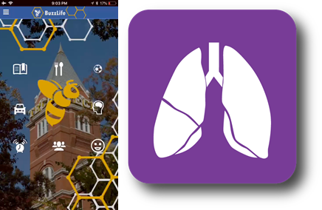

Caroline Settle, Mikaela Thurman and Yvonne Nguyen built on a recurring theme for the class of worrying about the health of Georgia Tech students. Their BuzzLife app will link students to online resources relating to campus transportation (including late night safe rides), academic planning, campus dining and nutrition, fitness and recreation, all the while helping them to control stress and monitor their sleep patterns. They chose topics based on an online survey of what students would like to see in such an app and why. While I am not at liberty to share the results, suffice it to say that it comes as no surprise that (Georgia Tech) students don’t get enough sleep, don’t work out enough, and crave help managing their time.

Keeping it on campus, the next group carried out one of the most practical exercises I have supported through the class yet, namely laying the foundations for a national intercollegiate conference on student mental health to be held here on February 15-17, 2019. Collin Spencer and Kristen Vossler are leaders of the GT Mental Health Student Coalition and were joined by Tessa Paget-Brown in what amounted to a full-time job arranging meetings to garner Institute-wide support and seek external funding to bring in representatives of local Schools, other ACC Schools and peer universities nationwide. Georgia Tech has well documented issues with student mental health, with four-year prevalence of debilitating anxiety and depression as high as one in four, a binge drinking culture to release tension, and seemingly one or more suicides every semester. To his credit, the President, Bud Peterson, launched an broad initiative of focus groups to find solutions, two dozen of which are now being implemented, though they are mostly Band-Aids and patches such as more counsellors, more faculty awareness and more student self-help. There is no concerted attention given to the root causes, which I hope the Conference will address. Maybe it is just what happens when you take a few thousand type-A young adult nerds and teach them to become engineers. GT is a fabulous place for many students, but an awful one for the more sensitive or uncertain. My personal opinion is that the issues have something to do with a bureaucratic and legalistic culture that undermines any opportunity for faculty to provide their customary pastoral and compassionate role. Or maybe it is the pervasive indifference of faculty to student problems, an attitude that you start with a C and need to earn that B, which is so different from the presumption that you are an A student and we sincerely hope you won’t fail to meet that evaluation. Competition is good, but it needs tempering.

Another group was concerned enough about a different policy issue that they actually went out and interviewed a State and a Federal legislative aid about it: the use of CRISPR-Cas9 for human genome engineering. Jared Chin-Shue urged Emily Yu and Chloe Baskowitz to join him in reviewing the science and policy, conducting a handful of interviews, and putting together a white-paper and website (<https://coco139.wixsite.com/crispr>). The views expressed are of course their own and could do with some seasoning based on real-world experience, but I love the urgency. Not surprisingly the aids are more knowledgeable about the issues than they expected – enough people now have personal stories of genetic diseases that awareness of the potential for genome editing is spreading. It is hearsay of course, but I was struck by the comments of Martha Zoller, State Policy Director for a Republican Georgia Senator, to the effect that funding should be private not Federal and the role of the government is to reduce regulations, somehow while protecting the embryos. I’m all for business getting involved, but this is fundamentally the reason why the South is always playing catch-up: California and New York see an industry of the future and invest in it to the tune of hundreds of millions, they bring in the experts in stem cells and genomics, and create the environment where investors want to be. Georgia just tries to incentivize entrepreneurs from outside to come here.

Speaking of governments and regulation, one area that could arguably do with a little more is recreational genomics. This was the target of the efforts of Catherine Johnson, Claudia Varnedoe and Soha Noorani, who produced a virtual flier, [shown here](https://docs.wixstatic.com/ugd/cbc9ac_26ef96be534e4535bd4cc72240077fa2.pdf), not something I was aware of but a nice way to provide lots of links around a topic. The particular object of their attention is Helix.com (<https://www.helix.com/>), the new kid on the block of an industry that has now attracted 12 million consumers, three quarter of those in the past year, with prime-time advertising now commonplace. Helix are different both in that they perform exome sequencing rather than whole genome genotyping, and that their model is to generate the data and then sell it to third parties who provide consumers with interpretations for a fee between $50 and $100 (if you want to download your sequence data, it will cost another $500). They are jaw-dropping in their audacity and mind-boggling in their “so-2018” stretching of the truth with their claims that all of their products are backed by the most rigorous science. What can you really learn about fitness and nutrition and health from your exome? Assuming nothing, I elected to purchase the wine-preference predictor Vinome for myself, which confirmed my 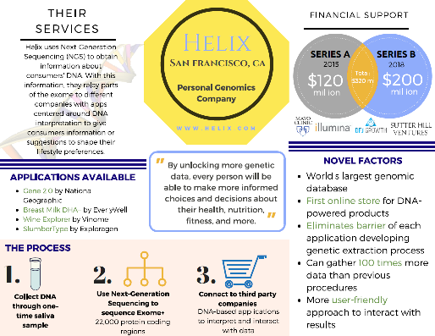suspicion that it is all about clever marketing – and likely explains the $320M in venture funding over two rounds. The science is garbage, I do not need my genome to tell me that I like big reds, which has more to do with growing up in Australia than a few taste receptor variants, and it is completely incorrect that I favor zinfandels! Good luck to them, and their advisors, the identities of whom have some high profile surprises.

Continuing the podcast tradition, Ann Johnson, Meg Whittling and Jessie Morris generated a Soundcloud series of four audio “Medical Musings” (<https://soundcloud.com/megen-wittling/sets/medical-musings-season-1>) on various personalized medicine topics: the science behind 23andme, the NORAD rare disease network, the GINA genetic non-discrimination act, and a personal story about how Ann’s mother found her biological mother and is now learning more about her identity through consumer genomics. Heart-warming stuff, very well received by the class, and a joy to see the pleasure this exercise brought the team. Will there be a Season 2?

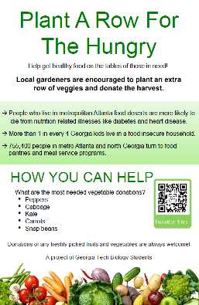Lastly, but most certainly not least, was a community-oriented project by Andi Otto, Hannah Green and Megan Young. Andi has been heavily engaged in student outreach efforts throughout her undergraduate career and knew folks at the Atlanta Community Food Bank, notably Fred Conrad, director of the community gardens project. One of the points of the class is for pre-med students to think about why people get sick, a big component of which is poor nutrition. One in four Georgia kids face food insecurity, many living in food deserts where access to fresh and healthy food is limited. The Food Bank delivers 60 million meals to ¾ of a million people in 29 counties each year, and is always looking for volunteers and also for donations. Their website has a Plant-a-Row paragraph encouraging people to donate surplus vegetables from their gardens, but funding cuts have limited their ability to advertise. Now it will link to this group’s new Weebly site, <https://plantarowforthehungry.weebly.com/>, which provides information on how and why to donate. During the semester they also toyed with the idea of proposing a string of new community gardens for this purpose along the Atlanta Beltline. It was a bit too much, but they did spend a couple of weekends handing out this flier on the Beltline, which itself was educational. If you’re not aware of the Beltline, I recommend reading Mark Prendergrast’s new book, [City on the Verge](http://cityontheverge.com/about/), which is all about the politics and history of this innovation in urban renewal. Atlanta is a city of 6 million people, only half of million of whom live in the city center encompassing Fulton county – though that is changing quickly as over 30 new high-rises are going up. The Beltline will eventually be a 22 mile walking trail and possibly monorail ringing the city and connecting dozens of communities from the wealthiest in the north, Buckhead, to the most troubled in the west, Bankhead. The completed trail starting a few blocks from my home is a hive of activity on weekends as dogs and people and bikes and artists mingle and enjoy a vision of what could be an alternative to just shipping people to and from the burbs in on overactive 8 lane freeways. It is truly working, and a model for dozens of other American cities. In this era of dysfunctional government, community activism is keeping hope alive, and knowing that it starts with small but meaningful projects such as this is a wonderful thing.