**COA 6114.  ART AND ARCHITECTURE IN GREECE, 3-0-3**

**Dr. Athanassios Economou**, **Associate Professor**

**College of Architecture**

**Georgia Institute of Technology**

**Summer 2012**

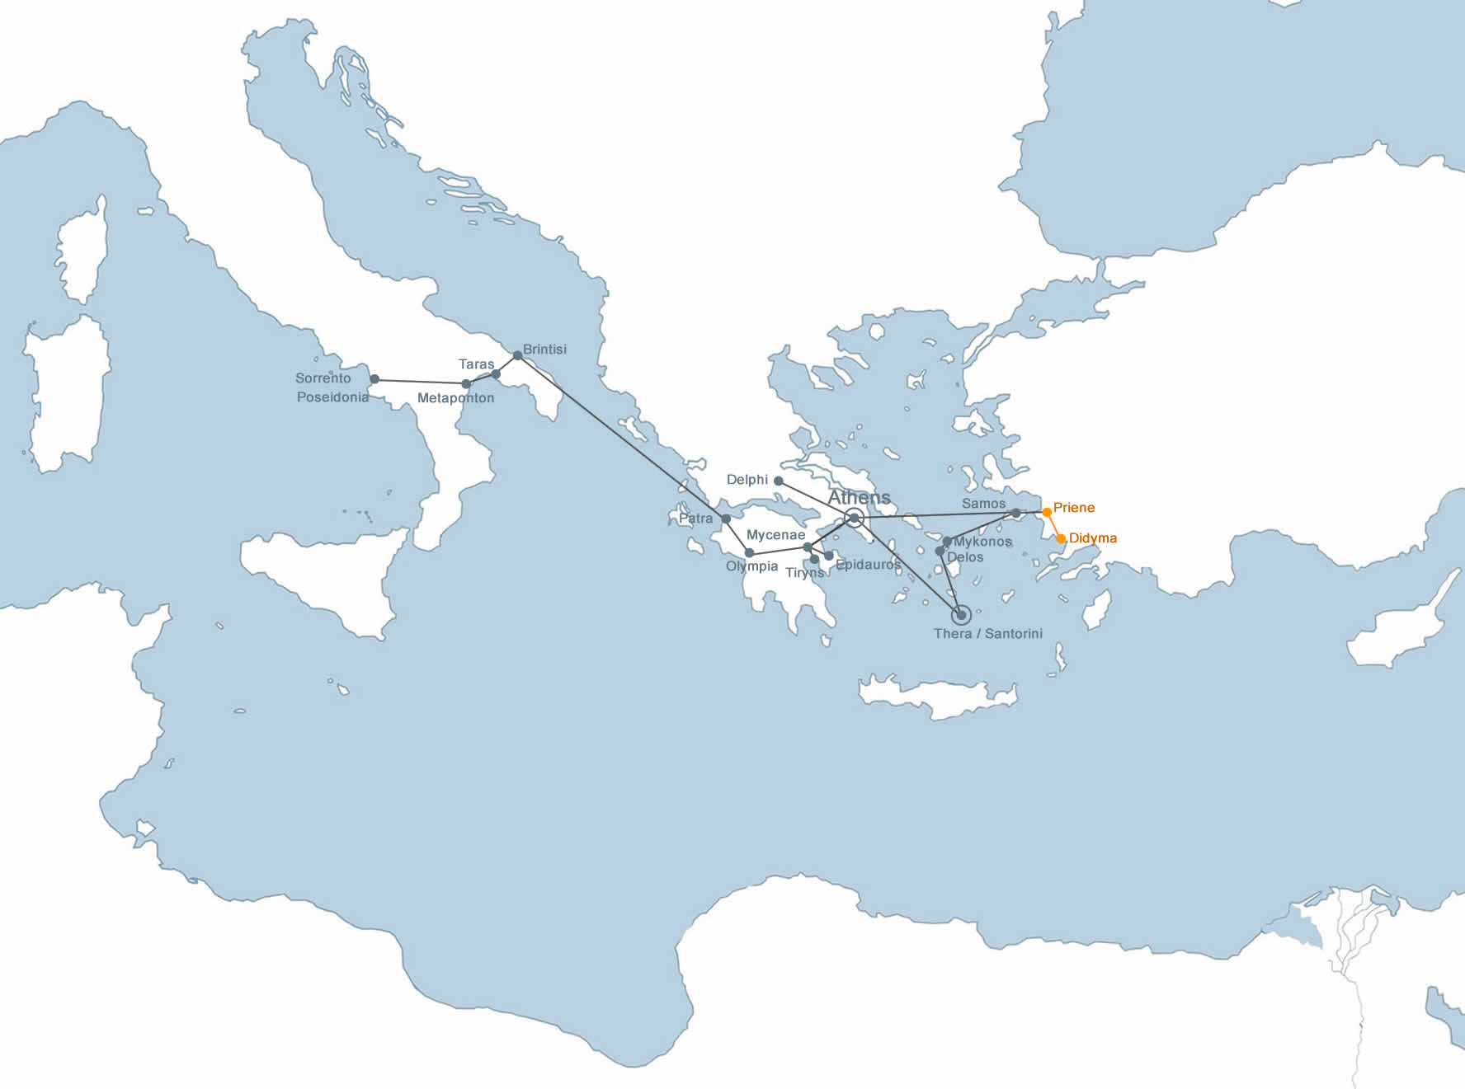

This course is part of a three-course sequence on the interrelated subjects of architecture, urban design, and the arts from the Bronze Age to the eighteenth century in Greece and Italy. This course is distinguished from the second and third in the sequence by its emphasis on the archaic, classical and Hellenistic Greek period.

**Course Objectives**

The purpose of the course is to provide an intensive on-site investigation of the role that the arts have played in the development of the ancient Greek civilization, and by extension the influence of this civilization on the historical development of the visual arts in the western world. The core of the class is a two-and-a-half-week intensive, on-site, study of cities, buildings, sculpture, and painting of the ancient Greek world in Greece, Turkey and South Italy. The course includes visits and lectures on some of the most important sites and museums of the ancient Greek world, including Mycenae, Athens, Delphi, Olympia, Epidauros and Delos in Greece; Priene and Didyma in Asia Minor in Turkey; and Paestum in South Italy.

**Course requirements**

Students are required to attend the lectures, read the assigned daily readings, and participate in the discussions. Additionally they are required to make a presentation, keep field notes, and produce a final journal. The specific requirements for the presentation, field notes and journal, follow below.

*Presentation*

Each student is required to give a fifteen-minute presentation of a specific topic assigned prior to the trip. Students may work in teams for more ambitious projects; in all cases the requirements of each presentation will increase proportionally in modules of fifteen minutes each. Presentations include topics pertaining to the contextual setting of the world-making of the classical world and include aspects of culture and myths, history of science, religion, sports, politics, theater, and so on. All presentations are given on-site and typically in sties that foreground the assigned topic; i.e. Olympia and sports; Epidauros and theater; Delphi and religion etc. All presentations have to be accompanied by an one-pager handout to be distributed to the class during the presentation.

*Field notes*The field-notes notebook consists of notes taken on-site during the lectures including text, sketches, diagrams, measurements, and so on. The field notes will be submitted in the end of the course for evaluation.

*Journal*

The journal consists of a conversion of the field notes in a formal presentation including text, commentary, reflections, as well as historical data, original or edited photos, diagrams, sketches, drawings, and other media if appropriate. Additionally to these requirements (that typically apply to the undergraduate version of this course: COA 3114), the journal should also include a reflective and critical synthesis of themes/projects/buildings presented in the course with comparable ideas/projects in contemporary architecture discourse. This illustrated essay should be given in the end of the journal and it should be presented in the same manner as the rest of the information provided in the journal. The journal will be submitted in the end of the course for evaluation.

**Learning Objectives**

The learning objectives of the course include:

* To understand the language and the vocabulary of ancient Greek architecture, building types and architectural construction and techniques.
* To understand the origins, development, usage and design characteristics of the courtyard structure as a major urban and architectural parametric building element.
* To obtain a working knowledge of the complex relations between the city form, architectural form and the arts in the ancient Greek world through coherent, structured and immersive on-site visits.
* To gain an appreciation of key aspects of ancient Greek civilization, including government, mythology, philosophy, sports, art and so forth, through constructive engagement and specific visits in sites, buildings and museums.
* To gain an appreciation of the origins and ramifications of architectural theory in the western world.
* To engage learning through immersive visits to the ancient sites, buildings and museums.
* To enhance visual acuity and learning through drawing, sketching, diagramming and direct experience to the artifact in hand.
* To critically reflect on the contemporary and dramatically changing architectural world of the Mediterranean through the study of the subject matter of the course.

**Grading**

All three course-specific assignment requirements (presentation, field-notes and journal) are graded for accuracy, completeness, comprehensiveness, and criticality. The grading of the class is distributed in the following fashion:

Presentation: 30%

Field notes: 20%

Journal: 50%

**Course Schedule**This course is organized in roughly three parts; the first part is in Athens and nearby sites, the second in the Aegean and Asia Minor, and the third in Peloponnesus and South Italy. Generally, on-site lectures are given Monday through Friday from 8:00 AM to 1:30 PM. This schedule varies, depending upon the site and the subject.

Sunday, May 13 1Orientation to the city of Athens

Monday, May 14 4 **Mycenae, Tiryns**

Mycenae: Lions’ Gate; Grave circle B; Megaron; Cistern; Treasure of Atreus; Tiryns: Cyclopean walls; Megaron; Circle edifice

Tuesday, May 15 5 **Acropolis, Akropolis Museum**

Acropolis: Propylaea, Temple of Athena Nike, Erechtheion, Parthenon; Acropolis Museum

Wednesday, May 16 5 **Athens: The classical city**

Agora: Panathenaic Way; Stoa Basileios; Stoa of Zeus; Temple of Apollo; Metroon; Bouleuterion; Tholos; Hephaisteion; Stoa of Attalos; Pnyx; Kerameis;

Thursday, May 17 5 **Athens: The Hellenistic city**

Panathenaikon Stadion; Olympeion; Hadrian’s Gate; Lysicrates monument; Theater of Dionysus; Odeion of Herodes Atticos; Philopappos monument; Hadrian’s Library, Tower of Winds; Roman Forum. National Archaeological Museum

Friday, May 18 4 **Delphi**

Delphi: Athena Pronaia, Temenos, Thesauroi, Temple of Apollo, Theater; Stadion, Archaeological museum.

Student presentation: Religion ( )

Saturday, May 19 - Individual Study Day (Athens)

Sunday, May 20 - Individual Study Day (Athens*)*

Monday, May 21 3 **Samos**

Eupalinos’ Tunnel; Archaeological Museum of Samos

Student Presentation: Seafare ( )

Tuesday, May 22 5 **Priene, Didyma**

Priene;Temple of Athena; Bouleuterion; Prytaneion; Theater; Stadion; Gymnasion. Miletos; Agora; Sacred way; Bouleuterion

Student presentation: War ( )

Temple of Apollo at Didyma

Wednesday, May 23 1 **Mykonos**

Orientation to the cyclades

Thursday, May 24 5 **Delos**

Harbor; Temple of Apollo; Gymnasium; Palaestra; Residential quarters; Letos lake; Kynthos sanctuaries; Theater. Archaeological Museum.

Student presentation: Work ( )

Friday, May 25 3 **Akroteri**

Xystos 3; Xystos 4; House of the ladies; West house; House of the Anchor; Complex D; Archaeological museum

Saturday, May 26 - Individual Study Day (Thera)

Sunday, May 27 - Individual Study Day (Thera)

Monday, May 28 3 **Epidaurus**

Epidaurus; Propylaea; Sanctuary of Asklepios; Tholos; Theater; Archaeological Museum.   
Student presentation: Theater ( )

Tuesday, May 29 5 **Olympia**

Altis; Temple of Hera; Temple of Zeus; Thesauroi; Philipeion; Zanes; Stadion; Paleastra; Workshop of Pheidias; Gymnasion.

Archaeological Museum.

Student presentation: Sports ( )

Total \***49** (12/17 days)  
*(*Does not include travel time to site)*

**Reading Assignments**

The bibliography on the architecture and the arts of the ancient Greek world is vast. A very selected list of readings pertaining to the daily visits is given here. Some additional recommended readings are included in the end.

*Required readings*

Akurgal, E. (1973). Didyma. Ancient civilizations and ruins of Turkey from prehistoric times until the end of the Roman Empire. Istanbul, Haset Kitabevi**:** 222-231.

Akurgal, E. (1973). Priene. Ancient civilizations and ruins of Turkey from prehistoric times until the end of the Roman Empire. Istanbul, Haset Kitabevi**:** 185-206.

Camp, J. M. (1986). Public Buildings of the Athenian Democracy. The Athenian Agora: excavations in the heart of classical Athens. New York, N.Y., Thames and Hudson**:** 90-116.

Cerchiai, L., L. Jannelli, et al. (2004). Poseidonia/ Paestum. The Greek cities of Magna Graecia and Sicily. Los Angeles, J. Paul Getty Museum**:** 62-81.

Coulton, J. J. (1977). The problem of design. Ancient Greek architects at work: problems of structure and design. Ithaca, N.Y., Cornell University Press**:** 51-73.

Coulton, J. J. (1977). The problem of scale. Ancient Greek architects at work: problems of structure and design. Ithaca, N.Y., Cornell University Press**:** 62-81.

Diamond, J. M. (1992). Horses, Hittites and History. The third chimpanzee: the evolution and future of the human animal. New York, NY, Harper Collins**:** 249-275.

Gruben, G. (1963). Delphi. Greek temples, theatres, and shrines. H. Berve, G. Gruben and M. Hirmer. New York, H.N. Abrams**:** 326-342.

Gruben, G. (1963). Epidaurus, The Sanctuary of Asclepius. Greek temples, theatres, and shrines. H. Berve, G. Gruben and M. Hirmer. New York, H.N. Abrams**:** 358-363.

Gruben, G. (1963). Olympia. Greek temples, theatres, and shrines. H. Berve, G. Gruben and M. Hirmer. New York, H.N. Abrams**:** 316-326.

Gruben, G. (1963). Priene. Greek temples, theatres, and shrines. H. Berve, G. Gruben and M. Hirmer. New York, H.N. Abrams**:** 473-480.

Gruben, G. (1963). Didyma. Greek temples, theatres, and shrines. H. Berve, G. Gruben and M. Hirmer. New York, H.N. Abrams**:** 463-470..

Gruben, G. (1963). Samos. Greek temples, theatres, and shrines. H. Berve, G. Gruben and M. Hirmer. New York, H.N. Abrams.

Gruben, G. (1963). Delos. Greek temples, theatres, and shrines. H. Berve, G. Gruben and M. Hirmer. New York, H.N. Abrams.

Jameson, M. (1990 ). Domestic space in the Greek city-state. Domestic architecture and the use of space: an interdisciplinary cross-cultural study. S. Kent. Cambridge [England]; New York, , Cambridge University Press**:** 92-113.

Jenkins, I. ( 2006). The Parthenon and its Sculptures. Greek architecture and its sculpture. London, British Museum Press**:** 71-107.

Jenkins, I. ( 2006). The Athenian Acropolis - Propylaea, Nike Temple and Erechtheum. Greek architecture and its sculpture. London, British Museum Press**:** 108-129.

Kostof, S. (1985). Bronze Age Cities: The Aegean and Asia Minor. A history of architecture: settings and rituals. New York, Oxford University Press**:** 91-113.

Kostof, S. (1985). Polis and Akropolis. A history of architecture: settings and rituals. New York, Oxford University Press**:** 137-159.

Palyvou, K. (2005). Akrotiri Thera : an architecture of affluence 3,500 years old. Philadelphia, Pa., INSTAP Academic Press.

Wycherley, R. E. (1951). Hellenistic cities. [Liverpool], Dept. of Civic Design, the University of Liverpool

*Additional recommended readings*

Vitruvius, The Ten Books on Architecture , Tr. Morris Hickey Morgan , Dover, 1960

Pausanias: Description of Greece Tr. J. G.Frazer, British Library, Historical Print Editions, 2011.

E. Guhl and W.Koner, The Greeks and Their Customs. Senate: United Kingdom, 1994

J. Boardman, J. Griffin, O. Murray (Eds), The Oxford Illustrated History of Greece and the Hellenistic World. Oxford University Press: United Kingdom, 2001

T Cahill, Sailing the Wine-Dark Sea: Why The Greeks Matter. Random House: New York, 2003.

R Morkot, The Penguin Historical Atlas of Ancient Greece. Penguin Books: London. 1996

Ovid, Metamorphoses, Tr. Allen Mandelbaum, Mariner Books. 1995