**ECE 8803: Electricity Markets/Power System Economics**

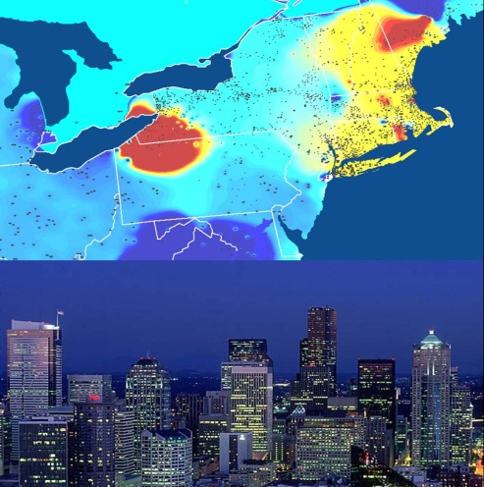

**Spring 2015, Prof. Santiago Grijalva**

**Description**: This course provides a comprehensive introduction to electricity markets and power system economics, including economic theory, market design, market models, and policy. The combined behavior of the physical system including the grid and the market is modeled in detail and simulated through software. Market interactions are simulated through auction and trading exercises. Emphasis is given to current trends: renewable energy integration, smart grid, consumer empowerment, and business models as drivers for emerging market architecture.

**Pre-requisites**: ECE4320 or ECON 3110 (microeconomics) or Utility Industry Experience.

Time and Place: MWF: 2-3, Location: Instructional Center 215

Instructor: Prof. Santiago Grijalva

e-mail: sgrijalva@ece.gatech.edu

Office Hours: Wednesday, 3 pm, Van Leer 284

Grading Policy: Homework (25%), Midterm (25%), Final (25%), Project: (25%)

**Topics**:

1. Electricity Industry Trends and Challenges for Markets

2. Review of Economic Theory and Electricity Supply and Demand

3. Markets and Risk Management

4. Electricity Market Architecture

5. Producer Participation: Strategy, Self-Scheduling

6. Introduction to Utility Regulation

7. Demand Response

8. Reserves Markets and Other Ancillary Services

9. Optimization Methods

10. Modeling the Grid

11. Sensitivities and Security

12. Software Simulation of the Grid

13. Methods of Economic Dispatch and Optimal Power Flow

14. Marginal Pricing Theory

15. Security Constrained Optimal Power Flow

16. Unit Commitment

17. Co-optimization of Energy and Reserves

18. Congestion Management

19. Emissions Dispatch and Carbon Trading

20. Investment and Asset Management

21. Oligopoly and Market Power Monitoring

22. Market Management Systems

23. Competition in Retail

24. Distribution System Operators

25. New Industry Business Models

**Text**: Instructor will provide full set of lecture notes

**Supplemental References**

1. D. Kirschen, G. Strbac, *Fundamentals of Power System Economics*, John Wiley, 2004
2. Sioshansi, *Competitive Electricity Markets: Design, Implementation, Performance*, Elsevier, 2008
3. S. Stoft, *Power System Economics: Designing Markets for Electricity*, Wiley, 2002
4. G. Rothwell, T. Gomez, *Electricity Economics*, IEEE Press, Wiley-InterScience, 2003
5. PowerWorld, *Simulator V18.0 User’s Guide*, PowerWorld Corporation, 2014
6. J. Welch, C.J. Bolling, “Competitive Electricity Markets: The Power of Choice”, ITC Holdings, 2009
7. D. Gan, “*Electricity Markets and Power System Economics*”, 2013
8. M. Shahidehpour, *Market Operations in Electric Power Systems*, IEEE Press, Wiley, 2002
9. J. Momoh, L. Mili, *Economic Market Design and Planning for Electric Power Systems*, (IEEE Press Series on Power Engineering), Wiley, 2009