**GER 4027**

**Political Songwriting in Germany, 1945 to Present**

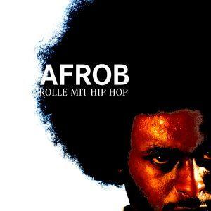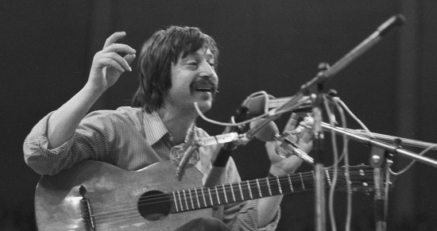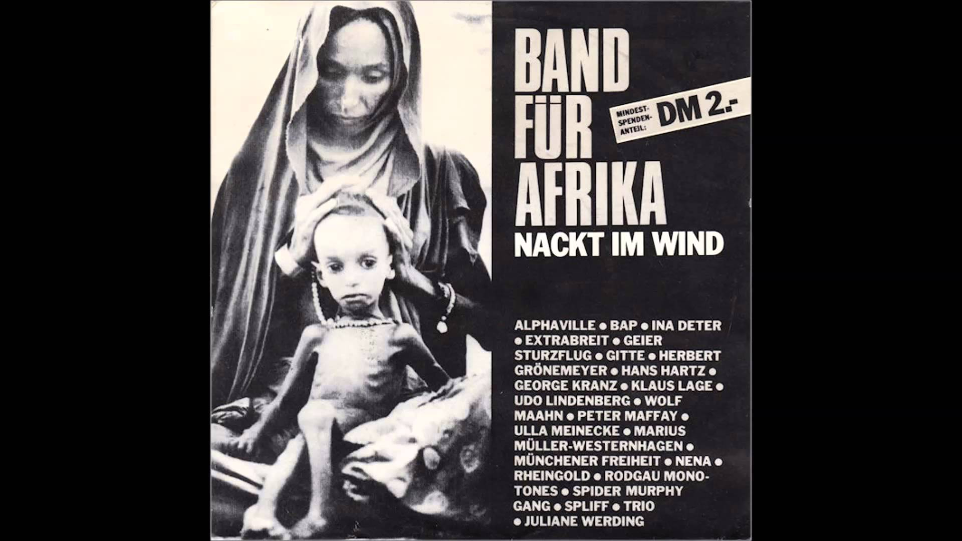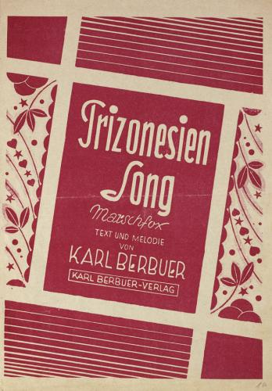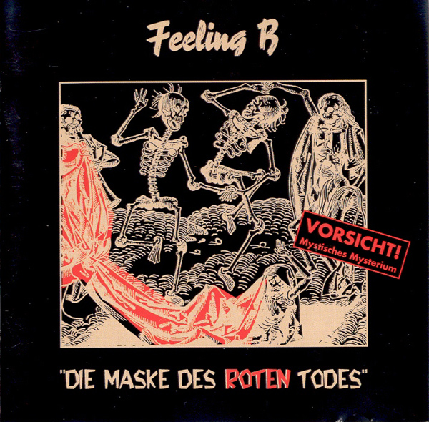

**Instructor: Dr. Jan Uelzmann**

Office: Swann 331

Course meets: TUE and THU, 12:05 - 1.25 pm

@ D. M. Smith 11

Office Hrs: TUE and THU, 4-5pm

Phone: (404) 385-7330

Email: [jan.uelzmann@modlangs.gatech.edu](mailto:jan.uelzmann@modlangs.gatech.edu)

**Texts:** Songs, essays, book chapters, historical writing, newspaper and magazine articles from the internet, films, newsreels, photography, and advertising. Links to the texts are available through T-Square.

Recommended Resources:

* Fulbrook, Mary. *A History of Germany, 1918-2008: The Divided Nation*. Malden, MA: Wiley-Blackwell, 2009. Print.
* LeMO. “Lebendiges Museum Online.” <http://www.dhm.de/lemo/>.
* “Jugendkulturen in Deutschland |Bpb.” <http://www.bpb.de/gesellschaft/kultur/jugendkulturen-in-deutschland/>
* <http://www.die-anderen-bands.de/>
* <http://www.mdr.de/damals-in-der-ddr/ihre-geschichte/index.html>

**Course Level:** This course is meant for students who have

Intermediate language proficiency in writing and speaking. Apart from the song lyrics, you will have to read longer German texts with at times complicated content for this course. The average “reading load” is 10 pp per session. The preparation of the texts with regard to understanding the vocabulary is your responsibility. I expect you to have understood the “gist” of the texts when you come to class. We will discuss reading strategies in a foreign language at the beginning of the class.

**Course Aims:**

This class, conducted in German, offers an overview of political songwriting in Germany (with occasional references to Austria) between 1945 and the present. Using songwriting as a lens through which to access the cultural history of the Federal Republic and the German Democratic Republic (GDR), we will discuss important sociopolitical issues such as identity, race, gender, immigration, political dissent, generational conflict, and sexuality, as they were prevalent in the public sphere during different times in both Germanies. This class rests on the premise to use "Songs" (which is used this way in German as well to set it apart from the classical "Lied") as an entryway to the history of the social development of Germany after 1945. The short form of a song, as well as the combination of lyrics and music (sometimes also video), the image and public persona of the songwriters, and the history of reception of their songs allow us a unique perspective on the popular culture and *Alltagsgeschichte* of a given period and its political system. The fact that music is particularly well suited to transport emotion will help us in understanding the lyrics and the social ambitions of the artists. This course will close with project work, during which you will collaborate to create an encyclopedia on German political songwriting after 1945 as a mobile iPhone/Android OS App.

|  |  |
| --- | --- |
| **ML PERFORMANCE GOAL #1: PROFESSIONAL COMMUNICATION** | |
| **ML Learning Outcome 1: Demonstrate oral and aural proficiency in the target language** | Students will demonstrate oral proficiency at the intermediate-high or higher level on the ACTFL scale, and will engage in critical discussion in the TL upon representative works in German political songwriting. |
| **ML Learning Outcome 2:** Demonstrate effective presentation skills in the target language | Students will collaborate on a mobile app/website that provides a resource on artists, prevalent themes, and the changing sociopolitical backgrounds of German political songwriting. |
| **ML Learning Outcome 3: Demonstrate writing proficiency in the target language** | Students will demonstrate writing proficiency at the advanced-low or higher level on the ACTFL scale through regular text analysis homework, three essays, and a five-page, final research paper. |
| **ML Learning Outcome 4:**  Demonstrate proficiency in comprehension of authentic written texts in the target Language | Students will demonstrate reading proficiency at the Advanced –mid or higher level on the ACTFL scale through advanced work with texts such as summarizing argumentative structures of authentic research texts, presenting authentic content in their own words to their peers, and others. |
| **ML PERFORMANCE GOAL #2: INTERCULTURAL SKILLS AND KNOWLEDGE** | |
| **ML Learning Outcome 5: Demonstrate in-depth knowledge of a *specific* target-language country or region** | The course will introduce students to the most important sociopolitical changes that Germany underwent between 1945 and today. |
| **ML Learning Outcome 6:**  Demonstrate the ability to analyze an issue from target-culture perspective(s) | Students will analyze issues from different periods of the German history since 1945 through the lens of German songwriting. |
| **ML Learning Outcome 7:**  Demonstrate critical reflection on cultural complexity and context | Students will critically reflect on the way music served as a medium to negotiate sociopolitical changes and issues at different points in time. |

**Grading**: all students are graded according to the same criteria:

10 % Participation

10 % Homework, preparing the texts

10 % Artist/Band Biography-presentation

05 % Vocabulary quizzes

15 % Essays: (2 Album reviews of 250 words, to be posted to mobile app)

25 % Midterm

25 % mobile app contributions

1. Artist biography focusing on the political aspect of the artists’ work (350 words, 10%).
2. Essay/Interpretation of a particular song and its political aspects (5-600 words, 15%).

**Attendance policy:**

In order to ensure a high quality learning environment in this class, you are allowed to miss four (4) class periods without documentation without repercussions. If you miss more than four classes, you are running the risk of receiving a lower course grade, as one percent of the final grade percentage will be deducted per extra unexcused absence.

In order to document absences, you must bring documentation from a doctor’s office on official stationery, your clergyman, or your supervisor in the military. The document must stating the date and time of your appointment explicitly, as well as the duration of your absence and a contact information of the issuing body.

**Participation:**

Be prepared to actively volunteer in class during every meeting. This class will greatly benefit from you taking an active role in it by volunteering during classroom discussions or activities.

***Participation grade profiles***

A: volunteers frequently and is well-prepared

B: volunteers several times and is well-prepared

C: does not usually volunteer but is usually well-prepared

D: does not volunteer and is generally poorly prepared

F: consistently unprepared

**Homework:**

For each course session, you have to prepare German and English texts and lyrics, which in the case of German also involves preparing and looking up the vocabulary. Most of the texts will be available as pdfs thorugh T-Square. I expect that you bring the texts to class either as hard copy or on your computer as pdf file. The readings will be accompanied with reading questions that are supposed to guide your reading towards the texts’ main points and arguments. These questions are to be answered in German, even if the text might be in English. These answers will be collected.

**Artist/Band Biography Presentations**:

During the course you will give one presentation of 15 minutes. Please time yourself in advance so that you do not exceed the time limit, which will lead to deductions. The presentation should contain power point slides containing your main points, illustrative images or a film clip. The contents of the presentations might also be part of a quiz or test. You can select a topic and date from the presentations list, but you can also choose your own topic in consultation with me. A handout with grading criteria for the presentations is available through T-square. Your presentation should also contain a 1-pp handout that contains your most important “takeaways” as bullet points and a list of 10-15 pertinent vocabulary items. You should also include short excepts/clips from songs you are discussing. You are free to select the artist you would like to discuss, but you have to let me know of your choice. A handout with grading criteria on the presentations is available on T-Square (Resources).

**Essays/Album Reviews**:

Throughout the semester, you will write two Album reviews that will be posted to the course App. You are free to choose the Albums you’d like to discuss. A list with suggestions is available trough T-Square (resources). Please avoid reviewing the same album twice. A handout with grading criteria on the reviews is available on T-Square (Resources).

**Vocabulary Quizzes:**

There will be six vocabulary quizzes this semester. You will have to keep a vocabulary notebook from which you will populate the quizzes. (More information to follow)

**Midterm:**

This course will have a midterm. The midterm has to be taken on the day assigned. If you for some reason cannot make it to class on that day, you will have to inform me as soon as possible and in writing.

**Mobile App Contributions**:

You will write the contributions for the app throughout the semester. We will then spend the last two weeks of the semester to create a mobile app out of our collected course work. The app will be only be available through a dedicated link, and not be public. We will use the AppGyver editor ([www.appgyver.com](http://www.appgyver.com)).

These are your app contricutions:

1. An artist biography (350 words), focusing on the political aspects of the artist’s work. This can be developed from your presentation.
2. An essay (5-600 words) in which you engage with ONE specific song by an artist of your choice (does not have to be the same as your biography, can be from one of the albums you reviewed) in more detail. Put the song you are discussing into its historic and socio-political context.
3. Two album reviews, in which you will critically discuss an entire album by an artist of your choice. (250 words)

*IMPORTANT: You have to write one contribution (from A and B) on a song/artist from pre-1989, and one from post 1989.*

**General Notes on the Course:**

**Texts:** You will realize quickly that you won’t be able to understand everything from the at times complicated readings, song lyrics, or films. ***This is normal and no reason for concern*.** You are expected to understand the most important points / “the gist.” To help you in this process, the texts are augmented by reading questions. Read these questions before you approach the text. If you read the text with the questions in mind, you will be able to navigate and understand the text better.

**Errors and Mistakes:**

Errors and mistakes are inevitable. In my classroom, I foster an atmosphere where mistakes will be treated respectfully. Language learning requires risk taking, and I want you to feel safe and relaxed, so that you can speak up in front of the class without any anxiety, even if you are not certain if your contribution is 100% correct. Please do not hesitate to contact me, if there is anything going on in the classroom that prevents me to speak up in class.

**Classroom Etiquette:**

Smart phones, tablets, and computers may be used only for class-related activities. *Students who use electronic devices for non-class related activities and create a disturbance will be asked to leave for the remainder of that class.* We must all do our best to make class a pleasant and valuable experience for everyone. Please conduct yourselves accordingly.

**Email Policy:**

The instructor will answer email between 8 am and 6 pm, Monday through Friday. You can expect an answer to your email within 24 hours.

**Special needs:**

Georgia Tech provides upon request appropriate academic accommodations for students with disabilities. To determine whether you qualify, please contact the ADAPTS Program at the Dean of Students office (http://www.adapts.gatech.edu). If they certify your needs, the School of Modern Languages will work with you to make appropriate arrangements. Please do not hesitate to talk to me to get the necessary assistance.

Der **Georgia Tech Academic Honor Code** fully applies to this course.

**Authorized collaboration and unauthorized collaboration FOR THIS CLASS:**

**Plagiarism:** Plagiarizing is defined by Webster’s as “to steal and pass off (the ideas or words of another) as one's own: use (another's production) without crediting the source.” If caught plagiarizing, you will be dealt with according to the GT Academic Honor Code.Quote and attribute any words that are not your own. Do not cut and paste anything into your paper. You may insert quotes but you will have to identify the author according to MLA (Modern Language Association) guidelines, which can be found at [www.mla.org](http://www.mla.org)

**For Homework/Essays/Quizzes/Tests:** Unless specifically identified as group work, homework, essays, quizzes, tests, etc. are to be completed alone. You are allowed (and encouraged) to work together with other students on homework, as long as you write up and turn in your own words. You are also allowed (and encouraged) to ask me questions. Cheating off of another person’s test or quiz is unethical and unacceptable. Cheating off of anyone else’s work is a direct violation of the GT Academic Honor Code, and will be dealt with accordingly. Use of any previous semester course materials is allowed for this course; however, I remind you that while they may serve as examples for you, they are not guidelines for any tests, quizzes, homework, projects, or any other coursework that may be assigned during the semester. (“Word” is saved copies of old tests, quizzes, homework, projects, or other coursework teachers have given in past semesters.) For any questions involving these or any other Academic Honor Code issues, please consult me or [www.honor.gatech.edu](http://www.honor.gatech.edu)

**Course Calendar[1]**

|  |  |  |  |
| --- | --- | --- | --- |
| **DATE** | **TOPIC** | **PREPARATION**  **(to be covered for the date indicated)** | **DUE:** |
| WEEK 1 | Syllabus. Introduction to course |  |  |
| WEEK 1 | 2000s: Afro-German Identities: *Alltagsrassismus* | Read:  Ricketts: „Afrodeutsch“ (Songtexte)  Ludwig on Afrodeutsche (Lesetexte) |  |
| WEEK 2 | 2000s: Afro-German Indentities – „Dis is wo ich herkomm“ | Read: Dirke on Hip Hop Made in Germany (Lesetexte) | Artist bio:  Samy Deluxe or Tyrone Ricketts |
| WEEK 2 | 2000s: Turkish-German Identities – women, Gangstas and „Kanakstas“ | Read: Diessel on Turkish-German Hip Hop (Lesetexte)  Aziza-A: „Es ist Zeit“ (Songtexte) | Artist bio: Aziza-A |
| WEEK 3 | 2000s: Turkish-German Identities – guest workers | Read: SPIEGEL on Gastarbeiter (Lesetexte) | Artist bio: Cartel  Quiz 1 |
| WEEK 3 | 2000s: German Identities – “Normalization” of German history, national pride | Read: Berg on Nationalstolz , ZEIT on Volkszugehörigkeit und Nationalstolz (Lesetexte) | Artist bio:  Wir sind Helden or Die Prinzen |
| WEEK 4 | 2000s: Rechtsrock and “Rock gegen Rechts” – The case of Frei.Wild | Read: SPIEGEL on Frei.Wild (Lesetexte)  Farin/Seils on Rechte Netzwerke und Rockmusik. (Lesetexte) | Artist bio: Frei.Wild |
| WEEK 4 | 1990s: Pogroms agains foreigners/asylum seekers and musical reactions | Read: Iken on Mölln  (http://einestages.spiegel.de  /s/tb/25968/brandanschlag-von-moelln-1992-ibrahim-arslan-erinnert-sich.html)  BAP: „Kristallnaach“ (Songtexte) | Artist bio: Advanced Chemistry  Album Review 1 DUE |
| WEEK 5 | 1990s: Music and the German trope of *Heimat* - Celebrating regionalism, the politics of dialect in popular music | Read: Taudien on Mundart:  http://klangschreiber.de/2012/12 /14/mundart-rockt/ | Artist bio: Wolfgang Niedecken and BAP  Quiz 2 |
| WEEK 5 | 1980s: The 1980s in the GDR up to the *Wendezeit* – GDR-Punks and the so-called „anderen Bands“ | Read:tba | Artist bio: Feeling B |
| WEEK 6 | 1980s: The GDR Youth radio station DT-64 and GDR pop music culture | Read: Dieckmann on DT-64 (Lesetexte) | Artist bio: Die Skeptiker |
| WEEK 6 | FILM: „Flüstern und Schreien“ | n.a. | n.a. |
| WEEK 7 | 1980s: The “official” GDR bands – „Silly“ and the songwriter Werner Karma | Read: Deutschlandradio on DDR Songtexter (Lesetexte)  Listen: Deutschlandradio-podcast on DDR Songtexter (Audio) | Artist bio: Silly  Quiz 3 |
| WEEK 7 | 1980s: Rock and protest culture in the Federal Republic– From the peace movement to the „Benefitzwelle“ | Read: SPIEGEL, „Atomraketen im Nachbargarten“ | Artist bio: Band für Afrika |
| WEEK 8 | 1980s: Rock and German-German relations – Udo Lindenbergs „Sonderzug nach Pankow“, The failed GDR-tours of Lindenberg and BAP in 1984 | Read: Beckmann on Lindenberg <http://einestages.spiegel.de/static/> authoralbumbackground/19841/ ein_kleiner_riss_in_der_mauer.html  Watch: PHOENIX-Doku „Die Akte Lindenberg“  [http://www.youtube.com/ watch?v=2xIJ_K5-kuw](http://www.youtube.com/watch?v=2xIJ_K5-kuw) | Artist bio: Udo Lindenberg |
| WEEK 8 | 1970s: *Liedermacher* in the GDR – The case of Wolf Biermann | Read: Biermann song lyrics, Thompson on Biermann (Lesetexte) | Artist bio: Wolf Biermann  Quiz 4 |
| WEEK 9 | 1970s: *Liedermacher* in the GDR and censorship | Read: Robb on Political Song in the GDR (Lesetexte) | Artist bio: Bettina Wegner  CD Review 2 DUE |
| WEEK 9 | 1970s: *Liedermacher* in the Federal Republic and the political Left -Hannes Wader and Franz-Josef Degenhart | Read: ZEIT Interview with Hannes Wader (Lesetexte) | Artist bio: Hannes Wader or FJ Degenhart |
| WEEK 10 | 1970s: GDR-Rock | Read: Rauhut on “Rockmusik und Jugendkultur in der DDR” | Artist bio: Renft  Quiz 5 |
| WEEK 10 | MIDTERM |  |  |
| WEEK 11 | SPRING BREAK |  |  |
| WEEK 12 | 1960s: The 68-movement in the Federal Republic: student revolts, APO, and RAF | Read: Brown on Ton, Steine, Scherben | Artist bio: Ton, Steine, Scherben |
| WEEK 12 | 1960s: 1968 in a divided Germany – Hippies in the Federal Republic, *Gammler* and *Blueser* in the GDR | Read: Siegfried on “Rock und gesellschaftlicher Wandel um 1968” | Artist bio: City |
| WEEK 13 | 1960s: Music and the Part in the GDR – conformist pop music and party propaganda vs. beat culture | Read: Lindner on “Zwischen Förderung und Verbot” | Artist Biography due (draft) |
| WEEK 13 | 1960s: the reception of “1848” and the *Vormärz* in the GDR and the Federal Republic | Read: Robb on Reception of 1848 | Quiz 6 |
| WEEK 14 | 1950s: music and political cabaret: Wolfgang Neuss (FRG) and Georg Kreisler (A) | Read: SPIEGEL on Neuss, SPIEGEL on Kreissler | Artist bio: Georg Kreisler  Artist Biography Due (Final) |
| WEEK 14 | 1940s: „Wir sind die Eingeborenen von Trizonesien – political *Schlager* during the occupation period | Read: Fulbrook on Occupied Germany. |  |
| WEEK 15 | Create App, Peer-review |  |  |
| WEEK 15 | Create App, Peer-review |  | Draft Period Essay Due |
| WEEK 16 | Create App, Peer-review |  |  |
| WEEK 16 | Course party: Launching the ApP |  |  |

Period Essay Due 28.4. 2pm

1. This course calendar represents current plans and objectives. These plans may need to change to enhance the class learning opportunity.  Such changes, communicated clearly, are not unusual and should be expected*.*