**GRMN 4028/6028**

**Americanization and Anti-Americanism in the**

**Federal Republic**

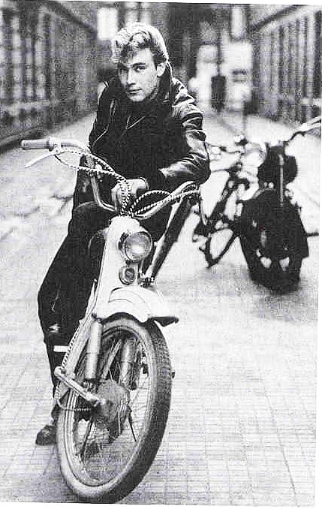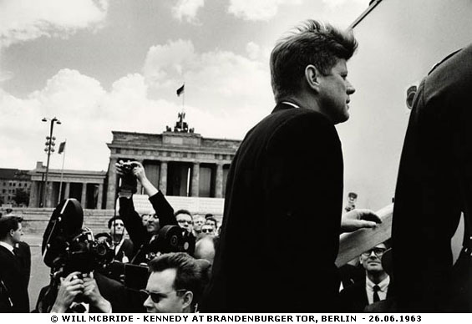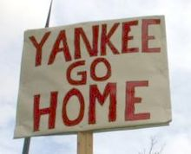

**Instructor: Dr. Jan Uelzmann**

Office: Swann 331

Course meets: Tue- Thu, 3:05 - 4.25 pm

@ Swann 115

Office hrs: Tue and Thu, 9-10 pm, and by appt.

Tel: (404) 385-7330

Email: [jan.uelzmann@modlangs.gatech.edu](mailto:jan.uelzmann@modlangs.gatech.edu)

**Texts:** Essays, Book chapters, historical texts, newspaper and magazine articles from the internet, films, newsreels, photos. Links to the texts (and many texts themselves) are on T-Square.

**Course aims:** This course will give you an overview about how central the influence of US culture was and continues to be on the social development of the FRG. Apart from discussing the highly dynamic and at times controversial reception of US culture, we will also gain an overview on anti-American tendencies in Germany and how these changed throughout the development of the FRG.

We will begin by developing working notions of “culture,” “cultural exchange,” and “Americanization” for the course. After that, we will trace the history of US-culture in the FRG from its beginnings in occupied Germany of 1945, through the Cold War, up until unified Germany. This will be done through exemplary case studies that we will reconstruct from numerous “texts” stemming from diverse domains such as film, science and technology, literature, politics, newsreels journalism, advertising, and photography.

**Learning Objectives:**

Upon completion of this course, students will be able to:

1. describe and understand German culture from a decentered, non-US perspective
2. describe the history of cultural contact between the US and Germany
3. critically appraise the US influence on West German notions and patterns of government, democracy, as well as on youth, consumer, and intellectual culture and concomitant patterns of anti-Americanism post 1945
4. develop and apply working definitions of notions such as “culture”, “Americanization,” and “anti-Americanism,” and critically reflect upon these concepts and their development over time
5. improve language proficiency on the intermediate-advanced level in speaking, listening and writing
6. analyze scholarly writing on intercultural and historical topics
7. conduct and complete research for a scholarly project in the TL

**Grading**:

10 % Participation

10 % Homework, preparing the texts

10 % Presentation (1)

15 % Essays, reaction papers (3)

25 % Exams (2)

30 % Final Paper (1)

**Attendance :** regular attendance (and participation, see below!) is crucial for passing this course. Students who are absent because of participation in approved Institute activities (such as field trips, professional conferences, and athletic events) will be permitted to make up the work missed during their absences. Approval of such activities will be granted by the Student Academic and Financial Affairs Committee of the Academic Senate, and statements of the approved absence may be obtained from the Office of the Registrar. Should you miss more than four classes unexcused, you will fail this class.

For more about the Institute Absence policy, see the catalog http://www.catalog.gatech.edu/rules/4/.

**Participation:** This class thrives on active and engaged discussion! I expect that you come to class well prepared and acquainted with the material to be covered, that you take part actively in class discussion, and that you ask questions if something is unclear. Everyone in this course should work together to create a relaxed and anxiety-free learning environment that invites participation and the exchange of ideas. Participation grades will be available on T-Square on a weekly basis.

Exemplary participation grade profiles:

A (9-10): regular participation and well prepared

B (8): irregular participation, but well prepared

C (7): prepared, but rarely participates

D (6): present, but doesn’t participate and is unprepared

F (0): not present in class

**Homework:** For every class session, you will have to prepare texts at home, which includes looking up notions/phenomena that you are unfamiliar with. Most texts will be made available as pdf files through T-Square, for others you might only receive a web address. I expect that you bring the texts to class either printed or on your computer/tablet and that you have annotated them or made notes about the texts’ main arguments/central points. Usually you will receive from me separate sets of reading questions that will guide you through the texts. These questions will be collected. HW grading rubric: 0-10, based on content.

**GRADUATE STUDENTS:** will receive different reading questions that foster a more thorough theoretical engagement with the texts and advanced intercultural comparisons.

**Presentation**:During the course you will give one presentation of 15 minutes. Please time yourself in advance so that you do not exceed the time limit, which will lead to deductions. The presentation should contain power point slides outlining your main points, illustrative images or a film clip. The contents of the presentations might also be part of a quiz or test. You can select a topic and date from the presentations list, but you can also choose your own topic in consultation with me. Presentation grade rubric: content (6pts), vocab (2pts), grammar (2 pts). A handout with grading criteria for the presentations is available through T-square.

**Essays/reaction papers**: The essays are meant as short reactions to a topic we just covered. You can select a particular aspect of a topic, or you can put different aspects/themes/issues into context in your essay. You will write three such reaction essays during the semester. Most importantly, do not provide a summary of the topic, but comment upon it. What aspect do you find interesting, what surprises you, what would you like to criticize and why? The essays should be about 300 words, Times New Roman 12 pt, 2-spaced. Bring your essays to class on the day assigned.

**GRADUATE STUDENTS**: The essays will be 600 words. Select a specific reading from the course and do the following: in the first part of your essay, summarize as precisely as possible the argument of the piece. In the second part, comment on the reading. Do you subscribe to the writer’s point of view or not? You will have to use secondary sources for your commentaries.

Each essay is worth 5% of your final grade. Essay grading rubric: content (5 pts), comprehensibility (5 pts), grammar (5pts), vocabulary (5pts), style (3pts), length & mechanics (2pts), extrapolated to 100

**Exams:** this class has two exams; there is no final exam. The exams have to be taken on the assigned day. If you are to miss an exam due to unforeseen circumstances you have to contact me as early as possible so we can find an alternative arrangement.

**GRADUATE STUDENTS:** will receive a different exam with questions that are geared towards intercultural comparison.

**Final Paper**: The final paper is meant as an opportunity for you to engage in more detail with a particular subject that you found especially interesting in the course. The paper should be about 1300 words long and contain evidence of engagement with secondary literature on the topic (at least 5 different references). You can select the topic yourself in consultation with me. On November 22nd, you have to submit a proposal of 150 words on your topic.

**GRADUATE STUDENTS:** The final paper should be about 2000 words long and contain at least 15 different references. Topics will be geared towards research-oriented topics that demand a greater level of engagement with theories or complex sociopolitical and historical developments.

Possible topics: „Rock & Roll in Germany,“ „Opel and General Motors,“ „The role of the US in the reconstruction of the German broadcasting networks,“ „The influence of the US constitution of the Basic Law,” „Coca Cola in 1950s West Germany,” „The role of the *Amerikahäuser*” „John F. Kennedy’s image in West Germany during the 1960s,” “Anti-Americanist tendencies in Germany since reunification,” or an analysis of a German film/novel/song discussed in the class with regard to the course topics.

Grading rubrics: content (20pts), grammar (5pts), vocabulary (5pts), extrapolated to 100.

|  |  |
| --- | --- |
| **ML PERFORMANCE GOAL #1: PROFESSIONAL COMMUNICATION** | |
| **ML Learning Outcome 1 : Demonstrate oral and aural proficiency in the target language** | Students will demonstrate oral proficiency at the intermediate-high or higher level on the ACTFL scale, and will reflect in the TL upon the US cultural impact on the Federal Republic post 1945/9, as well as patterns of Americanization and anti-Americanism in German culture. |
| **ML Learning Outcome 2:** Demonstrate effective presentation skills in the target language | Students will present on a topic connected to the US cultural impact on the Federal Republic. |
| **ML Learning Outcome 3: Demonstrate writing proficiency in the target language** | Students will demonstrate writing proficiency at the advanced-low or higher level on the ACTFL scale through regular text analysis homework, three essays, and a five-page, final research paper. |
| **ML Learning Outcome 4:**  Demonstrate proficiency in comprehension of authentic written texts in the target Language | Students will demonstrate reading proficiency at the Advanced –mid or higher level on the ACTFL scale through advanced work with texts such as summarizing argumentative structures of authentic research texts, presenting authentic content in their own words to their peers, and others. |
| **ML PERFORMANCE GOAL #2: INTERCULTURAL SKILLS AND KNOWLEDGE** | |
| **ML Learning Outcome 5: Demonstrate in-depth knowledge of a *specific* target-language country or region** | Students will critically reflect on the profound influence the US exerted on West German youth, consumer, and intellectual culture and concomitant patterns of anti-Americanism. This class will raise awareness of the nature of the German US-relations from 1945 until today. |
| **ML Learning Outcome 6:**  Demonstrate the ability to analyze an issue from target-culture perspective(s) | Students will trace the German encounter with US – culture from a German perspective. |
| **ML Learning Outcome 7:**  Demonstrate critical reflection on cultural complexity and context | Students will develop working definitions of notions such as “culture”, “Americanization,” “anti-Americanism”, and “Coca-Colonization” in this class and will be asked to critically reflect upon these concepts and identify changes in them over time. |

**Special needs:**

Georgia Tech provides upon request appropriate academic accommodations for students with disabilities. To determine whether you qualify, please contact the Office of Disability Services at 404.894.2563 or dsinfo@gatech.edu or [disabilityservices.gatech.edu.](http://depts.washington.edu/uwdrs/)  If they certify your needs, the School of Modern Languages will work with you to make appropriate arrangements. Please do not hesitate to talk to me to get the necessary assistance.

The **Georgia Tech Academic Honor Code** applies to this course.

**Authorized collaboration and unauthorized collaboration FOR THIS CLASS:**

**Plagiarism:** Plagiarizing is defined by Webster’s as “to steal and pass off (the ideas or words of another) as one's own: use (another's production) without crediting the source.” If caught plagiarizing, you will be dealt with according to the GT Academic Honor Code.Quote and attribute any words that are not your own. Do not cut and paste anything into your paper. You may insert quotes but you will have to identify the author according to MLA (Modern Language Association) guidelines, which can be found at [www.mla.org](http://www.mla.org)

**For Homework/Essays/Quizzes/Tests:** Unless specifically identified as group work, homework, essays, quizzes, tests, etc. are to be completed alone. You are allowed (and encouraged) to work together with other students on homework, as long as you write up and turn in your own words. You are also allowed (and encouraged) to ask me questions. Cheating off of another person’s test or quiz is unethical and unacceptable. Cheating off of anyone else’s work is a direct violation of the GT Academic Honor Code, and will be dealt with accordingly. Use of any previous semester course materials is allowed for this course; however, I remind you that while they may serve as examples for you, they are not guidelines for any tests, quizzes, homework, projects, or any other coursework that may be assigned during the semester. (“Word” is saved copies of old tests, quizzes, homework, projects, or other coursework teachers have given in past semesters.) For any questions involving these or any other Academic Honor Code issues, please consult me or [www.honor.gatech.edu](http://www.honor.gatech.edu)

**COURSE PLAN**

**Topics important dates**

WEEK 1 A Introduction to course. Culture and cultural transfer

Cultural stereotypes: US and Germany

WEEK 1 B Americanization and “Coca-Colonialization:”

(West) German history since 1945 as Americanization?

**READ**: Schildt, *Amerikanisierung*

Kuisel, *Coca-Cola and the Cold War (pp. 96-101, 112-*

*116)*

**PART 1 – 1945-1949: Western Occupation Zones**

WEEK 2 A The US as occupation power 1:

Occupation policies, Fraternization

**READ:** Jarausch, *Westwendung, Fraternisierung*

Poiger, *Occupation and Fraternization*

**PRESENTATION:** The history of the occupation zones in Germany, 1945-1949

WEEK 2B The US as occupation power 2: From De-nazification to re-orientation

**READ**: Jarausch, *Entnazifizierung*

**PRESENTATION:** the Nuremberg Trials

*1940s*

WEEK 3 A The US as occupation power 3: Reorganizing the press system, Creating the regional broadcasting system

**READ:** *Rundfunk in Deutschland*

**PRESENTATION:** The press system in the US occupation zone, 1945-1949

WEEK 3 B The US as occupation power 4: Marshall plan,

currency union, and the social market economy

**READ:** Jarausch, *Marktwirtschaft*

**PRESENTATION:** Soziale Marktwirtschaft

*1940s*

**PART 2 – 1949-1989: West Germany**

WEEK 4 A Cultural transfer:

The *Amerikahäuser*, Fulbright Fellowships, youth exchange

**READ**: Schildt, *Amerikahäuser*

**PRESENTATION:** Fulbright Fellowships

**Essay 1 due**

WEEK 4 B The “economic miracle:”

US-German joint-ventures: Opel, Coca-Cola

**READ:** Schutts, *Coca-Colonization (ENG)*

**PRESENTATION:** Ford in Germany

*1950s*

WEEK 5 A The consumer society: House wives, refrigerators, cars, and

gender

**READ:** *Schildt, Alltagskultur in der Konsumgesellschaft*

**PRESENTATION:** Status symbols of the Economic Miracle

WEEK 5 B Gender and Race in Post-war Germany: gender roles, „brown babies,“ and the nuclear family

**LESEN:** Fehrenbach, *Learning from America*

**PRESENTATION:** Family during the Economic Miracle

*1950s*

WEEK 6 A Youth culture: Jazz, Rock `n` Roll, and *Halbstarke*

**LESEN:** Poiger, *Halbstarke*

**WATCH:** WDR-Dokumentary *Halbstark*

<http://www.youtube.com/watch?v=k-WmQ1YEklY>

**PRESENTATION:** Elvis Presley in Germany

WEEK 6 B FILM: Georg Tressler, *Halbstarke*

*1950s*

WEEK 7 A **FILM**: Georg Tressler, *Halbstarke*

**PRESENTATION:** Horst Buchholz, the German James Dean?

US-precursors to the film *Halbstarke*

WEEK 7B **EXAM 1** **EXAM 1**

*1950s*

WEEK 8 A The years 1961-63: President Kennedy and the “frontier city Berlin”

**READ:** tba.

**PRESENTATION:** Berlin 1961: Confrontation at Checkpoint

Charlie

WEEK 8 B Coca-Cola and Anti-Communism

**READ:** Kuisel, *Coca-Cola and the Cold War*

**PRESENTATION:** Coca-Cola as a symbol of Capitalism

**Essay 2 due**

*1960s*

WEEK 9 A **FALL BREAK**

WEEK 9 B **FILM**: Billy Wilder: *One, Two, Three*

*1960s*

WEEK 10 A **FILM**: Billy Wilder, *One, Two, Three*

WEEK 10 B Anti-Americanism of the 1950s and 60s

**READ:** tba

**PRESENTATION:** US-culture vs. German „high culture” in

public perception

*1960s*

WEEK 11 A From Berkeley to Berlin: The concept of “1968”

**READ:** Jarausch, *Ausbruch von Protest*, *Kulturrevolutionäre*

*Aufbrüche*

**PRESENTATION:** Berkeley 1968,

The Extraparliamentary Opposition (APO)

WEEK 11 B The German Left and Vietnam

**READ:** tba

**PRESENTATION:** German positions toward the Vietnam war

*1970s*

WEEK 12 A From the student movement to the RAF

**READ:** Aust, *Baader-Meinhof Komplex*

**PRESENTATION:** The “German Autumn”

**Essay 3 due**

WEEK 12 B „No Nukes, Mr. Reagan:“ the Anti-nuclear movement, the

peace-movement, and the Green Party

**READ:** tba

**PRESENTATION:** theNATO-Double Track Decision and German reactions

*1980s*

WEEK 13 A Americanization in Radio, Cinema, and TV

**READ:** Maase, *German Broadcasting*

**PRESENTATION:** Hollywood cinema vs. German cinema

**Final Paper proposal due**

WEEK 13 B **EXAM 2 EXAM 2**

*1980/90s*

**PART 3 – 1990-today: The Berlin Republic**

WEEK 14 A America, re-unification and the Berlin Republic

**READ:** Berman, *Anti-Americanism and Americanization*

**PRESENTATION:** The relationship between the US and

Germany after re-unification

WEEK 14 B **THANKSGIVING**

*1990/2000s*

WEEK 15 A Paris-Berlin-Moskau: The Berlin Republic and new political

alliances in Europe

**READ:** tba

**PRESENTATION:** Franco-German relations 1945-today

WEEK 15 B George W. Bush and German Anti-Americanism

**READ:** Joffe, *Der Aufstieg des Anti-Amerikanismus*

**PRESENTATION**: George W. Bush’s image in Germany

Germany and the second Iraq War

**First draft of final paper due**

**(2 pages, 500 words)**

*2000s*

WEEK 16 A „Hyper power USA“?

**READ:** Josef Joffe, *Der Aufstieg des Amerikanismus*

**PRESENTATION:** The geopolitical role of the USA after the

end of the Soviet Union

WEEK 16 B Closing discussion: Future?

*today*

December 14 **Final paper due**