**GRMN 4310/6310**

**STEM in German History and Culture**

**Tuesday-Thursday, 3:00-4:30 pm**

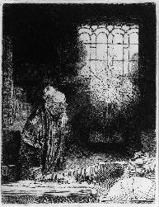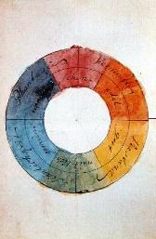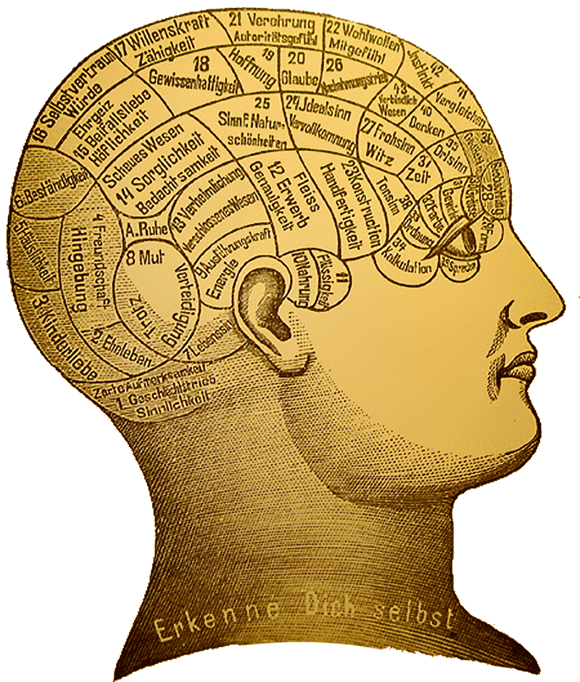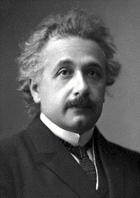 

**Dr. Jenny Strakovsky**

Office: Savant 307D

Office Hours: Mon, 2:00-4:00 pm

Email: [yevgenya.strakovsky@modlangs.gatech.edu](mailto:yevgenya.strakovsky@modlangs.gatech.edu)

**Course Description:** Germany’s scientists and innovators have had a pivotal role in the history of biology, medicine, physics, and engineering. This course examines the cultural contexts, media, discourses, and aesthetics that shape the rich history of science in the German-speaking world. Students will use interdisciplinary approaches—including cultural studies, philosophy of science, media studies, intellectual history, and discourse analysis—to examine the dialogue between science, culture, and the arts across several eras from 1800 to the present. As students will learn about key events in the German history of science, they will critically examine concepts like *discovery*, *innovation*, *knowledge*, *technology*, and *progress*. Readings include fiction, philosophy, and primary sources such as scientific papers, diaries, advertising, and news media. This course also aims to integrate the study of German language and culture with students’ long-term professional goals. The class includes site visits and interviews with leaders in science and industry. Students will conduct independent research and present on a specific topic in science, technology, or industry. They will also complete a service-learning project to support STEM learning in public education. *For MS-students and advanced BS-students. Taught in German.*

**Learning Objectives:**

* Students will discuss, present, debate, and write about scientific topics in German.
* Students will develop an intercultural understanding German-speaking and American approaches to science and technology.
* Students will identify, investigate, and analyze key turning points in the history of scientific and technological innovation in the German-speaking world, both in terms of empirical discovery and knowledge production, and in terms of cultural, social, economic, and environmental impact.
* Students will demonstrate the ability to use multiple disciplinary approaches to conduct research on a case study of scientific discovery.
* Students will demonstrate a historically informed understanding of the sciences in culture and society today.

**Grading Summary:**

|  |  |  |  |
| --- | --- | --- | --- |
| ***Component*** | ***Undergraduates (4310)*** | ***Graduate Students (6310)*** | ***Percentage*** |
| **Participation** | Regular attendance, active participation in discussion | | **15%** |
| **Homework** | Regular and critically engaged annotation of readings | | **15%** |
| **Essays** | 3 300-word blog posts Peer feedback | 5 300-word posts  Peer feedback | **15%** |
| **Research Presentation** | 12-15 Minutes | 18-20 Minutes | **25%** |
| **Teaching Toolkit Project** | | | **30%** |
| II. Materials | HW, 30-min activity | HW, 30-min activity | [15%] |
| III. Analysis | 800 Words,  5+ references | 1500 Words,  10+ references | [15%] |

**Attendance:** Regular attendance and activeparticipation are crucial for passing this course. Your final grade will be lowered three points for each unexcused absence in excess of 2. To have an absence excused, you must: (1) receive prior approval or (2) bring documentation of a medical or comparable emergency to the class directly following your absence. A visit to the clinic does not constitute a medical emergency unless homestay is prescribed. Students who miss more than six classes unexcused will receive an F.

Students who are absent because of participation in approved Institute activities (such as field trips, professional conferences, and athletic events) will be permitted to make up the work missed during their absences. Approval of such activities will be granted by the Student Academic and Financial Affairs Committee of the Academic Senate, and statements of the approved absence may be obtained from the Office of the Registrar. <http://www.catalog.gatech.edu/rules/4/>

**Participation:** This class thrives on active and engaged discussion! I expect that you come to class well prepared and acquainted with the material to be covered, that you take part actively in class discussion, and that you ask questions if something is unclear. Everyone in this course should work together to create a curiosity-driven and safe learning environment that invites participation and the exchange of ideas.

Students earn a participation score every week, scored out of 4 points. Unexcused absences result in a maximum score of 2 for the week. Final scores are divided by 4 to yield the participation grade earned. (The maximum score, 60 points, yields a final participation grade of 15%)

4: regular participation and well-prepared

3: irregular participation, but well-prepared

2: prepared, but rarely participates

1: unprepared and unengaged

0: not present

**Homework Annotation:** For every class session, you will prepare for in-class discussion by familiarizing yourself with the assigned texts. This includes (1) Active Investigation of Context: looking up vocabulary, unknown concepts, and the broader historical context associated with the case, (2) Critical Engagement: making substantive annotations to the text itself, which include discussion questions, close reading, commentary, or connections between multiple texts, (3) Reflection: writing 2-3 sentences of your overall reaction, which serves as your springboard into class discussion.

I expect that you bring your texts and annotations to class, to be prepared to engage with your classmates in a discussion of the text. You will sometimes receive additional assignments, such as reading questions, which will guide you through the texts. Homework will be randomly collected during the semester and graded on a scale of 1-10.

**Homework Grading rubric:** Active Investigation of Context: 30% (3 pts)

9-10=A | 8=B | 7=C Critical Engagement: 40% (4 pts)

6=D | <6=F Reflection: 30% (3 pts)

**Essay Blog:** Essay blog posts provide an opportunity to reflect on a reading, its contexts, its legacy, and its relationship to your interests. Each essay should be at least 300 words (TMR, 12pt, 2-spaced), address a specific aspect of a topic, use additional sources, and engage in argumentation, research, and reflection. Select a specific reading from the course and do the following: in the first part of your essay, summarize as precisely as possible the argument of the piece. In the second part, comment on the reading. Do you subscribe to the writer’s point of view or not? What aspect do you find interesting, what surprises you, what would you like to criticize and why?

Undergraduates will post **three** essays; Graduate students will post **five** essays. I expect you to comment regularly on other students’ essays, at least once on the work of each student in the course, and to incorporate feedback from other students into a revised/corrected version.

**Essay grading rubric:** Exposition (25%)

90%=A | 80%=B Grammar and Style (25%)

70%=C 60%=D | <59%=F Argumentation (25%)

Engagement with Course Themes (25%)

**Research Presentation:** You will give one presentation, which connects a topic from our course to a contemporary issue in science, technology or industry. For example, you could connect Goethe’s theory of plant metamorphosis to current work in botany or cognitive science, critically analyze Einstein’s role in popular culture, compare the concept of “innovation” in German and American start-up culture, or describe recent developments in German medicine. Topics for MS-students should be geared towards research-oriented questions that demand a high level of engagement with theories or complex scientific and historical developments.

Each student will sign up for one day to present, within 1-3 sessions after the relevant reading has been discussed in class. Undergraduates should present for 12-15 minutes; Graduate students should present for 18-20 minutes. Please time yourself in advance so that you do not exceed the time limit, which will lead to deductions. The presentation should contain Powerpoint slides outlining your main points, illustrative images, and an interactive component. The contents of the presentations might also become part of a quiz or test. A handout with grading criteria for the presentations is available through T-square.

**Presentation grading rubric:** Communication (20%)

90%=A | 80%=B Organization and Structure (20%)

70%=C 60%=D | <59%=F Depth of Content (20%)

Use of Multiple Disciplines: (20%)

Effective Q&A (20%)

**“German and STEM” Final Project:** A central component of this course is the examination of how German language and culture intersects with STEM, and how the history of this dialogue remains pertinent today. In your final project, you will prepare a toolkit for teaching topic in science, technology, or industry in a German classroom. You will also write a research-based proposal about why your toolkit should be included in a course (middle- or high school).

**I. Teaching Toolkit (50%):** You will develop an activity for an intermediate German language classroom, designed to teach students about a topic related to science, technology, and industry in Germany. This may be a toolkit for conducting a scientific experiment and discussing it in German, a reading activity on medical ethics, an introduction to local species in German, an app-making or coding activity, etc. Your toolkit should introduce students to the necessary vocabulary and signature grammatical structures required for discussing the topic. It should include a homework assignment to be completed before class, and an active 30-minute exercise that engages students in two or more disciplines: science, philosophy of science, cultural studies, literary analysis, etc. Everyone will do a trial run of their activity in class to receive feedback from the group. We will consider the principles of learning and knowledge production throughout the course, as we examine case studies of scientific discovery.

**Toolkit grading rubric:** Language (30%)

90%=A | 80%=B Organization and Structure (30%)

70%=C 60%=D | <59%=F Use of Multiple Disciplines: (20%)

Trial-run Workshop (20%)

**III. Research-based Toolkit Analysis (50%):** You will write a cover letter proposing the use of your toolkit in a German language classroom. This letter is addressed to a potential German teacher and serves several important aims: (1) to explain the activity and its goals (2) to introduce the topic and its contexts, including engagement with relevant scholarly sources, and (3) to demonstrate why this activity and theme is pertinent and important for students. Undergraduates will write letters of 600-800 words that contain at least 5 references; graduate students should write letters of 1200-1500 words that contain at least 10 references.

**Paper grading rubric:** Language (25%)

90%=A | 80%=B Explanation of Activity (25%)

70%=C 60%=D | <59%=F Depth of Research (25%)

Effective Argumentation (25%)

|  |  |
| --- | --- |
| **ML PERFORMANCE GOAL #1: PROFESSIONAL COMMUNICATION** | |
| **ML Learning Outcome 1 : Demonstrate oral and aural proficiency in the target language** | Students will demonstrate oral proficiency at the intermediate-high or higher level on the ACTFL scale, and will reflect in the TL on topics in biology, psychology, medicine, and engineering. |
| **ML Learning Outcome 2:** Demonstrate effective presentation skills in the target language | Students will present on a topic connected to science, technology, and industry in the German speaking world. |
| **ML Learning Outcome 3: Demonstrate writing proficiency in the target language** | Students will demonstrate writing proficiency at the advanced-low or higher level on the ACTFL scale through regular text analysis homework and multiple essays. |
| **ML Learning Outcome 4:**  Demonstrate proficiency in comprehension of authentic written texts in the target Language | Students will demonstrate reading proficiency at the Advanced–low or higher level on the ACTFL scale through advanced work with texts such as summarizing argumentative structures of authentic research texts, presenting authentic content in their own words to their peers, and others. |
| **ML PERFORMANCE GOAL #2: INTERCULTURAL SKILLS AND KNOWLEDGE** | |
| **ML Learning Outcome 5:** Demonstrate in-depth knowledge of a *specific* target-language country/region | Students will critically reflect on the role of Germany in the history of empirical science, philosophy of science, globalization, technological development, and cross-cultural industry. |
| **ML Learning Outcome 6:**  Demonstrate the ability to analyze an issue from target-culture perspective(s) | Students will closely analyze German-language case studies of scientific exploration and be asked to identify their unique features and perspectives. |
| **ML Learning Outcome 7:**  Demonstrate critical reflection on cultural complexity and context | Students will develop working definitions of notions such as “science,” “progress,” “innovation,” “discovery,” and “history,” and will be asked to critically reflect upon these concepts and identify changes in them over time. |

**Accommodations:** Georgia Tech provides upon request appropriate academic accommodations for students with disabilities. To determine whether you qualify, please contact the Office of Disability Services (http:// <http://disabilityservices.gatech.edu/> ). If they certify your needs, the School of Modern Languages will work with you to make appropriate arrangements. Please do not hesitate to talk to me to get the necessary assistance.

The **Georgia Tech Academic Honor Code** applies to this course.

**Authorized collaboration and unauthorized collaboration for this class:**

**Plagiarism:** Plagiarizing is defined by Webster’s as “to steal and pass off (the ideas or words of another) as one's own: use (another's production) without crediting the source.” If caught plagiarizing, you will be dealt with according to the GT Academic Honor Code.Quote and attribute any words that are not your own. Do not cut and paste anything into your paper. Excessive use of online translation services will be considered a form of plagiarism in this course.You may insert quotes but you will have to identify the author according to MLA (Modern Language Association) guidelines, which can be found at [www.mla.org](http://www.mla.org)

**Unless specifically identified as group work, homework, essays, quizzes, tests, etc. are to be completed alone.** You are allowed (and encouraged) to work together with other students on homework, as long as you write up and turn in your own words. You are also allowed (and encouraged) to ask me questions. Cheating off of another person’s test or quiz is unethical and unacceptable. Cheating off of anyone else’s work, including that of a digital translation service, is a direct violation of the GT Academic Honor Code, and will be dealt with accordingly. For any questions involving these or any other Academic Honor Code issues, please consult me or [www.honor.gatech.edu](http://www.honor.gatech.edu)

**Course Schedule**

*Week 1:*

**Tues:** Course Introduction: *What is a discipline?*

* C.P. Snow, “The Two Cultures”
* Rudolf Stichweh, “Die Zwei Kulturen? Gegenwärtige Beziehungen von Natur- und Humanwissenschaften“

**The Scientific Revolution: Grasping an Expanding Universe**

**Thurs:** Curiosity Cabinets and Encyclopedias

* Samuel Hahnemann’s Homeopathy
* Linnaean Taxonomy
* Gessner’s Thier-Buch

*Week 2:*

**Tues:** Mathematics: Introduction to Logic

* Selections from Leibniz, Kant

**Thurs:** Astronomy: The Copernican Revolution

* Kepler, “Dream of going to the moon”

*Week 3:*

**Tues:** Modern Perspectives on the Scientific Revolution

* Bertolt Brecht, *Galileo Galilei*

**Thurs:** MINT Heute: Recent papers/media on Astronomy, Physics, Mathematics

**Romantic Science and Organic Life**

*Week 4:*

**Tues:** Developmental Biology:

* Blumenbach, *Bildungstrieb*
* Goethe, *Metamorphose der Pflanzen*

**Thurs:** Cognition and the Scientific Process: Goethe and Newton on Color Perception

*Week 5:*

**Tues:** Popular Scientists: Alexander von Humboldt, *Kosmos*

**Thurs:** MINT Heute: Recent papers/media on Biology, Biophysics, Evolution

**Industrialization and Quantified Human Experience**

*Week 6:*

**Tues:** From Philosophy to Psychology

* Hermann von Helmholtz, Selected papers
* Wundt’s Laboratory

**Thurs:** Büchner, *Woyzeck,* selected neuroscientific writings

*Week 7:*

**Tues:** FILM: *Metropolis* andGeorg Simmel, “The Metropolis and Modern Life”

**Thurs:** Freud, Selected Readings on child psychology

*Week 8:*

**Tues:** Kafka, Selected Readings, e.g. *In der Strafkolonie, “Vor dem Gesetz”*

**Thurs:** (MINT Heute) Recent papers/media Social Sciences, e.g. Psychology, Sociology

**World War: Mechanization of Violence**

*Week 9:*

**Tues:** (WWI) Technology and Total War: Selected artifacts (G. Grosz, R. M. Remarque)

**Thurs:** (WWII) Mechanizing Genocide: Selected artifacts (documents, witness accounts)

**Reflections on Science and Society**

*Week 10:*

**Tues:** Albert Einstein as physicist and public figure (Selected Letters and lectures)

**Thurs:** The Manhattan Project: Dürrenmatt, *Die Physiker*

*Week 11:*

**Tues:** What is Innovation? What is Progress?:

* Bichsel, “Der Erfinder” and Böll, “Anekdote zur Senkung der Arbeitsmorale”

**German Industry and Innovation Today**

**Thurs:** *Umwelt*: Climate Science, Alternative Energy

*Week 12:*

**Tues:** German Cars: Audi, BMW, Mercedes, Volkswagen, Porsche

**Thurs:** The Tech Industry: Start-ups, Computer Science

*Week 13:*

**Tues:** *Teaching Toolkit Workshops*

**Thurs:** *Teaching Toolkit Workshops*

Week 14:

**Tues:** *Teaching Toolkit Workshops*

**Thurs:** *Teaching Toolkit Workshops*

Week 15:

**Tues:** **Guest Speaker** from Atlanta-based company, TBA.

**Thurs:** Closing Discussion