Service Operations Management

**MGT 4366**

**Professor Manpreet Hora**

**Fall 2012**

**Class Hours: T, Th: 8.00 AM to 9.30 AM**

**Office: College of Management, Room 4252**

**Phone: 404-385-3465**

**e-mail: [manpreet.hora@scheller.gatech.edu](mailto:manpreet.hora@mgt.gatech.edu)**

**Office hours: T, Th: 11:00 AM – 12:00 PM or by a prior email appointment**

**Introduction**

The tertiary sector or the “services sector” contributes about 70% of the gross domestic product of the US economy. This sector also provides employment to 80% of the working population. This course in “Service Operations Management” examines the firms in the services sector. Differentiating a service from a product on dimensions, such as, intangibility, perishability, involvement and participation of the customer in the production or delivery of service, this course focuses on the structural and infrastructural aspects of managing service operations. Specifically, we will consider services delivery, service encounter, service quality and management of capacity and demand. Using a blend of cases, selected book chapters and articles from business press and academic research, this course will explore these aspects in diverse service industries such as financial services, hospitality, retail and healthcare.

**COURSE OBJECTIVES**

1. To study "breakthrough" services in order to understand the operations of successful service firms that can be benchmarks for future management practice.
2. To develop an understanding of the "state of the art" of service management thinking.
3. To develop an awareness of the opportunities that information technology can have for enhancing competitiveness of service firms.
4. To appreciate the organizational significance of managing the service encounter to achieve internal and external customer satisfaction.
5. To understand the dimensions of service growth and expansion both domestically and internationally.
6. To gain an appreciation of the complexities associated with implementing change.
7. To appreciate the entrepreneurial opportunities in services.

**COURSE MATERIALS**

1. T-Square for presentations and articles.
2. Course Pack available from the Harvard website which includes all cases and a simulation used in this course.

**CASE METHOD**

The case method is used throughout the course. Study questions on each assigned case will be provided on the course website. These questions should serve as a starting point with additional insights being welcomed. All class members are expected to have read the case and reflected upon the assigned questions. Furthermore, class members are encouraged to apply concepts from the assigned readings to their analysis of the case.

**GRADING**

Your course grade will be based on the following team and individual activities and weights:

|  |  |  |  |  |  |  |  |  |  |  |  |  |  |  |  |  |  |  |  |  |
| --- | --- | --- | --- | --- | --- | --- | --- | --- | --- | --- | --- | --- | --- | --- | --- | --- | --- | --- | --- | --- |
| |  |  |  | | --- | --- | --- | | **Class Participation** | **20.00%** | **Individual** | | **Simulation** | **15.00%** | **Individual** | | **Group Project 1: Case Analyses** | **20.00%** | **Group** | | **Group Project 2: Walk-through Audit** | **30.00%** | **Group** | | **Final Report** | **15.00%** | **Individual** | | **Total** | **100.00%** |  | |  |  |

**CLASS PARTICIPATION – 20%**

This course itself is an example of service operations where co-production is required among the students and the instructor for a high quality service delivery. Therefore, to stimulate a rich-class environment, it is important to come prepared for the class. Active participation is expected throughout the entire class with thoughtful contributions to advance the quality of the discussion. Please note that the frequency (i.e., the quantity) of your interventions in class is not a key criterion for effective class participation. Meaningful contributions to class discussion include any comments, questions or analyses which advance the general class understanding of the case concept or issue.

Using the case method provides, through relevant managerial examples, a basis for class discussion on the underlying concepts. To guide us through the case, discussion questions will be provided on the course website. As you prepare for these questions, I encourage you to think of additional questions related to the particular session.

Attendance is a *sine qua non* to participation. Thus, please ensure that you attend all classes. If you cannot attend, please write an email to inform me beforehand and obtain notes from our fellow students.

Class contribution will be assessed (on a 0 to 4 scale) by the instructor. Also noted are absences and students who had their hands up but were not called on. Students who say nothing get 0; those who make valuable, insightful, in-depth contribution get 4. At the end of the course, the daily points are summed and the class ranked by these totals. These scores will be used as a first cut to assign grades. I will also be using index cards/ in-class quizzes to obtain feedback on certain cases and topic areas which will be part of class contribution.

Criteria that are useful in measuring effective class participation include:

1. Is the participant a good listener?
2. Are the points that are made relevant to the discussion? Are they linked to the comments of others?
3. Do comments show evidence of applying the concepts from the readings to the analysis of the case?
4. Is there willingness to test new ideas, or are all comments "safe" (e.g., repetition of case facts without analysis and conclusions?)
5. Do comments clarify or build upon the important aspects of earlier comments and lead to a clearer statement of the concepts being covered and the problems being addressed?

**SIMULATION– 15%**

The objectives of the Benihana Simulation are:

1. How to analyze capacity, demand rates, cycle time, and throughput in an operation.
2. How batching strategies improve throughput and importance of increasing capacity at bottlenecks.
3. How to optimize capacity in an operation. (Unused capacity is lost.)
4. How to minimize or eliminate demand variabilities (cyclical, stochastic, batch size, and service time.)
5. How to optimize across multiple variables in an operation and ensure consistency in the overall operations strategy.

The simulation seeks to help students understand the linkage between Demand Variability and Process Variability.

Visit the Harvard URL

* Once you are into the simulation, please take a few minutes to review each link on the "Prepare" tab.
* Work through each of the assigned challenges in the Benihana simulation.

More details on the deliverables and deadline will be discussed in class.

**GROUP PROJECT 1: Case Analyses – 20%**

An important element of this class is teamwork. You are to form your own team of no more than 5 students. Each team will be responsible for preparing **one** written case assignment and leading **one** case discussion.

**FACILITATING CASE DISCUSSION**

By the end of the second session, your team will need to select one case for your team to lead the class in its analysis. Facilitating a case discussion is not presenting a complete analysis of the case but rather leading the class in the case analysis. This requires the team to stimulate interest and draw out insights and ideas from the class creating active participation of class members who are expected to have read the case and thought about the assigned questions. Often the case discussion begins with a brief overview of the firm. Discussions of the assigned questions are facilitated using an outline or bullet form with inputs provided by the students. As a group, we will try to build a complete analysis of the situation and address the problems arising in the case applying the framework presented in the readings for the session. At the conclusion of the case discussion, the instructor will summarize the takeaways for the case analysis. Please ensure 45-50 minutes of presentation time.

Criteria for measuring the effectiveness of leading a case discussion include:

1. Ability to stimulate interest among your classmates.
2. Ability to relate the concepts from the readings to the issues in the specific situation.
3. How well the discussion generated insights and ideas from the participants.
4. How effectively the team led the discussion.
5. Was the analysis complete?

**WRITTEN ANALYSIS OF CASES**

By the end of the second session your team will need to select a case for written analysis during the course. The analysis will address the case questions and be limited to five pages, printed double-spaced, plus exhibits. I will be evaluating your papers using the attached “grading” sheet with particular attention being paid to your application of course reading material and concepts to the case analysis. The assigned questions for a case are shown in the detailed course outline following the case description. At a minimum these questions must be addressed in the written analysis with creative thinking beyond these issues being rewarded. **Written papers are due at the beginning of class**.

1. Papers should be printed, double-spaced, with normal margins. The name of the case should be on the first page of the text with your names, date, and course number. An executive summary is not required nor expected.
2. The page limit for each paper is five pages of text, plus exhibits. Note that these are maximum limits. Papers should be concise and coherent.
3. Exhibits should contain specific types of analyses (application of a framework, table of comparisons, cost analysis, competitive features, etc.) and information (web page of firm) that supports and is relevant, but would be too detailed for the body of the paper.
4. Please proofread/spell check your paper before turning it in. Papers for this course should be of the same quality that you would provide to the management of the business.

**GROUP PROJECT 2: Walk-through-Audit – 30%**

Each group will conduct a service project consisting of a Walk-through-Audit. The name of the service firm (only to be provided after the consent from the firm) and a brief project proposal is due for approval by September 18th with a first draft of your survey to be submitted by October 26th A presentation of the project will be made during the class (see schedule for details). A project report of five pages or less plus exhibits will be due on the day your group makes its presentation.

The Walk-through-Audit (WtA) Project involves the selection of a service in which you prepare an audit questionnaire used by management to evaluate the service from the perspective of a customer (I will provide an example of a WtA in class). A copy of the audit questionnaire, statistical analysis of the responses, and analysis of the gaps between management's perceptions and customer responses is expected in the report.

***Walk-Through-Audit Checklist***

1. Select service firm and get permission of management
2. Prepare a first draft of the audit questionnaire
3. Conduct audit (survey customers and managers)
4. Analysis of perception gaps between customers and managers
5. Prepare recommendations and present to management

**EXAM REPORT – 15%**

The final element for the course grade involves an individual case analysis report. Students should integrate the concepts covered in class and the managerial implications.

**CLASS BEHAVIOR - GROUP AND INDIVIDUAL NORMS**

Because every faculty member has somewhat different expectations as to class behavior and individual norms, I'd like to outline a few of mine at the outset.

1. If you do miss a class, please find out from a classmate what additional assignments might have been made, and what handouts you may have missed.
2. To help us all become acquainted as quickly as possible, please bring your name card to class. During the third class, I will distribute a seating chart and ask you to use the same seat for the remainder of the class. Team members may wish to sit together.
3. Preparation of the case and thinking about the assigned questions before class is essential for a stimulating and rewarding class experience.
4. For purposes of general class preparation, group work is strongly encouraged.
5. Class time is a perishable commodity, please be considerate by not arriving late for class. We will start and end promptly as scheduled.

**ATTENDANCE**

Class attendance and participation are direct factors in determining the course grade. There is a NO MAKEUP policy for all work described in this syllabus. Points can be earned only by your presence in class for 20% of your grade. If Georgia Institute of Technology is closed for any reason on a scheduled class day, you should be prepared to adjust the schedule accordingly including taking an exam during that next class session. In the next class meeting, the instructor will provide direction as to potential changes in course. (Also check the class web site for changes)

**CLASS WEB PAGE**

T-Square will be your source for the lectures (PowerPoint slides, etc), participation grade results and any extra articles, etc. that we do in the class.

**NOTE**

1. The course syllabus provides a general plan for the course; deviations may be necessary.
2. Students are responsible for the information contained in the Academic Honesty policies found at <http://www.honor.gatech.edu/>.

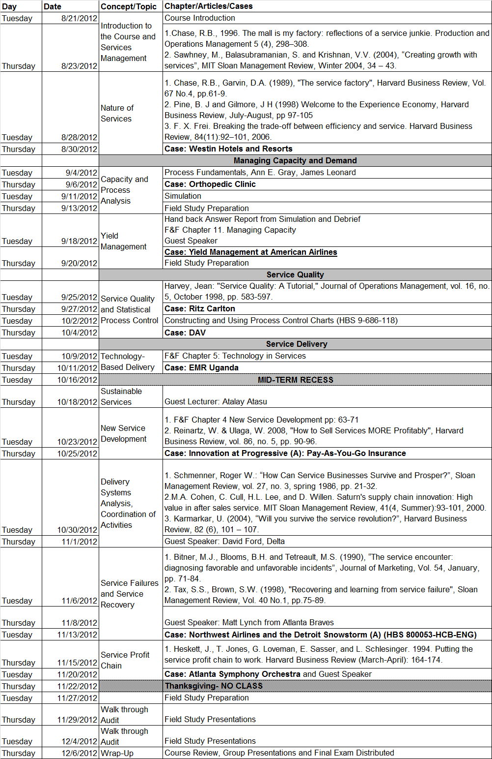

**GROUP/CASE_______________________________________ Date______________________**

**GRADING SHEET FOR WRITTEN PAPERS**

Analysis **Poor Excellent**

1. Is the analysis complete and comprehensive? |___|___|___|___|

2. Does the analysis apply concepts from the *readings*? |___|___|___|___|

3. Does the analysis show the relationships among important factors in the situation? |___|___|___|___|

4. Are assumptions made in the analysis stated explicitly? |___|___|___|___|

5. Does the analysis isolate the fundamental causes of problems? |___|___|___|___|

Recommended Action

1. Are the criteria for selecting recommendations stated? |___|___|___|___|

2. Is the plan of action integrated in a logical way and linked to the analysis? |___|___|___|___|

Exhibits

1. Are analyses in the exhibits done correctly? |___|___|___|___|

2. Do the key exhibits support and add to the text on key points?|___|___|___|___|

Overall Criteria

1. Is the paper logically consistent and effectively structured so

it sells its recommendations? |___|___|___|___|

2. Is there a high likelihood that the recommendations will

achieve their intended results? |___|___|___|___|

**GROUP/CASE_______________________________________ Date______________________**

**GRADING SHEET FOR FACILITATING CASE DISCUSSION**

Analysis **Poor Excellent**

1. Was the analysis of the case complete? |___|___|___|___|

2. Does the analysis apply concepts from the *readings*? |___|___|___|___|

3. Does the analysis show the relationships among important factors in

the situation? |___|___|___|___|

Case Discussion

1. Did the case discussion stimulate interest among class participants?|___|___|___|___|

2. How effectively did the team lead the discussion? |___|___|___|___|

3. How well was the timing and pace of the case discussion? |___|___|___|___|

Class Handouts/Presentation

1. Were the class handouts effective in communicating information? |___|___|___|___|

2. Was the PowerPoint presentation useful and well prepared? |___|___|___|___|

Overall Criteria

1. How well organized was the discussion? |___|___|___|___|

2. How well did the discussion draw out insights and ideas from the students? |___|___|___|___|