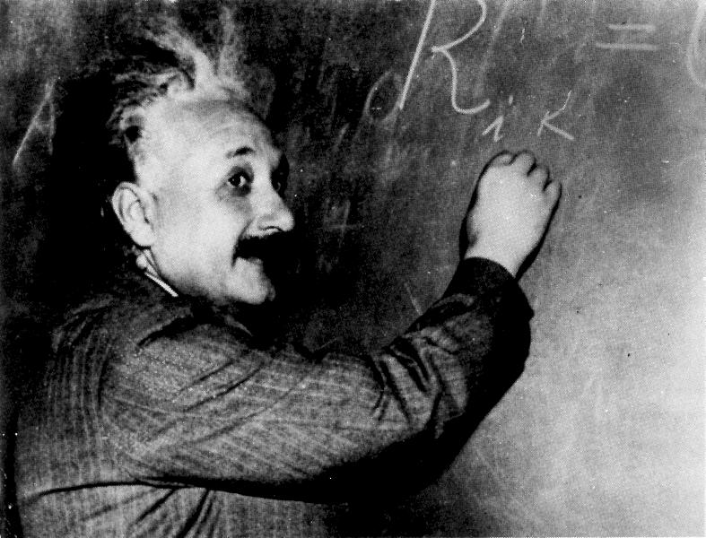

Relativity

**Course Objectives** As undergraduates with an interest in physics, you have been pursuing an understanding of the fundamental theories governing nature as we know it. You have taken classes on classical and quantum mechanics, electromagnetism, thermal mechanics and perhaps atomic physics. You are now about to delve into the theories of special and general relativity which explain how gravity works in the universe. Gravitational physics is becoming increasingly important in astrophysics, cosmology and particle physics. This course of Special and General Relativity uses a `physics’ ﬁrst approach. Pioneered by Prof. James Hartle, this approach allows us to access the concepts of general relativity while delaying the full mathematical development of differential geometry. We will cover some of the mathematics intrinsic to general relativity, but only as needed to understand the important physical ramiﬁcations of the theory.

**Instructor** Prof. Deirdre Shoemaker

1-65 Boggs Building

(404) 385-3908

[deirdre@gatech.edu](mailto:deirdre@gatech.edu)

http://www.cra.gatech.edu/deirdre

**Office Hours** M 2:00-3:30 PM, Th 1:30-3:00 PM

**Class Logistics** MWF 1:05-1:55 PM in Howey S107

**Prerequisites** Phys 3123

**Textbook**

Our textbook is “Gravity: An Introduction to Einstein’s General Relativity” by James Hartle, with a corresponding website <http://wps.aw.com/aw_hartle_gravity_1>. The website is useful, containing links to Mathematica notebooks, web supplements, textbook errata, and links to related websites. Other useful books are “A First Course in General Relativity” by Bernard Schutz and “Introducing Einstein’s Relativity” by Ray D’Inverno.

**Course Outline, Subject to Change**

Chapters 1,3-5

Chapters 2,6-9

Chapter 10

Chapter 12-13

Chapter 14

Chapters 16 & outside material

# Homework Policy

Homework sets will be due Fridays at the beginning of the class period. Unless special arrangements have been made with me before the assignment is due, we will use the following late assignment policy. Late assignments will be docked 5% if the assignment is turned in after class but before 5pm on the due date. Assignments will be penalized 10% for each late day, and 10% over a weekend. Turn in your late assignments to me personally, put them under my office door, or in my mailbox in the Physics Office in Howey. **Working in a group can help in understanding the homework questions and is encouraged; however, you must include the names of the group members on the homework papers you turn in to me.** No assignments will be accepted after solutions have been disclosed. The work you submit must be your own.

# Academic Integrity

Students are reminded of the obligations and expectations associated with the Georgia Tech **Academic Honor Code**.

# Exam Policy

We will have two exams. The first exam is tentatively scheduled for October 2. The second will be during the scheduled final exam time.

Introduction to Gravitational Physics and Special RelativityBasic Concepts of Geometry and General Relativity Including Curved Spacetime

Tests of General Relativity

Black Holes

Astrophysics of Black Holes

Gravitational Waves