|  |  |
| --- | --- |
| **URBAN LATIN AMERICA/** | **IBERO-AMERICAN CITIES** |
| **INTA 4803/8803/** | **SPAN 4350** |

**TIME: M-W-F 1:05-1:55PM**

**Swann 325**

**PROF. BARBARA D. LYNCH**

**Office: B16 Habersham / office hours: Thurs, 3:15-5:00 pm**

**Email:** barbara.lynch@inta.gatech.edu

**PROF. JUAN CARLOS RODRIGUEZ**

**Office: swann 313 / office hours: Wed, Fri 3:00-4:00 pm**

**Email:** [jrodriguez40@modlangs.gatech.edu](mailto:jrodriguez40@modlangs.gatech.edu)

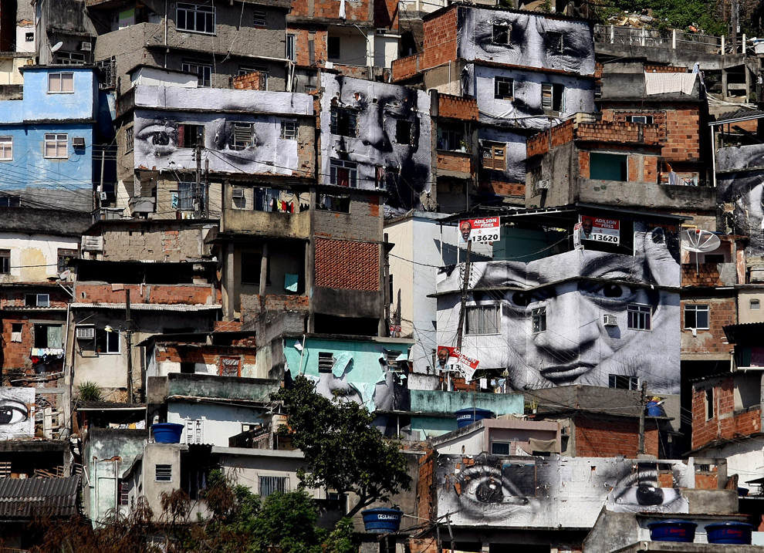

Favela de Providencia, Rio de Janeiro--JR

**COURSE DESCRIPTION**

This course examines the role of the city as built, cultural, and socio-political environment in Latin America. By looking at the history of the city in the region, students will be invited to explore the Latin American city in the context of its different stages and transformations: the pre-columbian city, the colonial city, the modern city, the neoliberal city. We will look at new forms of urbanization, including the growth of border towns and edge cities. Urban social movements and diverse expressions of urban culture from Latin America will be discussed in sessions dedicated to specific cities, including Rio de Janeiro, Buenos Aires, Mexico City, Caracas, Havana, Tijuana, Cochabamba, and Latino Atlanta.

**OBJECTIVES**

-to understand the role of the city in Latin America in the context of local, national and regional dynamics.

-to analyze urban experiences in Latin America from multiple perspectives (government, corporations, citizens, artists, activists)

-to learn how to identify, compare and map different urban issues and challenges in the region.

**REQUIREMENTS**

1. Active AND INFORMED Participation in Classroom discussions (30 percent)

It is expected that all students will come to class prepared to participate in discussions of the assigned readings listed below. Most readings will be available on T-square or at url addresses as indicated. The following text should be purchased at the Engineer’s Bookstore or as an electronic text:

Fernandez, Sujatha. 2010. *Who Can Stop the Drums? Urban Social Movements in Chávez’s Venezuela*. Duke University Press

We will read it in its entirety.

2. ReFLection Papers (54 Percent)

a. TRANSFORMATIVE EVENTS INURBAN HISTORY (Due FeBRUARY 6).

You will be assigned a city and a century in a matrix to be presented in class. Your task will be to select a single year in the century that you have been assigned and to write a 5-page essay discussing an event or a phenomenon occurring in that year that had a transformative effect on the urban landscape and on the lives of the city’s inhabitants. Do include visual materials in your account, but make sure that you source them properly and discuss in your text (Examples of such transformative events are the Lima, Peru, earthquake of 1746, the 1948 “Bogotazo” riots, the 1968 Olympics in Mexico City).

B. Compare urban images in each of the films. Social actors—what is made visible and invisible (DUE MARCH 12).

You will choose two of the movies discussed in class. The task is to compare the representation of the city in each of these films or documentaries in a 2-4 pages paper. You will be asked to explain how the filmmakers represent urban problems audiovisually (sounds, images, settings); how the film represents the images and voices of its participants; which points of views are made visible or invisible.

C. Border towns/boom towns/TOURIST TOWNS (16 percent; DUE April 9)

Much urban growth is occurring in smaller places—places that are located close to national boundaries, natural resources, and/or landscapes of interest to international tourists. All students will be required to produce either a 5-8-page (double spaced, 12-pt type, 1-in. margins) paper or a multimedia presentation on one such city. These papers or presentations should address a set of questions that will be distributed by mid-March.

All reflection exercises must include a list of references cited in the text as well as footnotes or in-text parenthetical citations indicating the sources of your information. Your bibliographies should include 2 or more Spanish-language references. Students taking the course as SPAN 4350 should turn in their papers to Professor Rodriguez; those taking the course as INTA 4803/8803 should submit papers to Professor Lynch.

3. MAPPING LATINO ATLANTA (16 PERCENT)

The goal of this assignment will be to produce a class map of latino(a) Atlanta. We will decide as a class which features the map should contain and assign responsibility for mapping them to working groups comprised of members of the class. We will dedicate our last class to preparing a synthesis of what we have learned about latino(a). The time period designated for the final for our course will be dedicated to a formal presentation of class findings. More information about the nature and timing of the formal presentation will be offered during the course of the semester.

**A NOTE ON ACADEMIC INTEGRITY**

As a member of the Georgia Tech community of scholars and practitioners, you are encouraged to explore the works of others, to develop your own voice, and to refine this knowledge and voice through analysis, dialogue and writing. That said, unless otherwise noted, assignments are to be prepared individually. It is important that you clearly differentiate your work from that of others. Complete and accurate representation of direct quotations and paraphrased materials is essential, including delineation of the materials used and documentation of sources. This applies both to printed and internet-based materials. Student conduct should conform to the Georgia Tech Honor Code. Institute policies regarding student plagiarism will be strictly enforced. Any student found to violate these policies will receive a failing grade for the assignment and will be subject to disciplinary action.

**COURSE CALENDAR**

|  |  |  |  |
| --- | --- | --- | --- |
| Week | | Topic | Resources |
| Jan 9,11,13 | | Las ciudades al momento del encuentro  a. Introduction  b. Tenochtitlan  c. Apropriando la ciudad precolombina | Bernal Diaz. Discovery and Conquest of Mexico, Chapter 5  León Portilla, Miguel. The Broken Spears: The Aztec account of the Conquest of Mexico. Chapters 14, 15  Documentary: El Templo Mayor |
| Jan 18,20 | | Las ciudades coloniales  a. The boom town: Potosi  b. The port: Rio de Janeiro  c. Mina y ciudad | Concolocorvo. *El Lazarillo*, Chapters XI, XII, XVI  Holloway, Thomas. Policing Rio de Janeiro: Repression and Resistance in a Nineteenth Century City. Chapters 6,7  Film: The Devil’s Miner |
| Jan 23, 25, 27 | | Construyendo la modernidad:  a.Ciudad Trujillo y San Juan  b. Montevideo  c. San Juan | Derby, Lauren. *The Dictator’s Seduction.* Chapter 2. San Zenón and the making of Ciudad Trujillo  Rosenthal, Anton. 1995. Fear in the street: trolleys and the reorganization of public space in Montevideo, Uruguay, 1906-1922. LASA Congress  Documentary: Isla Chatarra |
| Jan 30,  Feb 1,3 | | La Ciudad de Mexico  a. Distrito Federal  b. Megalopolis  c. Documentando la ciudad informal | Trillo, Tenorio. 1996. 1910 Mexico City: Space and Nation in the City of the Centenario. J. Latin American Studies 28: 75-104  Lomnitz, Claudio. The depreciation of life during Mexico City’s transition into the crisis. In J. Schneider and I. Susser, eds., *Wounded Cities.*  Documentary: Tepito |
| Feb. 6,8,10 | | Reflection exercise I: Transformative events in Urban history | |
| **DESPUES DE LA MODERNIZACióN** | | | |
| Feb13,15, 17 | | Buenos Aires  a. La Guerra sucia  b. La Violencia de la epoca neolberal | Sarlo, Beatriz. Cultural landscapes: Buenos Aires from Integration to Fracture.  Sikiink, Karthryn. 2008. From pariah state to global protagonist: Argentina and the struggle for international human rights. *Latin American Politics and Society 50*(1): 1-29  Auyero,Javier. 2000. The Hyper Shantytown. Ethnography 1: 93-116 Documentary: Memoria del Saqueo |
| 7. Feb 20,22,24 | | Caracas  a. Chavez y los Movimientos sociales  b. El golpe de estado del 2002 | Fernandez, Sujatha. Who Can Stop the Drums? Urban Social Movements in Chávez’s Venezuela (Duke University Press, April 2010)  Documentary: The Revolution will not be Televised |
| Feb 27,  29,  Mar 2 | | Rio de Janeiro:  Competition, exclusion and crime | Arias, Enrique. 2006. The dynamics of criminal governance: networks and social order in Rio de Janeiro. J. Latin American Studies 38: 293-325  Gay, Robert. 2010. Toward uncivil society: causes and consequences of violence in Rio de Janeiro. In E.D. Arias and D.M. Goldstein, eds. *Violent Democracies in Latin America*  Documentary: Bus 174 |
| Mar. 5,7,9 | | La Habana: Ciudad de la revolución  a. The changing urban fabric  b. housing Habañeros  c. Documenting Havana | Coyula, Mario and Jill Hamburg. 2003. The Case of Havana  Koont, Sinan. 2009. Urban agriculture in Havana  Documentaries:  Clips de Buscándote Habana; La Habana: Arte nuevo de hacer ruinas; Leal al Tiempo |
| Mar 12, 15,17 | | Reflection exercise II: IMAG(IN)ING THE CITY | |
| **CITIES ON THE EDGE/EDGY CITIE**S | | | |
| Mar 26, 28,30 | Ciudad de la frontera: Tijuana | | Anzaldua Borderlands. Chapter 1  Garcia Canclini. Chapter 7, pp on Tijuana  Castillo, Debra et al. 1997. Border lives: prostitute women in Tijuana.  Optional: Castillo, Debra. Borderlining. In Tijuana: Stories on the Border. http://books.google.com/books?id=OMZ8PSiQkrUC&pg=PA1&lpg=PA1&dq=Debra+Castillo+Borderlining&source=bl&ots=dJyOscEYjX&sig=fd7aT3lMq2JSW4MiECsKG1ICZeI&hl=en&ei=Jc-dTt-dOuj00gGlw5GCCQ&sa=X&oi=book_result&ct=result&resnum=1&sqi=2&ved=0CCEQ6AEwAA#v=onepage&q&f=false  Films: Norteado; Maquilapolis | |
| April 2,4,6 | Cochabamba: enfrentando lo neoliberal  a. El neoliberalismo en Bolivia  b. El agua es nuestro  c. Representanciones de Cochabamba | | Olivera, Oscar. Cochabamaba!: Water war in Bolivia pp. 7-49  Jim Schultz. The Cochabamba water revolt and its aftermath. *Dignity and Defiance*, Chapter 1  Films: El agua es nuestro carajo  Tambien la Lluvia CLIPS | |
| April 9,11,13 | Reflection Exercise II: Bordertowns, Boomtowns and tourist towns | | | |
| April 16,18, 20 | Latin American Atlanta I* | | Selections from Southern Spaces | |
| April  23,25,27 | Latin American Atlanta II | |  | |
| Finals week | Concluding symposium on Latino Atlanta | | | |

Our section on Latin American Atlanta will include at least one field trip or site visit, one or more guest lectures and a mapping exercise. A more detailed schedule of activities will be presented during the course of the semester.