SUMIT SINGH JADAUN  Golang/Python Lead Developer | Cloud Native Services and Infrastructure Architect  Phone: +91 8073420319  Email: sumitsinghjadaun@gmail.com  LinkedIn: linkedin.com/in/sumit-singh-jadaun-06a14b23  Bangalore, India | Open to roles across India | 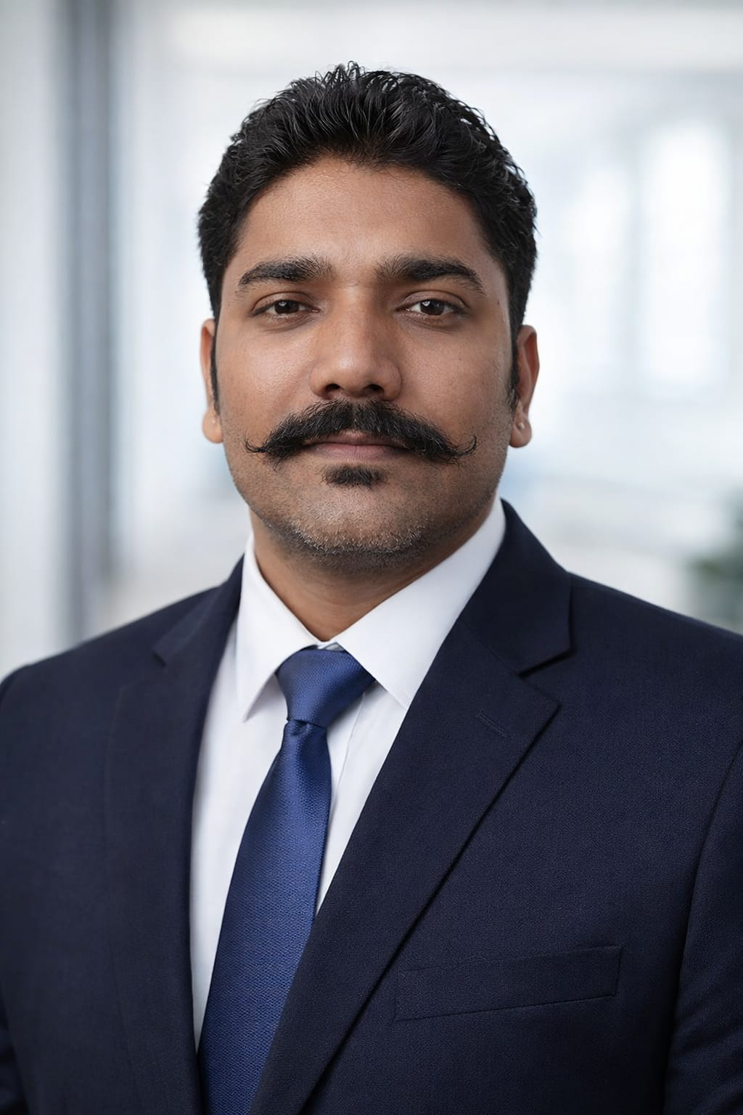
PROFESSIONAL SUMMARY
Software engineering professional with 13+ years of experience spanning backend services in Golang and Python, infrastructure automation, and converged/hyperconverged infrastructure. Principal Software Engineer experience at Dell Technologies, with contributions to microservice architecture, API design, event-driven integration, and leadership of a Python development team of 8–10 engineers. Hands-on work with Go microservices, Kubernetes, Temporal, Kafka, REST APIs, and gRPC.
TECHNICAL SKILLS
Docker, Git, Go, Helm, Kafka, Kubernetes, Linux, Microservices, Protocol Buffers, REST, gRPC, System design, Ansible, OpenAPI, Temporal, Authentication, Authorization, FastAPI, JWT, Leadership, OAuth 2.0, OpenID Connect, Pydantic, Python, RBAC, SASL, VMware, Vault, mTLS
PROFESSIONAL EXPERIENCE
Dell Technologies | Principal / Senior Software Engineer | Oct 2019–May 2026
- Designed REST/gRPC interfaces and Protocol Buffer contracts for Go microservices; created Helm charts defining deployments, services, ConfigMaps, Secrets, and service accounts for Kubernetes clusters.
- Built Go services using the Temporal Go SDK to start workflows and handle pause, resume, and cancellation signals; implemented REST interfaces, OpenAPI generation, and gRPC health checks.
- Contributed to microservice architecture discussions and evaluated Kafka client libraries through proofs of concept; developed producers and consumers for audit-event and service integration use cases.
- Contributed more than 60% of the cloud-interface microservice code for the On-Prem Cloud Controller; implemented REST APIs and developed Ansible playbooks and Python modules for infrastructure automation.
- Contributed to the architecture, design, and development of Python microservices using FastAPI and Pydantic for API implementation and data-model validation.
- Developed authentication (OpenID Connect, mTLS, JWT/bearer-token validation) and authorization (OAuth 2.0, RBAC) APIs; implemented Kafka audit logging with SASL authentication and retry handling for Kafka/Vault connectivity.
- Proposed approaches for a monitor-aggregator microservice and centralized shared component-health and pod-status logic in reusable Python framework classes.
- Guided technical design discussions, decomposed features into epics and stories, and coordinated with cross-functional teams to resolve engineering dependencies.
- Led 8–10 engineers developing the Atlas Python automation framework; implemented logging and reporting enhancements and completed Python 3.6-to-3.14 and plugin migration.
HCL Technologies | Technical Lead / Senior Software Engineer | May 2015–Oct 2019
- Riverbed client: Led 3–4 engineers developing Python automation for SteelFusion infrastructure; diagnosed automation-code issues across VMware, storage, and networking environments.
- Alcatel-Lucent client: Developed Python scripts for RF and modem-board automation, firmware initialization, and result analysis.
Powerwave Technologies R&D India | Engineer II – Software | Jul 2010–May 2013
- Developed Python scripts for radio-hardware interface data analysis and automated workflows using LabVIEW.
EDUCATION
M.Tech, Artificial Intelligence and Machine Learning | IIT Madras | Pursuing
B.Tech, Electronics & Communication Engineering | NIT Patna | 2010 | CGPA: 8.73/10

