# WLFJAD001 – Prac1 EEE3095S

GitHub link: [jadonwolffs](https://github.com/jadonwolffs)/[eee3095s](https://github.com/jadonwolffs/eee3095S)

<https://github.com/jadonwolffs>

1. Running ls to show the wlfjad001 dir

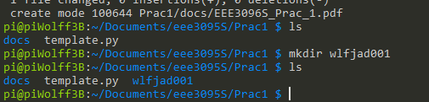

1. Running ifconfig to show adaptor settings

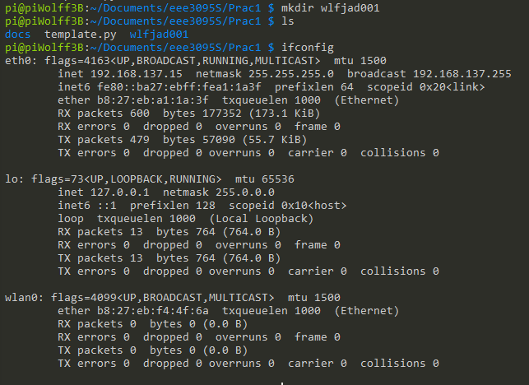

1. Running lscpu to show the details of the CPU on the Pi

