The purpose of this report is to investigate the relationship between how NHL teams score their goals and how well they do. With the salary cap factoring limiting teams from adding lots of the best players, the question of how to maximize any given roster with finite resources. A team that spends a lot of money on a few good players will have to have less talented players at the bottom of their roster. Another team may choose to have a more balanced roster. This is meant as a dive into which type of roster has performed the best since 2005 when the salary cap was implemented. All data has been taken from NHL.com.

Before starting, the strong correlation between a team scoring goals and winning must be acknowledged. This is intuitive, since hockey is a competition of which team can score the most. However, this is important to note early, as we will have to control for this factor later. Below you can see the relatively strong correlation from 2005-2018.

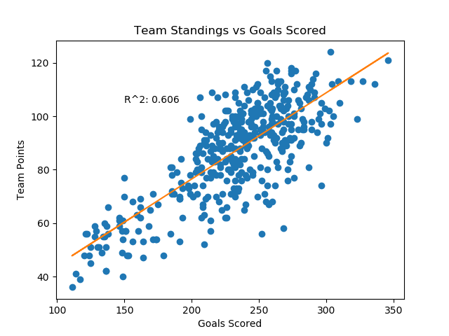

To remove this factor from biasing all the graphs, player metrics such as goals and assists are expressed as a percentage of team goals and assists. This allows us to observe which players are scoring their teams goals without worrying about the absolute scoring effect shown above. To evaluate how balanced or unbalanced a team’s scoring is, we will look at the standard deviation of the metric. Teams with high standard deviation have unbalanced scoring, whereas a low standard deviation implies a more balanced offense. Defense have been removed from the sample, and any player with less than 20 games played have also been removed.

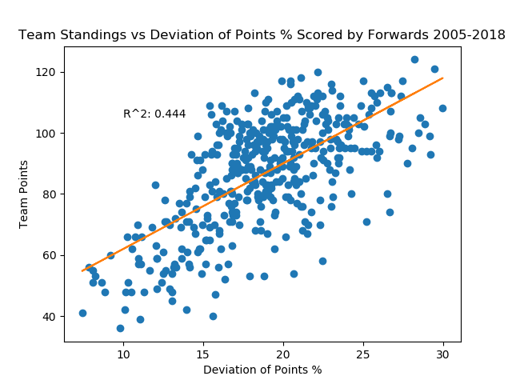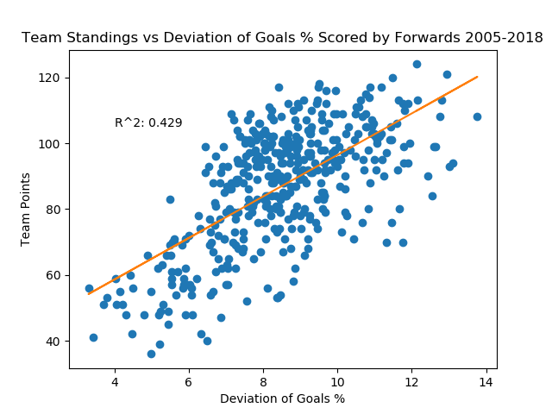

The above graphs show a significant correlation between the standard deviation of scoring and how well a team performed. From this, we can conclude that teams that have more unbalanced scoring in their forward group are more likely to be successful. This is not a perfect relationship, however an R-squared of 0.4 is significant enough to draw some helpful conclusions. The data shows that teams with unbalanced scoring are more successful; moving forward, teams should focus their resources and money on getting the highest scoring players possible, while focusing as much on their worst players.